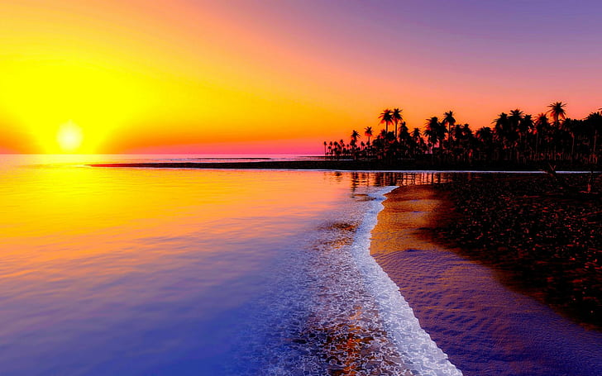

ASSIGNMENT

TRIP TO KUAKATA

### Sabrin Nahar: 221-15-5573 | CSE 122 | Date : **8**/11/2022

### PROGRAMMING AND PROBLEM SOLVING

### Tamjid Ahmed: 221-15-4895

### Ataur Rahman Samnan: 221-15-5555

### Traveling fasters a medium to build human connections with one another by learning about culture, food, new sites, music and the way people live their day to day lives in different parts of the world. It’s the best on site learning a person can get. While traveling , you do not just learn about new places, you also learn to relate with people living in different parts of the world that may took and live very much differently from you.

### It was our semester break .So we planned to go on a tour to get rid of the monotony of our life and to refresh our mind. At first we were thinking where can we go for a tour. Then we came to a decision that we are going to Kuakata. After planning the tour, we were waiting sincerely for the day to come. The day of starting the journey, we packed our bags and took necessary stuffs. We are two friends , Razin and I was going on this tour. Kuakata is a town in southern Bangladesh known for its panaromic sea beach. Kuakata beach is sandy sea beach where we can get unobstructed view of both sunrise and sunset over the bay of Bengal. It is about 271 kilometres far away from Dhaka.

### Razin lives in Uttara and we decided to get together at Syedabad Bus stand. I decided to join them directly at the bus stand from Mirpur. **Point of view of Razin**: I was already 15mins late from the time we fixed. So as soon as possible I took a Leguna from Diyabari,Sector-15.It took about 10mins to come at house building. Then I got off and took a local bus and started for Syedabad Bus Stand at 8.12pm.I reached at the Bus Stand at 10.17pm. **Point of view of Samnan**: At 8.30 pm I started to go for Syedabad. So I walked about 10 mins to Shewrapara and there I took a bus (Shikor).I reached the bus stand at 9.55pm. Going there I found out my friend Razin has not reached there. So I waited for him about 20mins.

### Finally we all got together at Syedabad. Then it was the high time to buy our tickets. We went to the Sakura Bus Counter which is situated at the Janapothe road, Syedabad. We bought two tickets of a good looking non-AC bus of Sakura Paribahan. So it was time for buying some snacks for the travelling hours. We bought some chips, biscuits and cold drinks for our journey. Our bus started for the journey at 11.50pm about 20mins late. At 12.30 almost our bus reached toll plaza of the Padma bridge. We were tired because of class on that day.So we gave a deep sleep. When I woke up, it was the time of sunrise and it was almost 5am.After 1 hour of journey more, Finally we reached our destination, Kuakata. We got off the bus at Shadar road of Kuakata. We got fresh in a restaurant named “Gazi Restora” which is situated at the sea beach area of kuakata. There we had our breakfast. I ate Paratas with Daal. Razin had Khichuri and Egg Omelette.

### After breakfast , it was time for the most important thing, search for a hotel. We were tired after the full night journey so we needed a rest. So we started to find vacant rooms in the hotel but unfortunately we couldn’t find any kind of vacant room there. But Allah heared us. After 50mins of searching and visiting of many hotels, we finally found a hotel which fulfilled our demand and in our budget. We got up in the hotel named “Hotel sea beach in” . The speciality of the hotel was the view of sea beach of kuakata from balcony. We took a little rest in the hotel. Then we went to visit the beach which is called “Kuakata zero point” at 11.30 am almost. There we enjoyed a lot together. It was the first tour of us together. So we wanted to visit all the sites and enjoy a lot. So we decided to visit all the places of Kuakata. So at noon we booked a bike to visit the tourist spots like Lebur Chor,Fish fry, Jhau Bon, Kakra beach, Jhinuk beach etc. Approximately at 2.30 pm , we started for the lebur chor by booking a bike. After reaching the Lebur Chor, We went to the fish fry spot to order our lunch .We bought a sea fish called Tuna fish. They took the fish and went to prepared the food for our lunch which could take about 30mins.So we gave our fish to the famous baburchi of Fish fry spot named “Saddam baburchi” . We enjoyed the beautiful scene of Lebur Chor.

### The taste of food was good and delicious. Usually I don’t like fishes but Saddam baburchi made me love the fish he cooked. After having our lunch we took rest in the Lebur Chor and came to know that it was the actual Jhinuk beach.Actually the lebur chor becomes the jhinuk beach in the afternoon at the time of the low tide. So we decided to wait for the jhinuk beach as it was 4pm already on the clock. In the evening I came to know that Razin became a little bit sick because of the long and restless journey and visiting the spot. So we both decided not to visit any spot on that day. So the next day at the morning, almost at 9 am we went to have our breakfast. So we went to Boishakhi restora to have our breakfast. After having breakfast , we started for Tin Nodir Mohona at 10 am. The junction of Andhar Onik, Payra and Bishkhali river is called as Tin Nodir Mohona. It was a nice place after all. After enjoying the site, we went for Jhau Bon.It is a silent place to enjoy the beauty of nature including Lebur Chor Canal. We decided to go back to Zero point after visiting Jhau bon. It was the lunch time when we came back to zero point at 3 pm. We both had Chicken biriyani this time which cost 160 taka per head. After having lunch we took rest at sea beach and waited for the evening to enjoy the sunset. Kuakata is the only place from where a person can see both sunrise and sunset.

### In the evening, we went to the fish market. There was ups and down on the prices of fish. We decided to have bar b q on the roof of hotel. So we wanted to buy some fish. After buying some fish then we enjoyed the fresh air of night at sea beach till mid night. After some time we went to hotel back and slept. The next day we checked out from the hotel and decided to visit the spots which we had to visit. After visiting the spots we had to go back to Dhaka as we had booked ticket for the 3 pm’s bus. We went to Poushi restaurant for our breakfast. After having break fast we went to visit Mistry Para at 10 am. There we took two tickets for 20 taka to enter Mistry para Mondir and Kua. There we visited Sri para Bouddho bihar and misty panir kua. After this we went to Rakhain polli and bought some chocolates and achar from Rakhain Market. After visiting the place we went to visit the main Kuakata. We visiting the Kua from which the place is named as Kuakata . After visiting the place we successfully completed our Kuakata tour. Then it was the time to go back to Dhaka. So we went back to the bus stoppage and returned home accordingly.

### It was really an enjoying trip for us. We will forever cherish these memories and I really hope that we can make more memories like these in the future .

**Cost table**

### 

**visited places**

