**Design Jam**

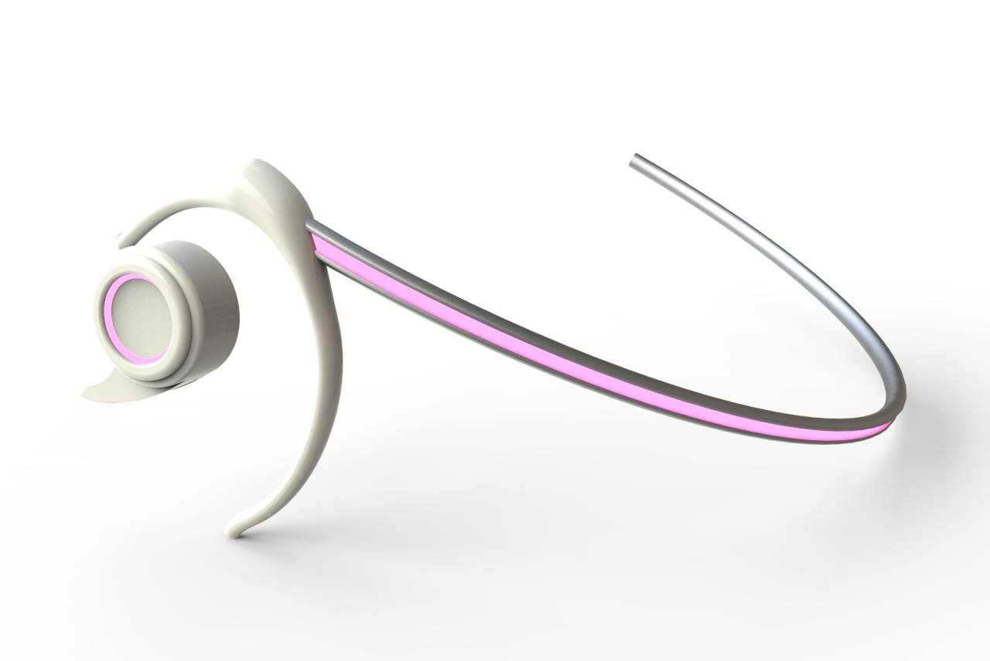

**Team Esparanto**

Prepared for: Design Jam #1 - Mobile Technology

Prepared by: Team Esparanto

September 30, 2015

**Brief**

How do we communicate our needs (desires), thoughts, emotions, and expression without speech?

**Team Name and Participants**

Sabrina Yeasmin

Shreya Sadhan

Rajdeep Das

Saumya Arora

Nevan Ryan

Kyle Purves

**Keywords:**

-Communication

-Beyond audio visual

-Universality

-Symbolism (Non-language base, UDL)

-Generational/Cultural

**Project Description**

There are times when we can’t communicate our thought by speaking out about it. At times we feel it would be really helpful if we could convey some particular thoughts with others without having to speak up about it. Aura is a small handy headgear, which creates 3d graphic above the head, which looks like a thoughtbubble. It will display 3D graphics for others to see, you can also use your hands to interact with the graphics by taking off the device.

**Objectives:**

* Making communication easier for people from different backgrounds and cultures.
* Making a form of communication that transcends language
* Creating a language aid for conversational purposes
* Making communication easier for people with disabilities
* Overcoming the communications gap amongst generations
* Communicating basic sentiment
* It will enhance your augmented reality experience.

**Considerations**

The factors the design solution needs to consider are:

-Make sure the device doesn’t become a second output to your smartphones

**Features**

The main feature of the product is to communicate with other people through a device which will contain data for as long as you want.

* The device will work as a mood detector. It will use heat censors to understand human emotions and produce it in terms of colors which will be showed in your aura depending on your choice.
* Live video sharing
* Creates Group Aura for team discussions.
* It will create a display of 25”
* Watch videos, play games, navigate
* You can use your voice to control it. Or something else (for someone who can’t speak.)?

**Audience:**

-Travelers/Newcomers

-Senior Citizens / Children

- People with disabilities

-Students/Educators

<http://link.springer.com/chapter/10.1007%2F978-3-642-21347-2_15#page-1>

http://www.racer.com.sg/files/33681218772436pdc2.pdf