**Design Procedure of a Conventional Low-Dropout Circuit**

|  |
| --- |
| Muhammad Aldacher,*Student Member, IEEE*  muhammadisaaldacher@gmail.com |

**1. Abstract**

This project discusses the design procedure of a conventional Low Dropout Voltage Regulator (LDO) circuit. The circuit consists of 2 stages, a 5-transistor operational transconductance amplifier (OTA) & a pass transistor, designed in 45nm CMOS technology. The circuit produces a regulated voltage of 0.9V using a reference voltage of 0.75V & a supply of 1.2V. A comparison is made between 2 compensation techniques to show how the stability, the PSRR, & the step-response behavior differ.

Supporting a load current range of 5mA ~ 30mA & a load capacitor of 200pF, the circuit achieves a worst-case PSRR of 8.894 dB, a loop gain of 43.22 dB, an offset of mean = 770uA & standard deviation = 1.513mV (1-sigma), with a current consumption of 250 uA (excluding the load current).

**2. Introduction**

*2.1 Motivation*

LDOs play a crucial role in modern electronic systems by providing stable and regulated output voltages despite varying input voltages and load conditions. The dropout voltage of the LDO represents the difference between the input supply voltage and the regulated output voltage. The LDO operates within a "regulation region," where the Pass Device is in the saturation region & delivers a stable output over various input supplies and output loads. An LDO includes a reference voltage, an error amplifier, a feedback network, and a series pass element, as shown in Fig.1(b). [1-3]

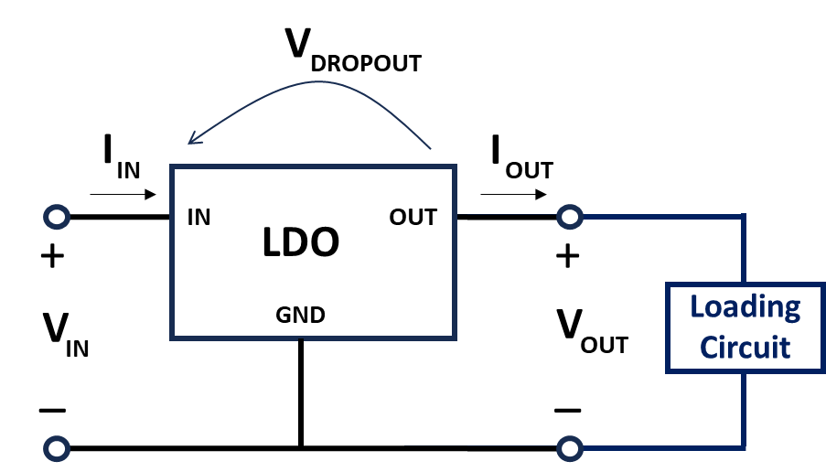 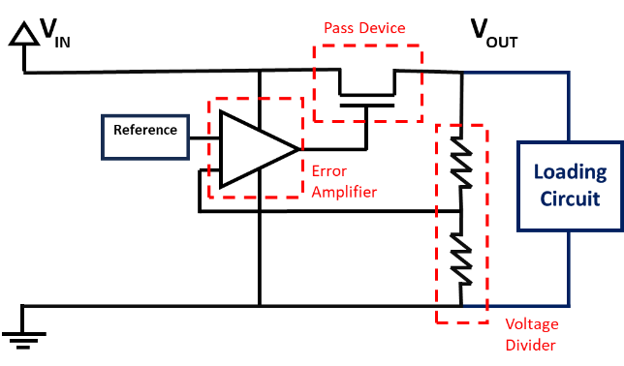

(a) (b)

Fig.1. LDO Block Diagram

(a) Top-Level View, (b) Main Blocks

*2.2 Main Topologies*

The 2 main LDO topologies based on the type of the pass device are LDOs using a PMOS pass transistor & those using an NMOS pass transistor. PMOS LDOs typically feature a lower dropout voltage and simpler construction, making them a common topology. However, this design often grapples with stability concerns due to the presence of two low-frequency poles, one at the pass device's gate and another at the regulated output node. As we will discuss later, addressing these stability challenges necessitates the implementation of compensation techniques to ensure the LDO loop’s stability.

NMOS pass-device LDOs typically exhibit faster response times owing to the higher mobility of electrons relative to holes. Moreover, NMOS LDOs, employing a common-drain configuration, exhibit reduced output resistance on the pass-device side as the transconductance (gm) of the pass transistor increases with the load current. This pushes the output pole to higher frequencies, particularly under higher load currents. However, it's worth noting that NMOS LDOs designed to support high current loads with a wide load range necessitate the inclusion of a charge pump circuit to elevate the pass-device's gate voltage. This addition contributes to an increase in LDO area and introduces some noise considerations. [4-6]

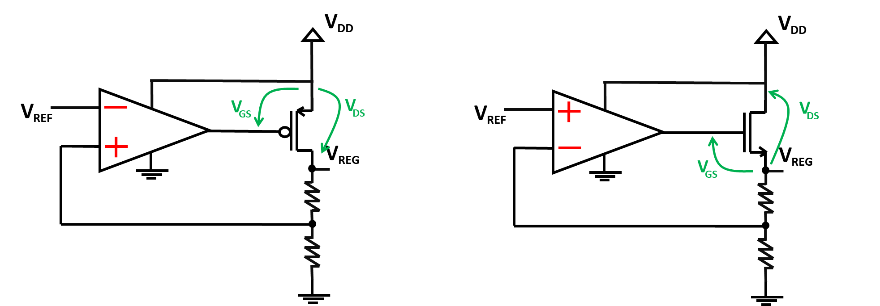

(a) (b)

Fig.2. LDO Topologies

(a) with PMOS pass device, (b) with NMOS pass device

The LDO loop is connected differently in the 2 topologies, mainly to form a negative-feedback system. In the case of the PMOS-based LDO, the PMOS pass-device is in a common-source configuration with the regulated output connected to the drain of the pass-device. Since the path from the gate-to-drain gives a negative gain, the feedback path is connected to the positive input of the OpAmp to give an overall negative-feedback loop, as shown in Fig. 3(a). On the other hand, the NMOS pass-device is used in the source-follower configuration with the regulated output connected to the source node which gives a positive gain from gate-to-source. In this case, the feedback is connected to the negative input of the Error Amplifier, as shown in Fig. 3(b).

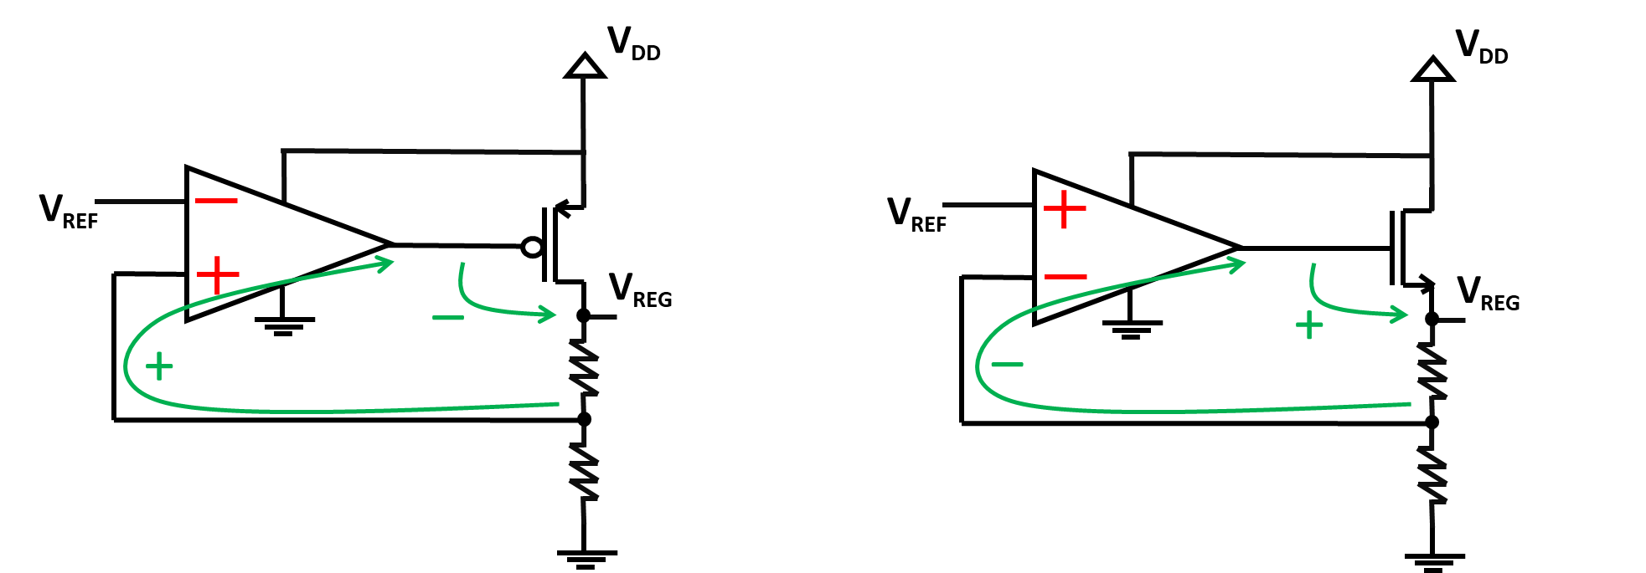

(a) (b)

Fig.3. LDO loop connections

(a) for PMOS pass-device LDOs, (b) for NMOS pass-device LDOs

Another difference in the LDO loop of the 2 topologies is the type of OpAmp used as the Error Amplifier. For the best Power-Supply Rejection (PSR), it is preferred to use an NMOS OpAmp with a PMOS pass-device, or a PMOS OpAmp with an NMOS pass-device, as explained in Ref [3] & shown in Fig. 4. In the following sections, the PMOS pass-device with an NMOS Error Amplifier is studied further.

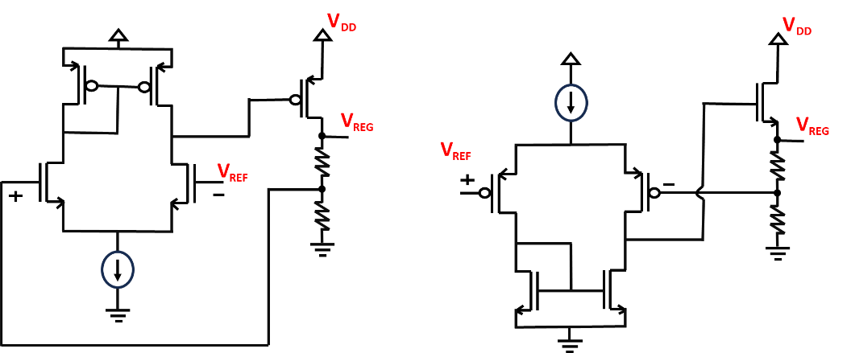

(a) (b)

Fig.4. LDO Error Amplifiers

(a) NMOS Error Amplifier, (b) PMOS Error Amplifier

**3. Basic Operation**

*3.1 DC Voltage Relationships*

Fig.5. PMOS LDO with the operation points & the load

Since the resistances in the LDO’s feedback form a voltage divider, the desired value for the regulated output voltage is determined mainly by the ratio between the 2 resistances & the value of the reference voltage, based on the following equation:

(1)

The pass device is used to provide the current needed by the load while being in the saturation region. Most of the pass device’s drain current should flow into the load, so R1 & R2 should be large enough so that IR would be negligible. The load current can be found using the MOSFET’s square-law equation:

(2)

All the devices must operate in saturation mode to ensure the correct operation. For the error amplifier, the transistors of the opamp must stay in the saturation region regardless of the load current value. At high load currents, the node voltage VG is low (VSG of pass-device is high), which could reduce the VDS of the NMOS devices. While at low load currents, VG is high (VSG of pass-device is low), which could reduce the VSD of the PMOS devices of the opamp. For the pass-device to be in saturation, its VDS should be greater than the overdrive voltage, as shown below:

(3)

(4)

*3.2 AC Operation & Compensation Techniques*

To ensure the stability of feedback control systems like LDOs, compensation is necessary. An RC network in the LDO helps stabilize the control loop by adding phase margin and reducing the risk of oscillations. In this sub-section, 2 types of these RC compensation techniques are discussed.

*3.2.1 Miller Compensation*

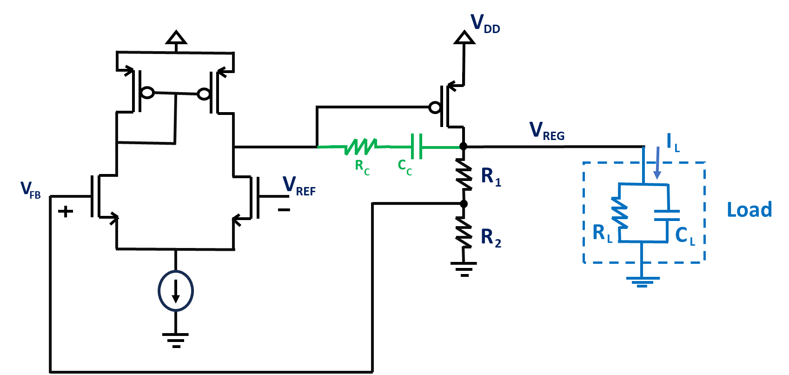

Fig.6. LDO with Miller Compensation

In Miller compensation, a capacitor CC is connected in negative feedback between the pass device’s gate (input) & drain (output) to give a large equivalent capacitor at the gate. This causes the dominant pole at the pass device’s gate to be shifted away from the non-dominant pole at the pass device’s drain, resulting in a better phase margin & a more stable system. [7-8] The following equations show the frequencies at which the dominant pole, the non-dominant pole, & the zero are located:

(5)

(6)

(7)

*3.2.2 RC (Lead-Lag) Compensation*

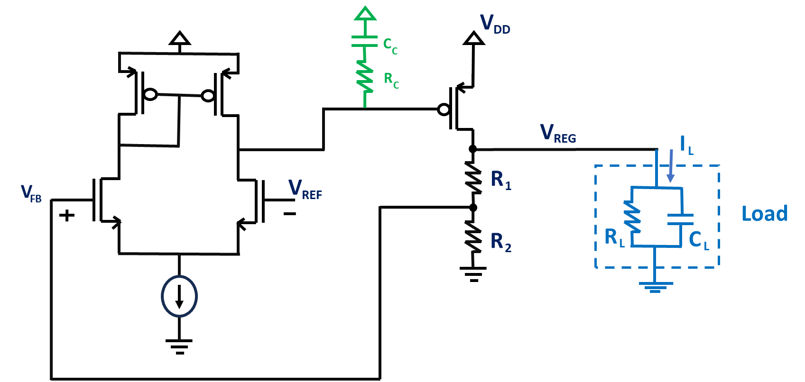

Fig.7. LDO with RC (Lead-Lag) Compensation

In this RC compensation, the added capacitor CC & resistance RC are used to create a pole & a zero pair. The values of CC & RC are determined to create the dominant pole and to set the zero location to cancel out the closest non-dominant pole. [9]

(8)

(9)

(10)

(11)

**4. Results and Discussion**

*4.1 DC Analysis*

In the DC analysis, the transistors are sized to ensure they are all in saturation for minimum load current (maximum VG,pass) & for maximum load current (minimum VG,pass). The values of the resistive divider are chosen to provide the 5/6 ratio from VREG to VFB & should be much bigger than RL so that almost all the current from the pass-device flows in the load. The total current consumption of the LDO, excluding the load current, is ~250uA. This includes 100uA from the OpAmp (50uA at both sides of the current-mirror) & 150uA from the resistive divider.

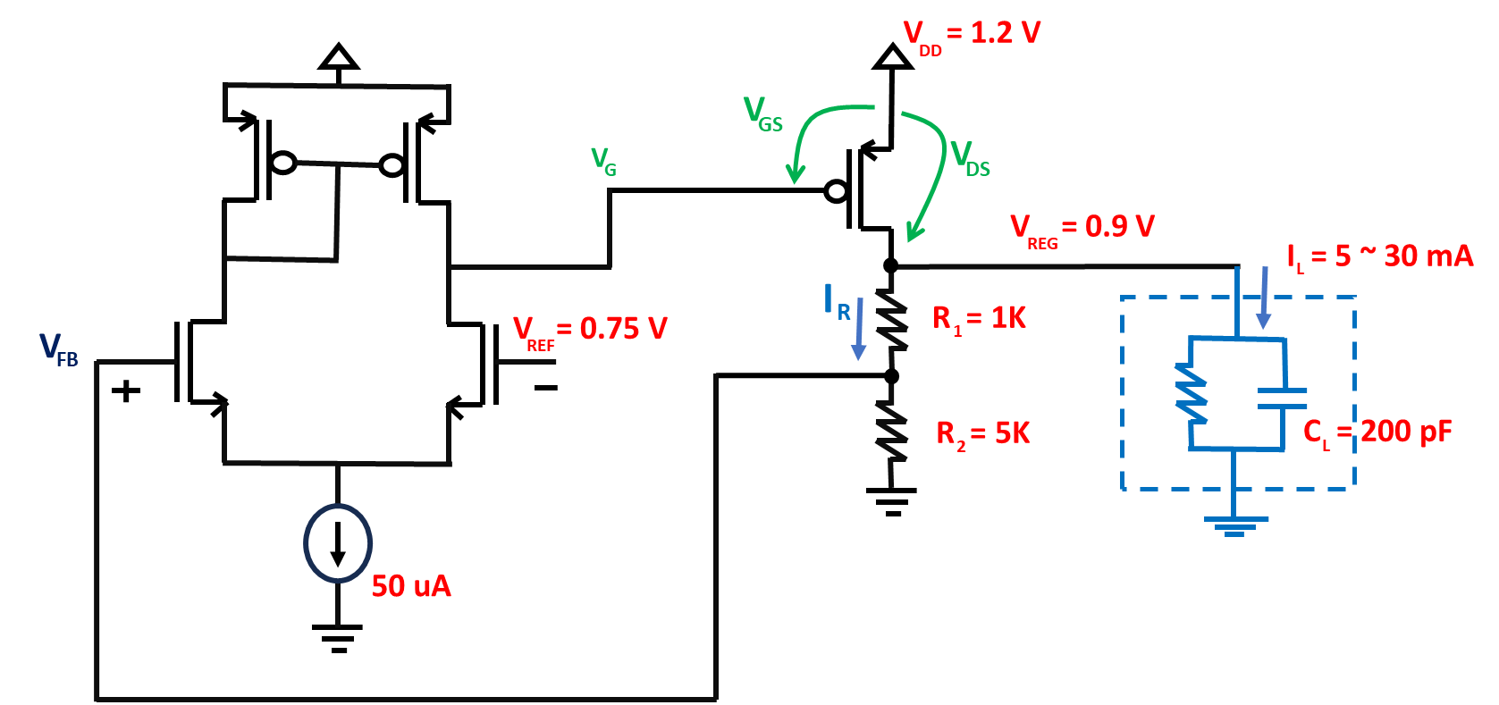

Fig.8. LDO with design values

*4.2 Monte-Carlo Analysis*

The Monte-Carlo analysis is done based on the DC analysis testbench to measure the offset between VFB & VREF. The offset’s mean & variation are measured at different X values, where X is the scaling factor multiplied by all the transistor dimensions (W & L). As X increases, mismatch reduces [10], as a result, the offset & its variation reduce. Running Monte-Carlo for 500 samples, the offset variation Vs X is shown in Table 1.

**Table 1: Monte-Carlo Simulation Results**

|  |  |  |
| --- | --- | --- |
| **Aspect Ratio =** | **Offset** | |
| **Mean** | **Variation** |
| X = 1 | 3.698m | 6.786m |
| X = 2 | 1.552m | 3.248m |
| X = 4 | 0.770m | 1.513m |

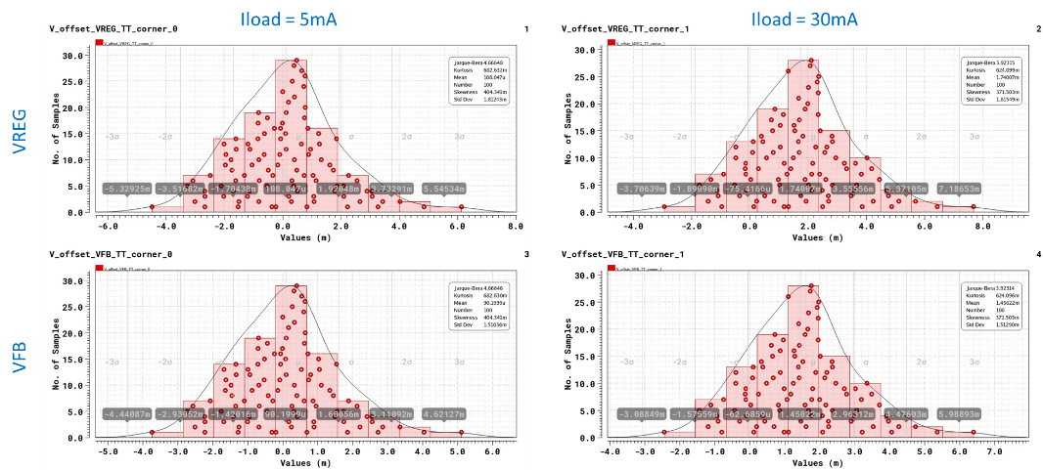

Fig.9. Offset Probability Distributions for X=4

*4.3 AC, STB, & Transient Analyses*

While changing the locations of the poles & the zero introduced by the compensation network, AC, STB, & Transient Analyses are observed together, since their measurements are all related. Through the AC analysis, we can observe the PSRR & the noise profiles of the system, while the STB analysis shows the closed-loop gain and phase. From equation (12), we can see how PSRR is related to the open-loop gain [11]. From the sweeps in Fig. 10, we can also see how increasing the PM (improving the stability) reduces the ringing in the output’s step-response [12].

(12)

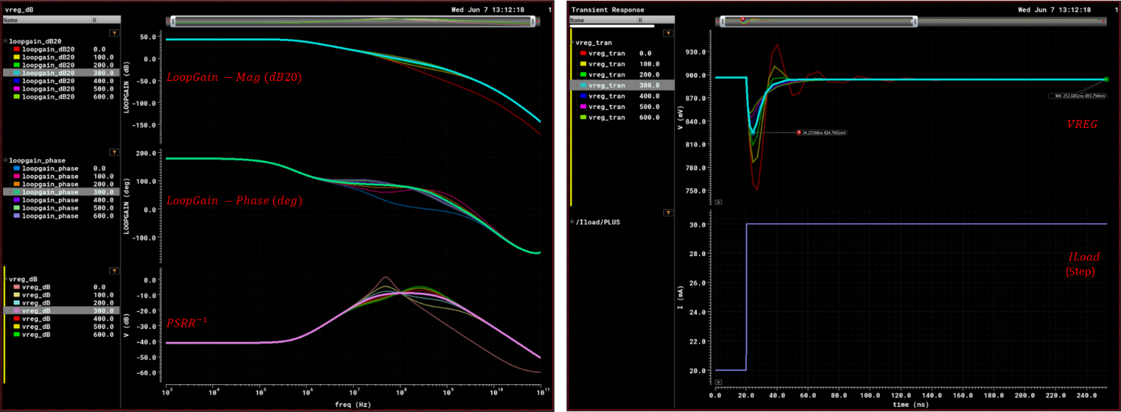

Fig.10. PSRR, Gain, Phase, & Step response of the LDO at different RC   
(Plots are for LDO with RC (Lead-Lag) Compensation & with Iload = 30m)

*4.4 Noise Analysis*

The output noise is related to the closed-loop gain, thus also effected by the zero & pole locations. The main contributors of the noise in the system are the bandgap (reference voltage), the resistor divider, and the input stage of the Opamp [13-14]. The bandgap noise is not considered in this study, so the noise observed at VREG is mainly due to the noise of the resistor divider & the Opamp shaped by the closed-loop. The output noise profile is shown in Fig. 11.

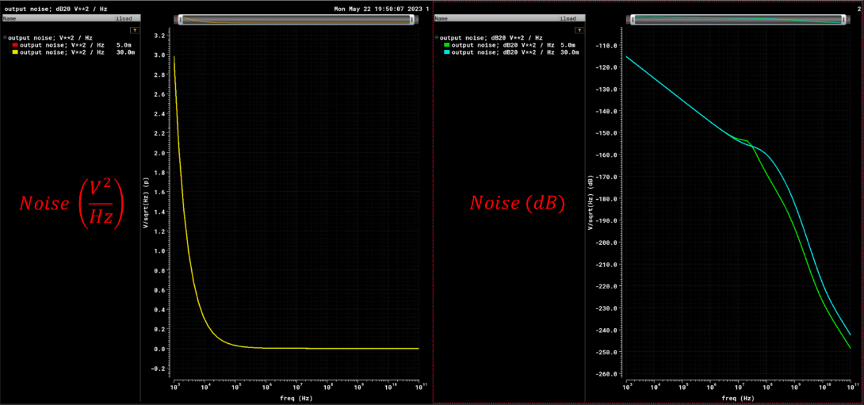

Fig.11. Output Noise of the LDO at Iload = 5m & 30m

*4.5 Schematics & Results*

The circuit schematics used for simulations on Virtuoso are shown in Fig. 12. Table 2 gives a summary of the results. Based on the PSRR results, the RC compensation is the preferred compensation technique in this study.

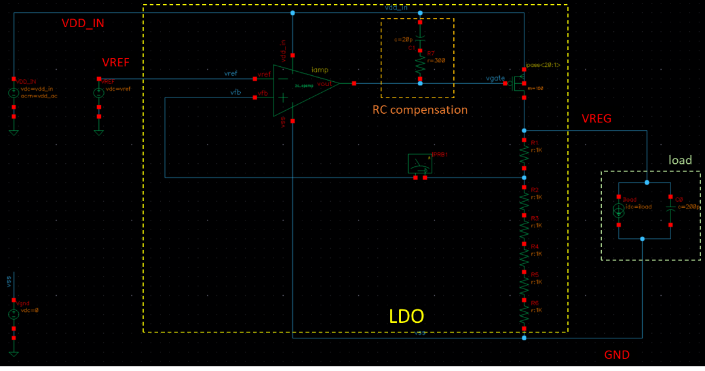

(a)

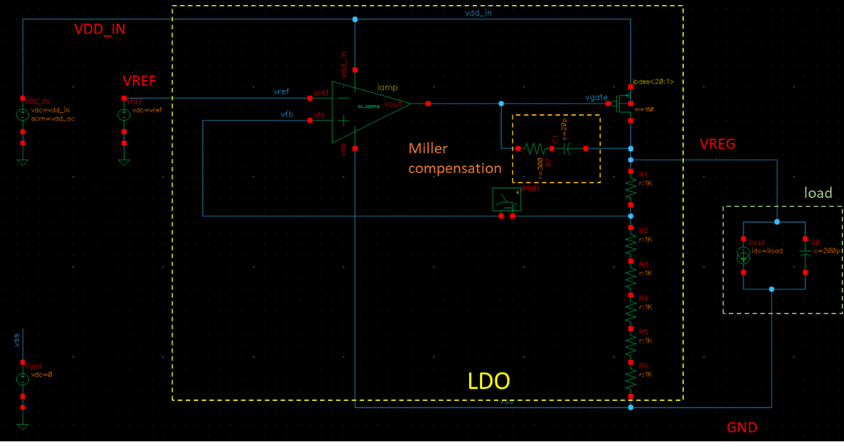

(b)

(c)

Fig.12. LDO Schematics on Virtuoso Cadence  
(a) with RC Compensation, (b) with Miller Compensation, (c) OpAmp used as Error Amplifier

**Table 2: Summary of Final Results**

|  |  |  |  |
| --- | --- | --- | --- |
| **Parameters** | | **Value** | |
| Supply Voltage | | 1.2 V | |
| Reference Voltage | | 0.75 V | |
| Regulated Voltage | | 0.9 V | |
| Load Current Range | | 5 mA – 30 mA | |
| Load Capacitor | | 200 pF | |
| Compensation | R | 300 Ohms | |
| C | 20 pF | |
|  |  |  |  |
|  | | **RC (Lead-Lag) Comp.** | **Miller Comp.** |
| DC Gain (min) | | 43.22 dB | |
| Phase-Margin (min) | | 60.34 deg | 99.23 deg |
| PSRR | @ DC | 41.14 dB | 41.14 dB |
| @ 1 MHz | 35.73 dB | 15.33 dB |
| @ 1 GHz | 13.13 dB | 8.24 dB |
| Worst case | 8.89 dB | 1.44 dB |
| Output Noise | Integrated from 1MHz to 10GHz | 191.7 uV2 | 104 uV2 |
| Settling time (99%) | | 16.29 ns | 20.05 ns |
| Offset | Mean (µ) | 770.2 uV | |
| Std Dev (σ) | 1.513 mV | |

**5. Conclusion**

This paper explores the design process and technical foundation of a traditional LDO circuit. By conducting simulations, we investigated the impact of two compensation techniques on PSRR, PM, Noise, and Settling time.

**References**

1. "[Linear Low Dropout Voltage Regulators](https://wiki.analog.com/university/courses/alm1k/alm-ldo-lab)", Technical Article, Analog Devices, 2021.
2. B. Razavi, "[The Low Dropout Regulator](https://ieeexplore.ieee.org/stamp/stamp.jsp?arnumber=8741287) [A Circuit for All Seasons]," in IEEE Solid-State Circuits Magazine, vol. 11, no. 2, pp. 8-13, Spring 2019, doi: 10.1109/MSSC.2019.2910952.
3. P. K. Hanumolu, "[Low dropout regulators](https://github.com/muhammadaldacher/Analog-Design-of-LDO-with-PMOS-pass-device/blob/main/References/%5BTutorial%5D%20Low%20Dropout%20Regulators%20%5BHanomulu%5D.pdf)," 2015 IEEE Custom Integrated Circuits Conference (CICC), San Jose, CA, USA, 2015, pp. 1-37, doi: 10.1109/CICC.2015.7338435.
4. M. H. Kamel, A. N. Mohieldin, E. -S. Hasaneen and H. F. A. Hamed, "[A hybrid NMOS/PMOS low-dropout regulator with fast transient response for SoC applications](https://github.com/muhammadaldacher/Analog-Design-of-LDO-with-PMOS-pass-device/blob/main/References/NMOS%20vs%20PMOS/A%20Hybrid%20NMOS-PMOS%20Low-Dropout%20Regulator%20with%20Fast%20Transient%20Response%20for%20SOC%20applications.pdf)," 2017 29th International Conference on Microelectronics (ICM), Beirut, 2017, pp. 1-4, doi: 10.1109/ICM.2017.8268850.
5. M. H. Kamel, Z. K. Mahmoud, S. W. Elshaeer, R. Mohamed, A. Hassan and A. I. A. Galal, "[Comparative Design of NMOS and PMOS Capacitor-less Low Dropout Voltage Regulators (LDOs) Suited for SoC Applications](https://github.com/muhammadaldacher/Analog-Design-of-LDO-with-PMOS-pass-device/blob/main/References/NMOS%20vs%20PMOS/Comparative_Design_of_NMOS_and_PMOS_Capa.pdf)," 2019 36th National Radio Science Conference (NRSC), Port Said, Egypt, 2019, pp. 305-314, doi: 10.1109/NRSC.2019.8734659.
6. A. Saha, A. Biswas, S. Dhabal, P. Venkateswaran, "[An Improved PMOS-Based Low Dropout Regulator Design for Large Loads](https://github.com/muhammadaldacher/Analog-Design-of-LDO-with-PMOS-pass-device/blob/main/References/NMOS%20vs%20PMOS/An_efficient_PMOS-based_LDO_design_for_large_loads.pdf)," arXiv preprint, arXiv:2209.12726, 2022.
7. S. Franco, "[Miller Frequency Compensation: How to Use Miller Capacitance for Op-Amp Compensation](https://www.allaboutcircuits.com/technical-articles/miller-frequency-compensation/#:~:text=What%20Is%20Miller%20Compensation%3F,stages%2C%20typically%20the%20second%20stage.)," Technical Article, All about circuits, 2019.
8. P.E. Allen, "[Design of two-stage OpAmps](https://aicdesign.org/wp-content/uploads/2018/08/lecture23-160311.pdf)," CMOS Analog Circuit Design, 3rd Ed., Oxford University Press, 2011.
9. E. Alon, "[Lec 15: Supply Regulation I](https://drive.google.com/file/d/1LdRAz_pcRIswL3aWN9GCisEXDwg8RBDr/view?usp=drive_link)," EE290C: High-Speed Electrical Interface Circuit Design, Course at Berkeley University, 2011.
10. B. Razavi, "[Design of Analog CMOS Integrated Circuits](https://drive.google.com/file/d/14HT0R-oztZRAJbOOP0i4hZYRGIiUSPJD/view?usp=drive_link)", 2nd Ed., **Ch.14: Nonlinearity & Mismatch**, Boston: McGraw-Hill, 2017.
11. T. Carusone, D. Jones, K. Martin, "Analog Integrated Circuit Design", 2nd Ed., [**Ch.7: Biasing, References & Regulators**](https://github.com/muhammadaldacher/Analog-Design-of-LDO-with-PMOS-pass-device/blob/main/References/%5BLec%5D%20LDO%20-%20Tony%20Carusone.pptx), John Wiley & Sons, Inc, 2012.
12. J. Stevens, "[Simplifying Stability Checks](https://github.com/muhammadaldacher/Analog-Design-of-LDO-with-PMOS-pass-device/blob/main/References/%5BTI%5D%20Simplifying%20Stability%20Checks.pdf)", Technical Article, Texas Instruments, 2013.
13. "[Understanding Noise and PSRR in LDO](https://www.allaboutcircuits.com/technical-articles/understanding-noise-and-psrr-in-ldos/)", Technical Article, All about circuits, 2015.
14. J. Teel, "[Understanding noise in linear regulators](https://github.com/muhammadaldacher/Analog-Design-of-LDO-with-PMOS-pass-device/blob/main/References/Noise_Analysis/%5BTI%5D%20Understanding%20noise%20in%20linear%20regulators.pdf)", Technical Article, Texas Instruments, 2005.