# UI Walkthrough Preparation Checklist

This document is a checklist to prepare for the walkthroughs and demos.

Following these steps will prepare you for all the walkthroughs. The steps are organized into the following sections:

1. **Prepare an organization**
2. **Prepare two repositories owned by the organization account**
3. **Prepare two project boards**
4. **Prepare the GitHub CLI**

## **Prepare an organization**

* Prepare an organization account (GHEC) for demo purposes. Use either an existing org or create a new one.
  + **Use an existing organization:** 
    1. Check which organizations you are a member of at **github.com > Settings > Organizations**.
    2. If possible, choose an organization where you see “Settings” (indicating admin access) AND the demo content is appropriate.

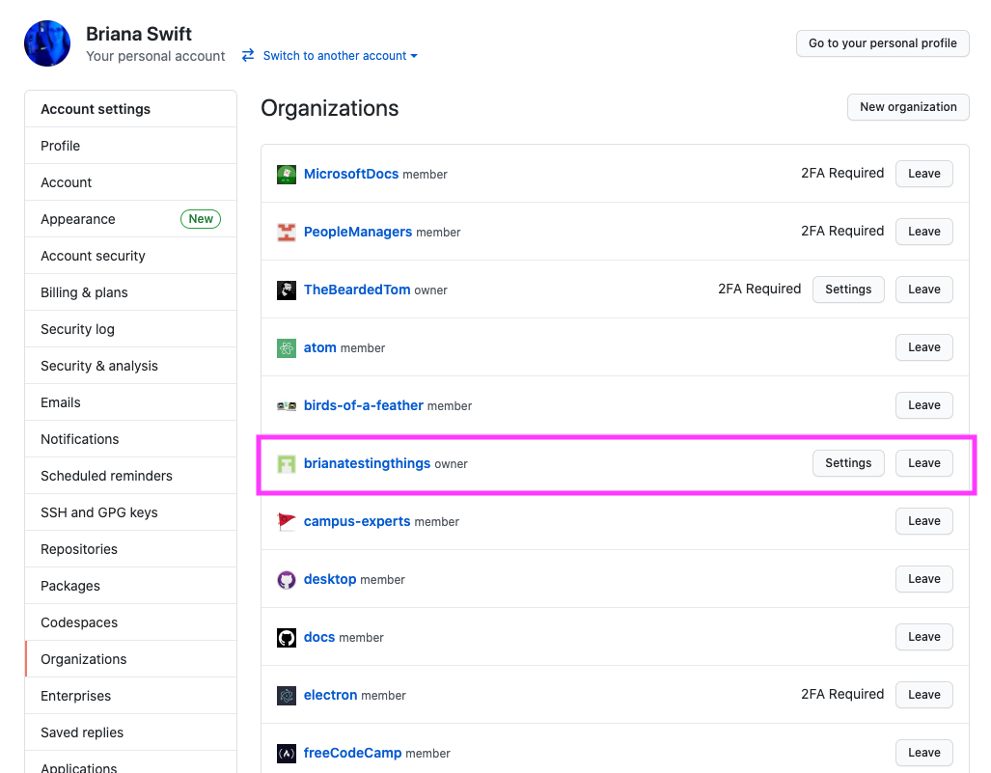

* + **Create a new organization:** 
    1. Create a new organization at <https://github.com/organizations/plan>. The Enterprise plan is preferable for full demo capabilities. Reach out to your contact in the GitHub Partner Program for additional details on free demo accounts.
* Have at least two individual accounts within the organization.
  + Org admin/owner
  + Org member (to be added to a team & repo)
  + Optional: Include more people, like bootcamp participants, to show team capabilities.

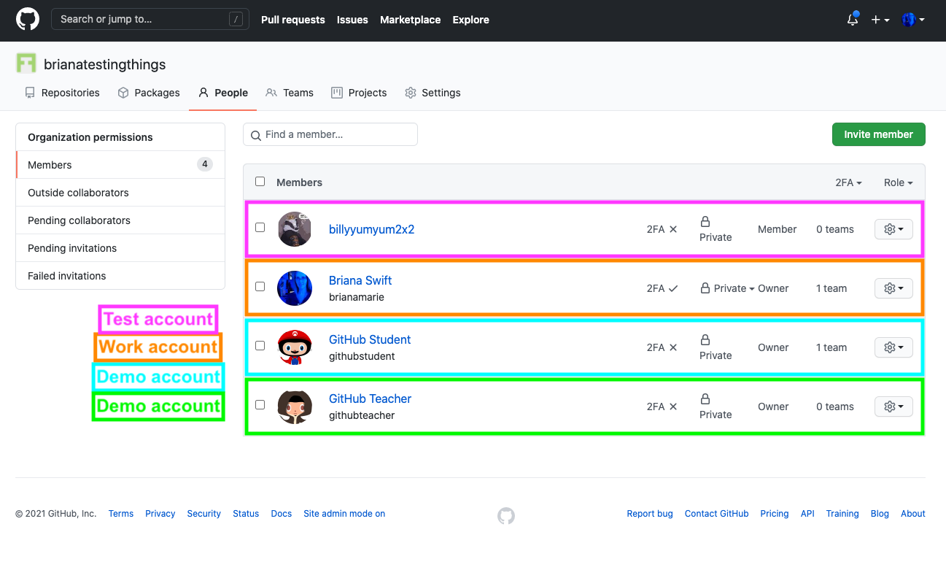

* Create multiple teams within the organization.

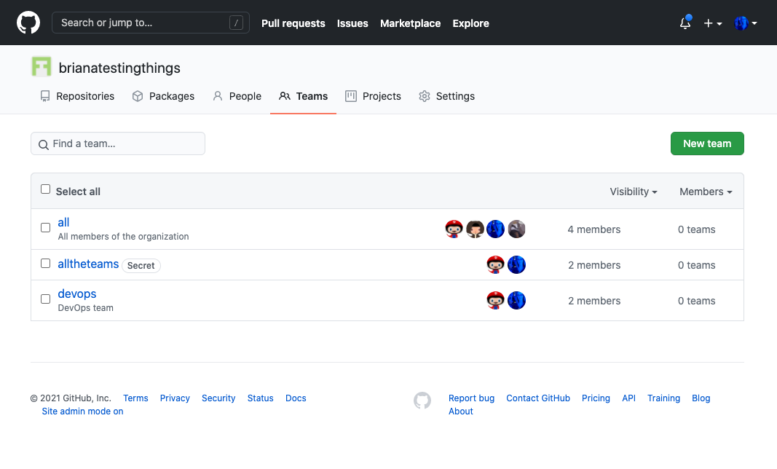

## Prepare two repositories owned by the org account

* **Calculator repository:** Prepare a version of [this calculator repository](https://github.com/microsoft/calculator) owned by the demo organization account.
  + Create a new empty repository on GitHub, selecting the demo org for the *Owner* field. (Do not initialize the repository with any files during setup.)

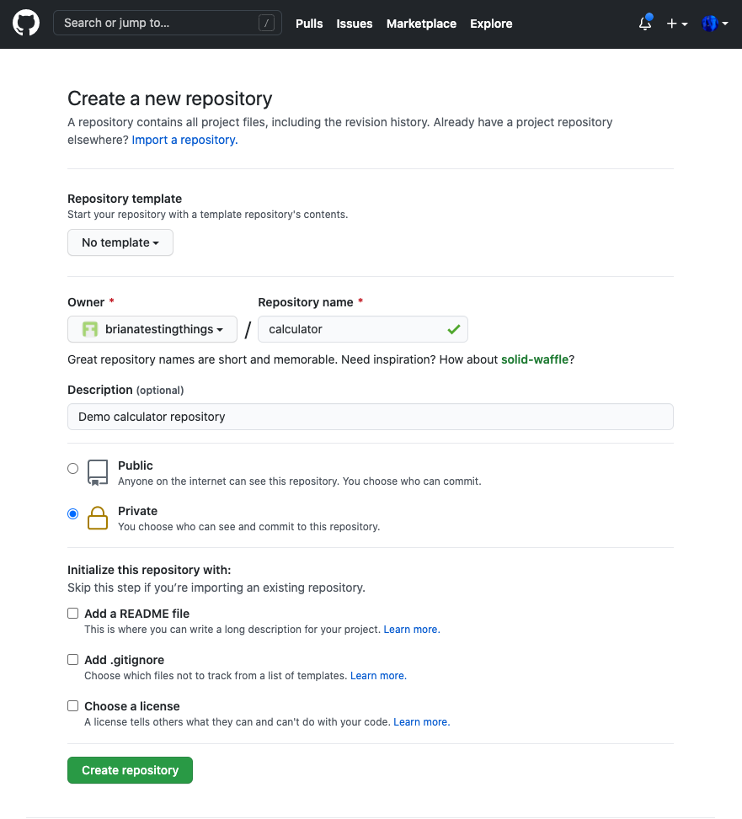

* + Clone the [microsoft/calculator](https://github.com/microsoft/calculator) repository into a temporary local location.

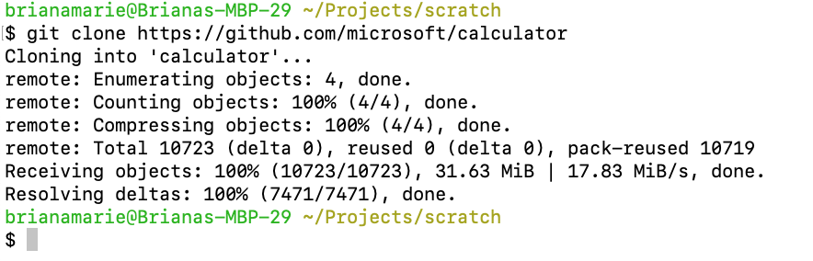

* + Add a new remote locally, pointing to your new repository on GitHub.

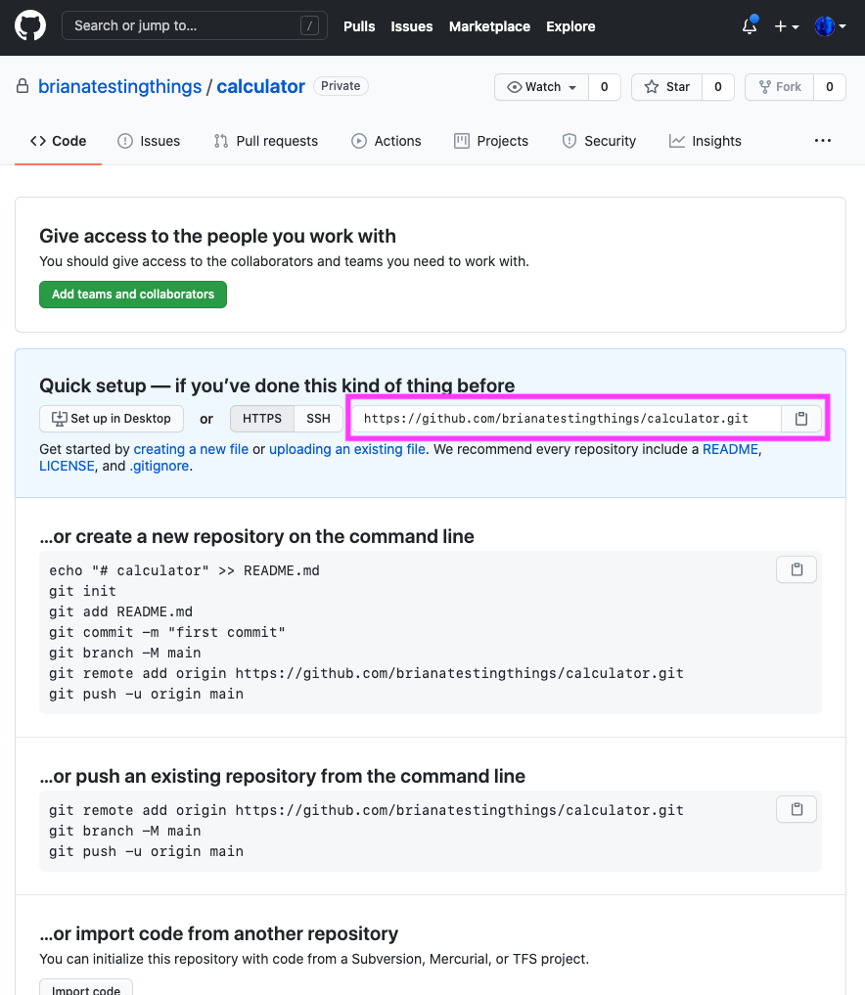

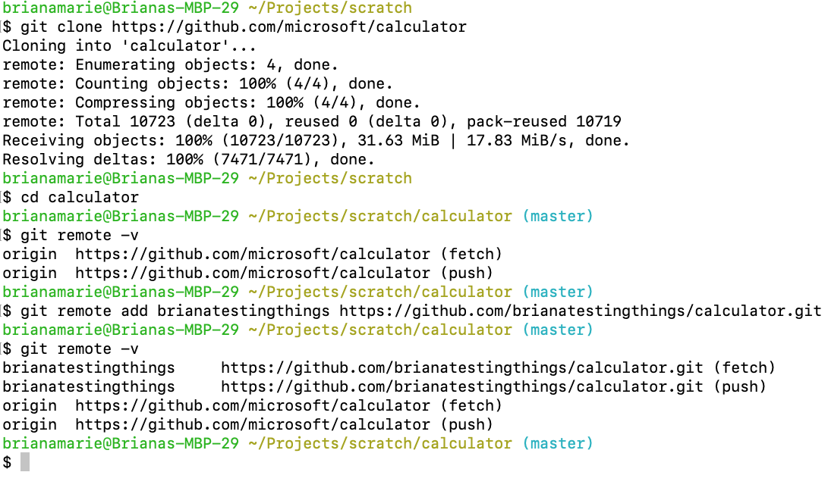

* + Push to the new GitHub repository

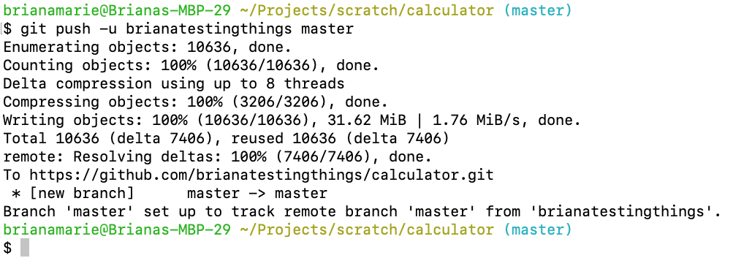

* **Template repository:**
  + Prepare a *template* repository ready to demo.
  + See <https://github.com/brianatestingthings/repository-template> as an example. (Optional – use this repository directly, by following similar process as Calculator repository.)
  + Ensure the repository can be used as a template.

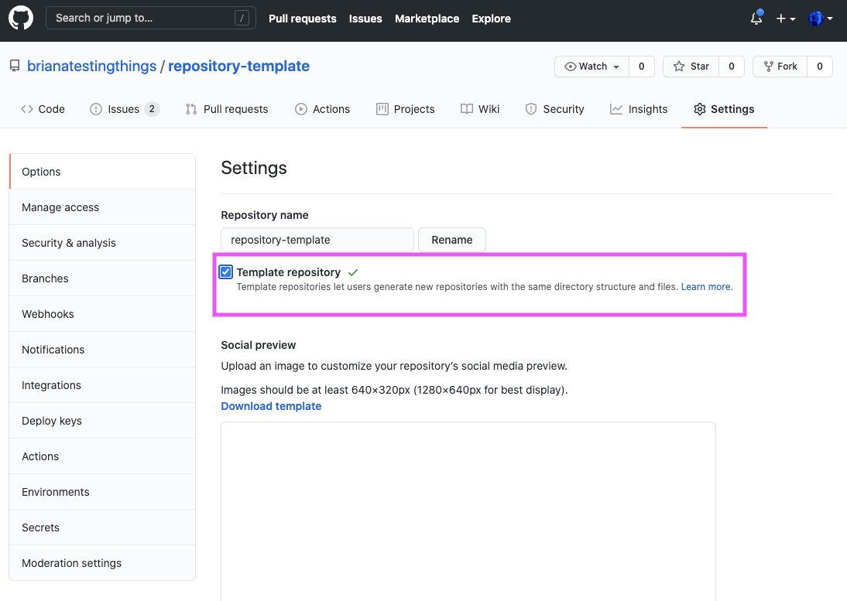

* + The template repository should include:
    1. Several issue templates
    2. An enterprise JSON file (or other configuration file [such as one for the Stale probot app](https://probot.github.io/apps/settings/))
    3. A super-linter installed and functional that uses Actions.
    4. At least two prepared open issues that contain examples of markdown (with cross-links, images, links, headers, quotes, lists, build statuses, workload diagrams, gifs or animations, terminal screenshots, table of contents, code blocks, inline code, etc.)
* Repositories should have topics.

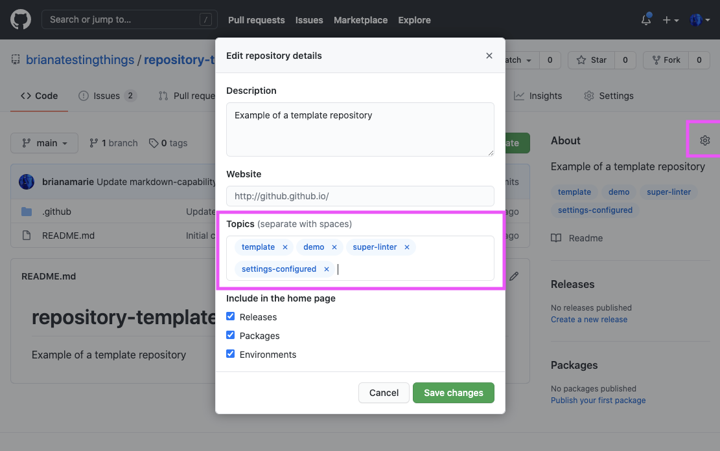

## Prepare project boards

* Prepare two populated, automated project boards
  + One at org level

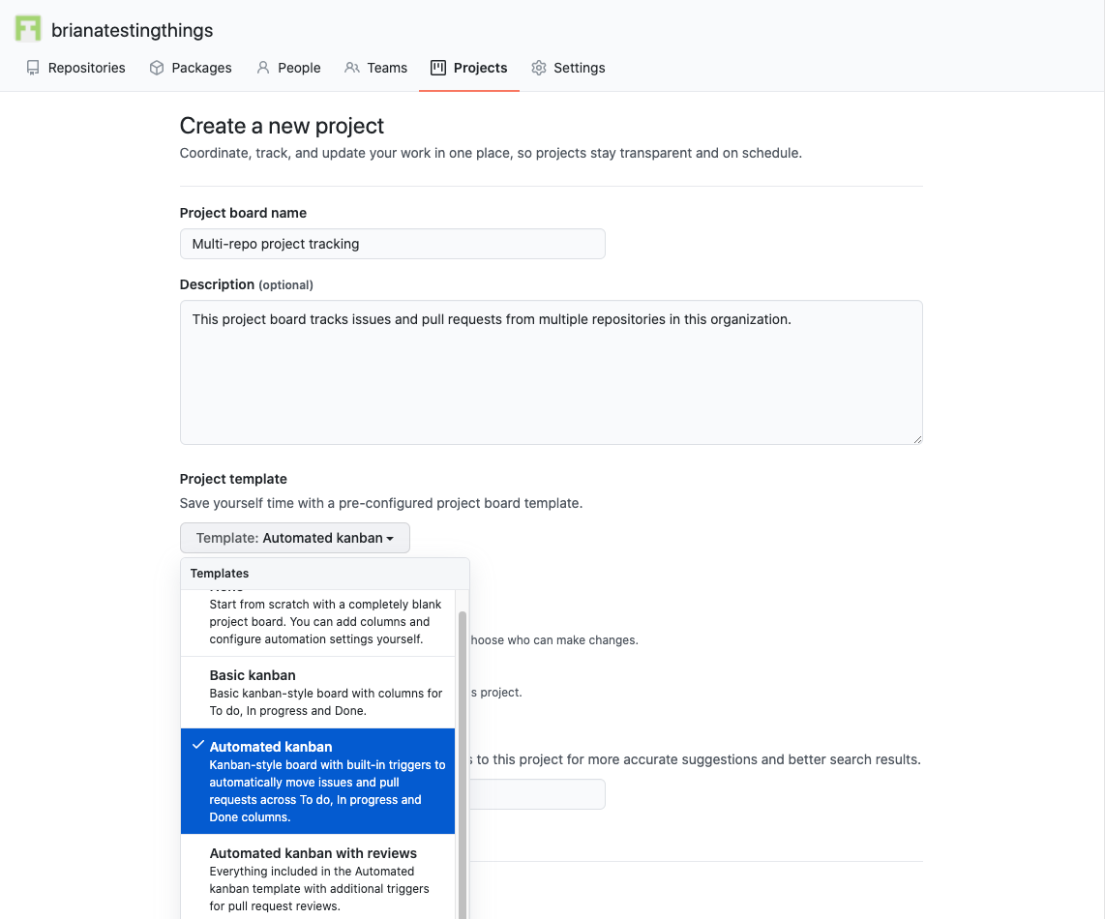

* + One at repo level, in the calculator repository

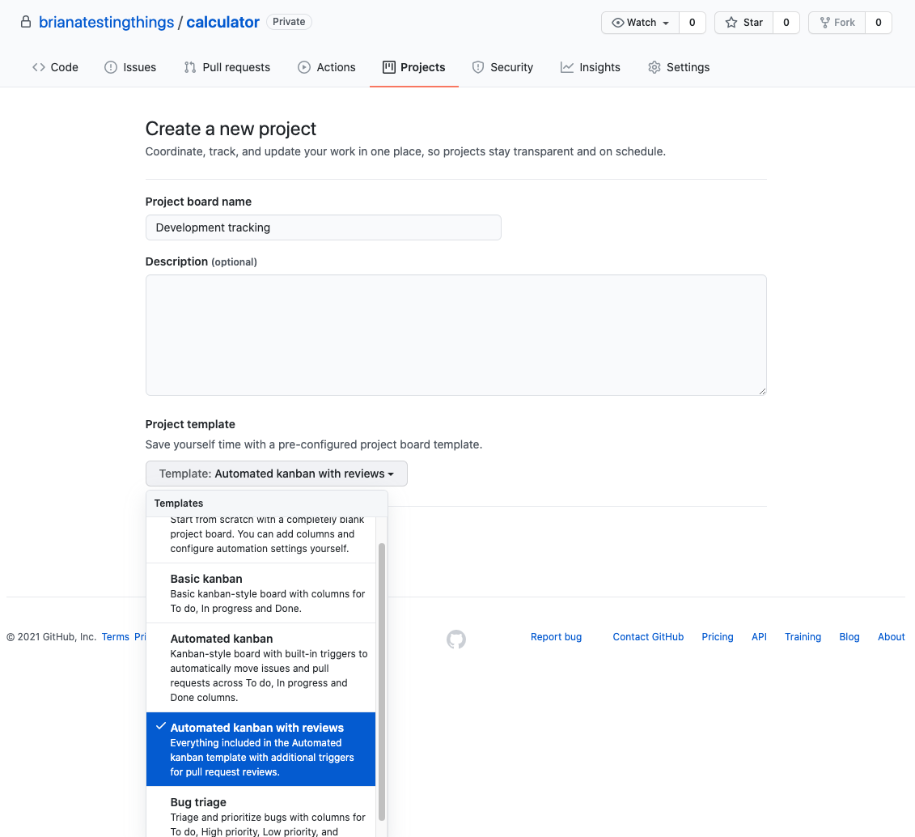

## Prepare GitHub CLI

* + Ensure [GitHub CLI](https://github.com/cli/cli) is functional on your machine

