# **Issues and Project Management - UI Walkthrough**

To setup for this walkthrough, please complete the steps in the document [00_Walkthrough-prep-checklist.docx](https://microsoft.sharepoint.com/:w:/t/GitHubContentandEnablement/EWkFzgwVfnpIu2vUb8VYhlwBeSPMiRdRDxvh6doY0L6wfg?e=GxRJzO).

**Walkthrough steps**

* **Auto-linking**
* Show resources:
  + - * [Configuring autolinks to reference external resources](https://docs.github.com/en/github/administering-a-repository/configuring-autolinks-to-reference-external-resources)
  + Comment with one issue link in another link (show the auto-shortening)
  + Show repository settings, autolink references; how to configure similar auto-shortening

* **Project board**
  + Show the prepared project board
  + Open a new issue to show automation on project board   
      
    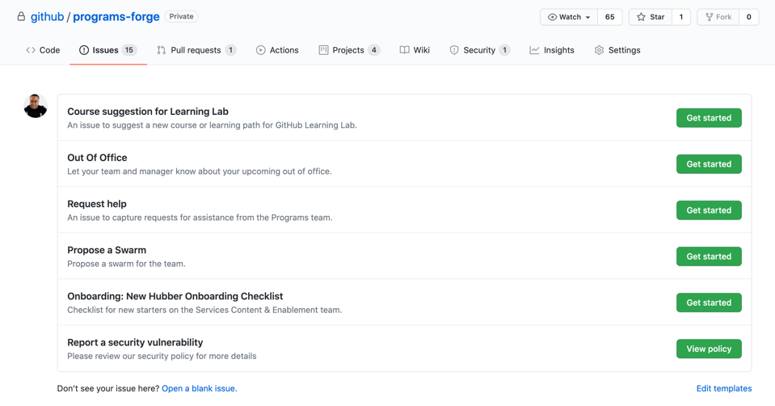
* **Create a new label**
* Optional: use emoji
* **Transfer an issue to another repository**
* Show that redirection is automatic
* **Open a new issue, showing the options available when there are multiple issue templates**

**GitHub CLI demo**

* **Clone the repository**
  + Open an issue locally. **Example:**    
      
    gh issue create --title “Sample issue from CLI” --body “CLI Issue body” --assignee @yourhandle