# Team and organization management - UI Walkthrough

To setup for this walkthrough, please complete the steps in the document [00_Walkthrough-prep-checklist.docx](https://microsoft.sharepoint.com/:w:/t/GitHubContentandEnablement/EWkFzgwVfnpIu2vUb8VYhlwBeSPMiRdRDxvh6doY0L6wfg?e=GxRJzO).

**Checklist**

* Show the organization pageGraphical user interface, application

  Description automatically generated
  + Walk through the tabs, especially members, teams, and settings  
    
  + In teams, show the team tabs, especially repositories
  + In Settings, show “Member privileges” and discuss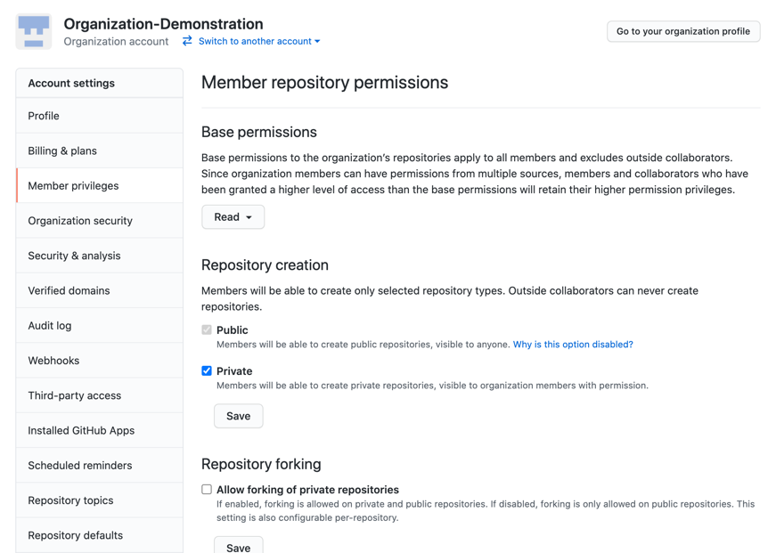
* As a non-admin user, first show a repository that cannot be accessed
* Then, as an admin, add that user to a team with access to that repository.
* As an admin, show the repository settings and walk through the options, especially “Manage access”
* Then, as the user again, show what access looks like, including that they cannot access the settings tab.

