# Repository and Policy Management UI Walkthrough

To setup for this walkthrough, please complete the steps in the document [00_Walkthrough-prep-checklist.docx](https://microsoft.sharepoint.com/:w:/t/GitHubContentandEnablement/EWkFzgwVfnpIu2vUb8VYhlwBeSPMiRdRDxvh6doY0L6wfg?e=GxRJzO).

## **Checklist**

* In calculator repository:
  + Show repository settings, and how to get to the settings page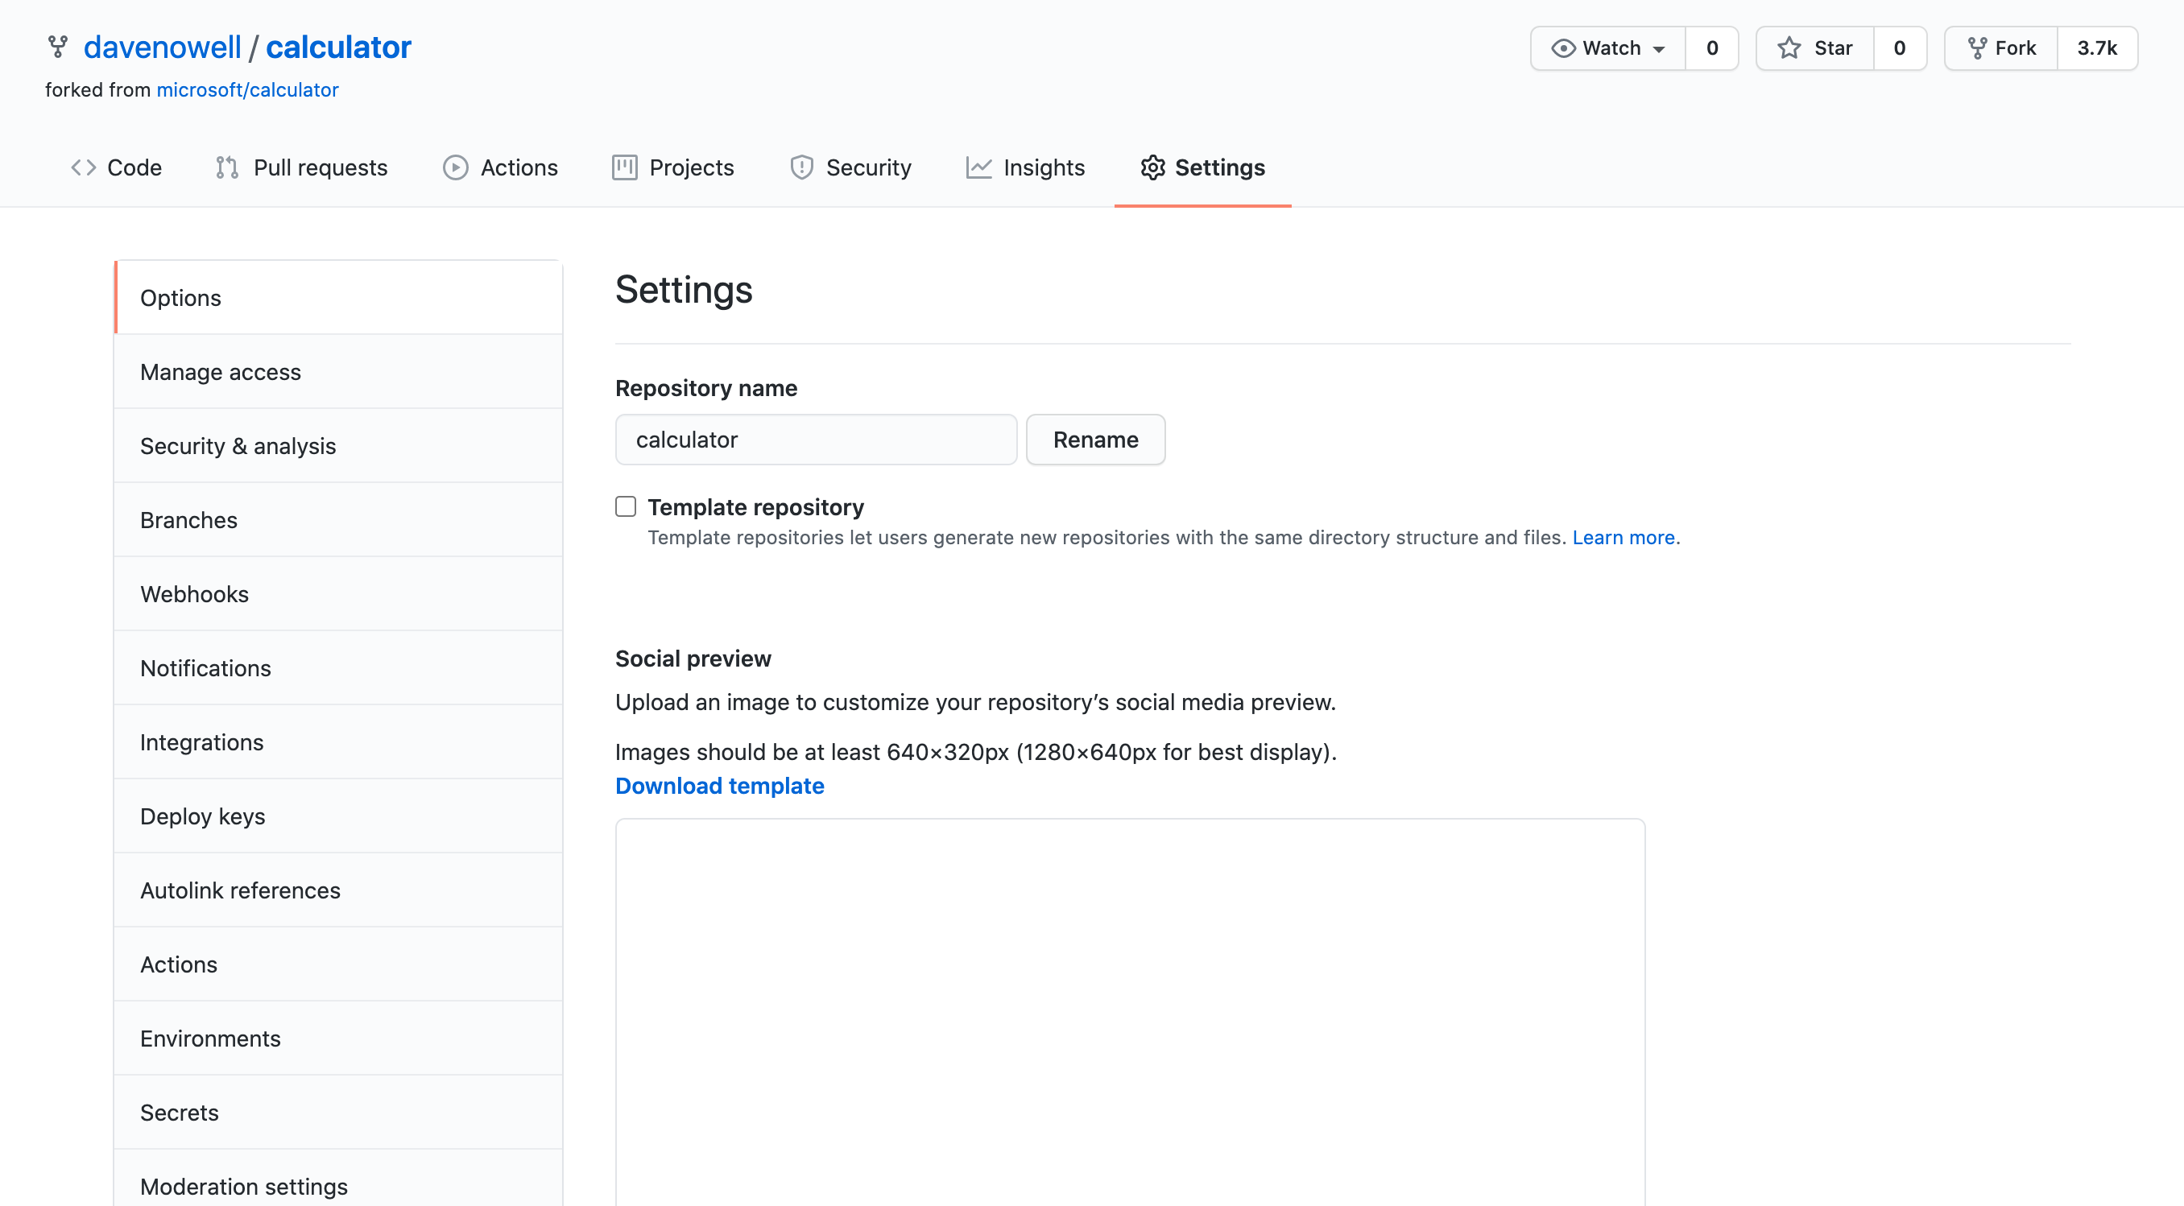
  + Configure branch protection for the default branch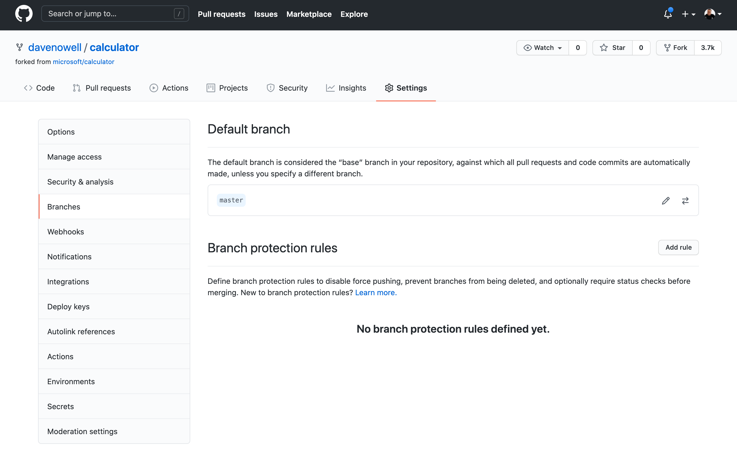
    - Show that you can configure branch protection for any branch
    - Show regex pattern possibilities
    - Select every type of protection, and explain them each one at a time
  + Create an issue template including a label, show that you cannot commit to the default branch, but instead must create a new branch and open a pull request to the default (protected) branch
  + Open a pull request, assign reviewers, assignees, labels, and add it to a project board
* Show the template repository with the enterprise.json file that would be applied to all new repositories using this template
* Show organization settings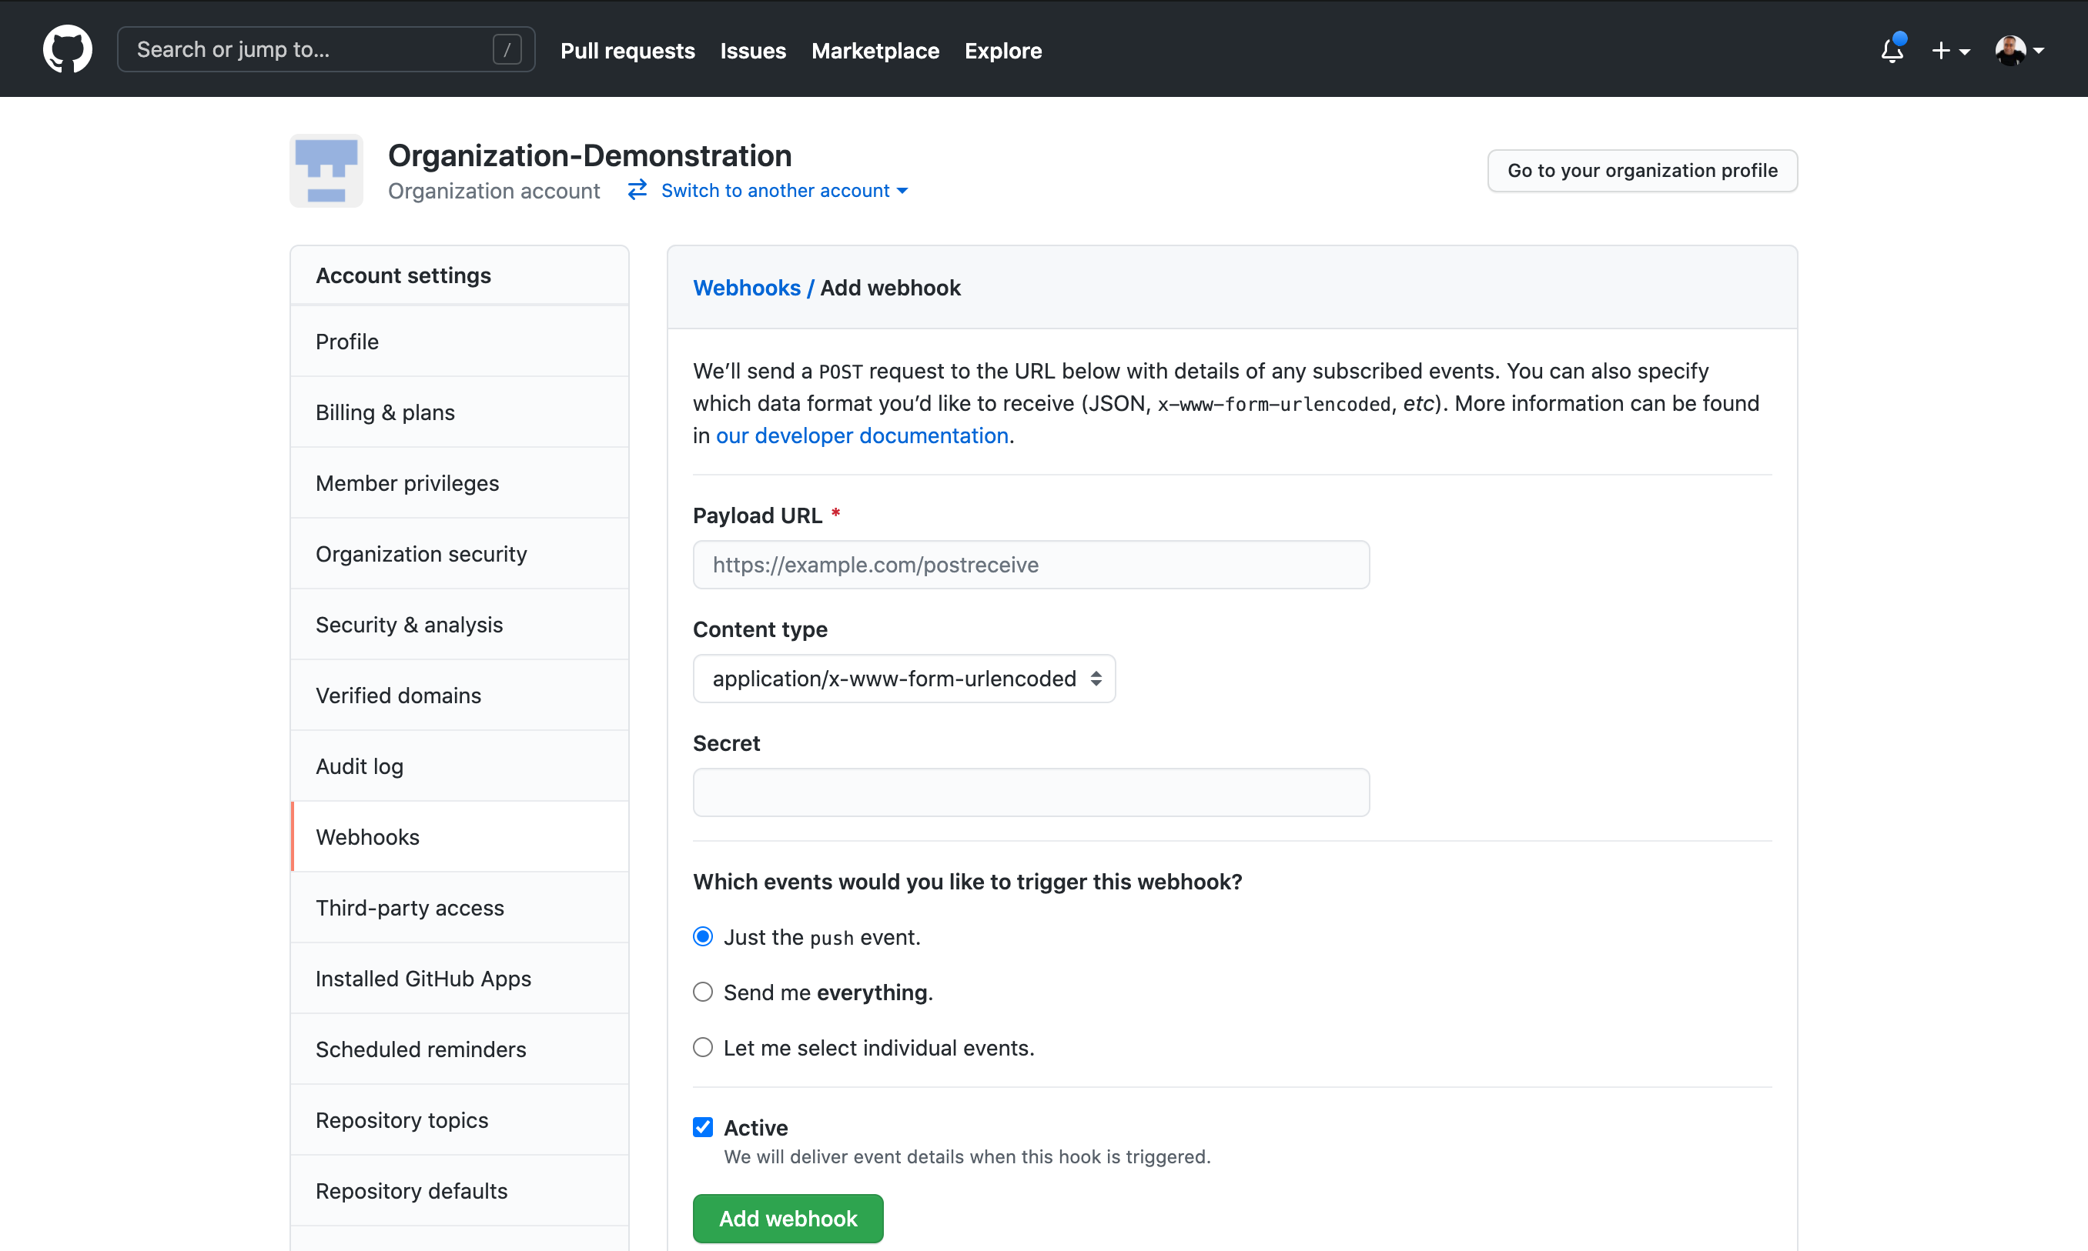
  + Show the webhook section
  + Add a webhook for smee.io
  + Create a new repository, discussing the options one by one when creating a repository
  + Watch the results in smee.io

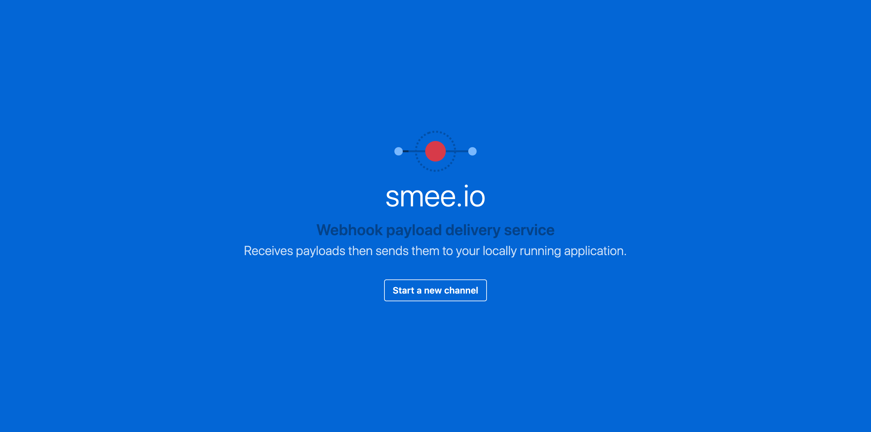

* Optional
  + Create or show a CODEOWNERS file
  + Show repository topics and filtering at the org level ​