# GitHub Actions - Walkthrough

# **Goal**

Demonstrate where and how to set up GitHub Actions.

# **Setup**

To setup for this walkthrough, please complete the steps in the document [00_Walkthrough-prep-checklist.docx](https://microsoft.sharepoint.com/:w:/t/GitHubContentandEnablement/EWkFzgwVfnpIu2vUb8VYhlwBeSPMiRdRDxvh6doY0L6wfg?e=GxRJzO).

## **Checklist**

* Add a [starter workflow](https://github.com/actions/starter-workflows) to a repository
  + Use the link “***set up a workflow yourself”*** from the Actions tab of the repository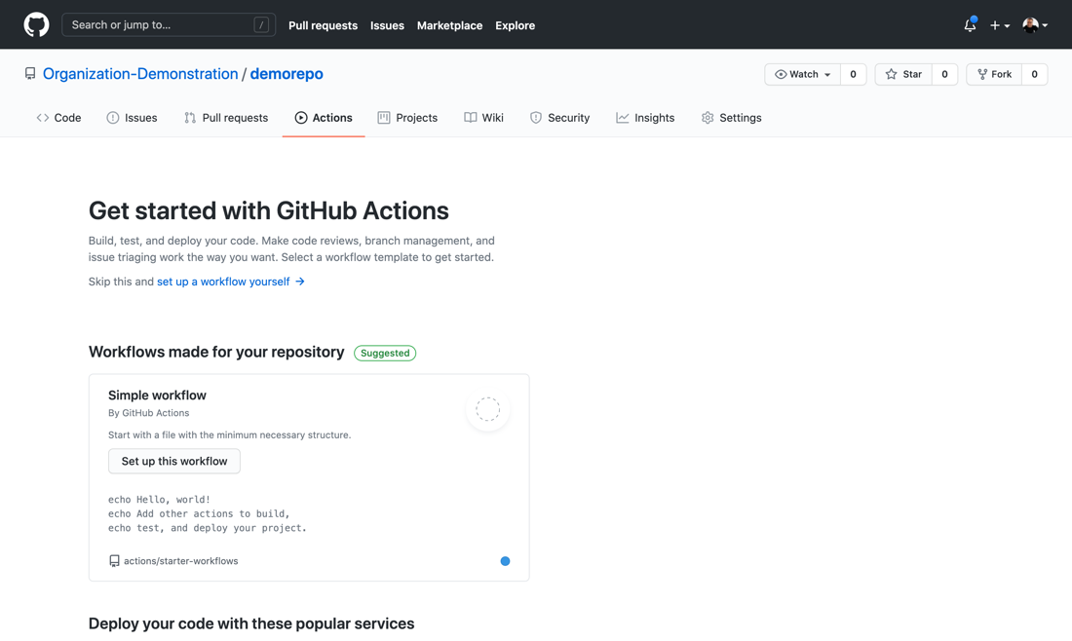
  + Show the documentation on the right-hand side before committing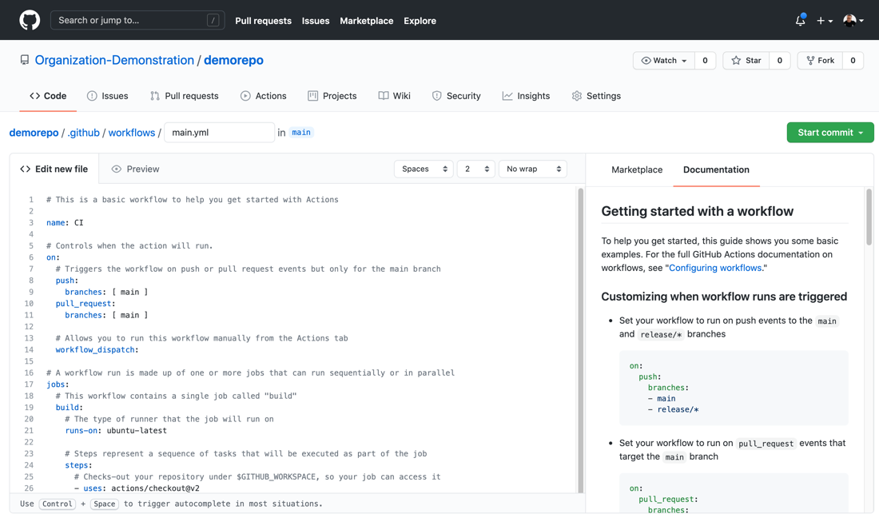
  + Show the output, including how defaults are populated, how tokens appear, and linking to a specific line in the output
* Add another workflow/action, like [Super-linter](https://github.com/marketplace/actions/super-linter)
  + Add the workflow/action
  + Demo the action running
  + Show the log output (Optional: show pre-completed output from another repo)
* Show the “Actions” section of the repository settings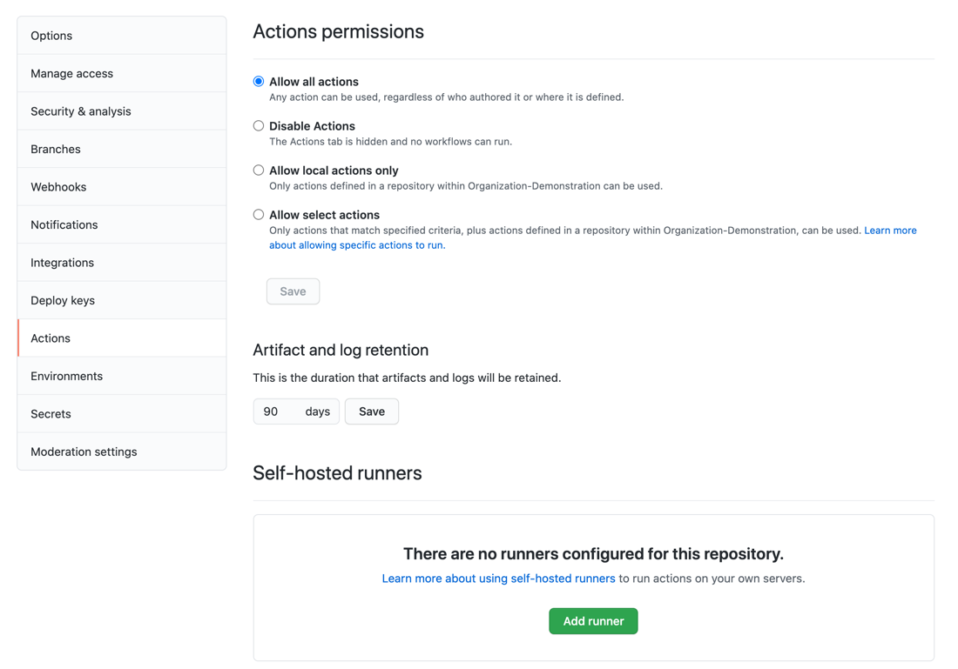
  + Show the options for what Actions can be enabled on the repository
  + Show where self-hosted runners can be configured
* In the organization settings, show the “Actions” tab
  + Show and discuss the available options