# Managing Secrets - Walkthrough

## **Goal**

Demonstrate to the audience how to manage secrets for GitHub Actions.

## **Checklist**

* Show the Secrets portion of the Settings tab in the repository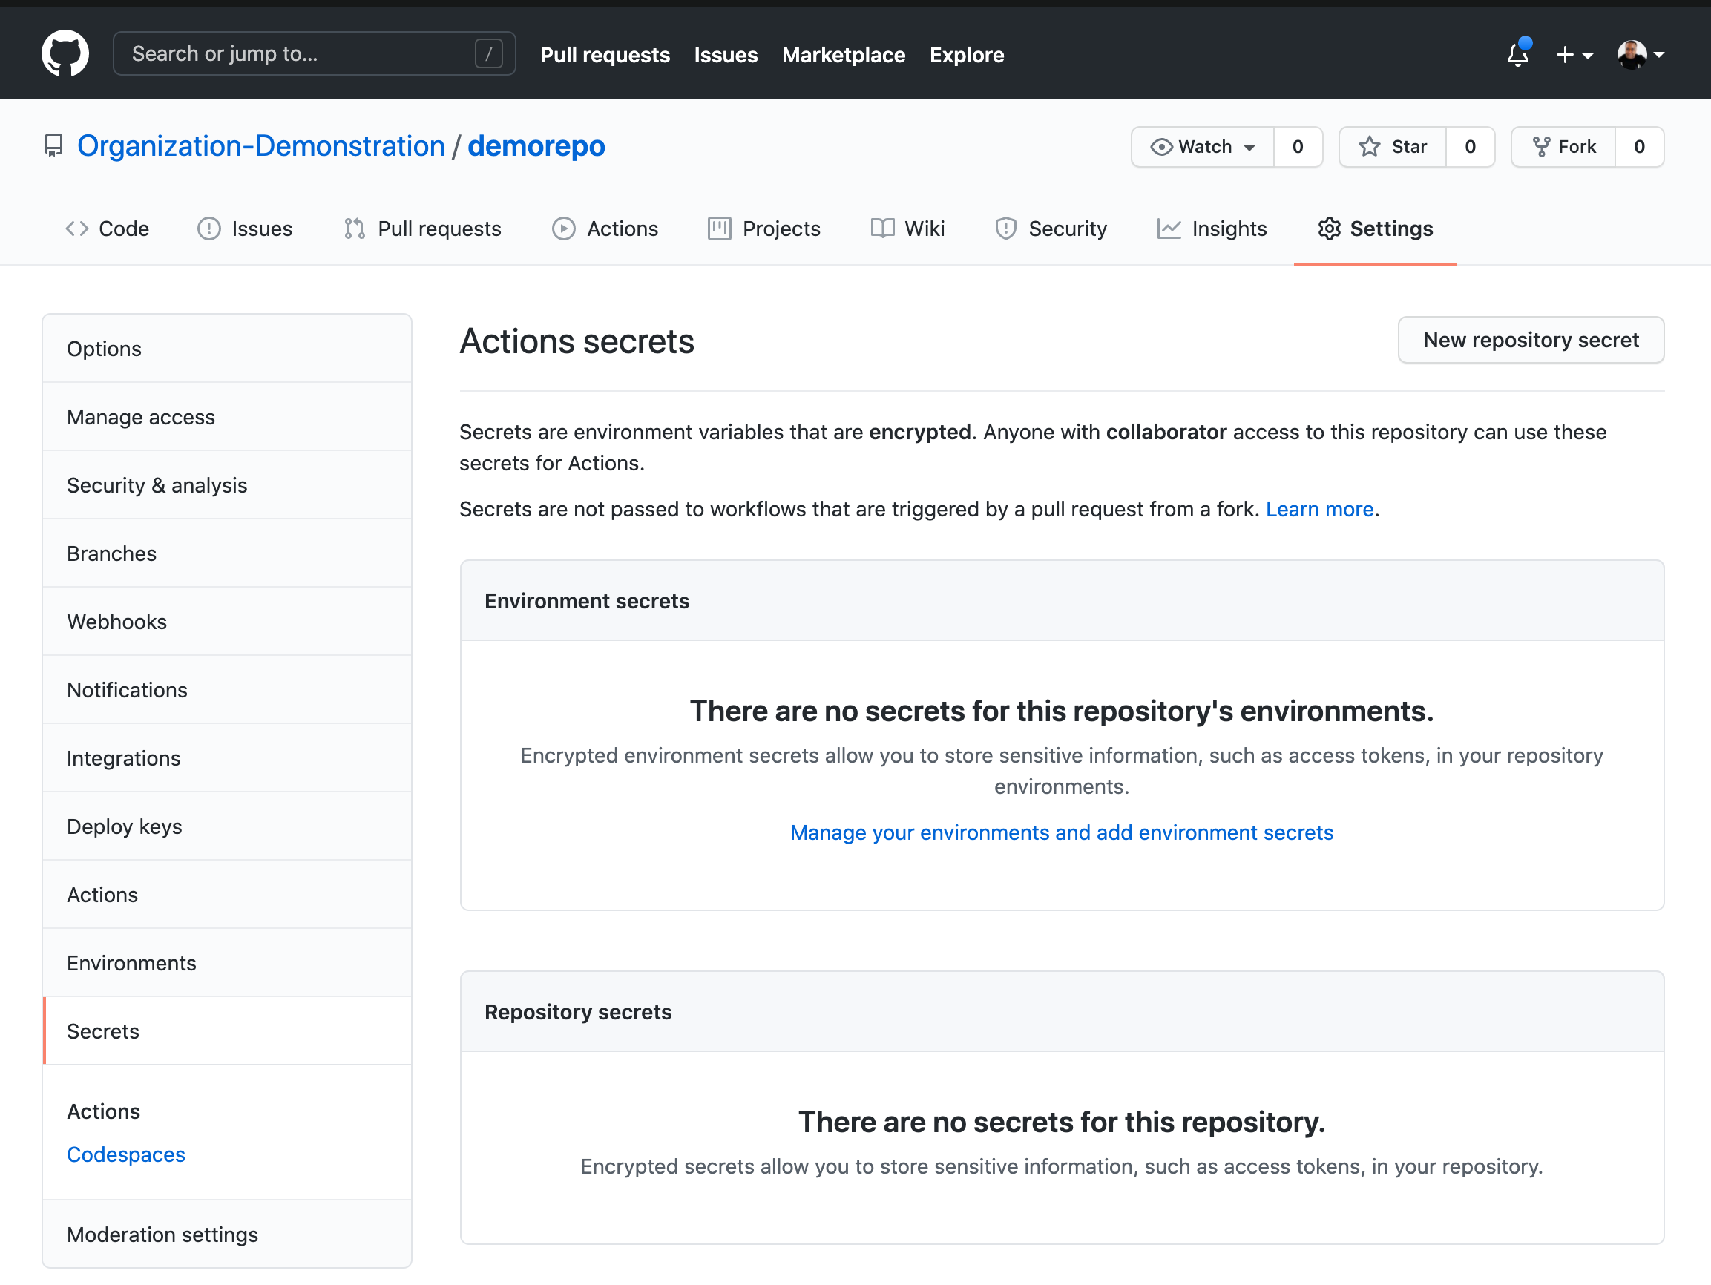
* Add a secret
* Show and discuss the options for access of that secret
* Edit a workflow file to echo the value of the secret
* Show that the output will not show the secret
* Show the [documentation on encrypted secrets](https://docs.github.com/en/actions/reference/encrypted-secrets)