10/25/2024

Sabrina Abro - 21SW102

Ainab Kazi – 21SW103

Areeba Hashmi – 21SW146

MAD PROJECT

MentorX - Counseling App

**Department of Software Engineering**

**Mehran University of Engineering and Technology, Jamshoro**

|  |  |  |
| --- | --- | --- |
|  | **Course: Mobile Application Development (SW-327)** | |
| **Instructor** | Ms. Mariam Memon **Assignment Type** | Complex Engineering Problem |
| **Semester** | 6th **Year** | 3rd |
| **Submission Deadline** | 20-10-2024 **Assessment Score** | 10(Project) + 5(Report) |

|  |  |
| --- | --- |
| **Complex Engineering Problem – Characteristics** |  |
| 1 Depth of knowledge Required | ☑ |
| 2 Range of Conflicting Requirements | ☑ |
| 3 Depth of Analysis Required | ☑ |
| 4 Infrequently Encountered Issues Involved | ☑ |
| 5 Beyond codes/standards of practice | ☑ |
| 6 Diverse groups of stakeholders with widely varying needs involved | □ |
| 7 Interdependence (high level problems including many component parts/subproblems) | □ |
| 8 Have significant consequences in a range of contexts | ☑ |
| 9 Judgement (Require judgement in decision making) | □ |

|  |
| --- |
| **Problem Description** |
| Develop a mobile application that solves a real world problem. Your application must conform to the following constraints:   1. It must uniformly work on all platforms and screen sizes of various phones and tablets. 2. The code should follow coding standards for mobile development. 3. Easily maintainable and understandable Code. 4. Depending on your application, it must have data stored either locally or on the cloud. 5. Optimal state management technique with respect to the app must be incorporated.     **Expected Deliverables:**   1. Project Proposal **(Deadline: 22 September 2024)** 2. Working Application (GitHub Links) **(Deadline: 20 October 2024)** 3. A report with following sections: **(Deadline: 20 October 2024)**    * Real World Problem Identification    * Proposed Solution    * Responsive User Interfaces (Screenshots of your app on different screens & platforms)    * Data Storage (With justification for using a particular database)    * [Optional Section] APIs/Packages/Plug-ins (if used with justifications for using them).    * Issues and Bugs Encountered and Resolved during Development |

|  |  |  |  |  |  |  |  |
| --- | --- | --- | --- | --- | --- | --- | --- |
| Rubrics | **PLO** |  | Assessment | |  | |  |
| Poor [0] | Below  Satisfactory [1] | Satisfactory [2] | Good  Effort  [3] | Proficient [4] | Marks |
| R1 Identification of constraints/require ments/demands | 3 | □ | □ | □ | □ | □ | 2+1 |
| R2 Maintainability of Code | 3 | □ | □ | □ | □ | □ | 2+1 |
| R3 Understanding of issues | 3 | □ | □ | □ | □ | □ | 2+1 |
| R4 Efficiency of the solution | 3 | □ | □ | □ | □ | □ | 2+1 |
| R5 Adaptability | 3 | □ | □ | □ | □ | □ | 2+1 |
|  |  |  |  | | **Total Marks** | | 10+5 |

1. **Real World Problem Identification**

In today's fast-paced digital world, many students face significant challenges in managing their career aspirations and academic paths. As they approach critical decisions regarding their future, they often experience anxiety and uncertainty about which direction to take. The complexities of exploring various career options, understanding personal strengths, and making informed choices can lead to missed opportunities and decreased confidence. Specifically, our target users include:

* **Students**: Struggling to identify their interests, capabilities, and suitable career paths. Many students lack the resources and guidance needed to make informed decisions about their future.
* **Professionals**: Seeking career transitions or further education but unsure about the next steps or how their current skills align with new opportunities.
* **Counselors/Tutors**: Looking for effective tools to assess students' strengths and weaknesses, schedule guidance sessions, and track student progress.

The primary problem is the absence of an integrated platform that combines assessment tests to evaluate students' interests and capabilities with mentorship guidance. This gap often results in confusion, time wastage, and increased stress for students as they navigate their educational and career choices. Our application aims to bridge this gap by providing personalized career counseling and assessments to empower students in making informed decisions about their futures.

**2. Proposed Solution**

To address the identified issues, we propose developing a comprehensive application that provides:

* **User Profiles:** Users can create and manage personal profiles, allowing them to track their progress and preferences over time.
* **Psychometric Assessments:** The application will include psychometric tests designed to evaluate students' interests, strengths, and capabilities. These assessments will help students better understand their inclinations and guide them toward suitable career paths.
* **Appointment Scheduling**: A built-in calendar feature that allows users to schedule, edit, and cancel appointments with counselors or mentors.
* **Counseling and Support Services:** Direct access to counseling services for students and professionals, offering personalized guidance based on assessment results and individual goals.

The application aims to enhance productivity and reduce stress by providing an all-in-one solution for career counseling, assessment, scheduling, and support management. By integrating these features, we intend to empower students to make informed decisions about their futures and provide professionals with the necessary tools to navigate their career transitions.

**3. Responsive User Interfaces**

Our application is designed to be fully responsive, ensuring a seamless experience across various devices. Below are screenshots of the app on different screens and platforms:

These interfaces were designed with user experience in mind, utilizing responsive design techniques to adapt to various screen sizes while maintaining functionality and aesthetic appeal.

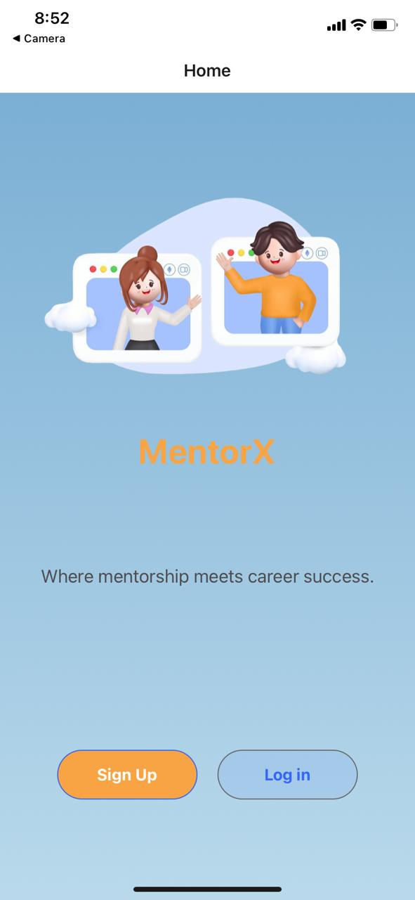

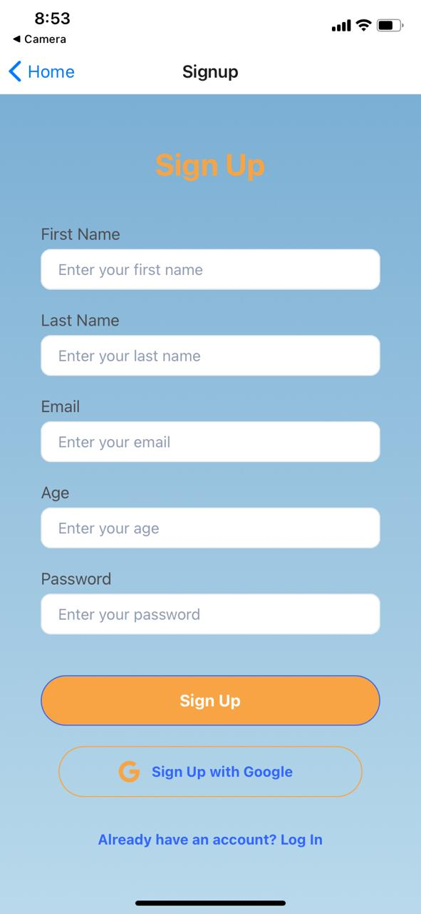

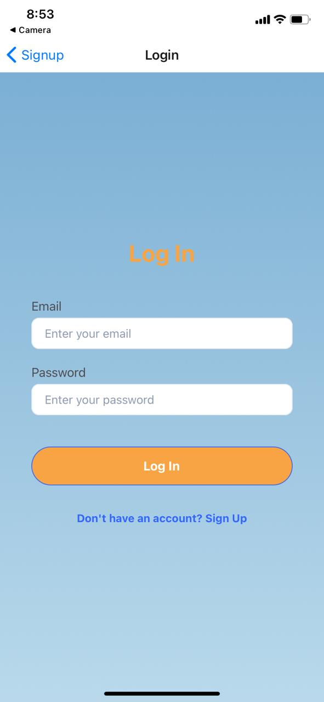

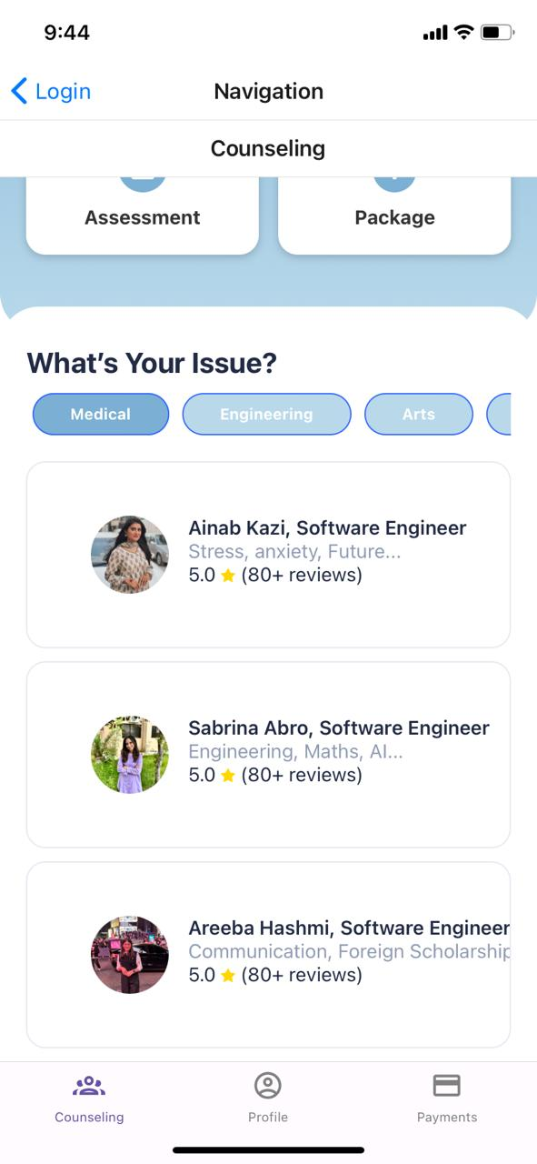

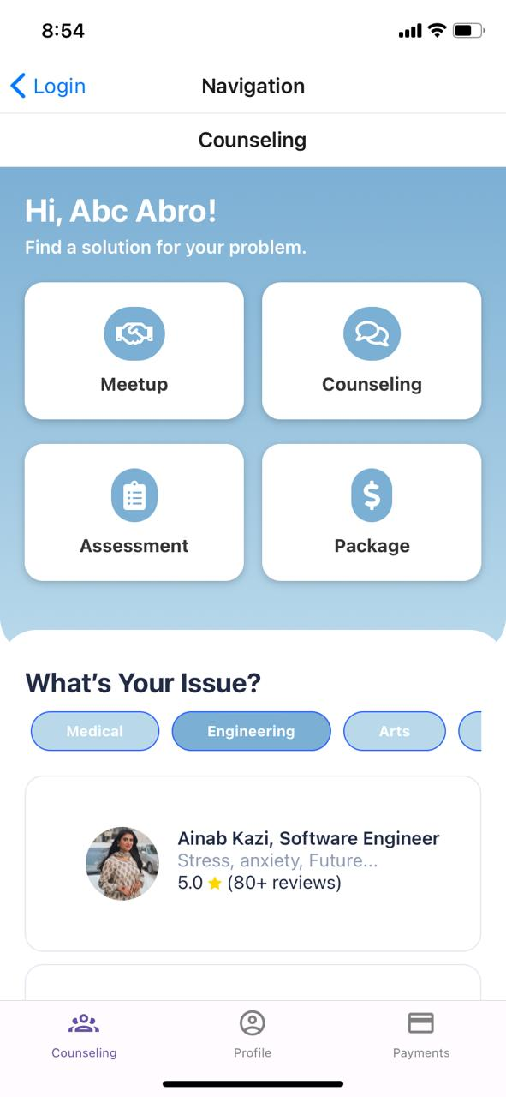

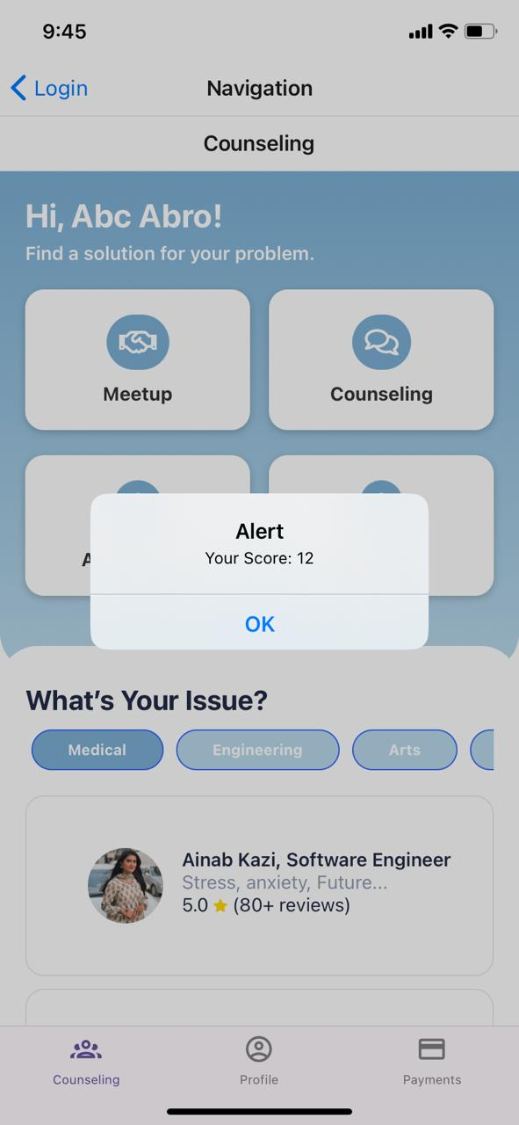

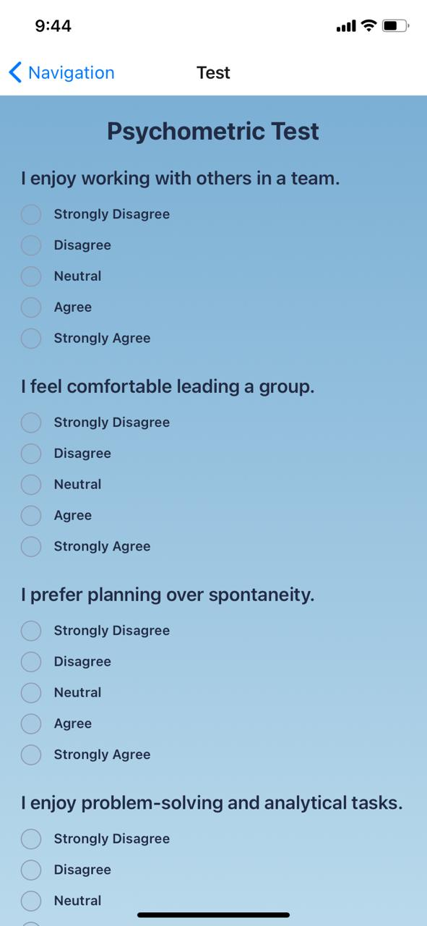

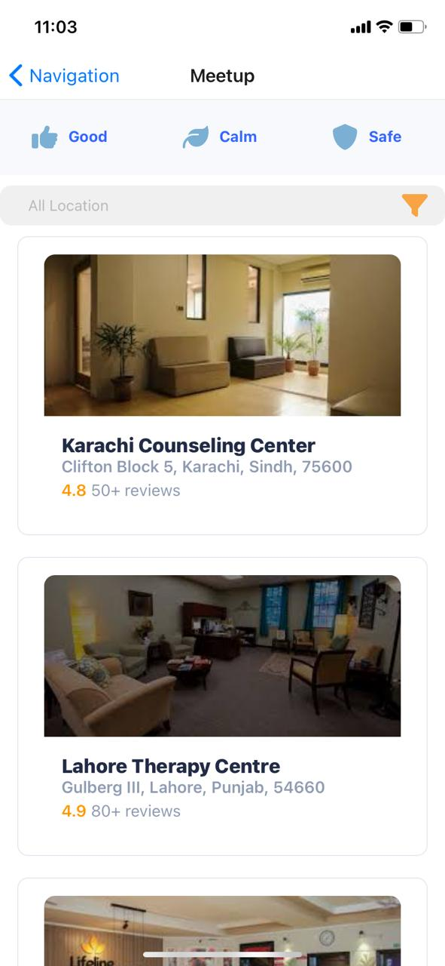

**4. Data Storage**

For our application, we chose **Firebase** as the primary database solution. The justification for using Firebase includes:

* **Real-Time Database**: Firebase offers real-time data synchronization, which is crucial for applications that require up-to-date information, such as appointment scheduling.
* **Scalability**: Firebase can scale effortlessly as user demand grows, ensuring that the application can handle increased loads without significant performance degradation.
* **Security**: Firebase provides robust security features, including user authentication and data validation rules, which are essential for protecting sensitive user information.
* **Cross-Platform Compatibility**: Firebase's support for web and mobile applications allows for a consistent development experience across different platforms.

**5. APIs/Packages/Plug-ins**

Several APIs and packages were used to enhance the functionality of the application:

* **Firebase Authentication**: Used for user authentication and management, ensuring secure access to the application.
* **React Navigation**: Implemented for seamless navigation between different screens in the app, enhancing the user experience.
* **UI Kitten**: Utilized for a consistent and visually appealing UI, which accelerates development with pre-built components.
* **Font Awesome**: Integrated for a wide range of icons, enhancing the visual appeal and functionality of the application.
* These tools were selected to improve development efficiency, enhance security, and provide a better user experience.

**6. Issues an** **d Bugs Encountered and Resolved during Development**

During the development process, we encountered several issues, including:

* **Authentication Delays**: Initially, users experienced delays in authentication. This was resolved by optimizing the Firebase authentication flow and ensuring proper handling of the authentication state.
* **Navigation Issues**: Users faced difficulties navigating between screens due to improper routing. This was fixed by implementing a more intuitive navigation structure using React Navigation.
* **Responsive Design Bugs**: Some components did not display correctly on smaller screens. We addressed this by applying CSS media queries and using a mobile-first design approach to ensure compatibility across devices.
* **tsconfig.json Configuration Issues**: We encountered several type errors due to incorrect configurations in the tsconfig.json file, which led to build failures. This was resolved by adjusting the configuration settings, ensuring all required dependencies were properly typed, and incorporating appropriate compiler options.
* **UI Block Failure with UI Kitten**: During implementation, we faced issues with UI Kitten where certain components failed to render correctly, resulting in UI blocks. This was addressed by ensuring all necessary dependencies were installed and up to date, and by reviewing the component usage according to the latest UI Kitten documentation.
* **Emulator Issues**: We faced challenges when testing on emulators, including slow performance and screen rendering problems. These were resolved by optimizing the emulator settings and ensuring that the latest version of the emulator was being used.

By identifying and resolving these issues, we significantly improved the application’s performance and user experience.