**Overview**

The project is to create a Python script that is capable of analyzing and extracting the election data from the given files.

**Results**

* There were a total of 369,711 votes in this election. This is support by evidence depicted below.

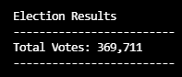

* The breakdown of votes is depicted in the following snippet from the Python script. The largest county turnout went to Denver with 306,055 votes which far exceeded the other counties.

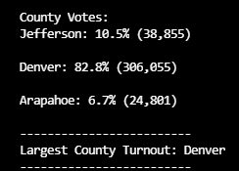

* The breakdown of each vote the candidates of the election received is shown in the image below. You can see that Diana DeGette blew away the competition with over triple the votes of the runner up.

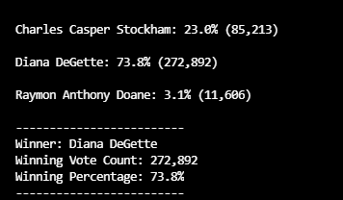

**Summary**

Overall the Python script for this project runs efficiently. With a few minor changes the script can be modified to run with any election data. There are only two things the script needs to run:

* A .csv file that holds the election data. Such as the one shown below.

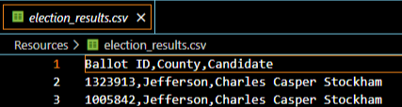

* If the data has additional headers then make sure to have the proper row selected as depicted in the image below or else the code will not run properly.

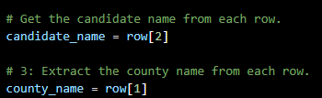

With those two points fulfilled the script can be repurposed for any election data analysis.