

Tax Invoice
ORIGINAL For Recipient

Tax Invoice on behalf of -
Legal Entity Name :
Restaurant Name :
Restaurant Address :
Restaurant GSTIN :
Restaurant FSSAI :
Invoice No. :
Invoice Date :
Customer Name : {customer_name}
Delivery Address : {delivery_address}
State name & Place of Supply: {place_of_supply}
HSN Code : 996331
Service Description : Restaurant Service

Particulars | Gross value | Discount | Net value | CGST  (Rate) | CGST (INR) | SGST  (Rate) | SGST (INR) | Total
{qty}{items_name} | {gross_value}{/items} |  |  | 2.5% |  | 2.5%
Item(s) Total
Restaurant Packaging Charge |  |  |  | 2.5% |  | 2.5%
Total Value
Amount (in words): {amount_in_words} Paisa Only
Amount of INR 468.5 settled through digital mode/payment received against Order ID: dated .
Supply attracts reverse charge : No

For ETERNAL LIMITED (FORMERLY KNOWN AS ZOMATO LIMITED)
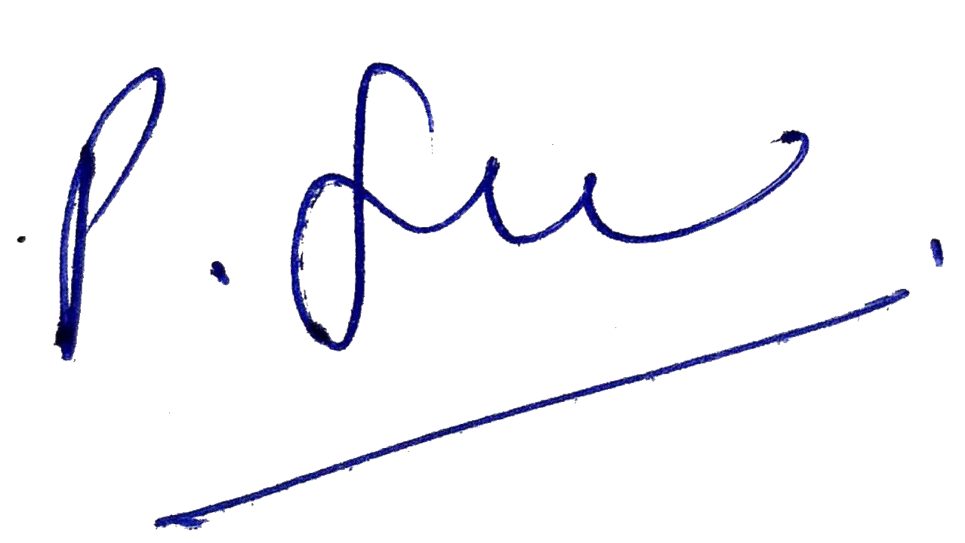
Eternal PAN : AADCD4946L
Eternal CIN : L93030DL2010PLC198141 Eternal GST : 06AADCD4946L1ZE Eternal FSSAI : 10019064001810
Authorized Signatory

