

Tax Invoice
ORIGINAL For Recipient
Tax Invoice on behalf of -
Legal Entity Name : {legal_name}
Restaurant Name : {restaurant_name}
Restaurant Address : {restaurant_address}
Restaurant GSTIN : {gstin}
Restaurant FSSAI : {fssai}
Invoice No. : {invoice_no}
Invoice Date : {invoice_date}
Customer Name : {customer_name}
Delivery Address : {delivery_address}
State name & Place of Supply : {place_of_supply}
HSN Code : 996331
Service Description : Restaurant Service

Particulars | Gross  value | Discount | Net  value | CGST (Rate) | CGST  (INR) | SGST (Rate) | SGST  (INR)) | Total
{#items}{qty} x {item_name} | {item_gross} | {discount_amount} | {item_net} | 2.50% | {item_cgst} | 2.50% | {item_sgst} | {item_total}{/items}
Item(s) Total | {items_gross} |  | {items_net} |  | {items_cgst} |  | {items_sgst} | {items_total}
Restaurant Packaging Charge | 29.19 | 0 | 29.19 | 2.50% | 0.73 | 2.50% | 0.73 | 30.65
Total Value |  |  | {total_net} |  | {total_cgst} |  | {total_sgst} | {total}

Amount (in words) : {amount_in_words}

Amount of {final_total} settled through digital mode/payment received against Order ID: {order_id} dated {invoice_date}
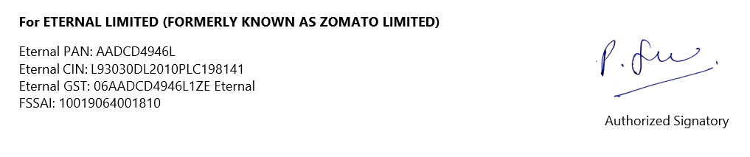
Supply attracts reverse charge : No

