
{letterDate}
Letter of Internship

To whom it may concern
This is to certify that {internName} has successfully completed internship program with Pearl Global Industries Ltd. with {department}.

Position: {position}
Date of Joining: {joiningDate}
Tenure: {tenure}
Location: {location}
Reporting to: {reportingTo}

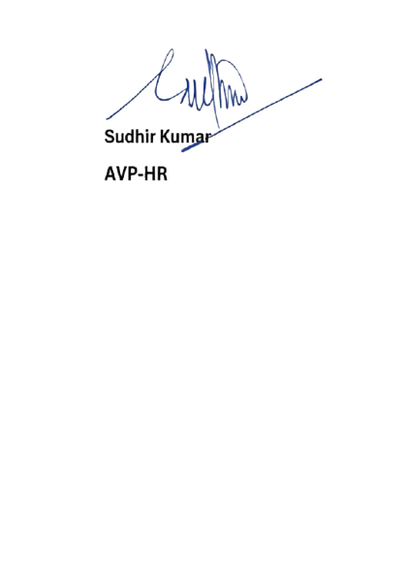
For Pearl Global Industries Limited Accepted

{letterDate}

