Genetic Algorithms: Assignment 2021

Aid Convoy Trucks

20 Marks

You should demonstrate your answer in the tutorial in week 13 or the Drop-in session in Week 13, or one of the Week14 sessions agreed by the class on 19/10/2021. A full list of possible demonstration times is listed below:
- Any Tutorial on Monday the 25th, (these are also get help tutorials, these run at 12:30, 13:30, 15:30, and 19:30 )
- Drop in sessoin on 29th October at 2:30PM and 3:30PM. (these are also get help tutorials)
- Marking Session on 2nd November at 11:30 AM
- Marking Session on 3nd November at 2:30 PM
- Watch anouncements for other marking sessions if needed
NOTE: The written report and code submission are due on the 6th November just before midnight via Canvas.

Genetic Algorithms is one of a set of meta-heuristics that have been applied to optimization problems that do not have algorithmic solutions. These problems have to rely on heuristics that are tailored to the problem, or meta-heuristics – generalised heuristics that can be applied to a variety of problems.
Your assignment is to investigate how well GA performs on one particular problem, the packing of 3 aid trucks to cyclone ravaged Darwin.
In the classes supplied there is a list of items that will be loaded onto the 3 trucks.
You need to code the following (This is a minimum – feel free to rewrite my shell)
- Your gene structure/class
- Your genome structure/class
- Your mutation strategy/system/method(s)
- Finish the method showBest() to display the answers
- Anything else needed to make the program run as a GA; (eg initialise the population with random genes)

You need to demonstrate your program at one of the times listed above.
You will also need to submit a short report which should include the following:
- Your gene structure
- Your genome structure
- Your mutation strategy
- Other Code you changed (if revelent to the GA, don’t stress on reporting Tkinter widget changes)
- A paragraph or two on things that you found interesting or difficult during development of your GA
There is no fixed size for your report, but I would expect it to be between 1 – 3 pages.

You will also need to zip all the project code for your GA project and submit it to Canvas. So I will be able to run it – to confirm it works should I need to do so.

Your submission needs to use my code as a base and be written in a recent version of python.

Marking Criteria:
To get a Pass (10+ marks) | The Program must give a ‘reasonable’ soloution relatively quickly without taking the item importance into account at all. (Trucks should fill to 18 or 19 on average)  The report will include the above items only
To get a Credit  (13+ marks) | The Program must give a ‘reasonable’ soloution relatively quickly which should include some bias to getting higher priority items onto the trucks (note 1=highest importance).  NOTE: you are not permitted to Bias the mutation routine; to achieve this , you can only change the score routine.  The report will include the above items only
To get a DI  (15+marks) | The Program must give a ‘reasonable’ soloution relatively quickly which should include some bias to getting higher priority items onto the trucks (note 1=highest importance). Additionally this solution should treat the hospital as a two truck load (i.e either take both hospital parts or none)  And, the convoy needs at least one of the three petrol items to refuel for the journey back. (i.e. one of the three items from, Petrol44a, Petrol44b or Petrol20  NOTE: you are not permitted to Bias the mutation routine , to achieve this , you can only change the score routine.  The report will include the above items only
To get a HD  (17+marks) | The Program must give a ‘reasonable’ soloution the same as the DI option above, additionally you must do an experiment on mutation rates.  To do the experiment do the following:  - Construct a Baseline in genetic Picture, using a mutation rate of 3% run for your chosen number of generations (if in doubt 500 would usually be enough) and record the score (you must have a population of at least 100)  - Modify the Baseline in geneticPicture so it has a 25% mutation rate run for the same number of generations, record the score  - Write a paragraph on that finding/result, suggesting what’s happening to affect the score  - Now Construct a Baseline in your assignment, using a mutation rate of 3%; you must have a population of at least 100, run for a fairly small number of generations (eg 50, or less) – record the score  - Modify the Baseline in in your assignment so it has a 25% mutation rate run for the same number of generations, record the score  - Write a paragraph on that finding/result, suggest what’s happening to affect the score  - Write a paragraph on the findings/results, on increasing mutation rate in your assignment vs its effect in genetic picture. This is the ‘heart’ of this experiment because the two genetic algorithms are quite different.

NOTE: you can modify the debug button any way you want, it’s just a placeholder.

Note : you must not overload the trucks if necessary you can underload by 1 or 2 , more then that is not a good solution

I may ask to see your code during the demonstration, I may also do a plagiarism check on your code.
Screen shot from my Pass level example answer
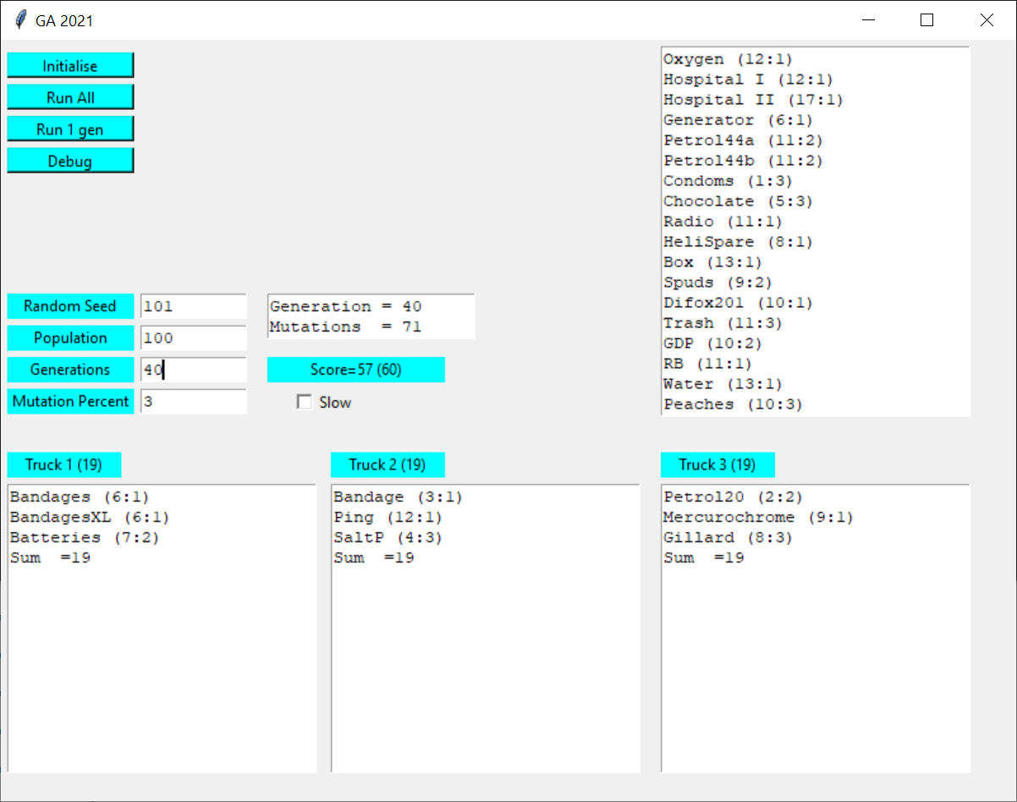
NOTE: correct usage is to press Initialise before Run 1 gen or Run All
The Items (name, long name, size, importance)
self.lst[0]=Item("Bandages","",6,1);
self.lst[1]=Item("BandagesXL","",6,1);
self.lst[2]=Item("Bandage","Full Body 'mummy' Cast",3,1);
self.lst[3]=Item("Oxygen","Oxygen Cylinders",12,1);
self.lst[4]=Item("Hospital I","Tent Hospital part 1",12,1);
self.lst[5]=Item("Hospital II","Tent Hospital part 2",17,1);
self.lst[6]=Item("Generator","Electricity Generator",6,1);
self.lst[7]=Item("Petrol44a","44 Gal Drum of Petrol",11,2);
self.lst[8]=Item("Petrol44b","44 Gal Drum of Petrol",11,2);
self.lst[9]=Item("Petrol20","20 L Gerrycan of fuel",2,2);
self.lst[10]= Item("Condoms","",1,3);
self.lst[11]= Item("Mercurochrome", "Disinfectant for wounds", 9, 1);
self.lst[12]= Item("Chocolate","Large box donated by Cadbury",5,3);
self.lst[13]= Item("Radio","Large multifreq radio+gen",11,1);
self.lst[14] = Item("HeliSpare","Helicopter Rotor", 8, 1);
self.lst[15] = Item("Box", "Grey box marked 'Top Secret'", 13, 1);
self.lst[16] = Item("Spuds", "Crate of Potates", 9, 2);
self.lst[17] = Item("Ping", "Machine That goes Ping", 12, 1);
self.lst[18] = Item("Difox201", "DF201 For mine resque", 10, 1);
self.lst[19] = Item("Trash", "Trash Disposal system", 11, 3);
self.lst[20] = Item("Batteries", "Mobile Phone batteries", 7, 2);
self.lst[21] = Item("GDP", "Government policy manual", 10, 2);
self.lst[22] = Item("Gillard", "For a good spin on the disaster", 8, 3);
self.lst[23] = Item("RB", "Rubber Bags and lime", 11, 1);
self.lst[24] = Item("SaltP", "Salt Pork", 4, 3);
self.lst[25] = Item("Water", "Water 100L", 13, 1);
self.lst[26] = Item("Peaches", "Tins Of Peaches", 10, 3);
self.lst[27] = Item("UGS", "UGS - Type 20", 11, 1);
self.lst[28] = Item("MS", "Coffin", 9, 2);
self.lst[29] = Item("Doctor", "Doctors Kit", 13, 1);

Importance 1 = Very Important
Importance 2 = Important
Importance 3 = Not Important

HINT: if you can maintain thes globals it will help you to make less mods to the interface they are in g.py module import the module and access using a g prefix (eg g.POPULATION)

POPULATION = 100;
MUTATIONPERCENT=3

generation=0; # Current generation
maxGeneration =20;
mutations = 0; # number of mutations
best = 0; # the nunber in the Population of the best individual
bestScore = -99991 # the score of the best individual

