Digital Literacy Project Report
Name: Anubhav Sachan
Course: CSE0001 Digital Literacy
University:
Program: B.Tech Computer Science
Year: 1st Year

Introduction
Digital literacy is an essential skill for students in today’s technology-driven world. It helps individuals use digital tools safely, communicate professionally, and maintain an effective online presence. This project helped me explore important digital platforms, create professional communication samples, and understand cyber safety practices.

Task-1: Infographic on Digital Literacy
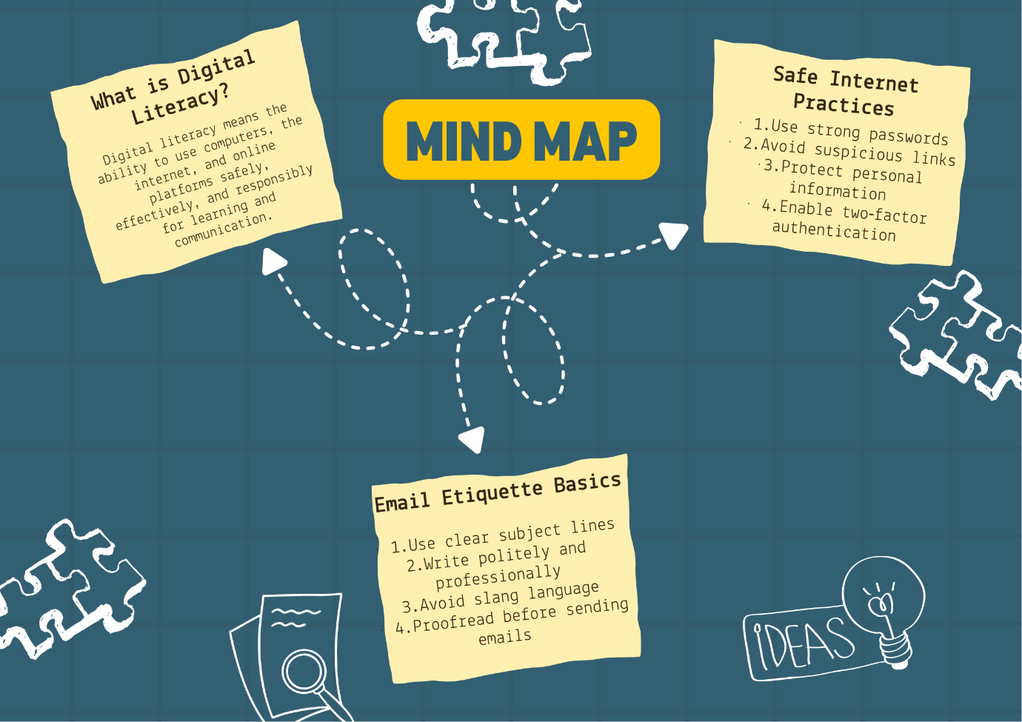

Reflection
Creating this infographic helped me understand the importance of digital literacy in academic and professional environments. I learned about safe internet practices and email etiquette while presenting information visually in a structured format. This task improved my awareness of responsible online behavior and strengthened my ability to communicate ideas effectively using digital tools.

Task-2: Digital Portfolio Setup
Platforms created:
- GitHub Profile
- LinkedIn Profile
- HackerRank Profile
Reflection
Creating my digital portfolio helped me build a professional online presence. I updated my GitHub profile with academic details and skills, improved my LinkedIn profile for networking, and used HackerRank to showcase coding ability. These platforms will help me track my progress and connect with opportunities in the future.

Task-3: Platforms Activity
Activities completed:
- Solved beginner problem on HackerRank
- Created Digital Literacy Awareness Google Form
- Collected responses and linked spreadsheet
Reflection
This activity improved my understanding of coding platforms and online collaboration tools. Creating the Google Form helped me learn how surveys are designed and how responses are recorded automatically. It enhanced my practical knowledge of digital tools used in academics.

Task-4: Email Etiquette and Professional Communication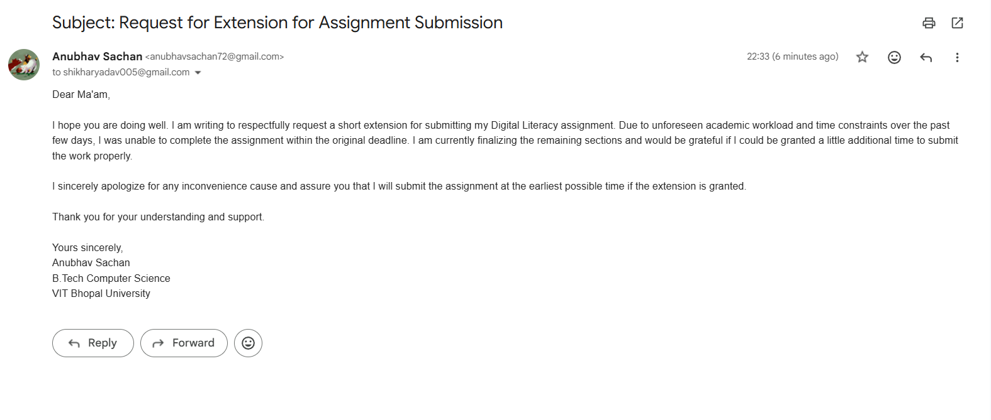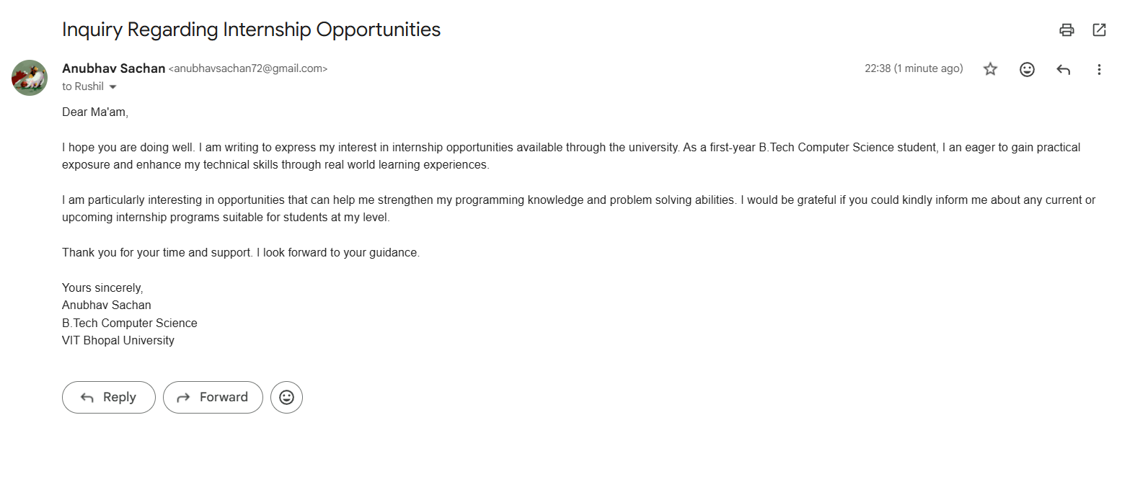
Reflection
Writing professional emails helped me understand how to communicate respectfully and clearly in academic environments. I learned the importance of subject lines, proper greetings, and structured communication.

Task-5: Cybercrime Awareness Case Study
Case Study: UPI Fraud Awareness
UPI fraud has become one of the most common cybercrimes in India due to the rapid growth of digital payment platforms. In many cases, fraudsters contact users through phone calls, SMS, or fake links pretending to be bank officials or customer support representatives. They try to trick users into sharing OTPs, PINs, or approving unknown payment requests. Once the user shares sensitive information or approves the request, money is transferred instantly from their account.
In a typical case, a student received a call claiming that their bank account needed verification for continued UPI services. The caller asked the student to click a link and enter their UPI PIN. Shortly after doing this, the student noticed that money had been deducted from their account without permission. Later, it was confirmed that the caller was a fraudster attempting to steal financial information.
This example shows how important it is to remain careful while using digital payment applications. Users should never share OTPs, PINs, or banking details with unknown persons. Awareness about such cyber threats can help prevent financial loss and ensure safe use of digital payment systems.
Reflection
This task increased my awareness of cybercrime risks such as online fraud and identity theft. I also learned prevention methods and how to report cybercrime using official portals.

Conclusion
This digital literacy project helped me improve my understanding of online safety, professional communication, and digital platforms. These skills will support my academic growth and future career development.

