|  |
| --- |
| Close-up image showing the leaf-sides of two oversized books side-by-side on a bookshelf, with additional books in soft focus background |
| Upload .pkg Solution in App Catalog |
| |  |  |  | | --- | --- | --- | | https://dips365.com | 1/29/20 | SPFx & PnP | |

1. Get App catalog URL from SharePoint Admin Panel. Go to below URL.

https://<Domain>-admin.sharepoint.com

1. Click on Open button under Apps

You will be redirected on below screen

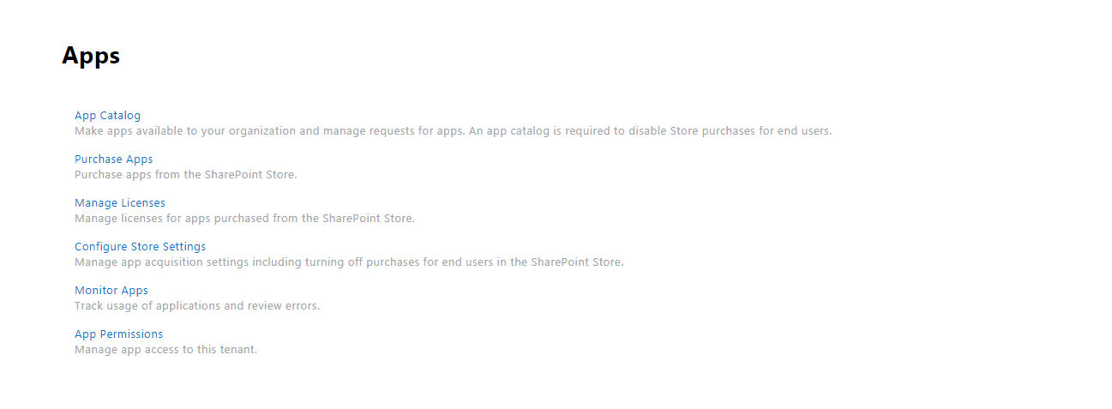

1. Click on App Catalog. Once you clicked on it, you will be redirected to App Catalog site. Screen looks like as below.

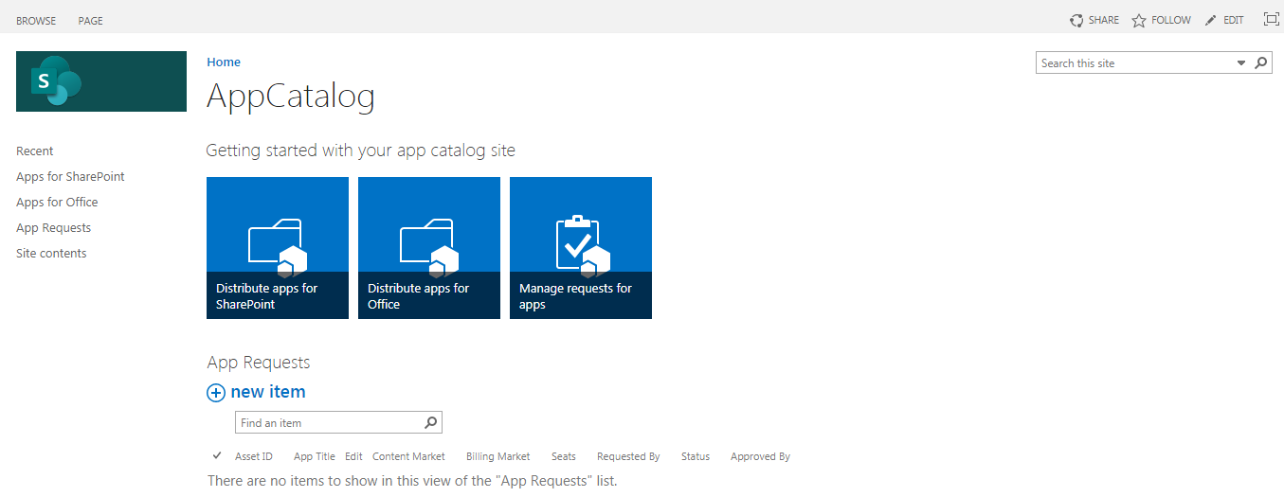

1. Click on “Apps for SharePoint”. A list of content will be opened right side.

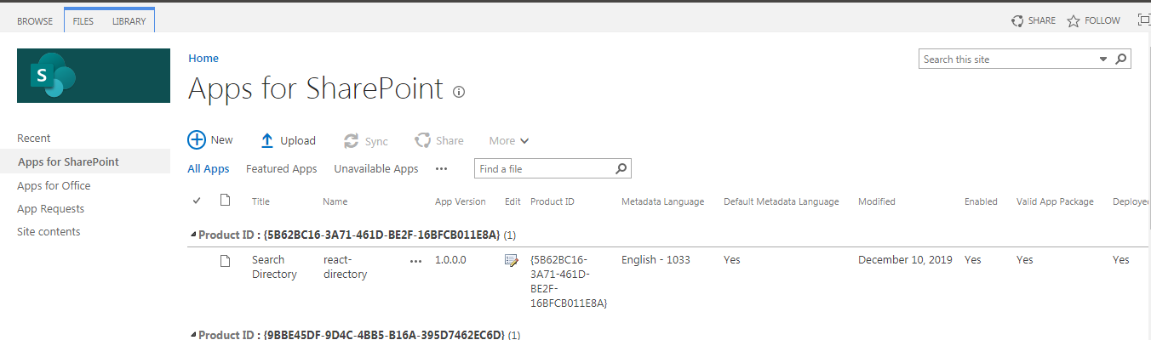

1. Upload or drag & drop “. sppkg” file in this list. A pop will be opened as below. Make sure “The client-side solution get content from the following domain should be SharePoint Online or any other CDN path. It should not be localhost”.

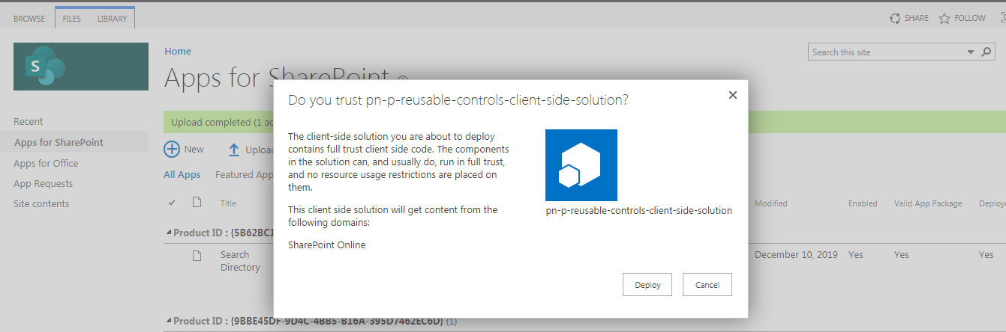

1. Click on Deploy button. Once deployment process is completed then open the site where you want to use this webpart or solution.
2. Open below URL in browser

https://<domain>.sharepoint.com/sites/Demo/_layouts/15/viewlsts.aspx. Click on App once you will be redirected to desire page.

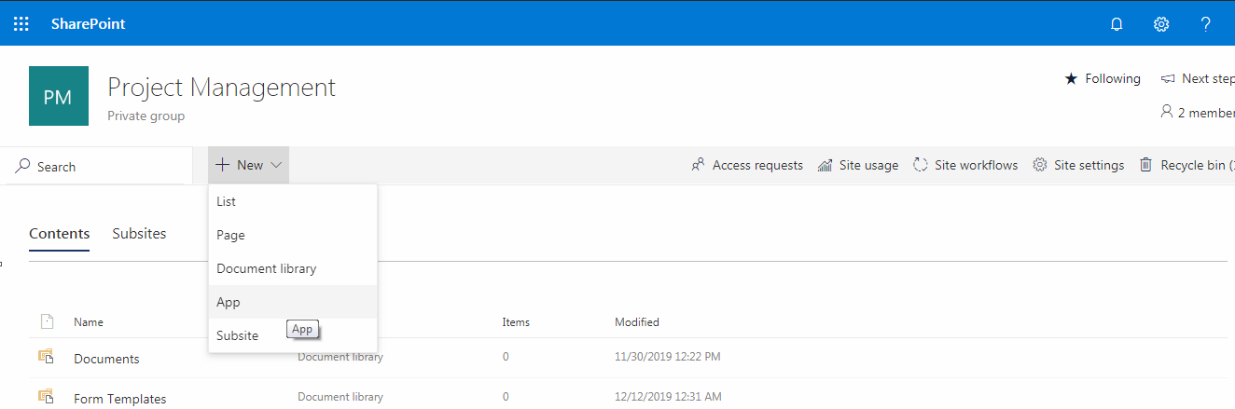

1. Click on “From your organization” as below. Click on app to install.

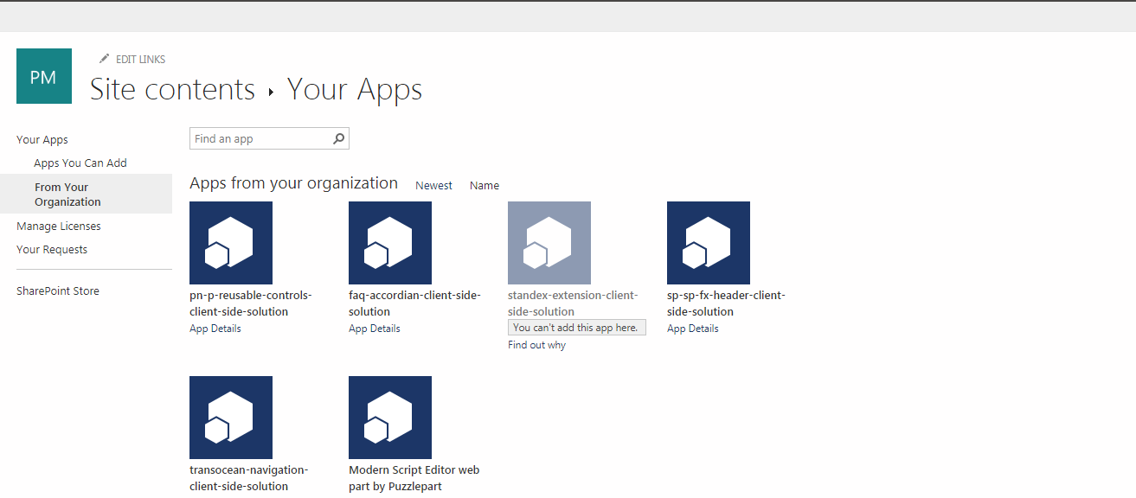

1. Once APP is installed, go to home page and edit the page. Click on + sign to add the webpart.  
   Select the webpart.

