A Project report on

# “LEAP – Leisure, Entertainment and Pleasure”

with

**Source Code Management**

(CS181)

Submitted by

|  |
| --- |
| **Team Member 1 Dhruv Arora 2110992073** |
| **Team Member 2 Prince Gupta 2110992024** |
| **Team Member 3 Priyanshu Garg 2110992065** |
| **Team Member 4 Kalpana 2110992096** |



# Department of Computer Science & Engineering

Chitkara University Institute of Engineering and Technology, Punjab

Jan- June

(2021-22)

|  |  |  |  |
| --- | --- | --- | --- |
| Institute/School Name | **Chitkara University Institute of Engineering and Technology** | | |
| Department Name | **Department of Computer Science & Engineering** | | |
| Programme Name | **Bachelor of Engineering (B.E.), Computer Science & Engineering** | | |
| Course Name | **Source Code Management** | Session | **2021-22** |
| Course Code | **CS181** | Semester/Batch | **2nd/2021** |
| Vertical Name | **Zeta** | Group No | G0X |
| Course Coordinator | **Dr. Neeraj Singla** | | |
| Faculty Name | **Dr Anuj Jain** | | |

Submission

Name:

Signature:

Date:

**Table of Content**

|  |  |  |
| --- | --- | --- |
| **S. No.** | **Title** | **Page No.** |
| 1 | Version control with Git | 3-5 |
| 2 | Problem Statement | 6 |
| 3 | Objective | 6 |
| 4 | Resources Requirements – Frontend / Backend | 7 |
| 5 | Concepts and commands, Workflow | 8-20 |

**1. Version control with Git**

**What is GIT and why is it used?**

Git is a version control system that is widely used in the programming world. It is used for tracking changes in the source code during software development. It was developed in 2005 by Linus Torvalds, the creator of the Linux operating system kernel.

Git is a speedy and efficient distributed [VCS t](https://www.w3docs.com/learn-git/version-control-software.html)ool that can handle projects of any size, from small to very large ones. Git provides cheap local branching, convenient staging areas, and multiple workflows. It is free, open-source software that lowers the cost because developers can use Git without paying money. It provides support for non-linear development. Git enables multiple developers or teams to work separately without having an impact on the work of others.

Git is an example of a distributed version control system (DVCS) (hence Distributed Version Control System).

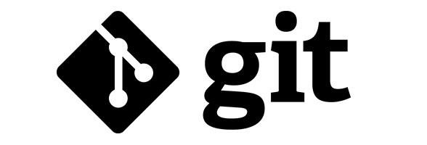

**What is GITHUB?**

It is the world’s largest open-source software developer community platform where the users upload their projects using the software Git.

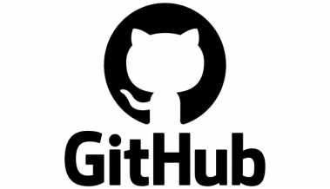

**What is the difference between GIT and GITHUB?** 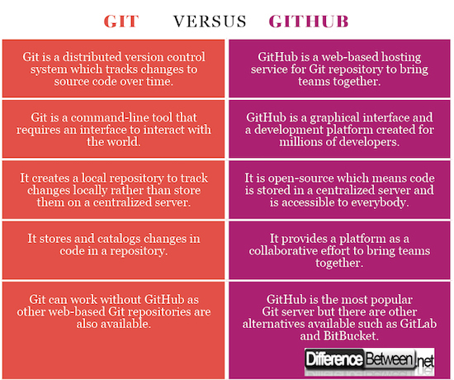

**What is Repository?**

A repository is a directory or storage space where your projects can live. Sometimes GitHub users shorten this to “repo.” It can be local to a folder on your computer, or it can be a storage space on GitHub or another online host. You can keep code files, text files, image files, you name it, inside a repository.

**What is Version Control System (VCS)?**

A version control system is a tool that helps you manage “versions” of your code or changes to your code while working with a team over remote distances. Version control keeps track of every modification in a special kind of database that is accessible to the version control software. Version control software (VCS) helps you revert back to an older version just in case a bug or issue is introduced to the system or fixing a mistake without disrupting the work of other team members.

**Types of VCS**

1. Local Version Control System
2. Centralized Version Control System
3. Distributed Version Control System
4. **Local Version Control System:** Local Version Control System is located in your local machine. If the local machine crashes, it would not be possible to retrieve the files, and all the information will be lost. If anything happens to a single version, all the versions made after that will be lost.
5. **Centralized Version Control System:** In the Centralized Version Control

Systems, there will be a single central server that contains all the files related

to the project, and many collaborators checkout files from this single server

(you will only have a working copy). The problem with the Centralized Version Control Systems is if the central server crashes, almost everything related to the project will be lost.

1. **Distributed Version Control System:** In a distributed version control system, there will be one or more servers and many collaborators similar to the centralized system. But the difference is, not only do they check out the latest version, but each collaborator will have an exact copy of the main repository on their local machines. Each user has their own repository and a working copy. This is very useful because even if the server crashes we

would not lose everything as several copies are residing in several other

computers.

## **2. Problem Statement**

Listening to music, podcasts, reading e-books, or getting the right news feed on the web can sometimes become difficult and inaccessible owing to repetitive and distracting adverts, and occasionally due to the paid policy of these programs. These websites' user interfaces and user experiences are both poor (UX). Apart from this you definitely can’t do all this in a single website, you’ll need to open and register on multiple websites to access these.

## **3. Objective**

PROJECT NAME: LEAP – LEISURE, ENTERTAINMENT AND PLEASURE

Our goal is to create a web app for our users that will provide them with a fresh experience with music, podcasts, news, e-books, and other content. Our prime objective is to create a lightweight online app with a very basic yet classic UI/UX that allows our customers to listen to music, podcasts, or read e-books and news on the same platform without paying a large fee or being bombarded with annoying adverts.

## **4. Resources Required.**

Frontend – HTML5, CSS3, Javascript

Backend – NodeJS

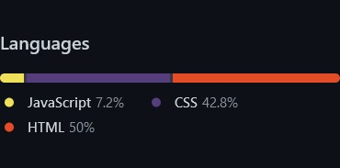

## **5. Concepts and commands, Workflow**

## **Aim:Create a distributed Repository and add members in project team**

* Login to your GitHub account and you will land on the homepage as shown below. Click on the button shown in the menu bar and then click on New Organization.

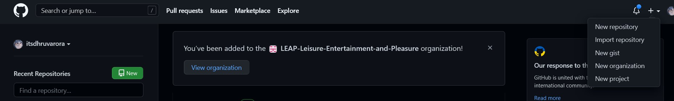

* Set Up Your Organization. Fill Your Organization’s Name and Other Details.

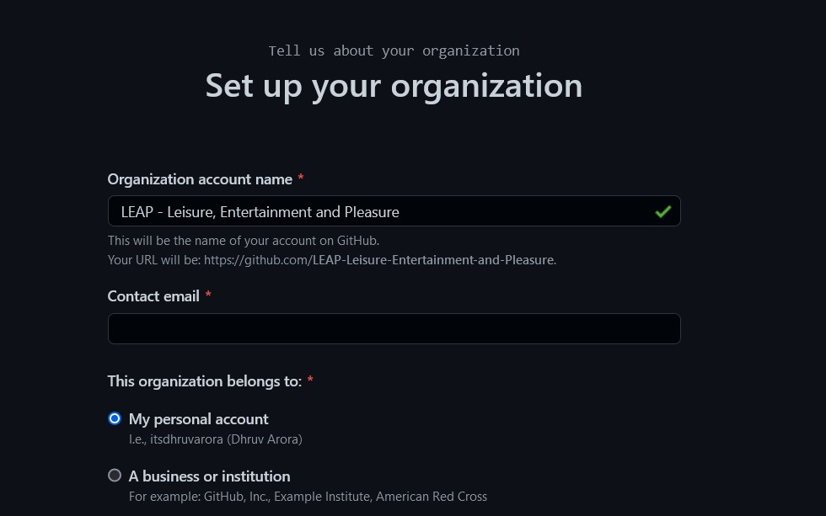

* After creating the repository, we have to create a Repository.

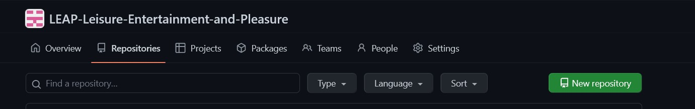

* Create a New Repo by Pressing the New repository button. Fill in the required details.

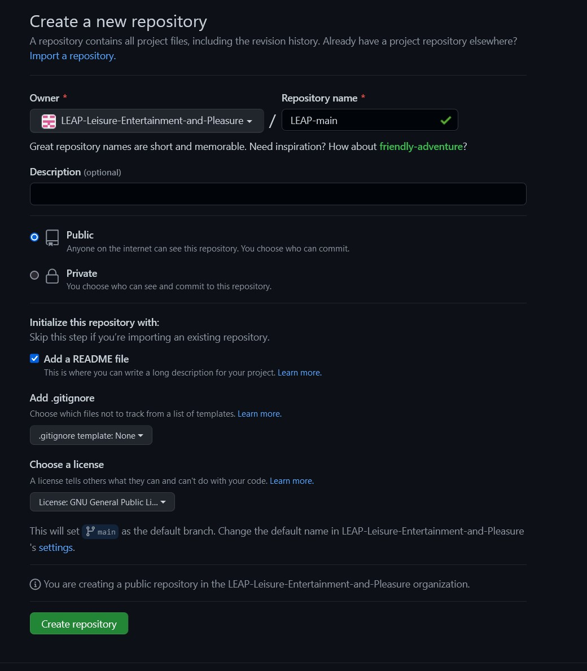

* If you want to import code from an existing repository select the import code option.

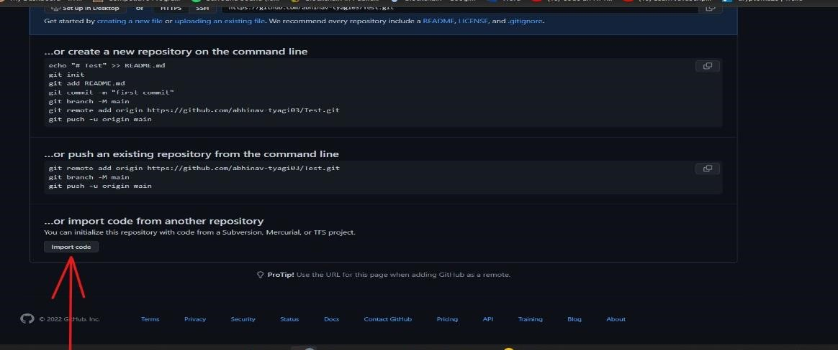

* To create a new file or upload an existing file into your repository select the option in the following box.

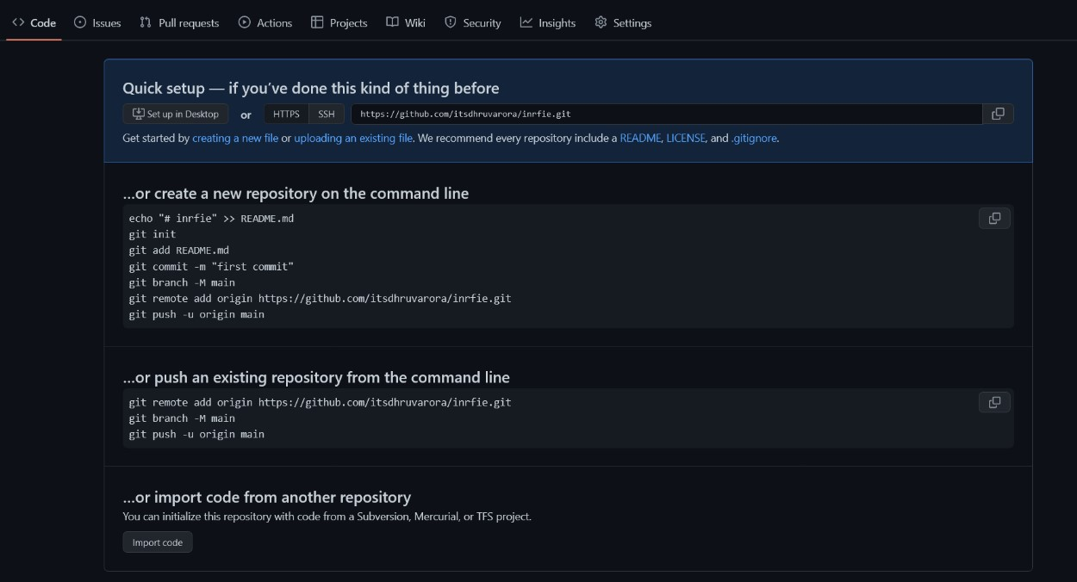

* Now, you have created your repository successfully.
* To add members to your repository, open your Organization and select People option in the navigation bar.
* Click on Collaborators option under the access tab.

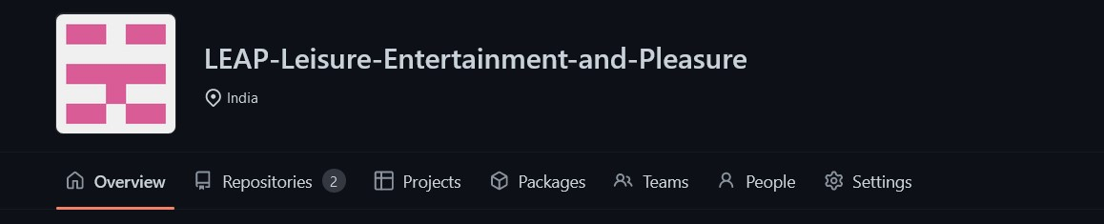

* To add members click on the add people option and search the id of your respective team member.

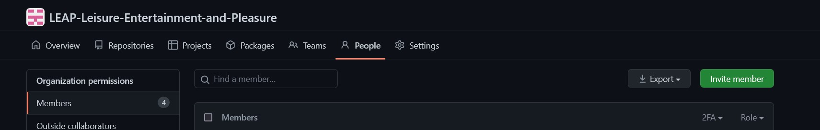

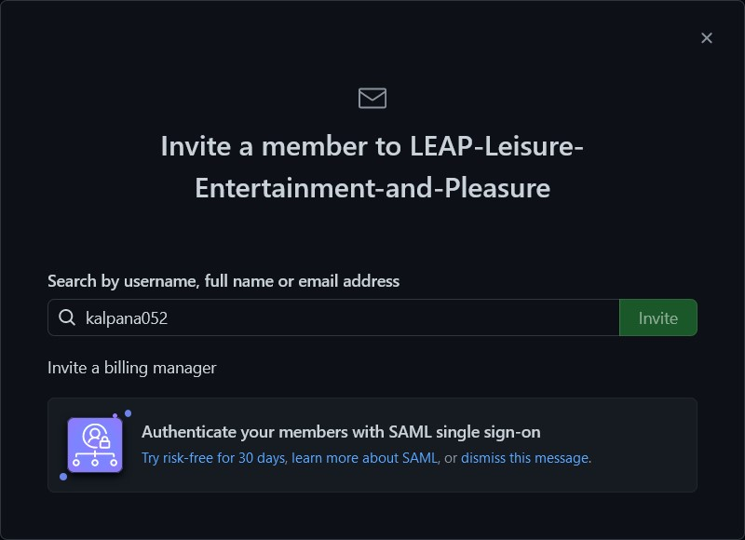

* To accept the invitation from your team member, open your email registered with GitHub.
* You will receive an invitation mail from the repository owner. Open the email and click on accept invitation.
* You will be redirected to GitHub where you can either select to accept or decline the invitation.

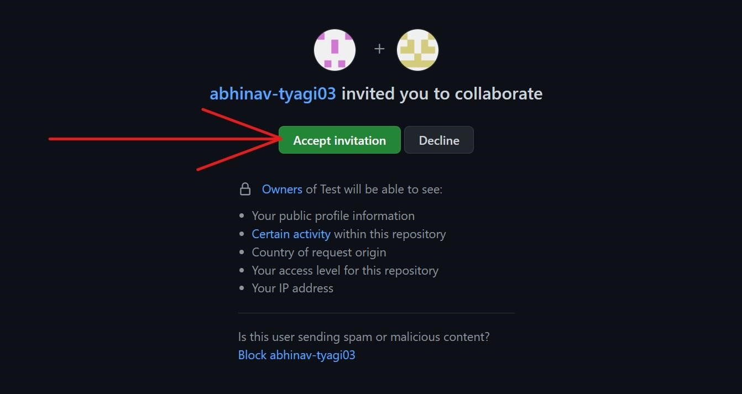

**S**



Itsdhruvarora



s



idjain8427



* Next, Open the desired Repository in the Organisation. Look and click on Settings -> Collaborators and Teams. Here you can Manage the role of each collaborator.

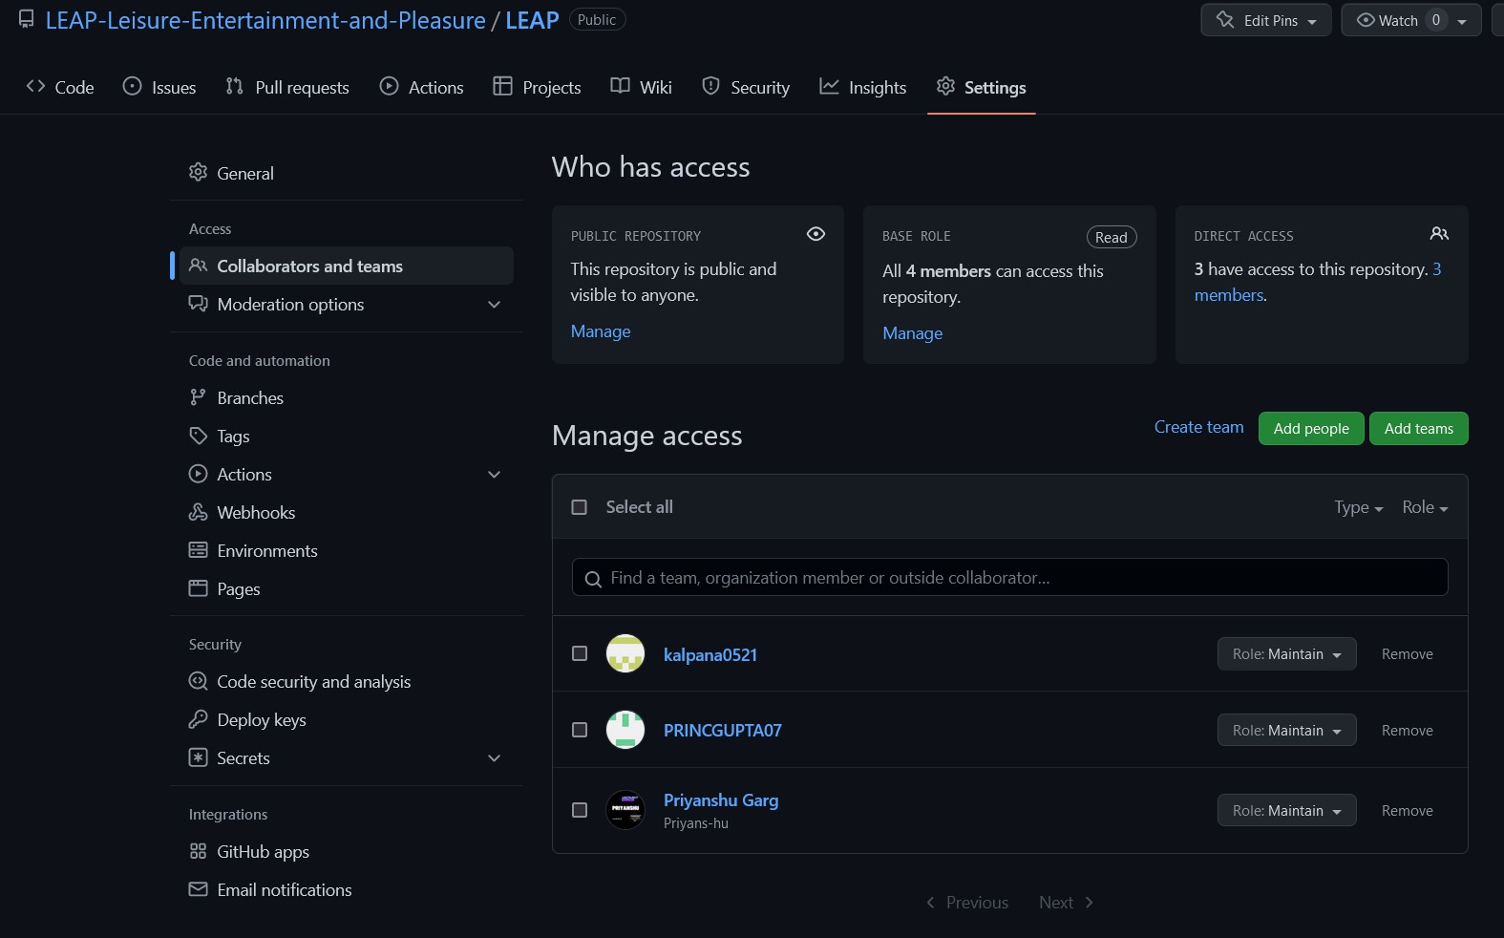

**Experiment No. 02** **m: Open And Close a Pull Request**

* 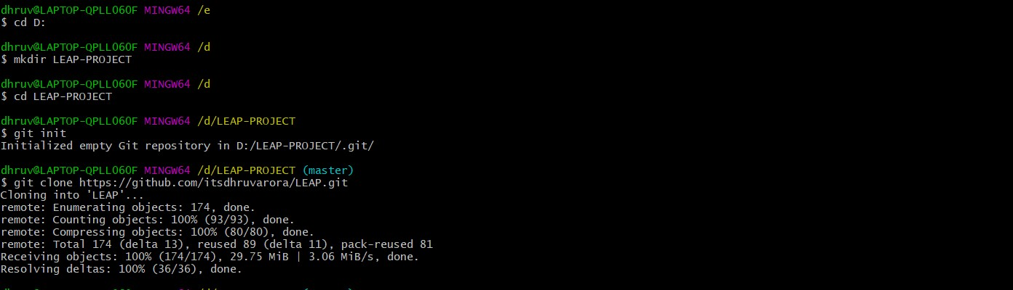To Open a Pull Request, First of All, it will be required to fork the repository and commit changes into your own.

* Add and commit the changes to the local repository.

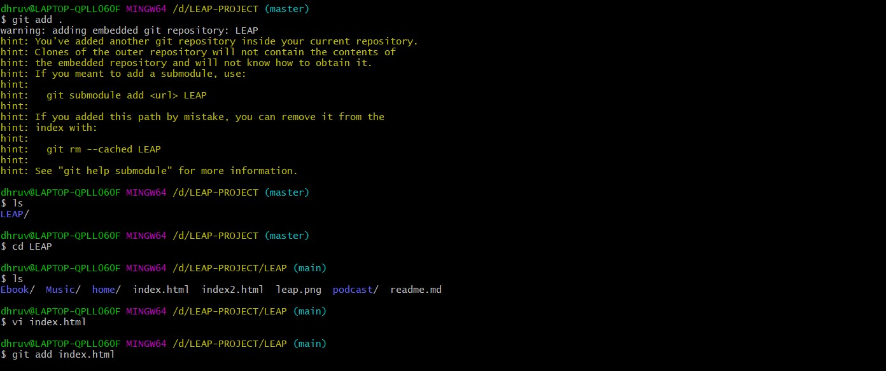

* Use git push origin branch name option to push the new branch to the main repository.

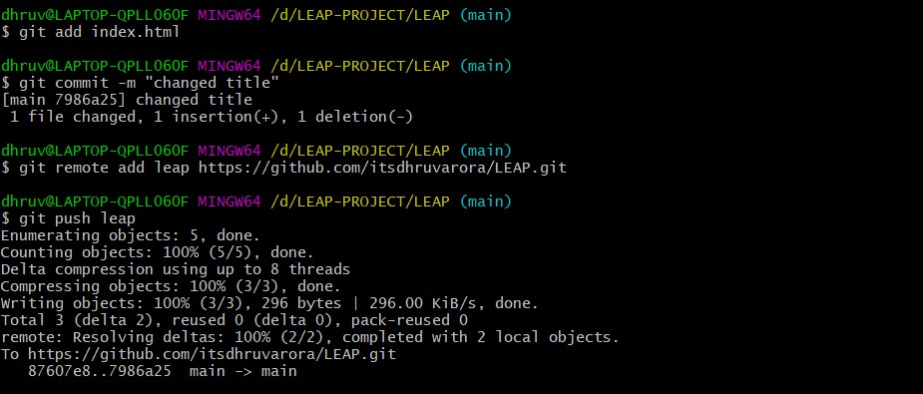

* After pushing new branch GitHub will either automatically ask you to create a pull request or you can create your own pull request.

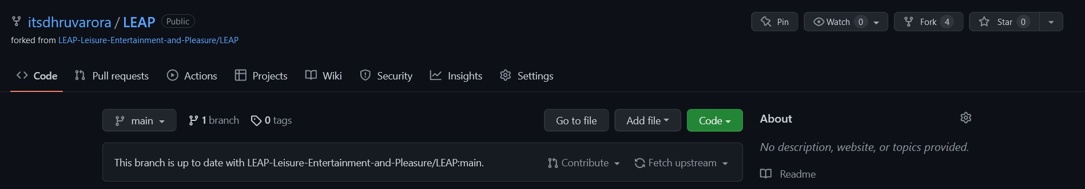

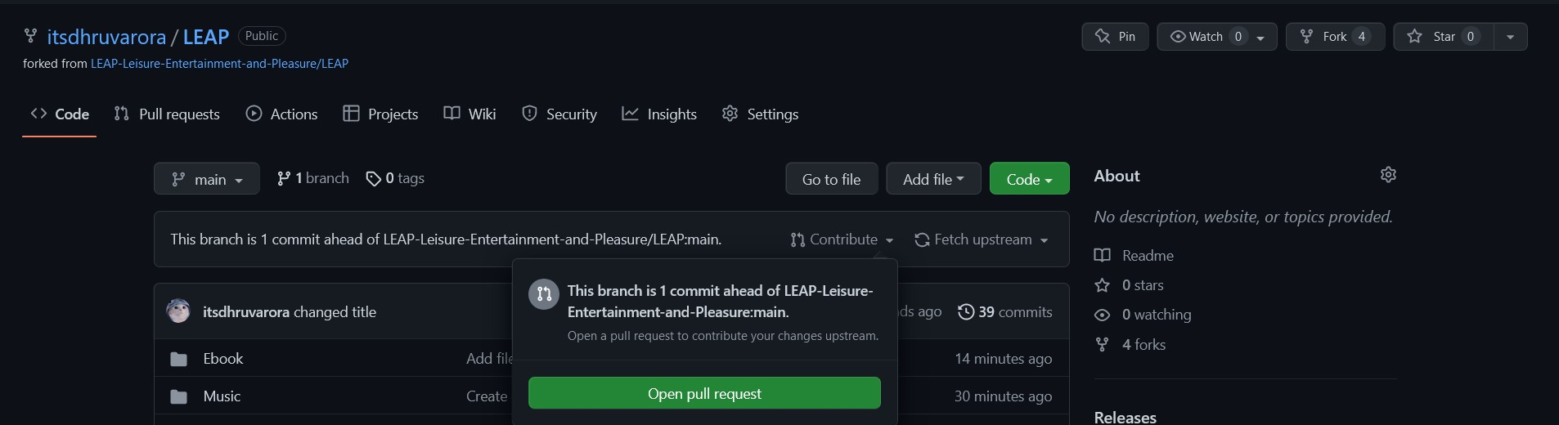

* To create your own pull request, click on pull request option.

* GitHub will detect any conflicts and ask you to enter a description of your pull request.  \

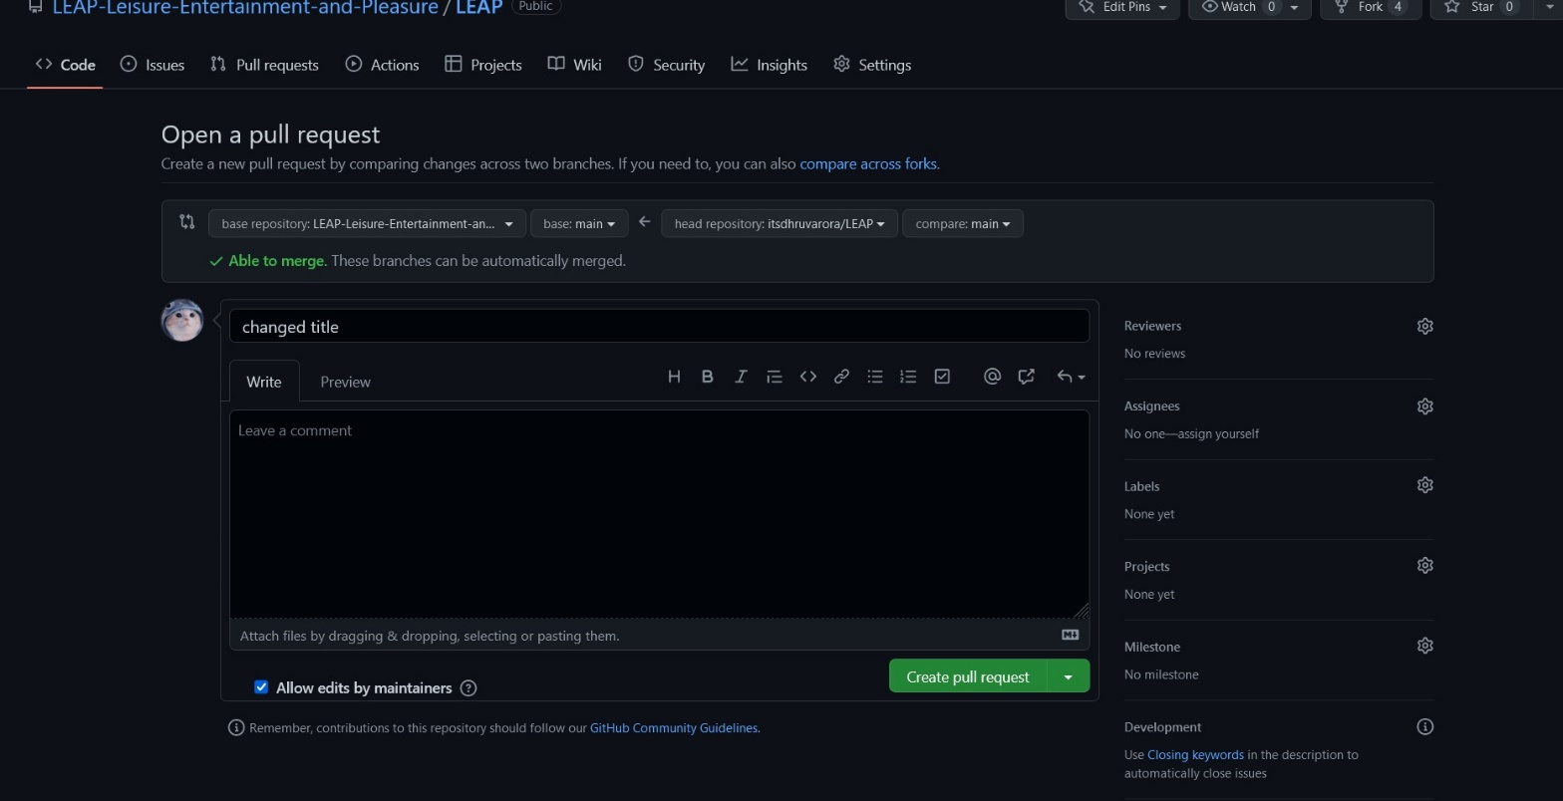

* After opening a pull request all the team members will be sent the request if they want to merge or close the request.

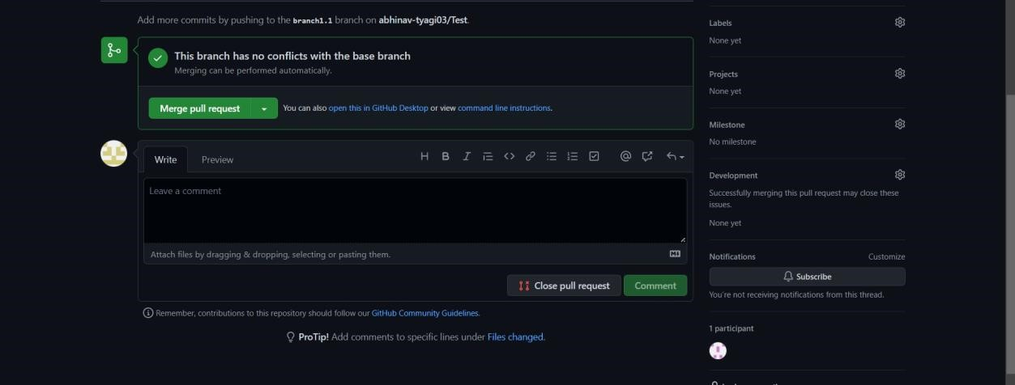

* If the team member chooses not to merge your pull request they will close you’re the pull request.

* To close the pull request simply click on close pull request and add comment/ reason why you closed the pull request.

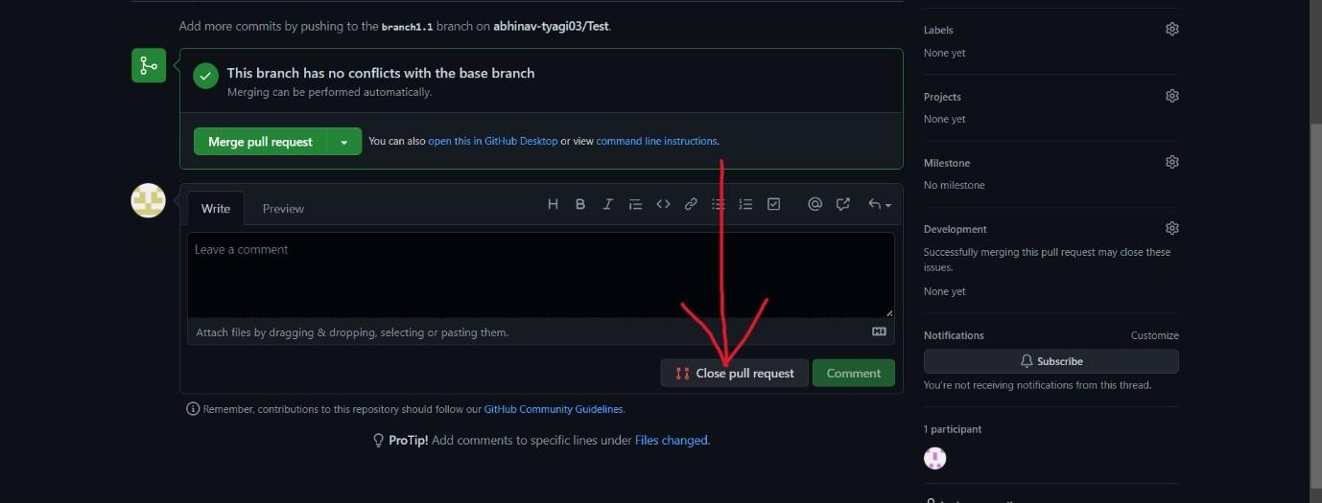

* You can see all the pull request generated and how they were dealt with by clicking on pull request option.

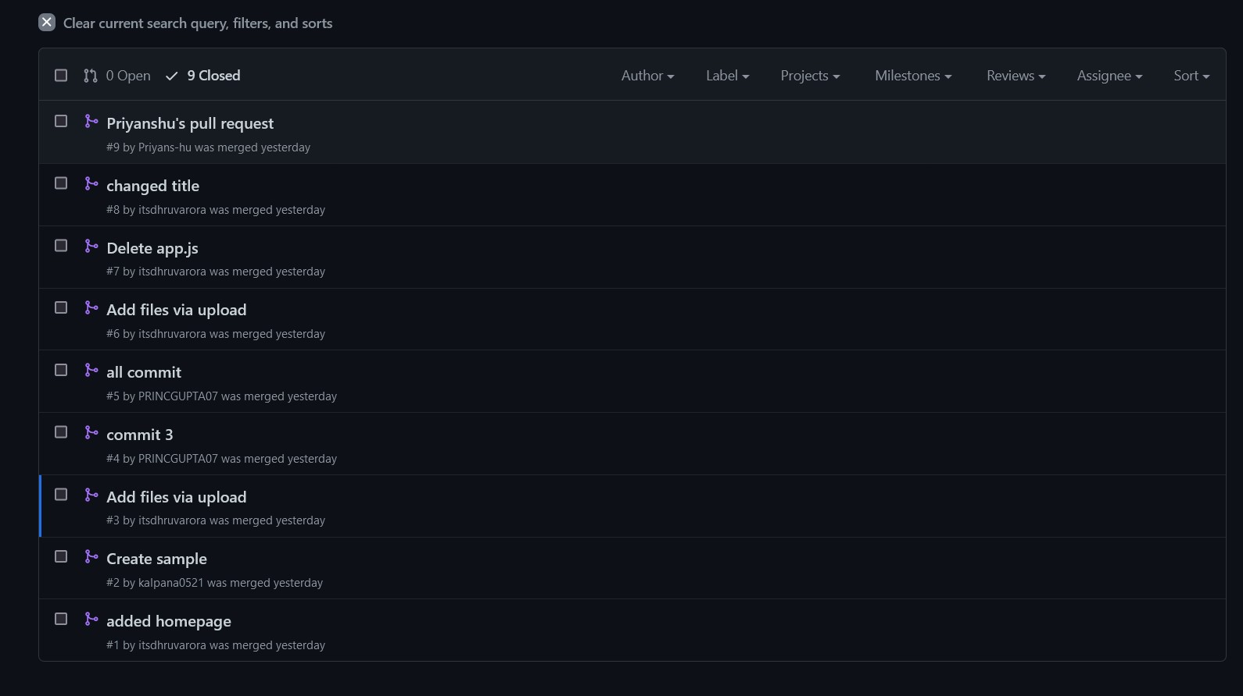

**Aim: Publish and print network graphs**

**Experiment No. 03**

The network graph is one of the useful features for developers on GitHub. It is used to display the branch history of the entire repository network, including branches of the root repository and branches of forks that contain commits unique to the network.

A repository's graphs give you information on traffic, projects that depend on the repository, contributors and commits to the repository, and a repository's forks and network. If you maintain a repository, you can use this data to get a better understanding of who's using your repository and why they're using it.

Some repository graphs are available only in public repositories with GitHub Free:

* Pulse
* Contributors
* Traffic
* Commits
* Code frequency
* Network

**Steps to access network graphs of respective repository** 1. On GitHub.com, navigate to the main page of the repository.

2.Under your repository name, click Insights.



3.At the left sidebar, click on Network.

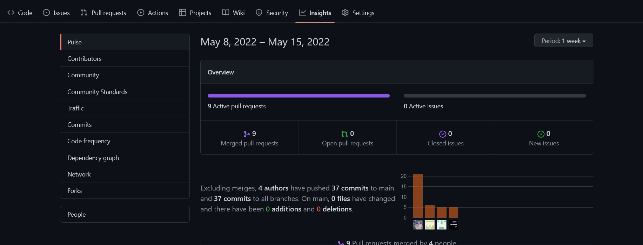

* You will get the network graph of your repository which displays the branch history of the entire repository network, including branches of the root repository and branches of forks that contain commits unique to the network.

