DG Sample Code Check

System Analysis Report
Generated on April 02, 2026
Healthcare Benefits Correspondence Automation System

1. Executive Summary
This is a healthcare benefits correspondence automation system built on the Pick/MultiValue (UniData) platform. It manages three key categories of regulatory and benefits notices:
- COBRA notices — Initial introduction letters and dependent notices for COBRA continuation coverage
- HIPAA privacy notices — Notice of Privacy Practices for both self-funded (SF) and fully-insured (FI) groups
- Disabled dependent letters — Review requests, recertifications, approvals, denials, and no-response letters for disabled dependents
The system is implemented through 3 main programs:
Program | Purpose | Output
COBRAN | Process COBRA initial notices | SmartComm correspondence for employees and dependents
HIPAA.NPP | Generate HIPAA Notice of Privacy Practices | SmartComm (SF) or PCL print files via FTP (FI)
PRINT.DISABLED.DEP.LETTERS | Generate disabled dependent letters (6 types) | SmartComm correspondence
These programs interact with shared data records including EMPLOYEES, EMPLOYERS, EROPTIONS, DEPENDENTS, and ERADJ, and submit correspondence through a centralized *CREATE.CORRESP.TRACKING subroutine that interfaces with the SmartComm document management system.
Key Finding: Significant functional coupling exists across the 3 programs, with 8+ shared concerns (eligibility filtering, employer loading, billing, audit) duplicated in each. This report provides a detailed decoupling strategy with 8 proposed extracted subroutines.

2. Record Types — Full Analysis

2.1 EMPLOYEES Record
Description: The core employee/member record. Contains multi-valued status codes, effective dates, coverage fields, and demographic information.
Key Format: EEID (Employee ID, e.g., 12345)
Loaded via: $INCLUDE BP EMPLOYEES.INS → MAT EEREC
Field Name | Purpose
EESTATUS | Multi-valued status codes: A (active), P (pending), T (terminated), D (deceased), W (waived), R (retired), I (inactive)
EENEED | Trigger flag: C (COBRA), N (HIPAA NPP), X (exclude/old record)
EEFILENO | Foreign key to EMPLOYERS record (multi-valued, indexed by EEIDX)
EEEFFDATE | Multi-valued effective dates, sorted descending
EERELATIONSHIP | E (employee), S (spouse), C (child)
EETERMDATE | Employer termination date
EEMEDCOV / EEDENCOV / EEVISCOV | Medical, dental, and vision coverage codes
EEHIPAA.SENT | Multi-valued dates of last HIPAA notice sent (indexed by DEPIDX)
EEDEPNO | Multi-valued dependent numbers
EELAST / EEFIRST | Employee last and first name
EEADD1/EEADD2/EECITY/EESTATE/EEZIP | Employee address fields
CALL *READREC('',MAT EEREC,EMPLOYEES,EEID,'')
LOCATE TODAY IN EEEFFDATE<1,1> BY 'DR' SETTING EEIDX ELSE NULL
Used by: COBRAN, HIPAA.NPP, PRINT.DISABLED.DEP.LETTERS

2.2 EMPLOYERS Record
Description: Employer/group master record. Contains employer-level configuration for billing, termination, trust type, and insurance carrier information.
Key Format: FILENO (derived from EEFILENO<1,EEIDX>)
Loaded via: $INCLUDE BP EMPLOYERS.INS → MAT ERREC
Field Name | Purpose
EREFFDATE | Multi-valued employer effective dates
ERCOBRAFEE | COBRA fee flag (Y/N/dollar amount) — determines if COBRA billing applies
ERBILLEDTO | Date through which employer has been billed; used to determine next billing period
ERACTUAL.STATE | Employer actual state (for jurisdiction logic)
ERTRUST | Trust code — determines SF (self-funded) vs FI (fully-insured) routing
ERTERMDATE | Employer termination date
ERINS.CARRIER | Insurance carrier code (used for FI CERTS.LAYOUT lookup)
IF EEFILENO<1,EEIDX> <> FILENO THEN
FILENO = EEFILENO<1,EEIDX>
CALL *READREC('',MAT ERREC,EMPLOYERS,FILENO,'')
END
Used by: COBRAN, HIPAA.NPP, PRINT.DISABLED.DEP.LETTERS

2.3 EROPTIONS Record
Description: Employer options/configuration record. Contains flags and fee amounts for COBRA notices, HIPAA privacy practices, and disabled dependent validation.
Key Format: FILENO (same key as EMPLOYERS)
Loaded via: $INCLUDE BP EROPTIONS.INS → MAT EOREC
Field Name | Purpose
EOEFFDATE | Multi-valued effective dates for option changes
EOCOBRA.NOTICE | Dollar amount for COBRA notice billing
EOHIPAAP | HIPAA fee/flag — blank means skip HIPAA processing for SF
EODDV | Disabled dependent validation flag (Y = enabled)
Used by: COBRAN, HIPAA.NPP

2.4 DEPENDENTS Record
Description: Dependent member record. Contains disabled dependent letter tracking, address information for alternate-address mailing, and relationship/coverage dates.
Key Format: EEID.DEPNO (e.g., 12345.01)
Loaded via: $INCLUDE BP DEPENDENTS.INS → MAT DPREC
Field Name | Purpose
DPDEP.NEED | Comma-delimited codes: RR, RC, IA, LA, DL, NR (disabled dep letter types)
DPDDL.SENT | Multi-valued dates when disabled dep letters were last sent
DPDDL.LETTERS | Multi-valued comma-delimited letter codes sent on each date
DPDISABILITY.EXPIRATION.DATE | Required for Limited Approval (LA) letters
DPREL.TYPE.EFFDATE | Relationship type effective date (used in HIPAA alt-address logic)
DPADD1-DPZIP / DPCOUNTRY | Dependent address fields for alternate-address detection
CALL *READREC('',MAT DPREC,DEPENDENTS,EEID.DEPNO,'SKIP')
CALL *WRITEREC('',MAT DPREC,DEPENDENTS,EEID.DEPNO,'TRANS.LOG,':PROGRAM.NAME)
Used by: HIPAA.NPP, PRINT.DISABLED.DEP.LETTERS (COBRAN indirectly)

2.5 ERADJ (Employer Adjustments) Record
Description: Billing adjustment record for employer-level charges. Uses an increment-or-create pattern with suffix iteration.
Key Format: FILENO + BILLPERIOD + SUFFIX (e.g., 12345200401)
Loaded via: $INCLUDE BP ERADJ.INS → MAT EAREC
Field Name | Purpose
EADESC | Description (e.g., "5 COBRA NOTICES" or "3 HIPAA")
EACOMMENTS | Multi-valued list of EEID or EEID.DEPNO that were billed
EADISTFIELD | Distribution field code: COBRACHG or HIPAA
EADISTAMOUNT | Distribution dollar amount per line
EACOVPERIOD | Coverage period in YYYYMM format
EAAMOUNT | Running total amount
Used by: COBRAN (COBRACHG), HIPAA.NPP (HIPAA)

2.6 CORRESP.DATA.REC (In-Memory Dynamic Array)
Not a persistent file record — this is an in-memory dynamic array assembled before calling *CREATE.CORRESP.TRACKING. Structure defined by CORRESP.INPUT.DEF record BASIC.SMARTCOMM.DOC.1.
Attribute | Field Name | Purpose
<2> | GroupNum / FILENO | Employer group number for the correspondence
<5> | AdditionalEEIDDepno | Secondary dependent EEID.DEPNO
<6> | AdditionalDependentPurpose | RECIPIENT or SUBJECT
Used by: All 3 Programs

2.7 CORRESP.TRACKING Record
Auto-generated by the *CREATE.CORRESP.TRACKING cataloged subroutine. Central correspondence dispatch mechanism.
Parameter | Value
CORRESP.INPUT.DEF.ID | 'BASIC.SMARTCOMM.DOC.1'
RECIPIENT.TYPE | 'DEPENDENT'
METHOD.REQUESTED | 'LOOKUP'
REQUEST.SOURCE | PROGRAM.NAME (varies per program)
DOCUMENT.NAME | Template name (varies by letter type)
Used by: All 3 Programs

2.8 SAVEDLISTS / Audit Lists
Named lists stored in the &SAVEDLISTS& system file. Used for audit trails, process resumption, and tracking.
List Name Pattern | Program | Purpose
COBRAN.DONE{logname} | COBRAN | Input list of EEIDs to process
COBRAN.DONE{logname}.{date}.{time} | COBRAN | Timestamped completion audit
STORE.MERITAIN.COBRA.INTRO.LETTER | COBRAN | EEIDs that received employee notice
STORE.MERITAIN.COBRA.DEPENDENT.NOTICE | COBRAN | EEID.DEPNOs that received dep notice
HIPAA.P{logname} | HIPAA.NPP | Input list of EEIDs for HIPAA processing
HIPAA.PDONE{logname} | HIPAA.NPP | Completed EEID.DEPNOs (all)
HIPAA.PDONE.SC.{logname} | HIPAA.NPP | SF members sent to SmartComm
EEID.LIST.{logname} | HIPAA.NPP | Filtered EEID.DEPNO list for processing
Used by: COBRAN, HIPAA.NPP

2.9 Supplementary Records
Records used primarily by HIPAA.NPP for the fully-insured (FI) processing path:
Record | Key/Description | Purpose
SYSMGMT | HIPAA.DAILY.COUNTER | Daily run counter to prevent duplicate filenames
GROUPINFO | $INCLUDE BP GROUPINFO.INS | Group-level info; GINPP field determines output control
CERTS.LAYOUT | $INCLUDE BP CERTS.LAYOUT.INS | Certificate layout definitions keyed by insurance carrier
CERTS.MERGE | $INCLUDE BP CERTS.MERGE.INS | Merge field definitions for certificate generation
CERTS.TEXT2 | $INCLUDE BP CERTS.TEXT2.INS | Text templates for FI HIPAA forms
LETTER.COPIES | $INCLUDE BP LETTER.COPIES.INS | Copy/distribution configuration
OUTPUT.CONTROL | $INCLUDE BP OUTPUT.CONTROL.INS | Output routing; contains HIPAA.YEARS for FI cutoff
FTP.LOG / FTP.REQUESTS | $INCLUDE BP FTP.*.INS | FTP transmission tracking for FI print files

2.10 SmartComm Configuration
All 9 document types use the BASIC.SMARTCOMM.DOC.1 setup in CORRESP.INPUT.DEF:
# | Letter Description | Document Name | SmartComm ID | Returns Image
1 | HIPAA Notice of Privacy Practices | Meritain.HIPAA.Notice | 690679345 | N
2 | COBRA Introduction Letter | Meritain.COBRA.Intro.Letter | 690680007 | N
3 | Dependent COBRA Introduction Letter | Meritain.COBRA.Dependent.Notice | 690680105 | N
4 | Disabled Dependent Denial Notice | Disabled.Dependent.-.Denial | 690918681 | Y
5 | Disabled Dependent Indefinite Approval | Disabled.Dependent.-.Indefinite.Approval | 690918738 | Y
6 | Disabled Dependent Recertification | Disabled.Dependent.-.Recertification | 690918752 | Y
7 | Disabled Dependent Review Request | Disabled.Dependent.-.Review.Request | 690918765 | Y
8 | Disabled Dependent Limited Approval | Disabled.Dependent.-.Limited.Approval | 690918728 | Y
9 | Disabled Dependent No Response Letter | Disabled.Dependent.-.No.Response | 690918705 | Y

3. The 9 Letter Types — Identified from Code
Each letter type is discoverable from the source code alone, without requiring the CSV configuration file.

From COBRAN.md
1. Meritain.COBRA.Intro.Letter — assigned to TEMPLATE.NAME at line 178
2. Meritain.COBRA.Dependent.Notice — assigned to DEP.TEMPLATE.NAME at line 182

From HIPAA.NPP.md
3. Meritain.HIPAA.Notice — assigned to DOCUMENT.NAME at line 1287

From PRINT.DISABLED.DEP.LETTERS.md (lines 148-173)
4. Disabled.Dependent.-.Review.Request (code: RR)
5. Disabled.Dependent.-.Recertification (code: RC)
6. Disabled.Dependent.-.Indefinite.Approval (code: IA)
7. Disabled.Dependent.-.Limited.Approval (code: LA)
8. Disabled.Dependent.-.Denial (code: DL)
9. Disabled.Dependent.-.No.Response (code: NR)

Summary Table
# | Letter Name | Template/Document Name | Source Program | Trigger Condition | SmartComm ID | Returns Image
1 | COBRA Intro Letter | Meritain.COBRA.Intro.Letter | COBRAN | EENEED='C', ERCOBRAFEE!='N' | 690680007 | N
2 | COBRA Dependent Notice | Meritain.COBRA.Dependent.Notice | COBRAN | Spouse at different address | 690680105 | N
3 | HIPAA Notice | Meritain.HIPAA.Notice | HIPAA.NPP | EENEED='N', SF group, EOHIPAAP not blank | 690679345 | N
4 | Disabled Dep Review Request | Disabled.Dependent.-.Review.Request | PDDL | DPDEP.NEED contains 'RR' | 690918765 | Y
5 | Disabled Dep Recertification | Disabled.Dependent.-.Recertification | PDDL | DPDEP.NEED contains 'RC' | 690918752 | Y
6 | Disabled Dep Indefinite Approval | Disabled.Dependent.-.Indefinite.Approval | PDDL | DPDEP.NEED contains 'IA' | 690918738 | Y
7 | Disabled Dep Limited Approval | Disabled.Dependent.-.Limited.Approval | PDDL | DPDEP.NEED contains 'LA' | 690918728 | Y
8 | Disabled Dep Denial | Disabled.Dependent.-.Denial | PDDL | DPDEP.NEED contains 'DL' | 690918681 | Y
9 | Disabled Dep No Response | Disabled.Dependent.-.No.Response | PDDL | DPDEP.NEED contains 'NR' | 690918705 | Y

4. Dependency Graph
This diagram shows how the 10+ record types relate to each other through foreign keys and data flow:
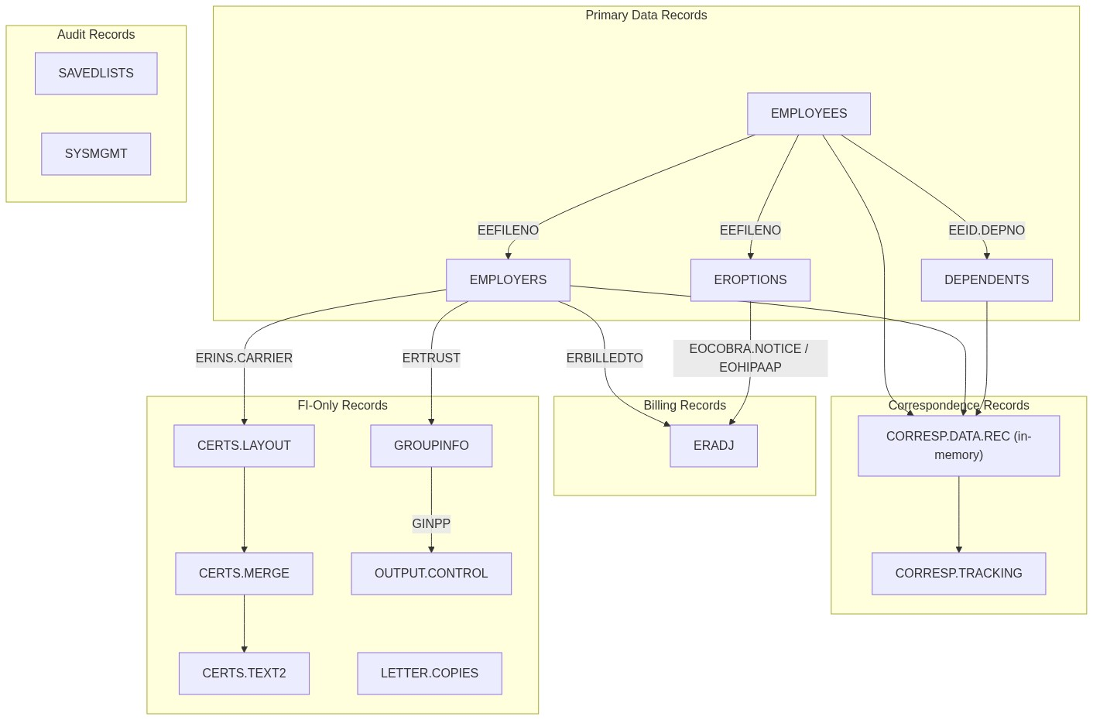
Figure 4.1: Record Type Dependency Graph

5. Current Coupling Map
This diagram shows the 8+ functional concerns tangled across the 3 programs:
[Diagram could not be rendered. Mermaid code:]
graph LR
subgraph "COBRAN"
C1["Eligibility Filtering"]
C2["Employer/Group Loading"]
C3["Letter Generation (EE)"]
C4["Letter Generation (Dep)"]
C5["Billing (ERADJ)"]
C6["Audit Lists"]
end
subgraph "HIPAA.NPP"
H1["Eligibility Filtering"]
H2["Employer/Group Loading"]
H3["SF/FI Routing"]
H4["SmartComm Submission"]
H5["Legacy PCL Generation"]
H6["Billing (ERADJ)"]
H7["FTP Transmission"]
H8["Audit Lists"]
H9["Letter Storage"]
end
subgraph "PRINT.DISABLED.DEP.LETTERS"
P1["Eligibility Filtering"]
P2["Dep Need Validation"]
P3["Letter Generation"]
P4["Dep Record Update"]
P5["Error Reporting/Email"]
P6["Security Check"]
end
Figure 5.1: Current Coupling Map

6. Coupling Points Table
Concern | Where It's Tangled | Shared Records
Eligibility Filtering | COBRAN: MAIN.LOOP  HIPAA.NPP: FILTER.EEIDS  PDDL: VALIDATE.DEP.DATA | EMPLOYEES, EMPLOYERS, EROPTIONS, DEPENDENTS
Employer/Group Loading | COBRAN: MAIN.LOOP  HIPAA.NPP: SET.SKIP.FILENO  PDDL: GENERATE.DD.LETTERS | EMPLOYERS, EROPTIONS
Correspondence Submission | COBRAN: SUBMIT.CORRESP.REQUEST  HIPAA.NPP: SUBMIT.CORRESP.REQUEST  PDDL: SUBMIT.CORRESP.REQUEST | CORRESP.DATA.REC, CORRESP.TRACKING
Billing (ERADJ) | COBRAN: DO.BILLING (COBRACHG)  HIPAA.NPP: DO.BILLING (HIPAA) | ERADJ, EROPTIONS, EMPLOYERS
FI HIPAA Generation | HIPAA.NPP only: GET.HIPAA.FORMS + GENERATE.HIPAA.FORMS | CERTS.LAYOUT, CERTS.MERGE, CERTS.TEXT2, GROUPINFO, OUTPUT.CONTROL
FTP Transmission | HIPAA.NPP only: FTP.FILE subroutine | FTP.LOG, FTP.REQUESTS, REDCARD.PCL
Audit List Management | COBRAN: END.REPORT.FILE  HIPAA.NPP: SAVE.LIST commands | &SAVEDLISTS&
Dependent Record Update | PDDL only: UPDATE.DEP.NEED + WRITE.DEP.REC | DEPENDENTS

7. Decoupling Strategy
The following 8 extracted subroutines are proposed to decouple the shared concerns:

7.1 *CHECK.LETTER.ELIGIBILITY
Proposed Signature:
SUBROUTINE *CHECK.LETTER.ELIGIBILITY(IS.ELIGIBLE, EEID, MAT EEREC, MAT ERREC, MAT EOREC, LETTER.TYPE, TODAY)
Extracts from:
- COBRAN — MAIN.LOOP (lines 196-271): status checks, EENEED='X' skip, LOCATE effective date
- HIPAA.NPP — FILTER.EEIDS (lines 458-556): status exclusions, coverage checks
- PDDL — VALIDATE.DEP.DATA + CHECK.DEP.NEED (lines 303-467): DEP.NEED validation
Current Duplicated Pattern:
IF INDEX(EENEED,'X',1) > 0 THEN CONTINUE
LOCATE TODAY IN EEEFFDATE<1,1> BY 'DR' SETTING EEIDX ELSE NULL
IF EEEFFDATE<1,EEIDX> = '' AND EEIDX > 1 THEN EEIDX -= 1
Extraction: Consolidates the common effective-date LOCATE, EENEED='X' exclusion, and status filtering into a single subroutine. Each program passes its LETTER.TYPE to invoke the appropriate eligibility rules.

7.2 *LOAD.EMPLOYER.CONTEXT
Proposed Signature:
SUBROUTINE *LOAD.EMPLOYER.CONTEXT(LOAD.OK, FILENO, MAT ERREC, MAT EOREC, LAST.FILENO)
Extracts from:
- COBRAN — MAIN.LOOP (lines 232-260): conditional read when FILENO changes
- HIPAA.NPP — SET.SKIP.FILENO (lines 743-775): reads EMPLOYERS + EROPTIONS
- PDDL — GENERATE.DD.LETTERS (lines 691-705): reads EMPLOYERS per dependent
Extraction: Encapsulates the cached employer+eroptions read pattern. Eliminates 3 copies of the same caching logic.

7.3 *SUBMIT.LETTER.REQUEST
Proposed Signature:
SUBROUTINE *SUBMIT.LETTER.REQUEST(ERROR.MESSAGES, FILENO, RECIPIENT.ID, DOCUMENT.NAME, PROGRAM.NAME, ADDITIONAL.DEPNO, ADDITIONAL.PURPOSE)
Extracts from all 3 programs' SUBMIT.CORRESP.REQUEST subroutines.
Extraction: Wraps the CORRESP.DATA.REC assembly and *CREATE.CORRESP.TRACKING call. All 3 programs use identical parameter setup.

7.4 *ADD.NOTICE.BILLING
Proposed Signature:
SUBROUTINE *ADD.NOTICE.BILLING(EEID, FILENO, MAT EEREC, MAT EAREC, MAT EOREC, MAT ERREC, DIST.TYPE, EEIDX, EOIDX)
Extracts from COBRAN DO.BILLING (COBRACHG) and HIPAA.NPP DO.BILLING (HIPAA).
Extraction: Parameterizes the distribution type and the fee source field. The increment-or-create ERADJ loop is identical in both programs.

7.5 *GENERATE.FI.HIPAA.NOTICE
Proposed Signature:
SUBROUTINE *GENERATE.FI.HIPAA.NOTICE(PCL.OUTPUT, EEID, MAT EEREC, MAT ERREC, FILENO, FORMS.DATA)
Extracts from HIPAA.NPP GET.HIPAA.FORMS + GENERATE.HIPAA.FORMS. Isolates the FI-specific PCL generation into a reusable subroutine.

7.6 *SUBMIT.PRINT.FTP
Proposed Signature:
SUBROUTINE *SUBMIT.PRINT.FTP(FTP.STATUS, FILENAME, FTP.ID, PROGRAM.NAME)
Extracts from HIPAA.NPP FTP.FILE subroutine. Parameterizes the filename, FTP.ID, and program name.

7.7 *SAVE.PROCESS.AUDIT
Proposed Signature:
SUBROUTINE *SAVE.PROCESS.AUDIT(PROGRAM.NAME, UV.LOGNAME, STORE.LISTS, LIST.NAMES)
Extracts from COBRAN END.REPORT.FILE and HIPAA.NPP end-of-process code. Standardizes audit trail naming and list saving.

7.8 *UPDATE.DEP.LETTER.STATUS
Proposed Signature:
SUBROUTINE *UPDATE.DEP.LETTER.STATUS(MAT DPREC, EEID.DEPNO, CUR.NEED, ERROR.DEP.NEED, TODAY, PROGRAM.NAME)
Extracts from PDDL WRITE.DEP.REC + UPDATE.DEP.NEED. Encapsulates the dependent letter tracking update logic.

8. Decoupled Architecture
After extraction, the 3 programs become thin orchestrators that delegate to shared subroutines:
Figure 8.1: Decoupled Architecture

9. Priority Order for Decoupling
Priority | Extraction | Impact | Reason
1 | *SUBMIT.LETTER.REQUEST | High | Used by all 3 programs; most duplicated code block; standardizes SmartComm interface
2 | *CHECK.LETTER.ELIGIBILITY | High | Most complex duplicated logic; eligibility bugs affect all letter types
3 | *LOAD.EMPLOYER.CONTEXT | High | 3-way duplication; caching logic is error-prone; simplifies all 3 programs
4 | *ADD.NOTICE.BILLING | Medium | 2-way duplication; billing errors have financial impact
5 | *SAVE.PROCESS.AUDIT | Medium | 2-way duplication; standardizes audit trail naming; low risk
6 | *UPDATE.DEP.LETTER.STATUS | Medium | Single program but complex multi-step update; isolates dependent record mutation
7 | *GENERATE.FI.HIPAA.NOTICE | Low | Single program; isolates legacy PCL path; enables future deprecation
8 | *SUBMIT.PRINT.FTP | Low | Single program; isolates FTP concern; simplifies HIPAA.NPP main flow

10. Program Flow Diagrams

10.1 COBRAN Flow
Shows the GOSUB call flow for the COBRAN program:
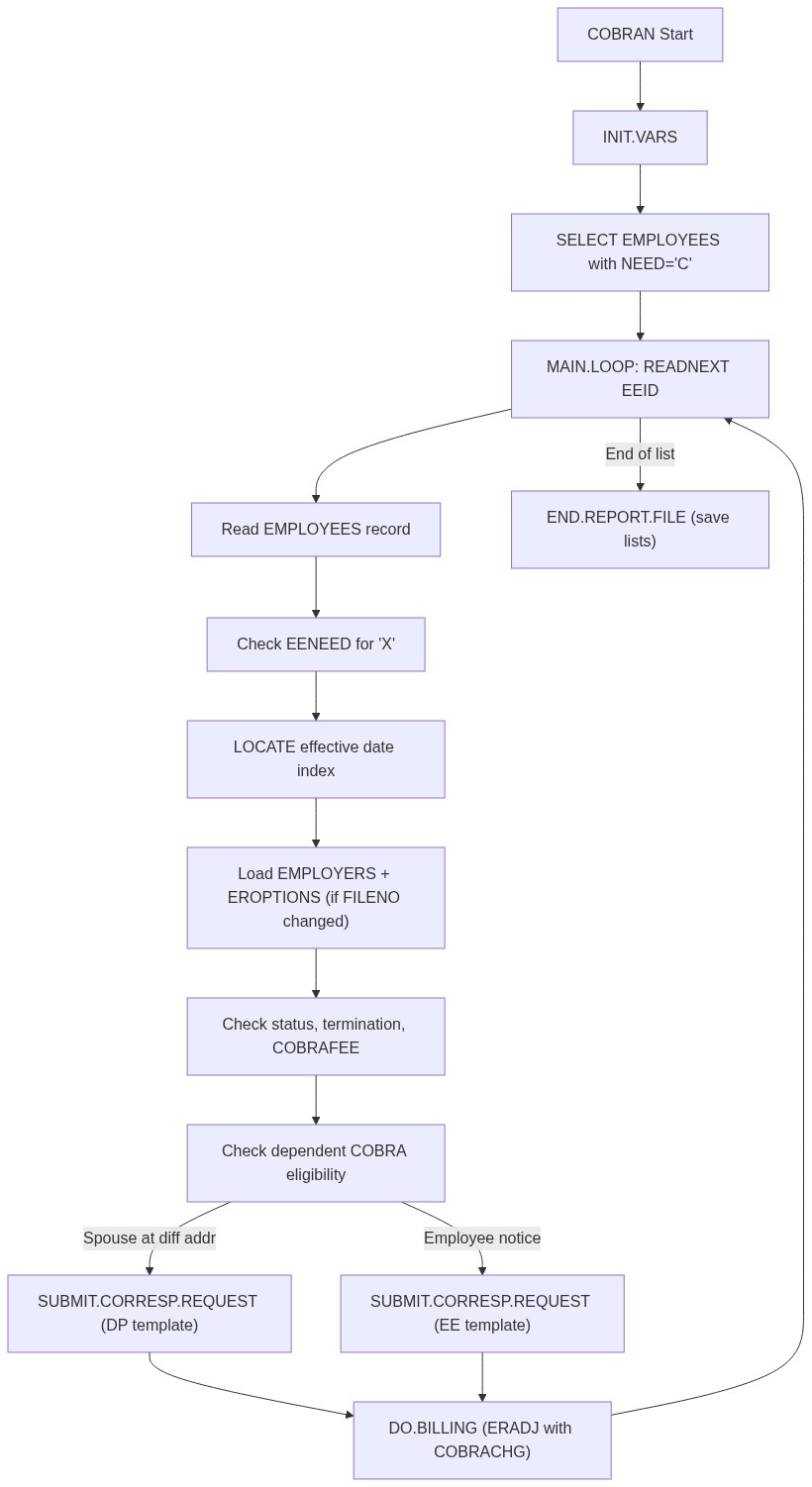
Figure 10.1: COBRAN Program Flow

10.2 HIPAA.NPP Flow
Shows the dual-path flow for self-funded (SmartComm) and fully-insured (PCL/FTP) HIPAA notice processing:
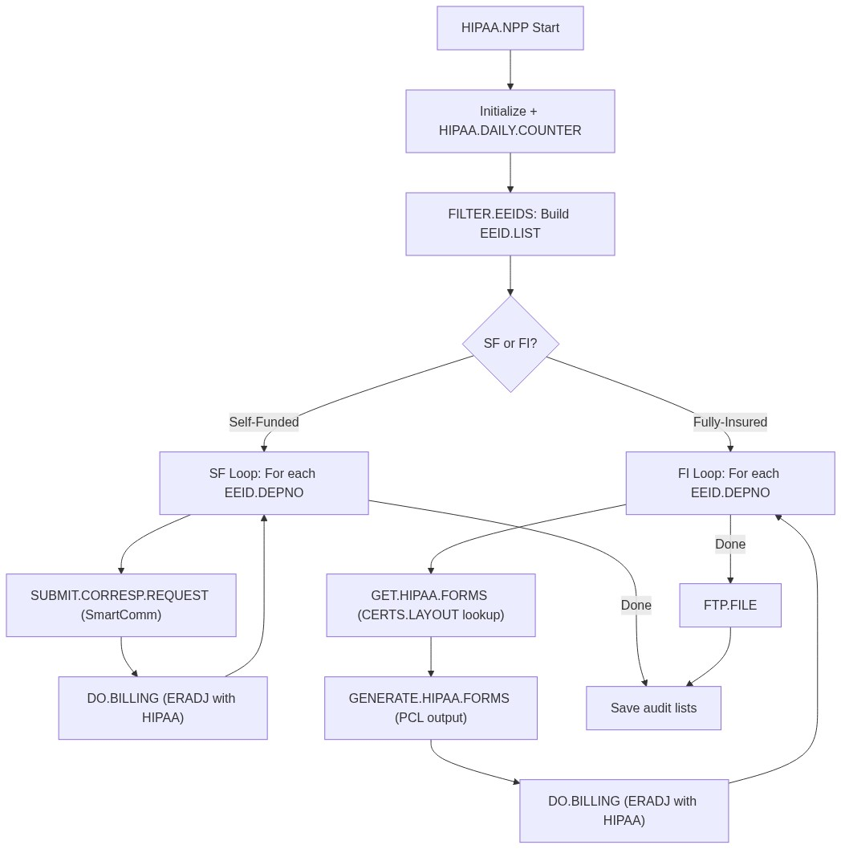
Figure 10.2: HIPAA.NPP Program Flow

10.3 PRINT.DISABLED.DEP.LETTERS Flow
Shows the disabled dependent letter generation flow:
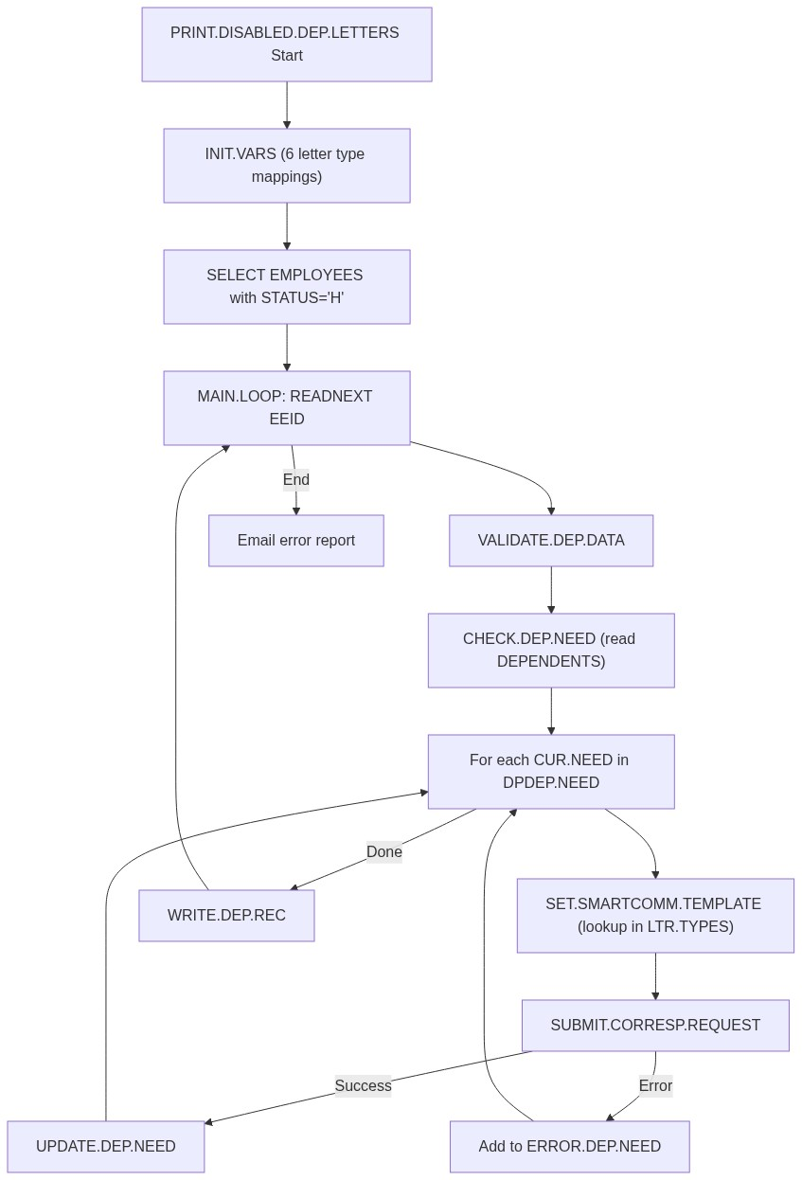
Figure 10.3: PRINT.DISABLED.DEP.LETTERS Program Flow

