Notes

Switches
Ws Morandi
Milky yellow pros

Reference Keyboards
The guy that used ergogen
:3ild Cat
PCB Design Guide
Mill Max soldering

Pro Micro NRF52840 vs nice nano
Nice nano might be better for low power
Pro Micro is cheaper and easier to find

Stabilizers
Screw in
PCB clip in
Plate mount

GitHub Kicad footprints
https://github.com/bstiq/nice-nano-kicad
Kaihl MX switches (hotswap compatible))
https://github.com/tyetye/MX_Alps_Hybrid.pretty/tree/master

Tools
Ergogen
Zmk

Dimensions References

Dimensions
https://cdn.sparkfun.com/datasheets/Components/Switches/MX%20Series.pdf 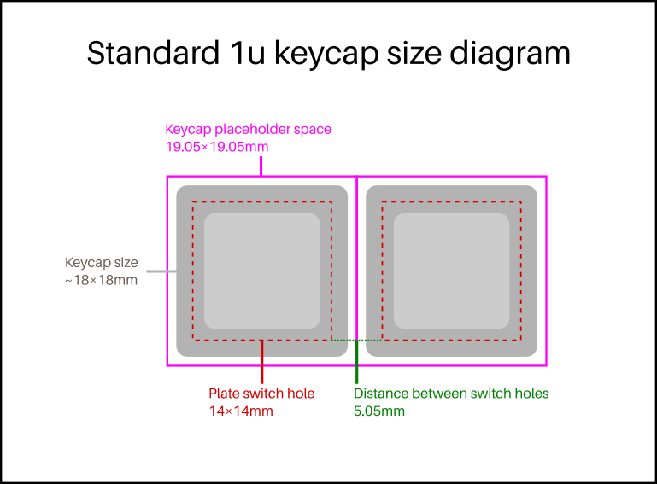

Standard space bars have each stabiliser stem's middle 1/2 unit from the end. This rule applies to 6u, 6.25u, 7u and 8u.
So, for a standard 6.25u space bar, the distance between the middle points of the stabiliser stems is 6.25 - 2*½ = 5.25u, or 100.0 mm.

Footprints

Garbage but kinda cool
Keypad library (only for Arduino)
https://forum.arduino.cc/t/arduino-nano-33-ble-sense-hid/675014/6

Coding Things
matrix {
rows = <&gpio0 6>, <&gpio0 8>, <&gpio0 17>;
columns = <&gpio1 11>, <&gpio1 13>, <&gpio0 12>;
diode-direction = "col2row";
};

Diode direction and columns and rows have to be specified

