Deep Learning Notes for Beginners

What is AI?
AI enables computers to perform tasks that normally require human intelligence.

AI Hierarchy (Important!)
│ Artificial Intelligence |
│ Machine Learning │
│ Deep Learning │
- AI → broad concept
- ML → subset of AI; learns from data
- DL → subset of ML; uses neural networks

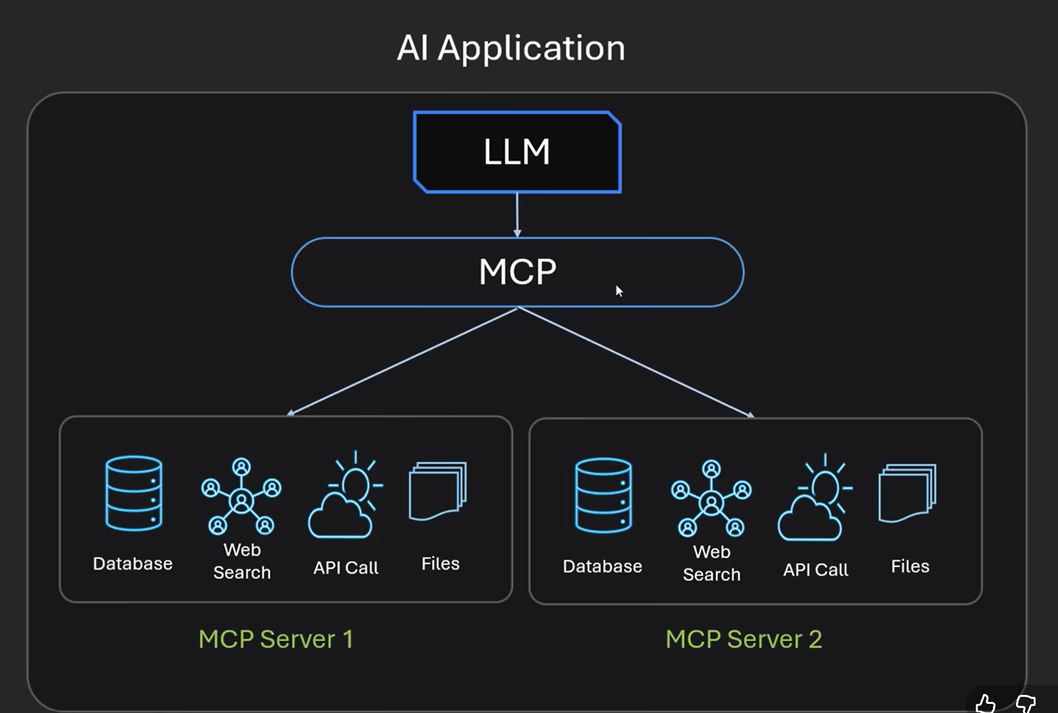

What is Machine Learning?
ML allows systems to learn patterns from data instead of explicit programming.

— Types of Machine Learning
Type | Description | Example
Supervised | Learns from labeled data | Spam detection, price prediction
Unsupervised | Finds patterns in unlabeled data | Customer segmentation
Reinforcement | Learns by reward/punishment | Game AI, robotics

What is Deep Learning?
Deep Learning uses neural networks with multiple layers to automatically learn patterns from data.

Human Learning vs Deep Learning
Just as a child learns from examples, deep learning models learn from large datasets.

Neural Network
A neural network is a collection of mathematical functions (neurons) connected together.

Neural Network Structure
Input Layer -> Hidden Layer(s) -> Output Layer

Neuron Formula
Output = (Input × Weight) + Bias

Weight
Weight represents the importance of an input feature.

Bias
Bias shifts the output up or down and provides flexibility.

Why Weight and Bias?
Weights learn relationships. Bias helps fit real-world data accurately.

Forward Propagation
The network generates a prediction from the input.

Loss Function
Measures the difference between actual and predicted values.

Backpropagation
Calculates how weights should change to reduce errors.

Training Loop
Predict -> Error -> Update Weights -> Repeat

Automatic Feature Learning
Useful patterns become stronger because they reduce prediction errors.

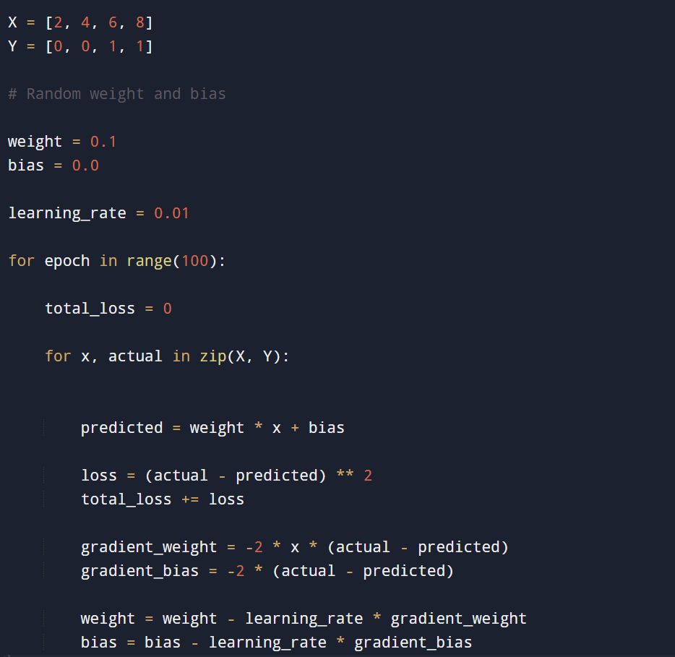
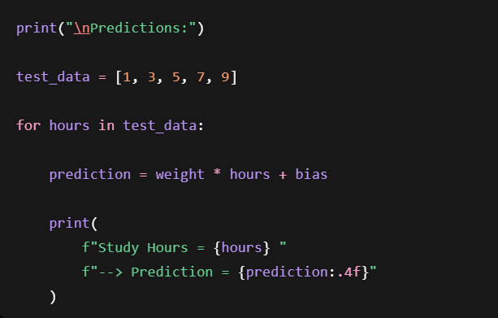

In code:
X = [2, 4, 6, 8]
Y = [0, 0, 1, 1]
Here:
- X = Input (Study Hours)
- Y = Correct Answer

Step 1: AI Starts With No Knowledge
weight = 0.1
bias = 0.0
Suppose the AI's brain currently uses:
y=wx+by
Currently:
w = 0.1
b = 0
AI has no idea what the correct values should be.

Step 2: First Training Example
Student Studies 2 Hours
x = 2
actual = 0
Actual answer:
Fail

Step 3: Forward Propagation
predicted = weight * x + bias
Substitute values:
predicted = 0.1 × 2 + 0
predicted = 0.2
AI predicts:
20% Pass

Step 4: Calculate Error
Actual:
0
Predicted:
0.2
Code:
loss = (actual - predicted) ** 2
Calculation:
(0 - 0.2)²
0.04
Loss means:
"How wrong was I?"
Smaller loss = better.

Step 5: Backpropagation
This is the learning step.
gradient_weight = -2 * x * (actual - predicted)
Substitute values:
= -2 × 2 × (0 - 0.2)
= 0.8
This tells us:
"Weight is causing error. Adjust it."
Think of gradient as:
Direction to improve

Step 6: Update Weight
Code:
weight = weight - learning_rate * gradient_weight
Substitute:
weight = 0.1 - (0.01 × 0.8)
weight = 0.092
The AI slightly changes its knowledge.
Before:
Weight = 0.100
After:
Weight = 0.092

PYTHON LIBRARIES – FOR AI:
Artificial Intelligence (AI)
│
├── Data Processing
├── Machine Learning
├── Deep Learning
├── NLP
├── Computer Vision
├── LLMs
├── RAG
├── AI Agents
└── MLOps

1. Data Processing Libraries
Used to clean and prepare data before training.
Library | Purpose
NumPy | Arrays, matrices, mathematical operations
Pandas | DataFrames, CSV handling
Polars | Faster alternative to Pandas
Example:
import pandas as pd
data = pd.read_csv("students.csv")

2. Machine Learning Libraries
Used for classical ML algorithms.
Library | Purpose
Scikit-learn | ML algorithms
XGBoost | Advanced prediction models
LightGBM | Fast boosting models
CatBoost | Handles categorical data well
Algorithms:
Linear Regression
Logistic Regression
Decision Tree
Random Forest
KNN
SVM

3. Deep Learning Libraries
Used to build neural networks.
Library | Purpose
TensorFlow | Deep Learning
PyTorch | Deep Learning
Keras | Simplified Deep Learning
Example:
import torch
import torch.nn as nn
These libraries provide:
Neural Networks
CNNs
RNNs
Transformers

4. Computer Vision Libraries
Used for image and video AI.
Library | Purpose
OpenCV | Image processing
YOLO | Object detection
Detectron2 | Detection and segmentation
Applications:
Face Detection
Number Plate Recognition
Medical Imaging

5. NLP Libraries
Used for text processing.
Library | Purpose
NLTK | NLP basics
spaCy | Fast NLP processing
Gensim | Word embeddings and topics
Applications:
Sentiment Analysis
Text Classification
Keyword Extraction

6. LLM Libraries
Used to work with large language models.
Library | Purpose
Transformers | Load LLMs
Sentence Transformers | Text embeddings
vLLM | Fast inference
llama.cpp | Run LLMs locally
Example:
from transformers import AutoModel

Model Context Protocol (MCP) Notes
What is MCP?
MCP (Model Context Protocol) is an open standard created by Anthropic that allows AI models to communicate with external tools, applications, databases, and data sources through a standardized interface.
Simple Analogy
Think of MCP as:
USB-C for AI
Just as USB-C allows different devices to connect using the same standard, MCP allows different AI models to connect to different tools using a common protocol.

Why Was MCP Created?
Large Language Models (LLMs) are powerful at understanding and generating text, but they cannot directly:
- Read files from your computer
- Access GitHub repositories
- Query databases
- Send emails
- Call external APIs
- Access Slack or Notion
Without MCP, developers must create separate integrations for each AI application.
Example:
Claude → GitHub Integration
Claude → Slack Integration

ChatGPT → GitHub Integration
ChatGPT → Slack Integration
This creates duplicate work.
With MCP:
Claude
ChatGPT
Gemini
Cursor
Windsurf
|
MCP
|
---------------------
| | | | |
GitHub Slack DB Files APIs
One standard works across multiple AI applications.

MCP Architecture
MCP consists of three main components:
1. MCP Host
The application that contains the AI.
Examples:
- Claude Desktop
- Cursor
- Windsurf
Responsibilities:
- Runs the AI model
- Manages user interaction
- Hosts the MCP client

2. MCP Client
Acts as a bridge between the AI and MCP servers.
Responsibilities:
- Connects to MCP servers
- Sends requests
- Receives responses
- Passes information back to the AI

3. MCP Server
Provides tools, resources, and prompts.
Examples:
- GitHub MCP Server
- MongoDB MCP Server
- Filesystem MCP Server
The server exposes capabilities that AI models can use.

What Are MCP Tools?
Tools are functions that allow AI models to perform actions outside their normal capabilities.
Examples
readFile(path)

getIssues(repo)

searchDocuments(query)

sendEmail(to, subject, body)
These functions are called MCP Tools.

What Do MCP Tools Do?
1. Perform Actions
Examples:
- Read files
- Write files
- Query databases
- Access APIs
- Create GitHub pull requests

2. Fetch Real-Time Information
LLMs only know information from training data.
Tools allow AI to access:
- Current GitHub issues
- Latest Slack messages
- Database records
- Project files

3. Bridge Information Gaps
Tools provide information that the model would otherwise not have access to.

How Tool Calling Works
Suppose a user asks:
Get documents from MongoDB
Step 1
User sends prompt.
User
↓
LLM
Step 2
LLM determines it needs database data.
Step 3
MCP Client calls:
getDocuments()
tool.
Step 4
Tool executes actual code.
db.collection.find(...)
Step 5
Results are returned.
MongoDB
↓
Tool
↓
LLM
↓
User
The AI uses the returned data to generate its response.

Does MCP Contain the Functions?
No.
This is a common misconception.
MCP only defines:
- How tools are exposed
- How tools are discovered
- How tools are called
The actual implementation must be written by someone.

Example: File Reading Tool
Tool:
readFile(path)
Actual implementation:
public String readFile(String path) {
return Files.readString(Path.of(path));
}
MCP does not provide this code.
Someone must implement it.

Example: GitHub Tool
Tool:
getIssues(repository)
Implementation:
public List<Issue> getIssues(String repo) {
return githubApi.fetchIssues(repo);
}
Again, MCP only defines how AI calls the function.
The logic is written by developers.

Do I Need To Write Every Tool Myself?
Not always.
There are two situations.

Situation 1: Existing MCP Server
Someone already created the server.
Example:
GitHub MCP Server
It already contains tools such as:
readFile()
listFiles()
getIssues()
createIssue()
createPullRequest()
commitChanges()
You simply install and use it.
No coding required.

Situation 2: Custom MCP Server
Suppose your college has:
Attendance System
Student Portal
Internal Database
No MCP server exists.
You create your own tools:
getAttendance(studentId)

getMarks(studentId)

submitAssignment(studentId)
You implement the code and expose it through MCP.

Does Every LLM Need a Different MCP Server?
No.
This is one of MCP's biggest advantages.
Without MCP:
ChatGPT GitHub Integration

Claude GitHub Integration

Gemini GitHub Integration
Separate implementations are needed.
With MCP:
GitHub MCP Server
can be used by:
- ChatGPT
- Claude
- Gemini
- Cursor
- Windsurf
One server works for many AI applications.

MCP vs REST API
REST API
Designed for software-to-software communication.
Example:
Frontend
↓
Spring Boot API
↓
Database

MCP
Designed for AI-to-tool communication.
Example:
LLM
↓
MCP Server
↓
REST API
↓
Database
Many MCP servers internally use REST APIs.
MCP does not replace REST.
It complements REST.

MCP vs REST Comparison
REST API | MCP
Software ↔ Software | AI ↔ Tools
Stateless | Can maintain context
Fixed endpoints | Dynamic tool discovery
Developer-driven | AI-driven
Traditional applications | AI agents

GitHub Example
Suppose you ask:
Fix errors in my Spring Boot project.
Step 1
AI accesses repository.
Using tools:
listFiles()
readFile()
Step 2
AI analyzes source code.
Example:
@Autowired
private UserService userService
AI identifies missing semicolon or configuration issues.
Step 3
AI prepares fixes.
Step 4
AI uses tools such as:
writeFile()

commitChanges()

createPullRequest()
to update the repository.

Important Concept
GitHub MCP Server is NOT intelligent.
It only provides actions.
Examples:
readFile()

writeFile()

createPR()

commitChanges()
The intelligence comes from the LLM.

Easy Analogy
GitHub MCP Server = Hands
LLM = Brain
The Brain decides what to do.
The Hands perform the action.

Why MCP Is Important
Benefits:
- Standardized AI integrations
- Reusable tools
- Less duplicate development
- Easier AI agent creation
- Better access to real-time information
- Works across multiple AI applications

Interview Definition
Model Context Protocol (MCP) is an open standard created by Anthropic that enables AI models to securely communicate with external tools, APIs, databases, files, and applications through a standardized interface. It allows developers to build tools once and use them across multiple AI systems.

