

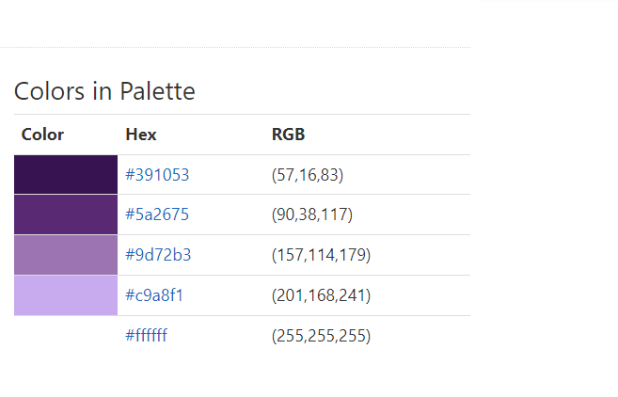<https://www.color-hex.com/color-palette/52336>

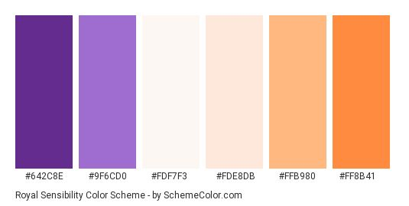

<https://za.pinterest.com/pin/88242473940527692/>

<https://hookagency.com/blog/website-color-schemes-2020/>

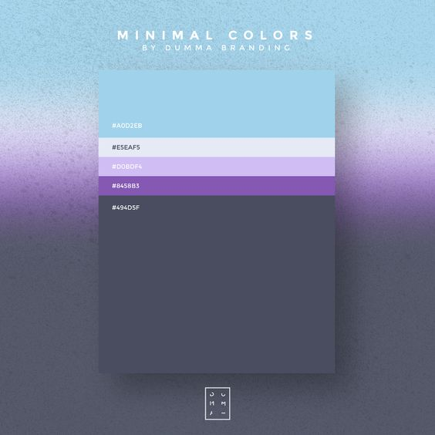

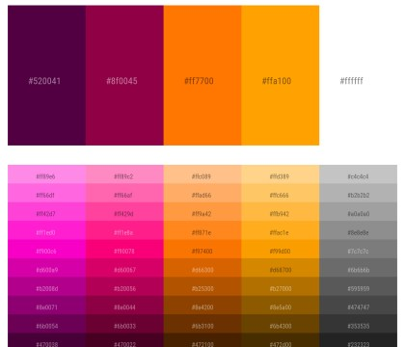

<https://icolorpalette.com/purple-and-white>