Namma Metro Operations &
Information Management System
UML Design Document

A comprehensive set of UML diagrams documenting the object-oriented
analysis and design of the Namma Metro system.

Diagrams Included
1. Use Case Diagram
2. Class Diagram
3. Activity Diagram — Ticket Booking Flow
4. State Diagram — Train & Ticket States

Technology: Java Spring Boot · MySQL · MVC Architecture
Design Patterns: Singleton · Factory · Observer · Adapter · State

1. Use Case Diagram
Actors: Passenger · Metro Operator · Admin · System (Automated)

Description
This diagram shows all interactions between the four primary actors and the Namma Metro system. Each swimlane of use cases is color-coded by actor role:
• Green (Passenger) — Register/Login, search routes, view schedules, book/cancel tickets, receive notifications.
• Orange (Operator) — Manage schedules, update train status, report and resolve incidents, notify passengers.
• Purple (Admin) — Manage users, stations, routes, trains, generate reports, view system logs.
• Pink (System) — Automated tasks: auto-cancel expired tickets, send delay alerts via scheduled jobs.
«include» relationships are shown with dashed arrows — Book Ticket always includes Fare Calculation, and Update Train Status triggers Notify Passengers.

Use Case Diagram
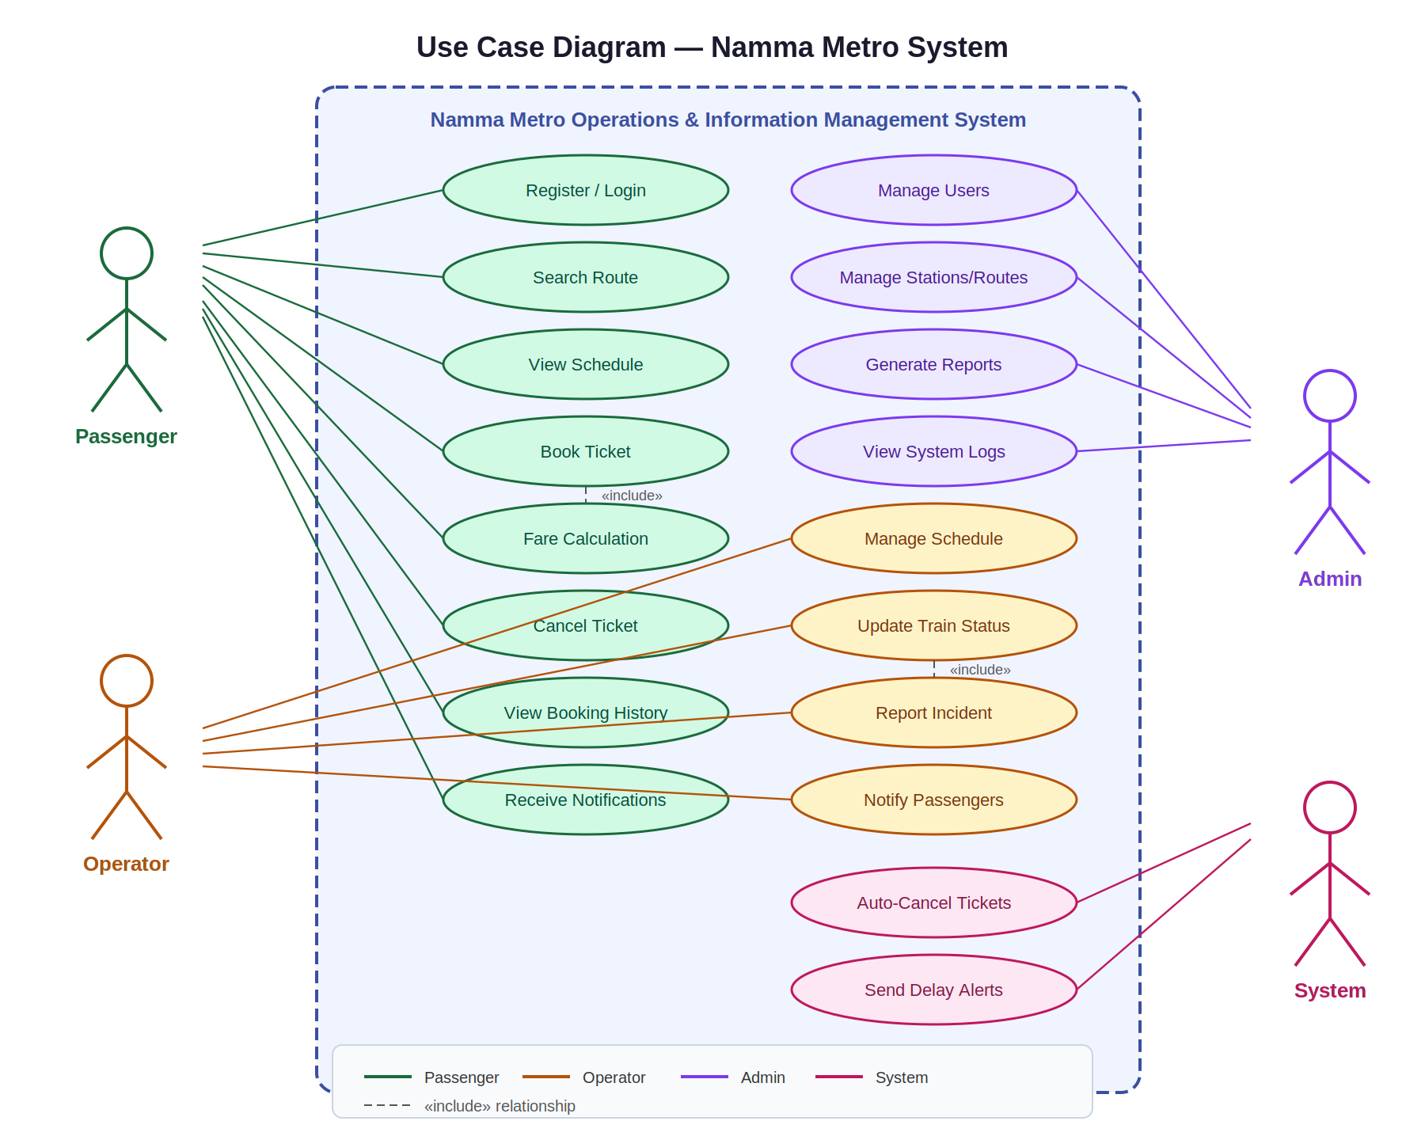

2. Class Diagram
Key classes and their relationships within the MVC model layer

Description
The class diagram illustrates the core model classes, their attributes, methods, and relationships:
• User (abstract) — base class extended by Passenger, Operator, and Admin. Implements the Factory Pattern via UserFactory.
• Passenger — holds bookings, has a metroCardHolder flag for fare discounts. Linked to many Tickets.
• Ticket — captures fare, QR code, booking time, and status (BOOKED → CONFIRMED → USED/CANCELLED/EXPIRED).
• Train — holds current TrainState (State Pattern interface). Publishes status changes to observers.
• Schedule — links a Train to a Route with departure/arrival times.
• Route — defines source, destination, and a list of intermediate Stations.
• Notification — created by the Observer pattern when train status changes.
• Incident — reported by operators, linked to a Train or Route, has severity and resolution status.

Class Diagram
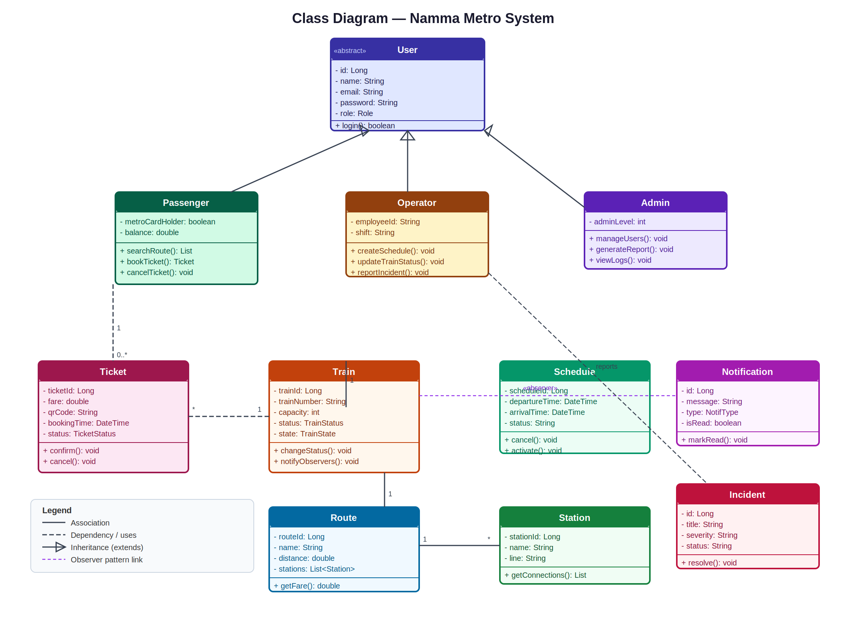

3. Activity Diagram — Ticket Booking Flow
Swimlanes: Passenger · System · Automated Service

Description
This activity diagram traces the full ticket booking workflow across three swimlanes:
Passenger lane (blue) — The user logs in, enters source and destination, selects a route and schedule, views the fare breakdown, and confirms the booking. They also have the option to cancel post-confirmation.
System lane (green) — Handles route search with a decision branch (routes found vs not found), fare calculation using the FareCalculationEngine (Base fare ₹10 + ₹5/km, 10% metro card discount), ticket creation with BOOKED status, and QR code generation (UUID-based).
Automated Service lane (orange) — After ticket creation, the service auto-confirms the ticket within 2 minutes, sends a booking confirmation notification (via Observer + Adapter patterns), and updates status to CONFIRMED. A separate scheduled task runs to expire outdated tickets.
Key decision points: route availability check, and post-view cancel option with refund calculation (100% if >1 hour before departure, 50% otherwise).

Activity Diagram
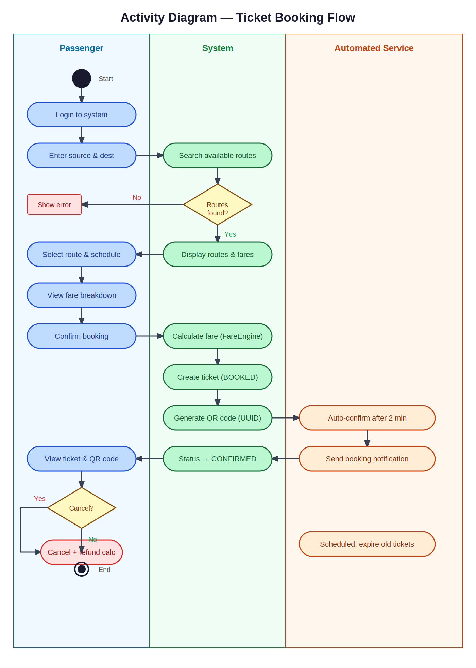

4. State Diagram — Train & Ticket States
Two parallel state machines: Train lifecycle and Ticket lifecycle

Train State Machine
Implemented using the State Pattern (Behavioral) — TrainState interface with concrete classes RunningState, DelayedState, CancelledState, MaintenanceState:
SCHEDULED — Initial state when a schedule is created.
RUNNING — Train departs on schedule. Can transition to DELAYED (incident) or CANCELLED (severe issue).
DELAYED — Service disrupted. Can recover back to RUNNING when incident is resolved.
CANCELLED — Service stopped. Triggers auto-cancellation of all associated confirmed tickets.
COMPLETED — Train successfully completes its trip. Terminal state.
MAINTENANCE — Operator manually pulls train out of service for repairs. Can be set from any state.
Ticket State Machine
Ticket status transitions enforced at the service layer with automated expiry via @Scheduled Spring tasks:
BOOKED → CONFIRMED: Auto-triggered after 2 minutes or on payment confirmation.
CONFIRMED → USED: Marked when journey is completed (future: QR scan integration).
CONFIRMED → CANCELLED: Passenger cancels; refund calculated by time-before-departure rules.
BOOKED / CONFIRMED → EXPIRED: Automated scheduler marks tickets past departure time as expired.

State Diagram
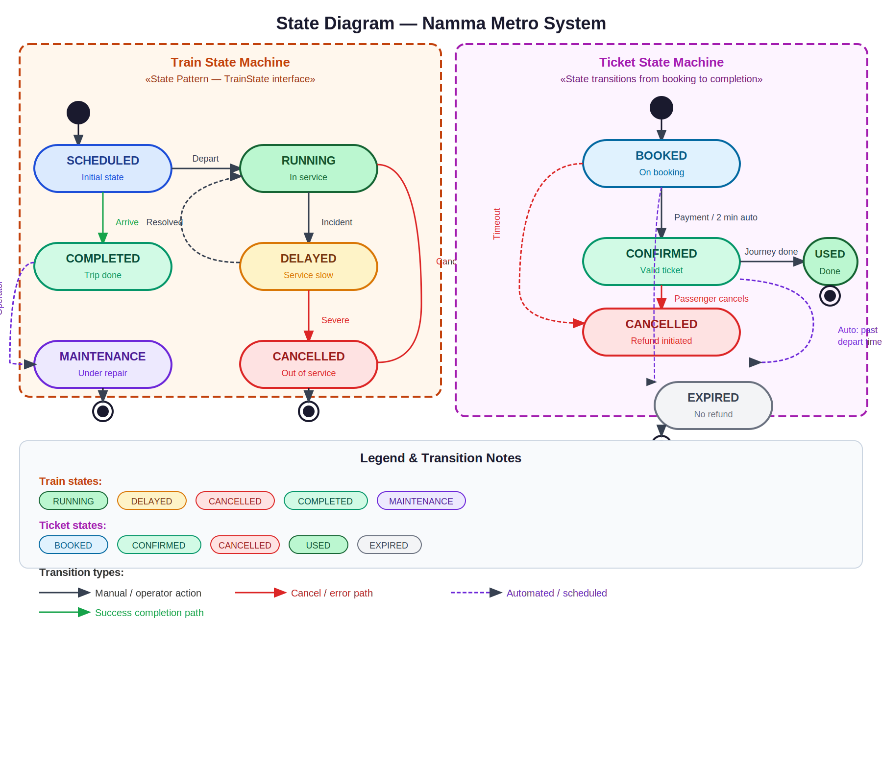

5. Design Patterns & Principles Summary

Design Patterns Implemented
Creational Patterns
Singleton Pattern — DatabaseManager class ensures only one database connection instance exists throughout the application lifecycle. Used in: config/DatabaseManager.java

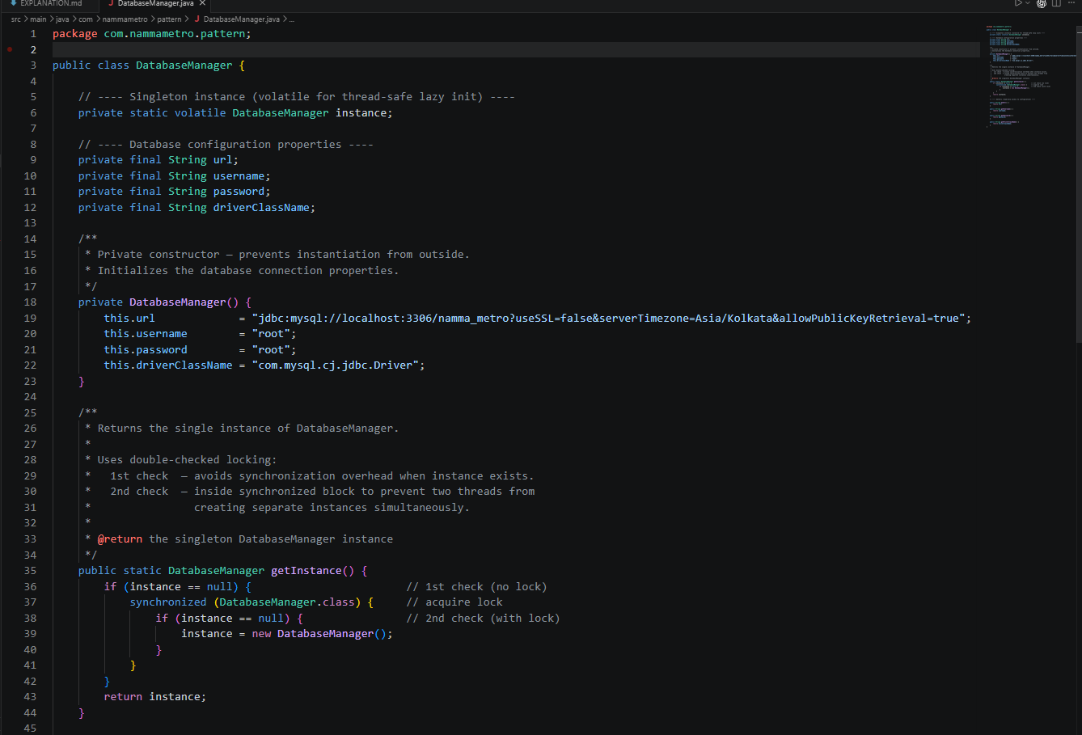

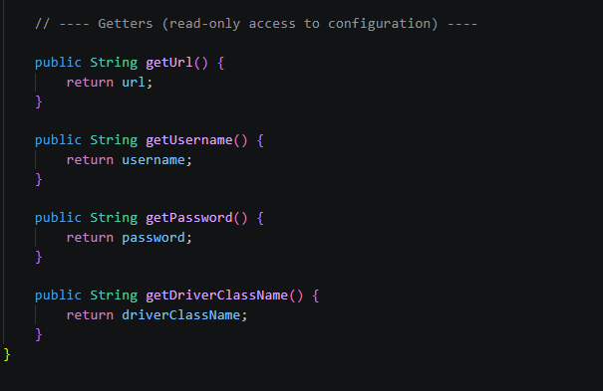
Factory Pattern — UserFactory.createUser(role) returns a Passenger, Operator, or Admin object based on the role enum. Eliminates conditional instantiation logic across the codebase. Used in: pattern/UserFactory.java
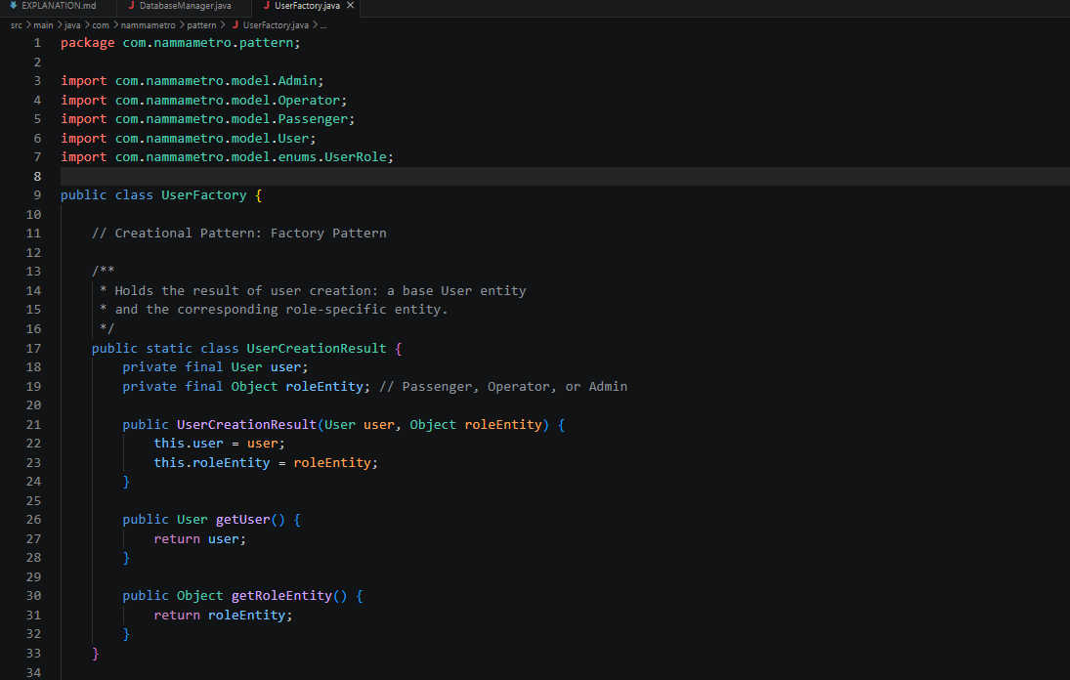
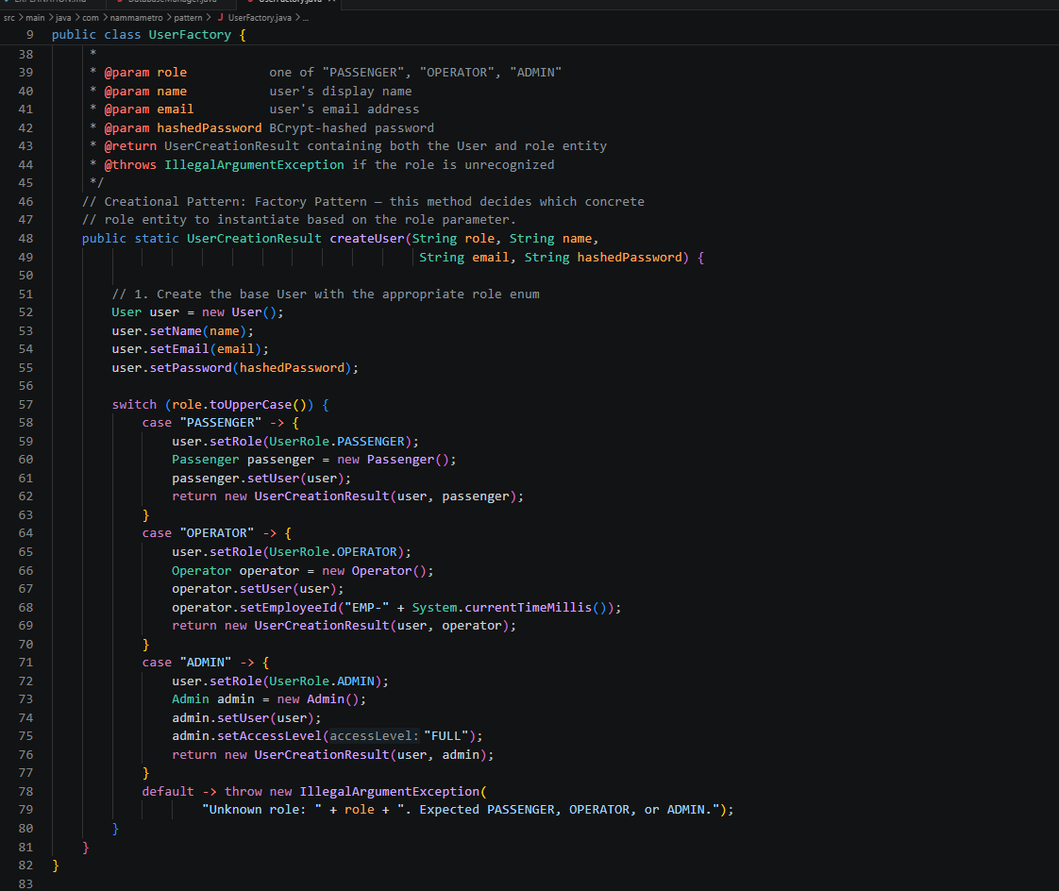
Structural Patterns
Adapter Pattern — NotificationSender interface is implemented by EmailNotificationAdapter, SMSNotificationAdapter, and AppNotificationAdapter. The NotificationService depends on the interface, not the concrete adapters — satisfying the Dependency Inversion Principle. Used in: pattern/adapter/

AppNotificationAdapter.java
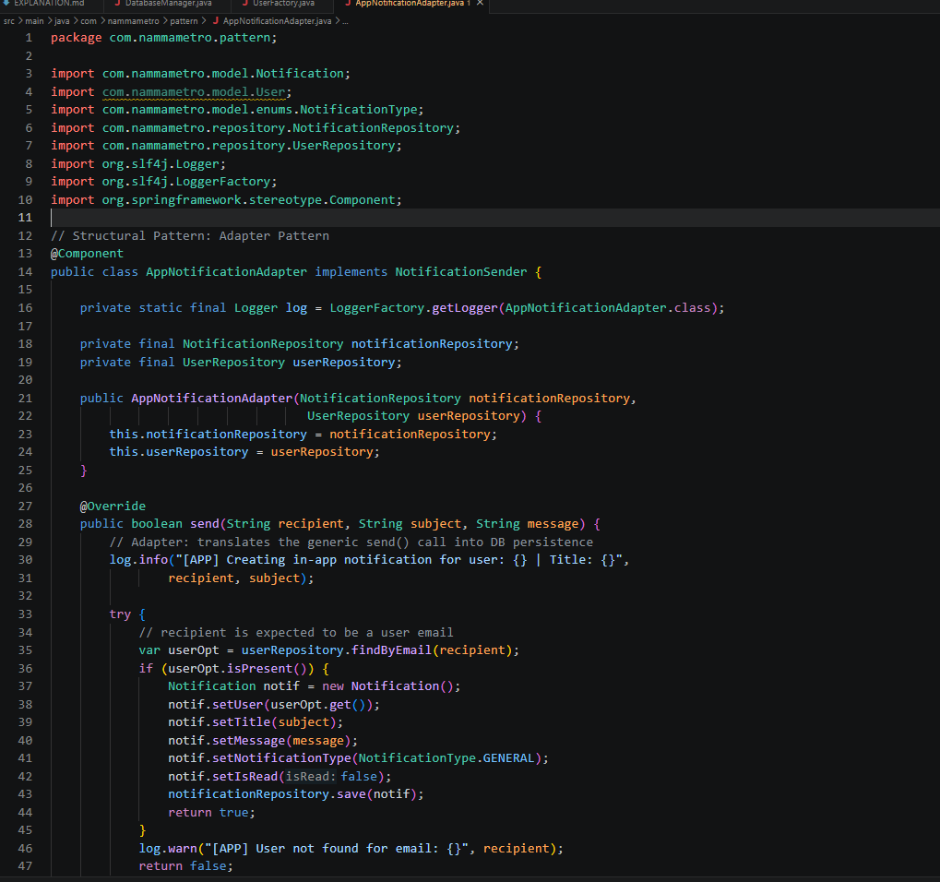

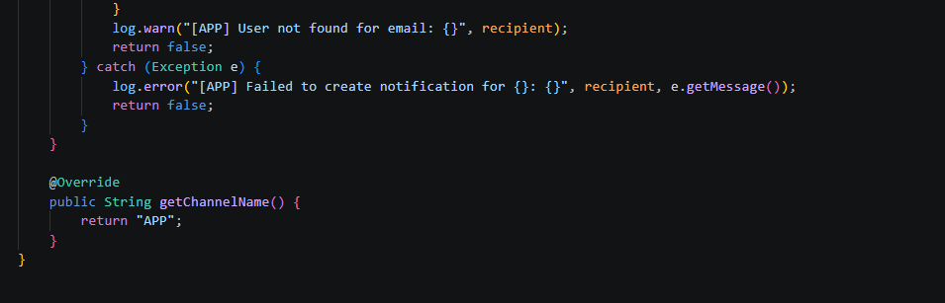

EmailNotificationAdapter.java
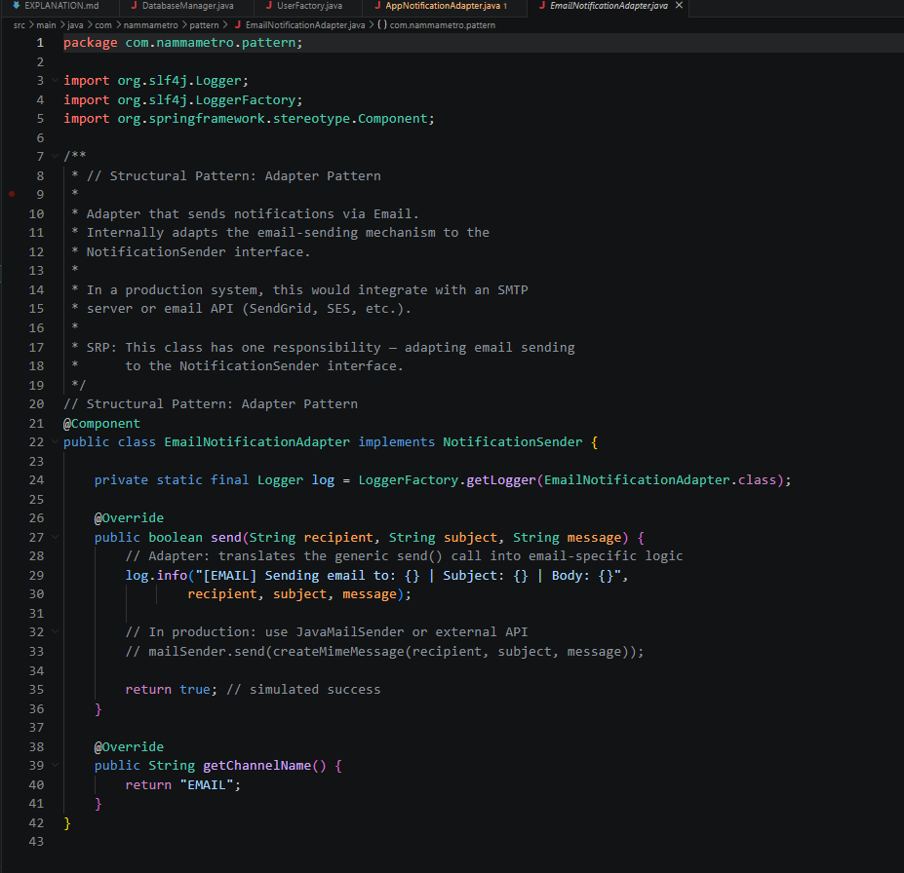

SMSNotificationAdapter.java
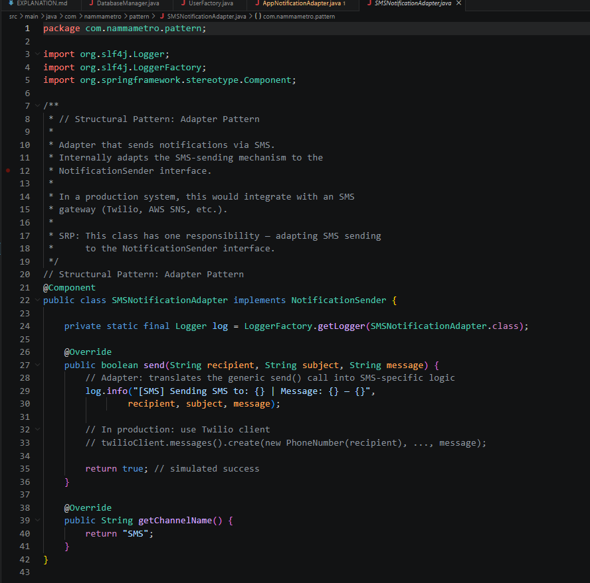

Behavioral Patterns
Observer Pattern — TrainStatusPublisher maintains a list of TrainStatusObserver instances. When train status changes, all observers are notified — PassengerNotificationObserver creates notifications for affected passengers, IncidentLogObserver logs the event. Used in: pattern/observer/

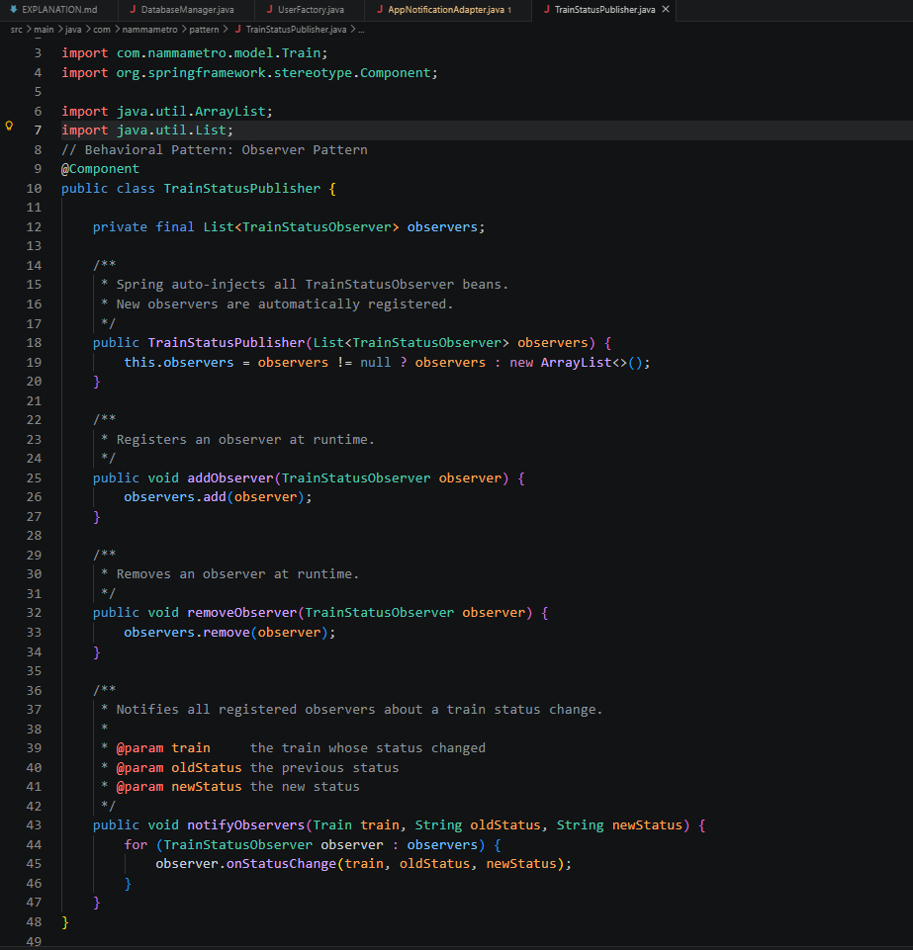
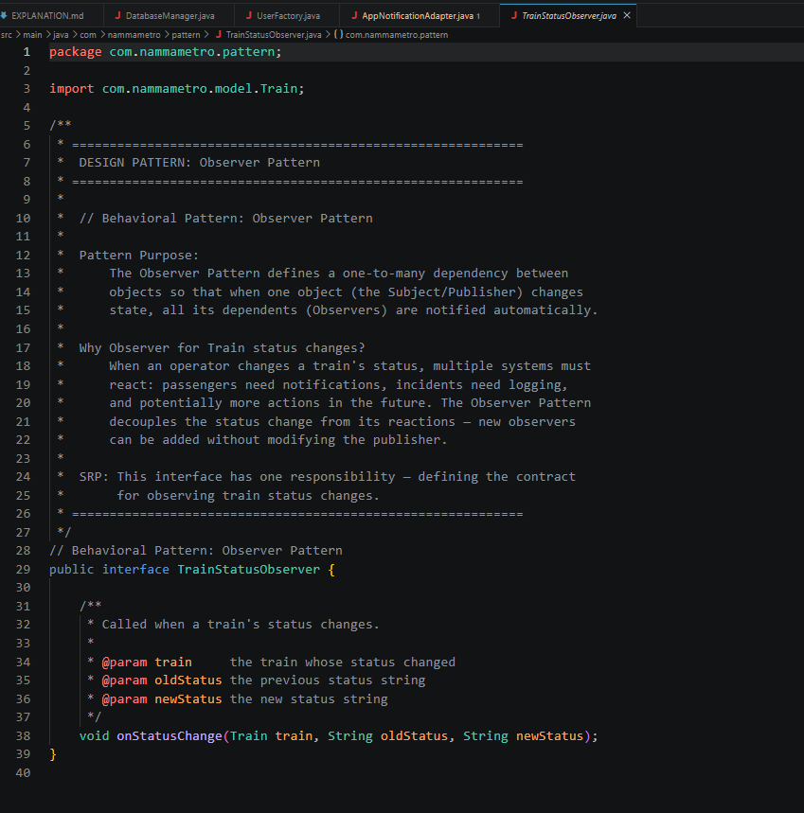
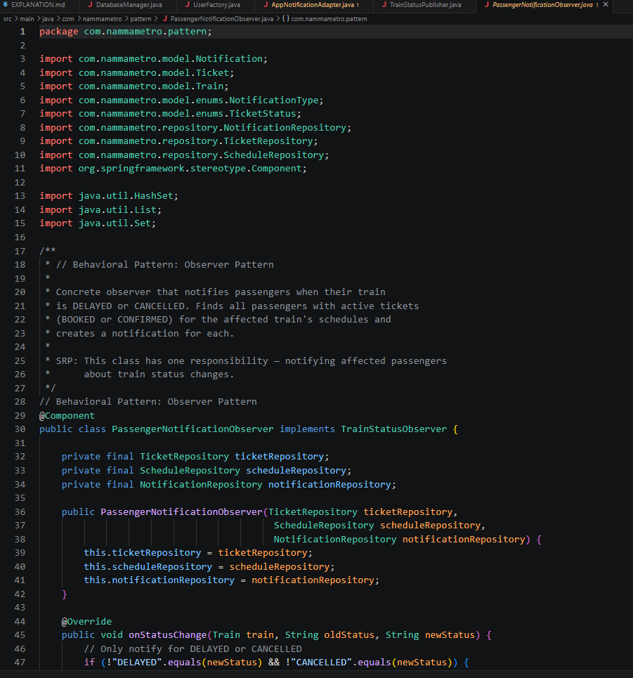

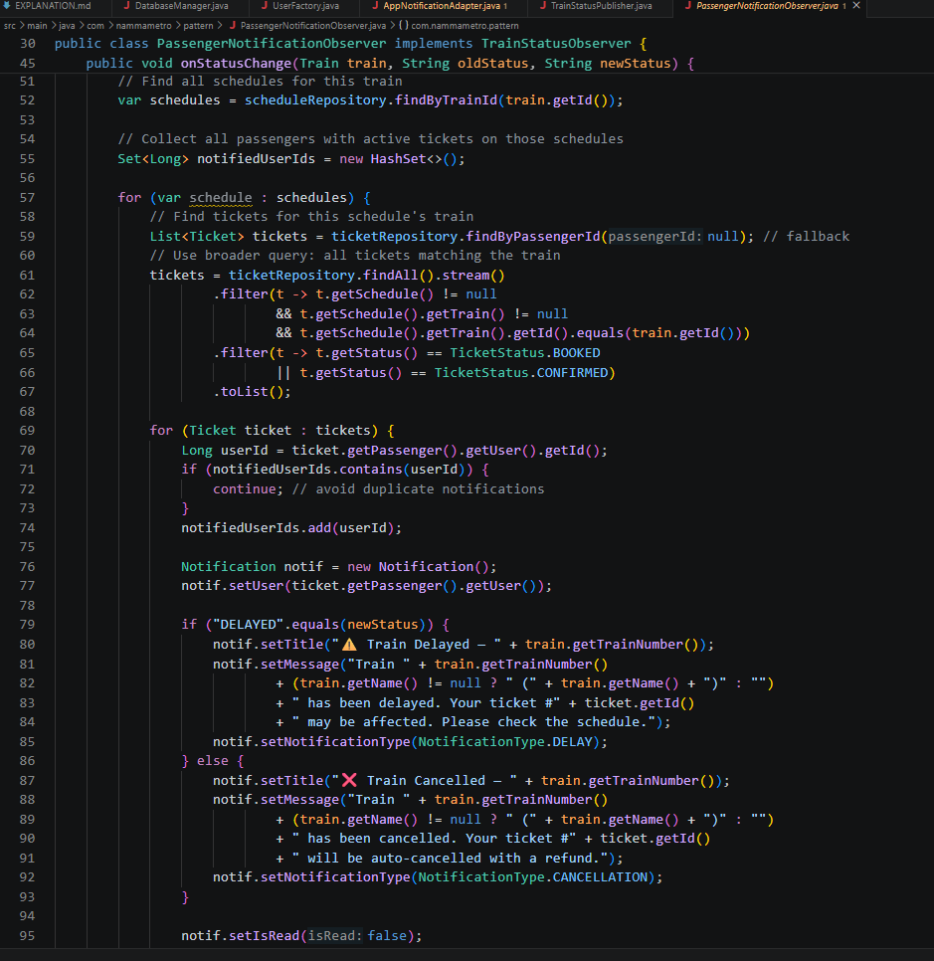

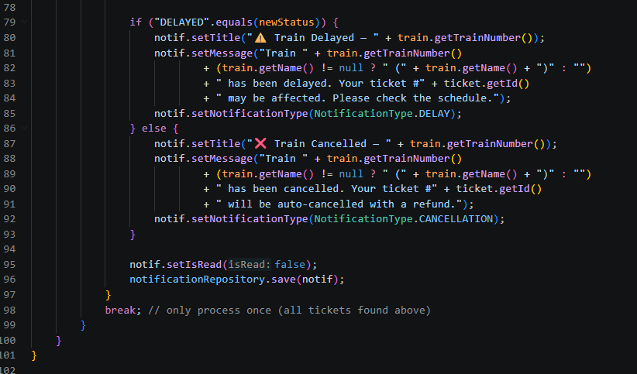

State Pattern — TrainState interface with concrete states: RunningState, DelayedState, CancelledState, MaintenanceState, CompletedState. The Train class delegates status behavior to the current state object. Used in: pattern/state/
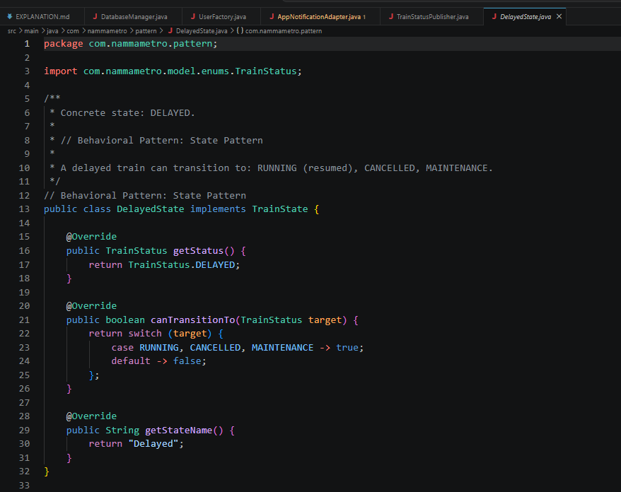

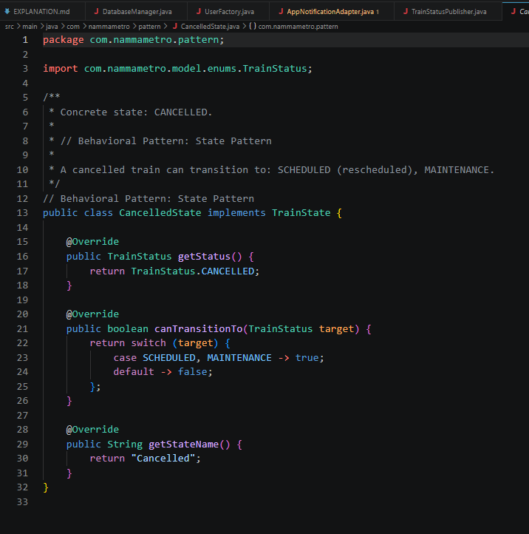

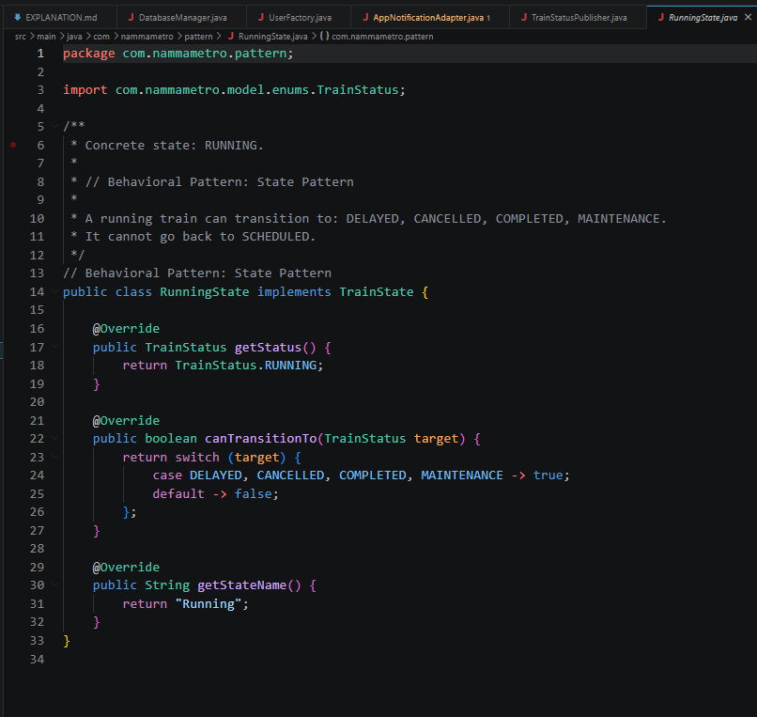

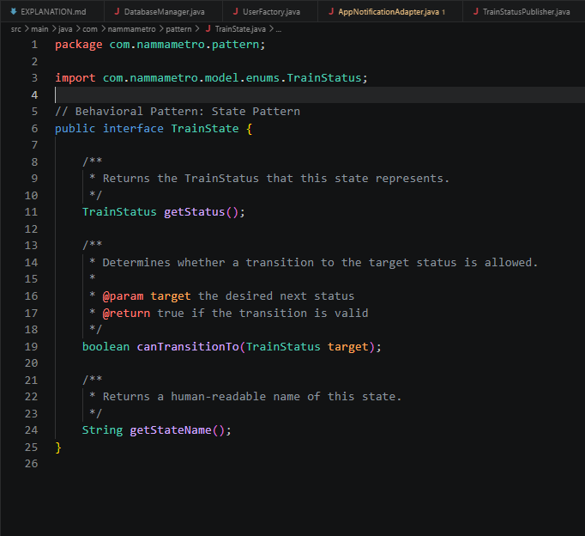

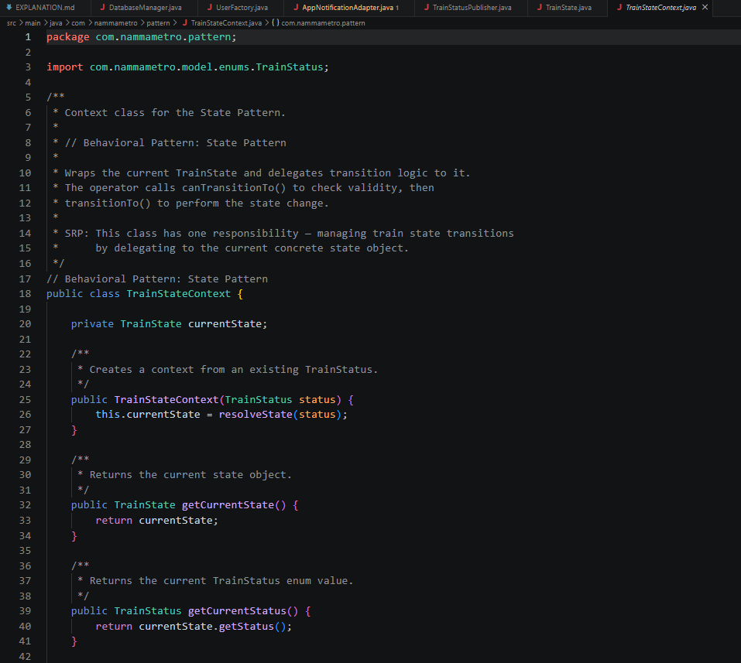

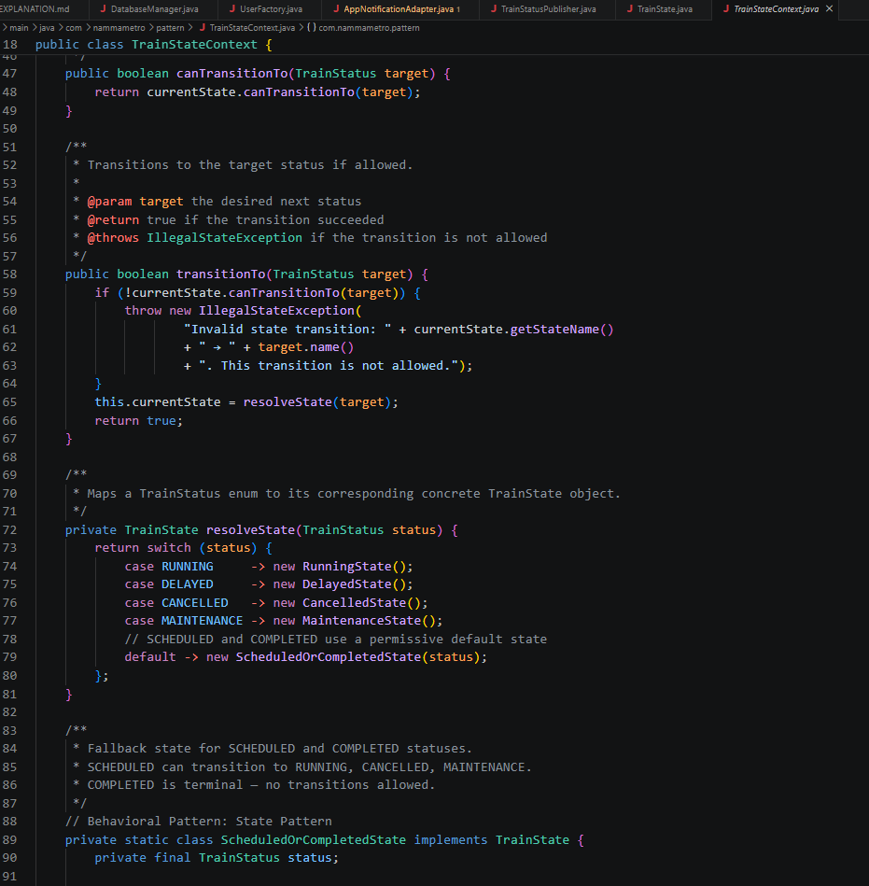

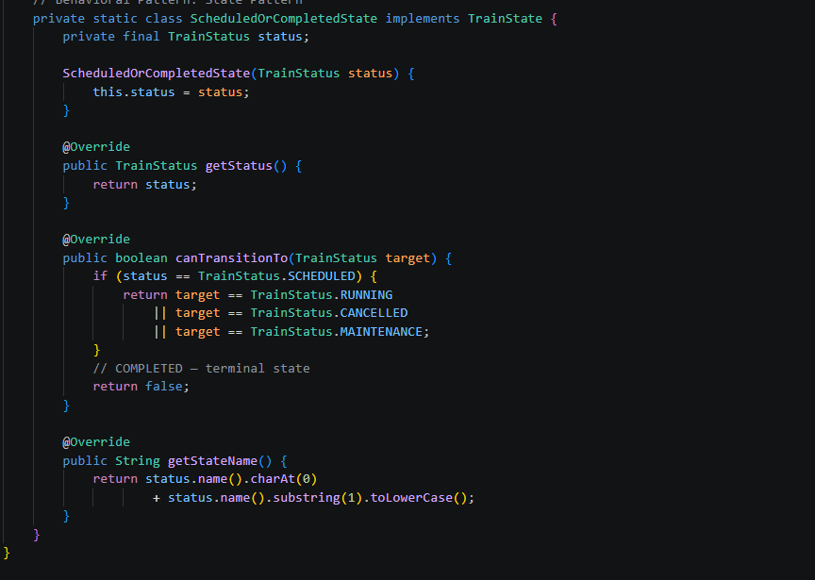

Design Principles Applied
Single Responsibility Principle (SRP) — Every class has exactly one reason to change. AuthController handles only auth routes. JwtUtil handles only token operations. FareCalculationEngine handles only fare logic. No class mixes concerns.
Open/Closed Principle (OCP) — The FareCalculationEngine is open for extension (add new discount rules by extending BaseDiscountRule) but closed for modification. New ticket types and fare rules are added without changing existing code.
Dependency Inversion Principle (DIP) — NotificationService depends on NotificationSender interface, not on EmailAdapter or SMSAdapter directly. All service classes depend on repository interfaces, not concrete JPA implementations.
Interface Segregation Principle (ISP) — Three separate service interfaces: PassengerService (bookTicket, cancelTicket, searchRoute), OperatorService (createSchedule, updateStatus, reportIncident), AdminService (manageUsers, generateReport, viewLogs). No class is forced to implement methods it doesn't use.

