**Report - Mumbai Neighborhood Analysis**

**Table of Contents**

1. Summary

2. Introduction

3. Research methodology

4. Results

5. Conclusion

6. Acknowledgement

7. Reference

**1. Summary**

The main objective of this project is to locate and analyze various neighborhoods in the metropolitan city of Mumbai, India.

There has been a consistent influx of people to the city for various purposes. This project would help them get a quick overview of different locales in the city, thus helping them decide on their own to choose the best location based on the facilities available around these locales.

**2. Introduction**

Mumbai is a highly dense metropolitan city in Central-Western India inhabiting people from different parts of the country as well as the world. It is the financial capital of the country. Thousands of tourists from across the globe visit the city every year, pertaining to its rich cultural heritage and iconic monuments. The city is home to the famous Gateway of India near the iconic Taj Mahal Palace hotel, the duo being the face of the city for many decades now. It is also famous as the hub of Bollywood-the mainstream film industry in the country.

It is a city of ample opportunities in terms of jobs, business, cinema, etc. All these make it a 'dream city' for many and for a reason is nicknamed 'The City of Dreams'.

There has been a consistent influx of people to the city. The population in Mumbai is so diverse that different people have entirely different interests and needs. It has people belonging to all the sections of the society ranging from high-class to middle-class to even people without the basic necessities and dwell in the biggest of slums. Surprisingly, it is also home to one of the largest slums in the world.

Given the span of the city and diversity it hosts, it is a cumbersome task for anyone who visits the city to figure out which place to visit, according to his or her preferences.

This project aims at answering the very keen question literally anyone visiting the city will have - Where to go about in Mumbai??

**3. Research Methodology**

**Data Resources**

1. Wikipedia

2. Foursquare.com

**Data Collection**

The data requirement for the project:

1. Data pertaining to the neighborhoods in the city: This data is collected from Wikipedia (https://en.wikipedia.org/wiki/List_of_neighbourhoods_in_Mumbai) through web- scraping using the python library 'BeautifulSoup'.

2. Geospatial data of various venues in different neighborhoods: The geospatial data is leveraged from 'Foursquare.com' using the foursquare API.

**Data Pre-processing**

Raw data was processed such that each neighborhood was reduced to its top ten venues, and clustering was done based on the same.

**Modelling**

K-means Clustering, which is a type of unsupervised machine learning, was used to cluster various neighborhoods based on the similarity of venues they housed.

All the neighborhoods in the city were clustered into five clusters and further mapped with distinct colors using the folium library, for better visualization.

**4. Results**

The neighborhoods of Mumbai were finally clustered into five clusters, with each cluster different from the other in terms of the venues around. The neighborhoods within the same cluster had more or less similar venues.

Three of the five clusters had only one neighborhood, whereas the remaining two contained the rest.

**5. Discussion**

Cluster 1 contained 37 neighborhoods with Indian restaurant being the dominant most common venue in its neighborhoods.

Cluster 2,3, and 4 contained one neighborhood each with ATM, shopping store and garden being the most common venues, respectively.

Cluster 5 contained the most with 46 neighborhoods. However, there was no one dominant most common venue, considering all the neighborhoods within the cluster.

**6. Conclusion**

It can be concluded that there are five different kinds of neighborhood in Mumbai based on the venues they housed.

Each cluster of neighborhoods is highlighted in distinctive color for easy understanding.

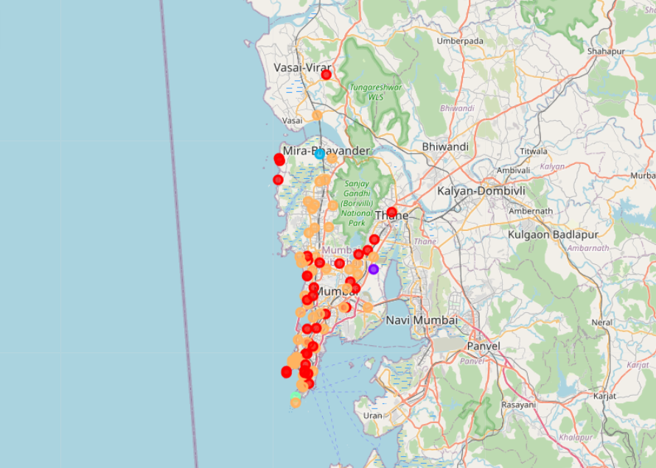

**7. Acknowledgement**

I would like to acknowledge the efforts of the Coursera team in providing all the essential knowledge in the form of videos, hands-on labs, study material, etc. to complete this project.

**8. References**

1. Wikipedia

2. YouTube

3. Stack overflow