**Project Name: - DrugCart** (like 1mg)

**Introduction:**

DrugCart is an Online Medicines Shopping Web-site, where a customer can purchase a Medicines at lower price, better selection.

**Order medicines online**

Get free medicine home delivery in over 1800 cities across India. You can also order Ayurvedic, Homeopathic and other Over-The-Counter (OTC) health products. Your safety is our top priority. All products displayed on Tata 1mg are procured from verified and licensed pharmacies.

**Book lab tests**

Book any lab tests and preventive health packages from certified labs and get tested from the comfort of your home. Enjoy free home sample collection, view reports online and consult a doctor online for free.

**Consult a doctor online**

Got a health query? Consult doctors online from the comfort of your home for free. Chat privately with our registered medical specialists to connect directly with verified doctors. Your privacy is guaranteed.

**Pages: -**

1. Home Page

2. Listing Page

3. Product Detail Page

4. Sign in Page

5. Sign Up Page

6. Add to Cart Page & delete from cart

7. Payment Page

8. Footer: About us, contact us, Follow us etc.

**Demo of project:**

**Home Page-**

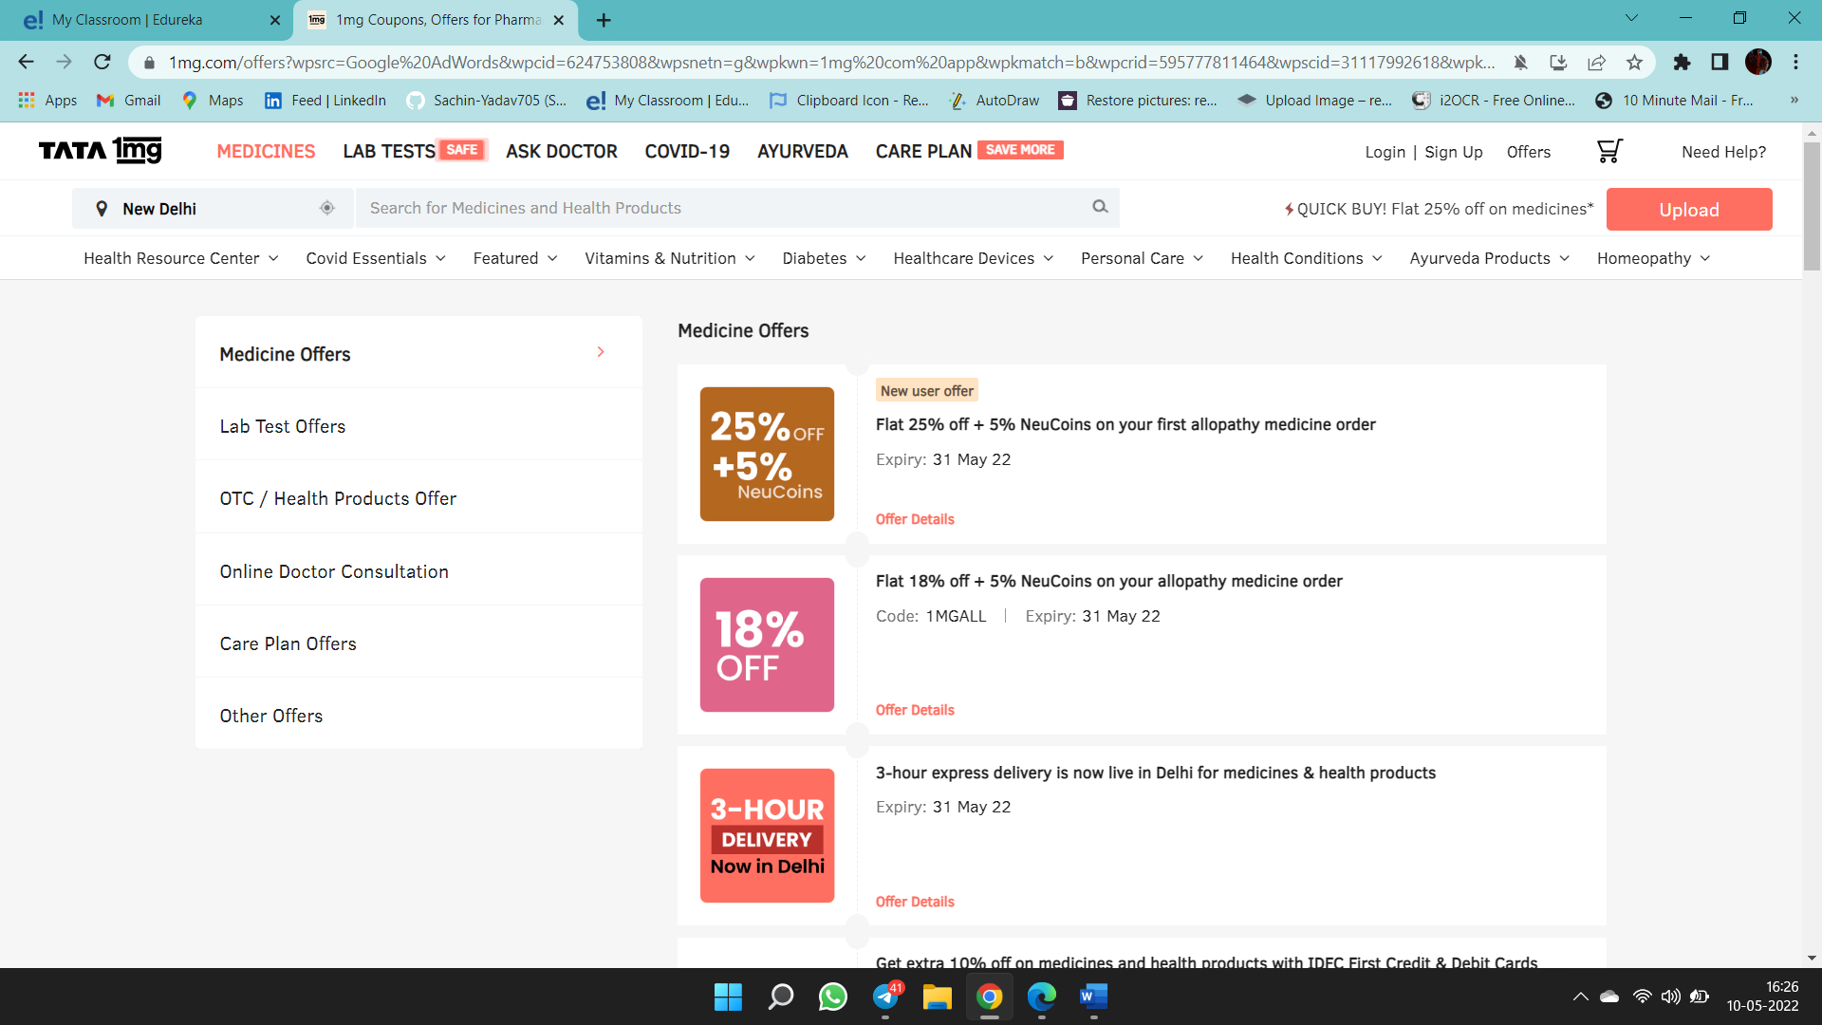

**Login Page-**

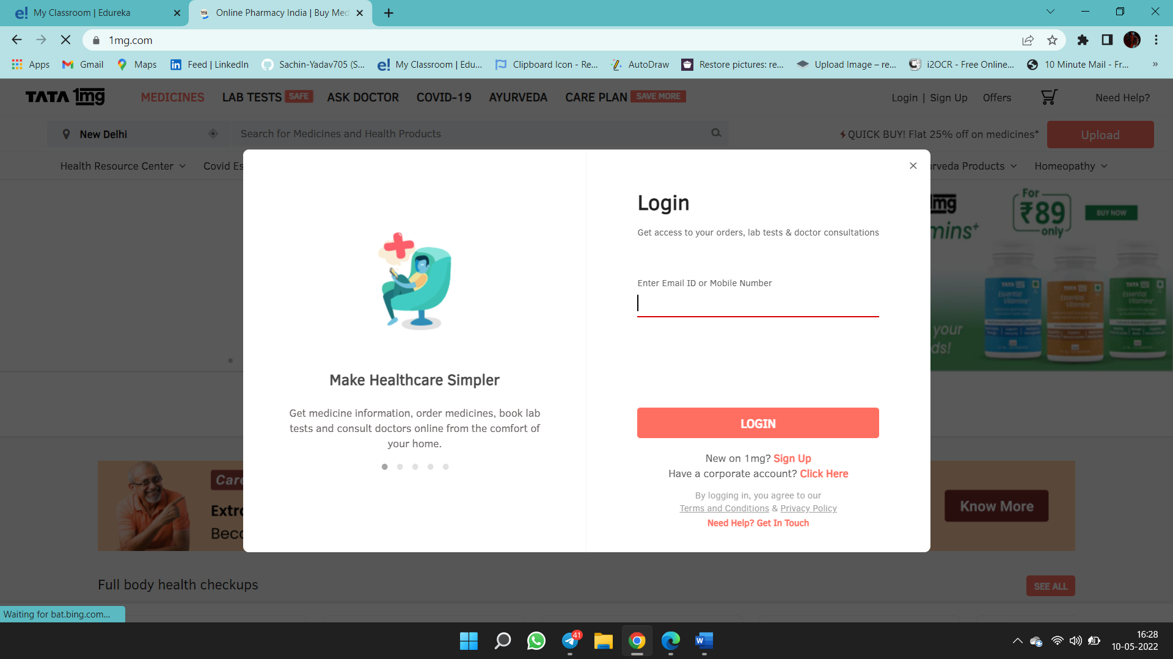

**Technologies to be use**

**Frontend:**

* HTML
* CSS
* Bootstrap
* Reactjs

**Backend:**

* Nodejs, Expressjs
* Json web tokens

**Database:**

* mongo DB

**version-controller:**

* GITHUB

**Text-editor:**

* Visual-studio code