**Unit-Test cases for the Rest-Api.**

**Test Case:1**

**Zookeper Started**

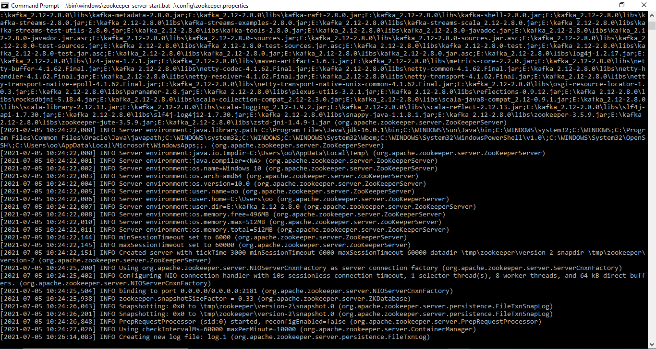

**Test Case:2**

**Kafka started**

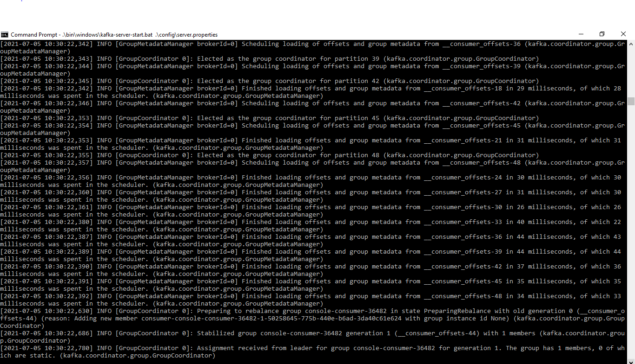

**Test Case:3**

**Topic Created**

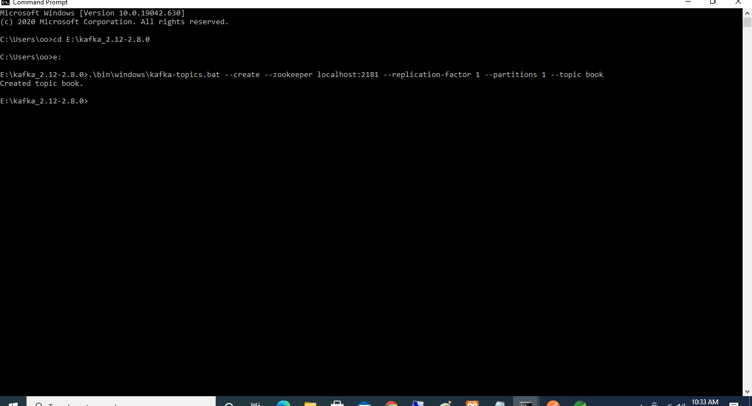

**Test Case:4**

**Welcome Page Response while hitting Api**

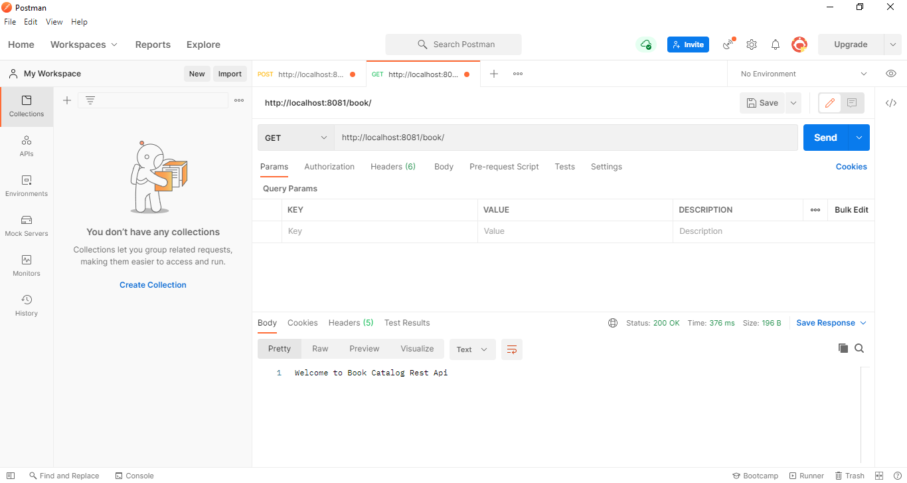

**Test Case:5**

**Step:1**

**Hitting Add Api with success message with all the parameter(Post Method)**

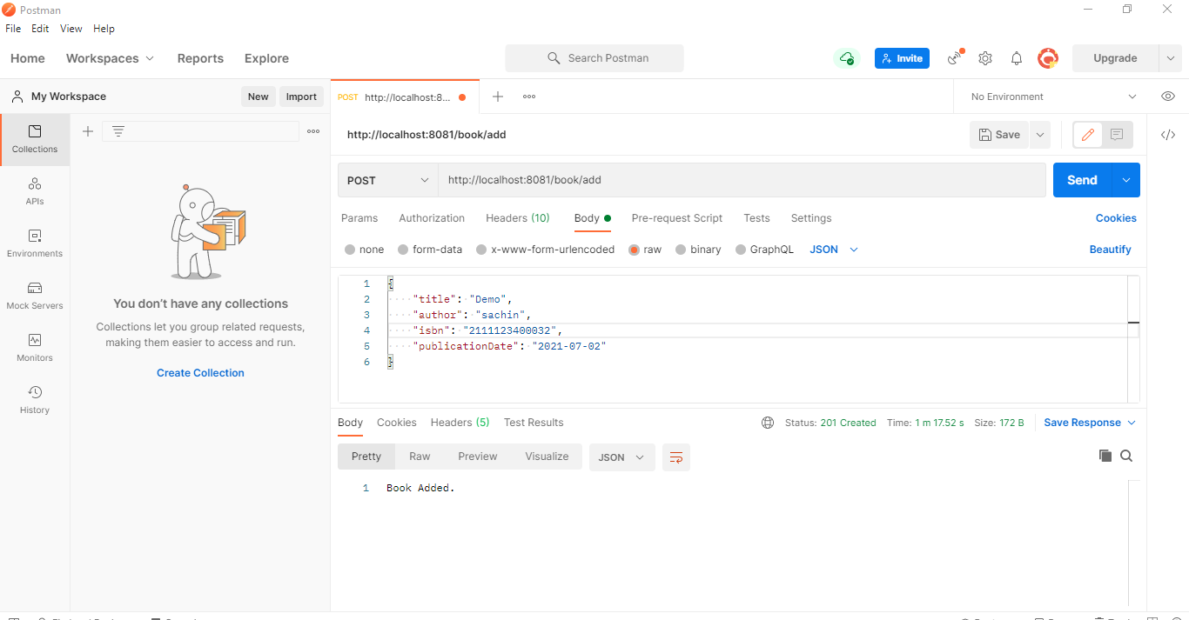

**Step:2**

**Add-Api Console Page**

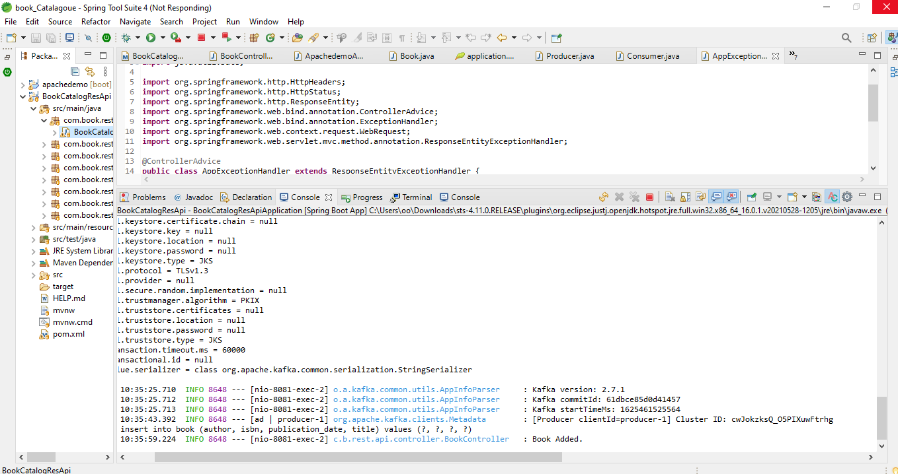

**Step:3**

**Hitting Add Api in Postman with optional parameter (Post Method)**

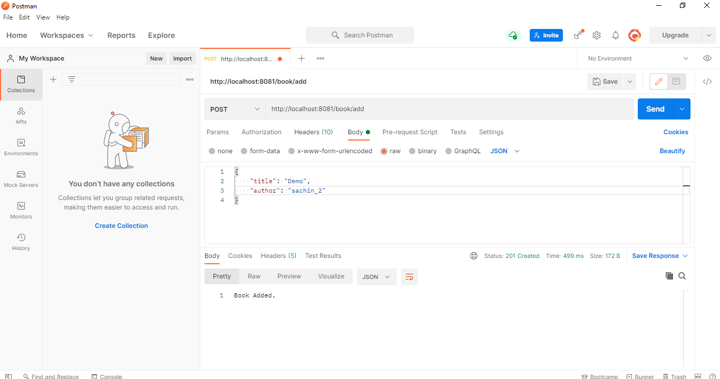

**Step:3**

**Getting Kafka topic message while adding a new data in db**

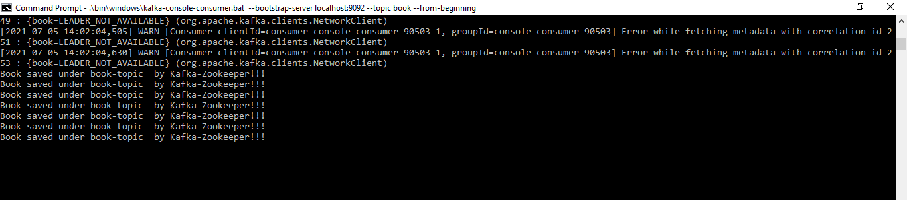

**Test Case:6**

**Step:1**

**Update Api with the Key_id in Postman (Put Method)**

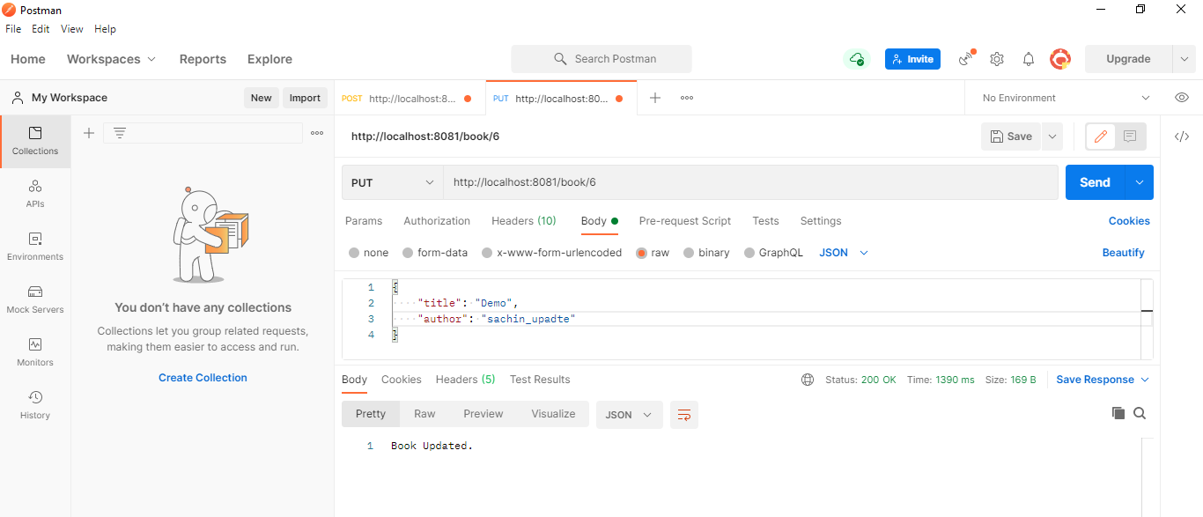

**Step:2**

**Data in the Table while hitting Update Api w.r.t Postman**

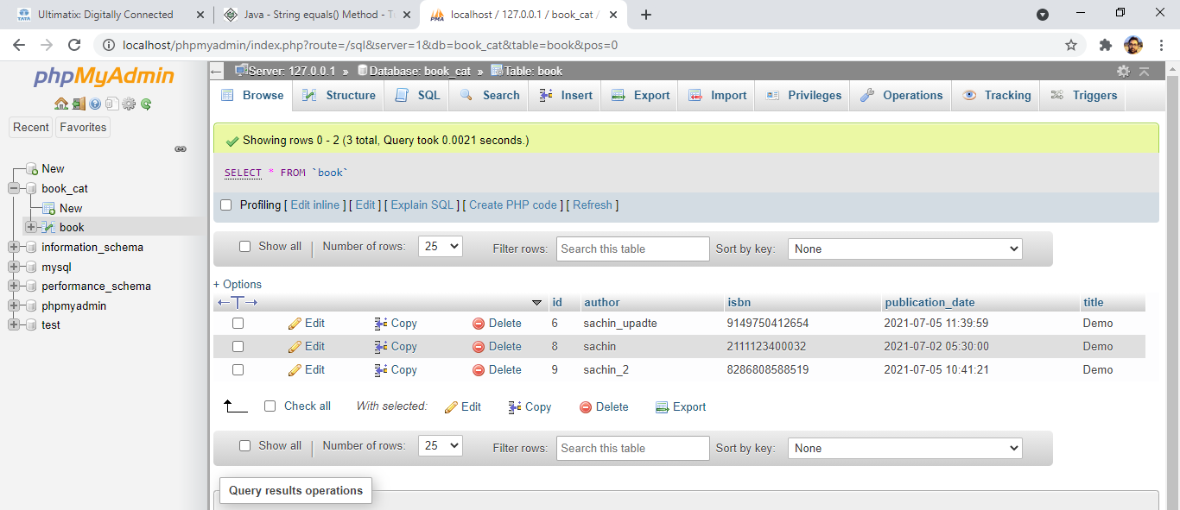

**Step :3**

**Bad Request Response when no Key_ID is passed via Postman(Put Method)**

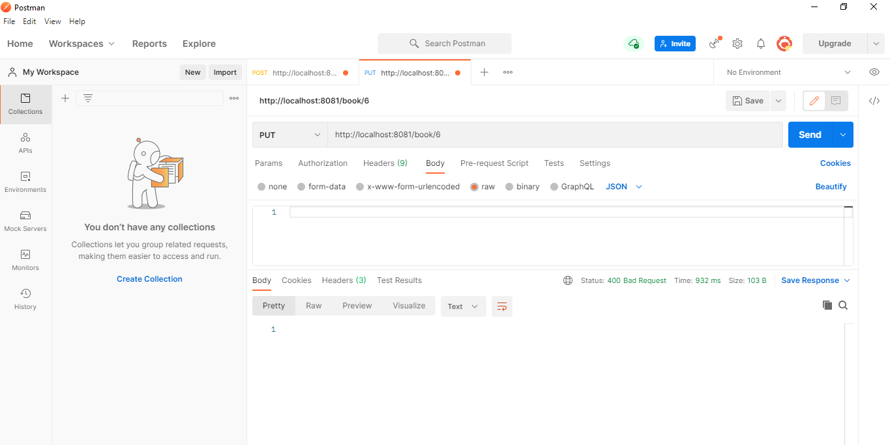

**Test Case:7**

**Step:1**

**Delete Api with Key_ID in Postman(Delete Method)**

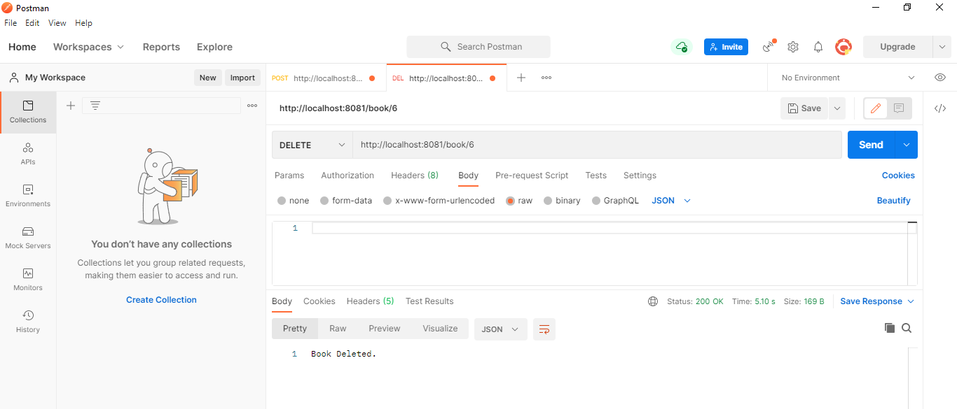

**Step:2 Delete Api without Key_ID in Postman(Delete Method)**

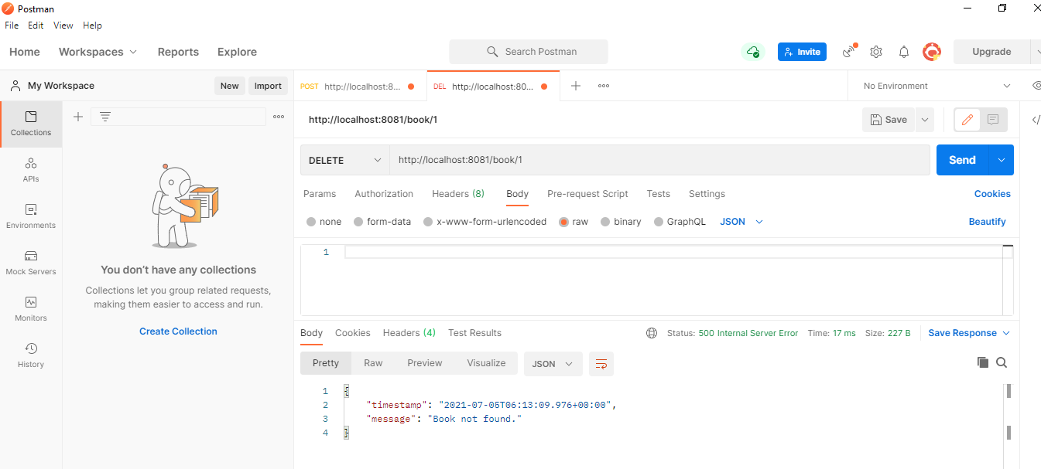

**Step:3**

**Data in the Table w.r.t Delete-Api**

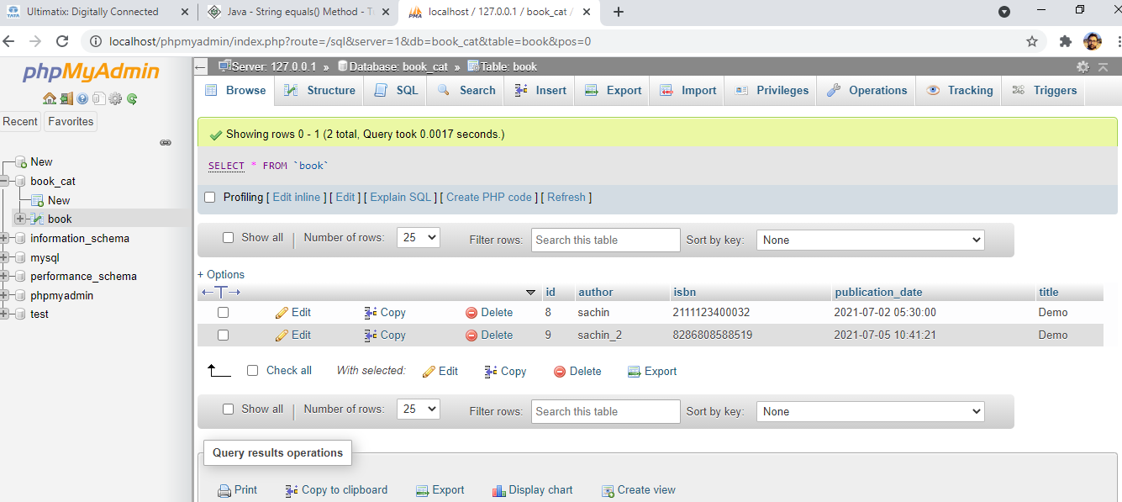

**Test Case:8**

**Step:1**

**List of all book Api in the postman (Get Method)**

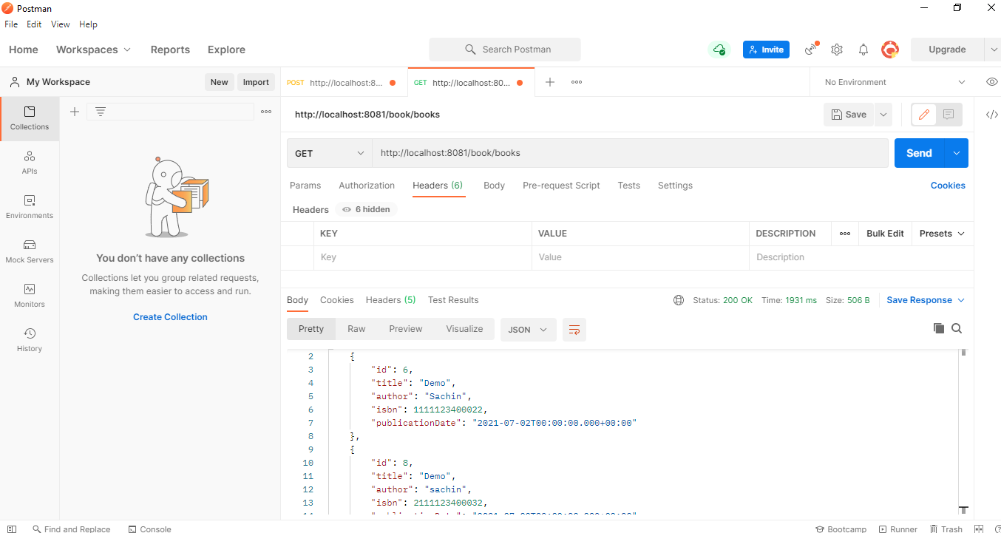

**Step:2**

**List-Api when no record found message in postman**

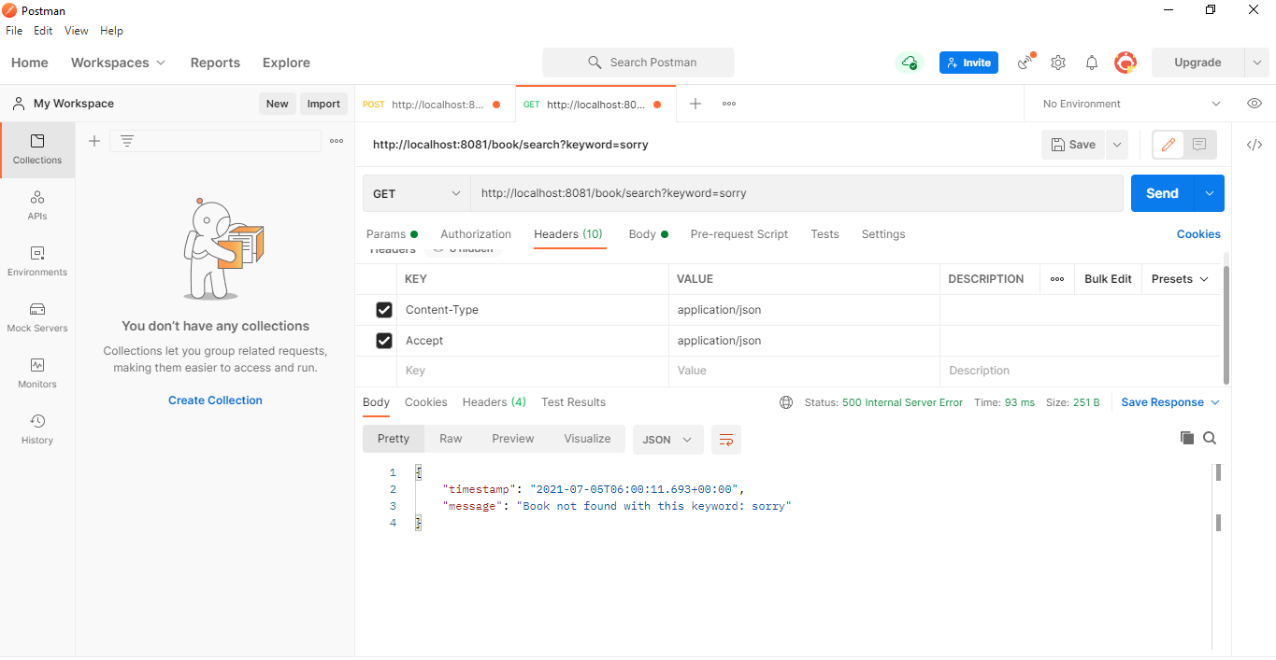

**Step:3**

**List of all the books with search filter on the three column with one keyword (Get Method)**

**In below, screenshot 1 gives the output with ISBN ID and screenshot 2 gives the output with author_title**

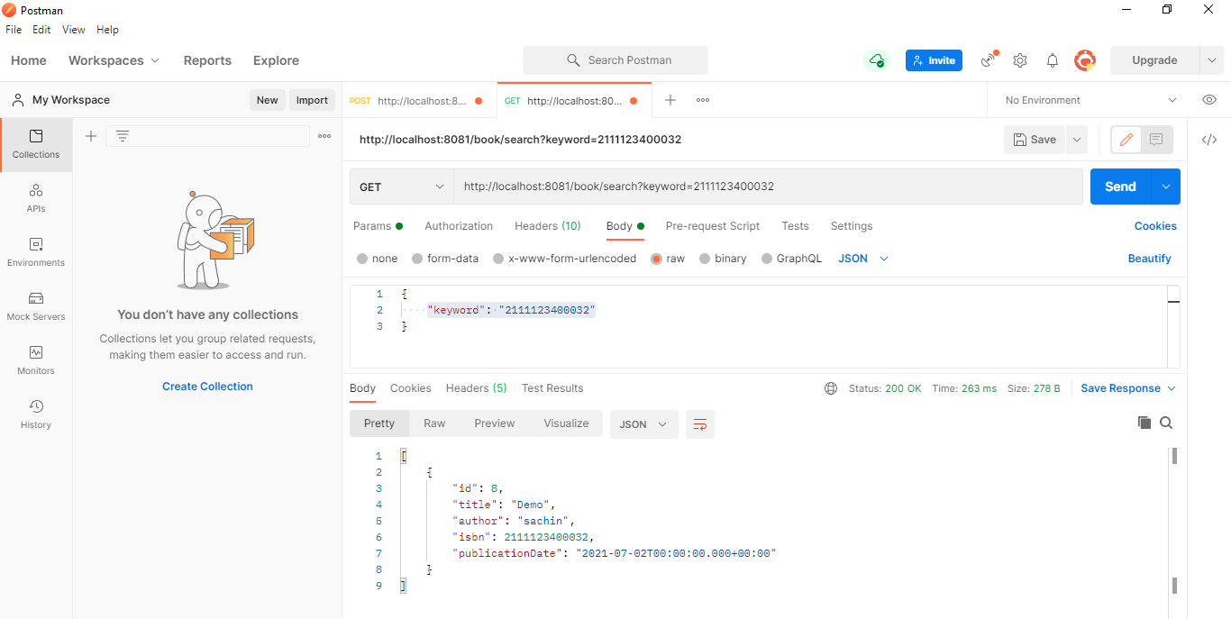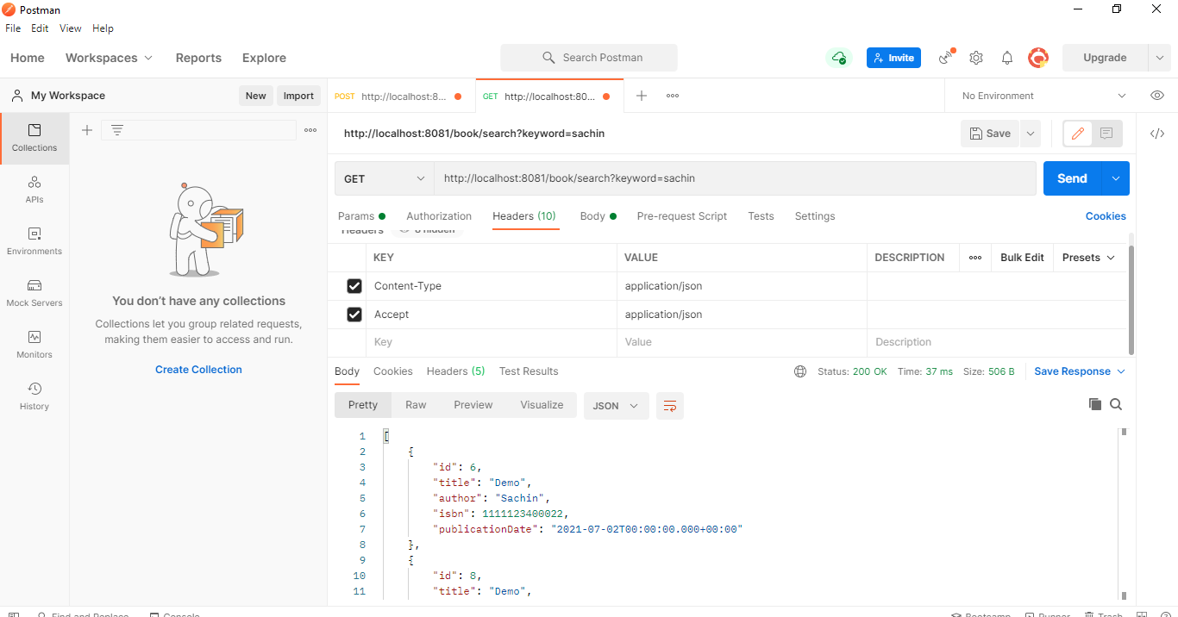

**Test Case:9**

**Step:1**

**Path Variable in Get Method w.r.t the Book_Id**

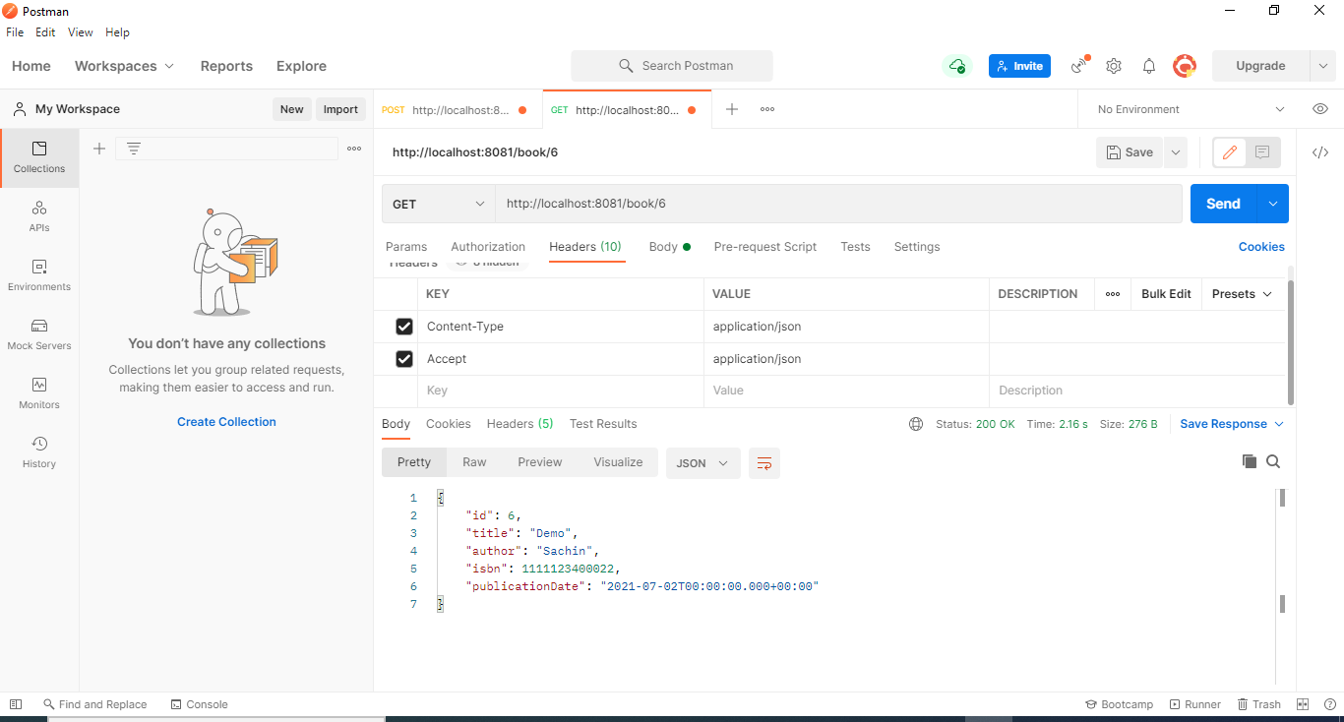

**Test Case:10**

**When the Url is Invalid on the server**

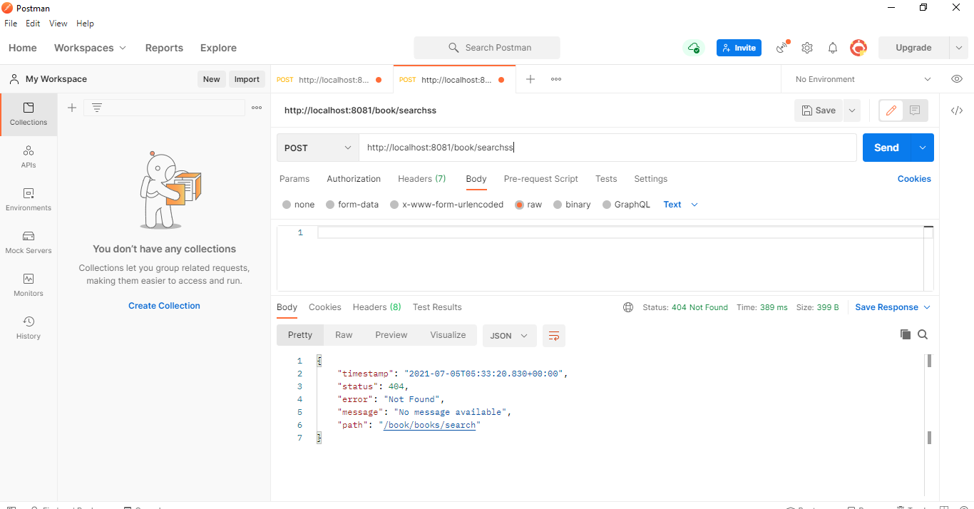

**Test Case: 11**

**Content-Type invalid exception by spring boot controlleradvice**

