Crowd Pressure Waves and Real-Time Measurement of

Stampede Dynamics Using a Low-Cost Sensing System
Data Analysis Report
Project 2 (Omotec) — Krishiv Kedia

1. Project Overview
This project uses a physical analogue — hundreds of packed plastic balls (10 mm and 13 mm sizes) standing in for a densely packed crowd — to safely study how force builds up and redistributes in dense crowds, and what role obstacles play in triggering dangerous conditions. A 6-sensor force rig (Back/Middle/Front rows, Left/Right) measures force at 8 Hz under the packed balls, for 48 different experimental configurations, each repeated 10 times.
Research objectives (from the original proposal):
- Understand how crowd density affects the build-up of pressure between people.
- Develop a mathematical model explaining how pressure waves form and move through a crowd.
- Build a low-cost sensor device to measure pressure changes and detect wave-like behaviour.
- Test the model using experiments and compare results with real sensor data.
- Identify the conditions under which crowd pressure becomes dangerous and can lead to stampedes.

2. Data Used
All data lives in data_logging_final/: an INDEX.csv design table describing 48 experimental setups ('versions', V1-V48), and 480 trial recordings (v{version}t{trial}.csv, 10 trials per version).
Property | Value
Total trials | 480 (48 versions x 10 trials)
Sensors per trial | 6 (Back/Middle/Front, each Left/Right) + Total
Sampling rate | 8 Hz (125 ms)
Trial duration | 30 seconds
Samples per trial | 240
No-obstacle versions | V1-V12: sweep total_balls (300-600) x ball-size ratio (equal/1:3/3:1)
Obstacle versions | V13-V48: fixed density, full factorial obstacle_shape(2) x size(3) x angle(3) x position(2)
Obstacle design | 36 configurations x 10 trials = 360 trials

3. Methodology — Steps Performed
Step 0 — Environment setup
Python virtual environment; pandas, numpy, scipy, matplotlib, seaborn, pyarrow, statsmodels.
Step 1 — Load & validate
Merged all 480 trial files with INDEX.csv metadata. Verified Total_N exactly equals the sum of the 6 sensors (0.0000 N max deviation), and that resting force matches theoretical expected weight almost perfectly (measured = 0.999 x expected, R^2 = 0.9998).
Step 2 — Investigate an unexpected universal drift
Every one of the 480 trials showed a consistent downward drift in total force. Tested and ruled out: random noise (100% of trials negative, not chance), simple settling-to-equilibrium (drift ACCELERATES rather than flattens, confirmed via early-vs-late slope paired t-test and via degenerate exponential-fit tau values), and a session/instrument warm-up artifact (no correlation with within-version trial order, p=0.56). Best-supported explanation: continued physical rearrangement of the packing, stronger in denser/obstacle-disturbed setups.
Step 3 — Feature engineering
Converted each 240-sample trial into ~30 summary features (baseline force, drift rate, detrended fluctuation, L-R asymmetry, front-back gradient). An initial 'wave lag' cross-correlation method (searching for a delayed-copy relationship between sensor rows) was rigorously tested and found to never reliably detect anything, even in obstacle trials. This was replaced with a 'redistribution strength' feature (plain correlation between raw row signals), which detected a strong, real anti-phase relationship: force shifts from one row to another as the packing settles, rather than a pulse arriving late.
Step 4 — Density -> pressure relationship (V1-V12)
Tested whether density alone (without an obstacle) destabilizes the packing. See Results section 4.4 for the full, reconciled account of this step, which included an initial exploratory pass and a more rigorous per-trial statistical follow-up.
Step 5 — Obstacle factor analysis (V13-V48)
Factorial ANOVA across obstacle shape/size/angle/position on three candidate 'danger' outcomes.
Step 6 — Model validation
Power spectral density check for a literal oscillating wave; exponential relaxation model fit per sensor row.
Step 7 — Statistical rigor pass
Bootstrap confidence intervals on headline claims; Tukey HSD (multiple-comparison corrected) post-hoc tests on obstacle angle and on all 36 individual versions.

4. Results

4.1 Data Quality & Calibration
The sensor rig is well calibrated and trustworthy: across all 480 trials, measured resting force = 0.9991 x expected theoretical weight + 0.02 N (R^2 = 0.99976, mean error -0.034% +/- 0.252%).
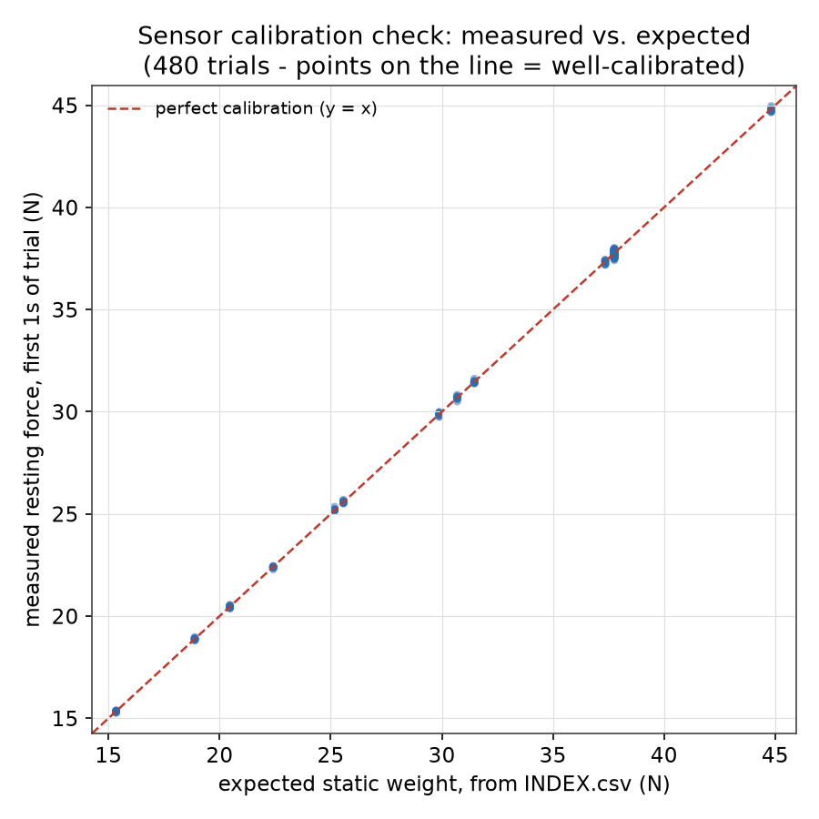
Figure 1. Measured vs. expected static weight, all 480 trials.

4.2 The Universal Drift Finding
100% of all 480 trials show a negative drift in total force (mean ~-0.029 N/s). Early-window vs. late-window slope comparison (paired t-test, n=480) showed the drift significantly ACCELERATES rather than flattens (t=19.30, p=7.8e-62) -- ruling out simple settling-to-equilibrium. Drift magnitude correlates weakly with version number (r=-0.168, R^2=0.028) but not at all with within-version trial order (r=-0.027, p=0.56), pointing to a physical rather than session-timing cause.
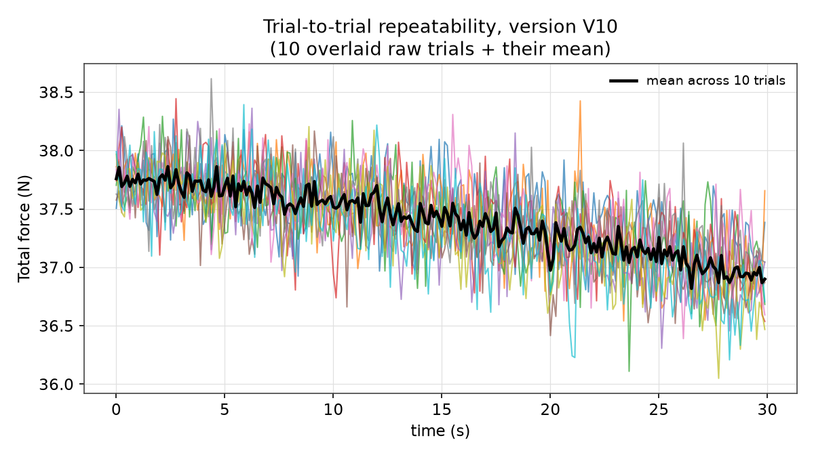
Figure 2. Ten repeated trials of one setup, overlaid.
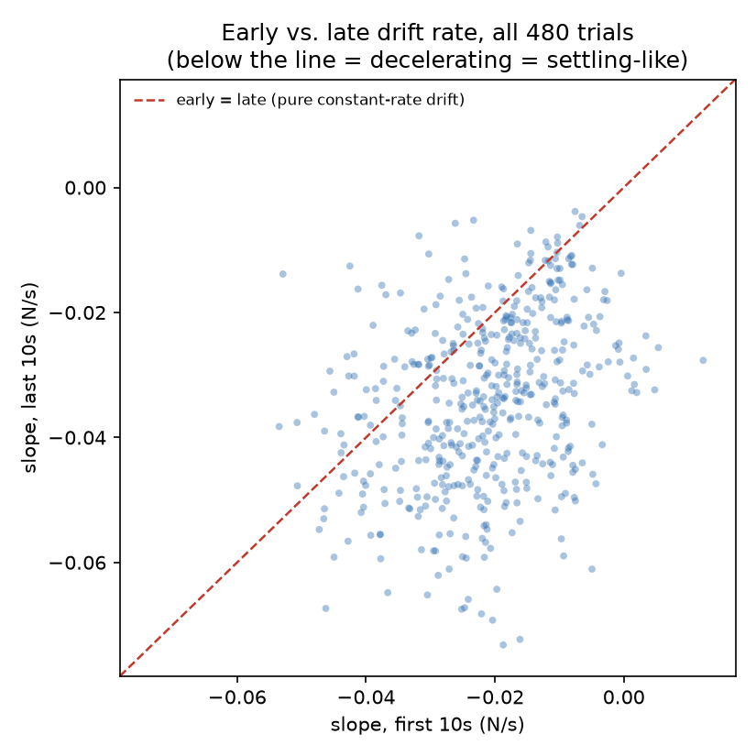
Figure 3. Early vs. late drift rate across all 480 trials.

4.3 Feature Engineering & the Redistribution Discovery
The originally planned 'wave lag' detection method was invalidated (peak cross-correlation stayed ~0.11-0.16 everywhere, below any reliable threshold, even in obstacle trials). In its place, a 'redistribution strength' feature (plain whole-trial correlation between raw sensor rows) revealed a strong, validated effect: obstacle trials show much stronger and more consistent front-back anti-correlation (mean r=-0.81, std 0.11) than no-obstacle trials (mean r=-0.40, std 0.31). Using all three rows, Middle's own dynamics are essentially unaffected by obstacle position (middle vs. middle_back), while Front and Back shift oppositely -- Front consistently gains force, Middle and Back (which move together, r~+0.47) consistently lose it, in every obstacle trial and, more weakly, even at baseline.
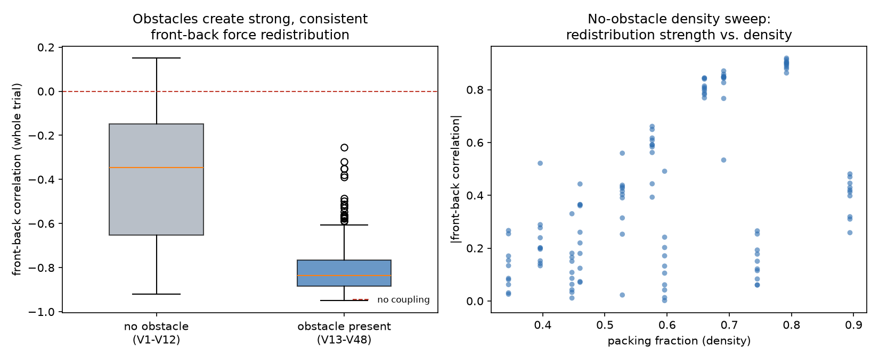
Figure 4. Left: obstacle vs. no-obstacle redistribution strength. Right: vs. density.

4.4 Density -> Pressure Relationship (V1-V12)
An initial exploratory pass (version-level averages, n=12 points) fit both a linear and a threshold/'hinge' model to mean force and fluctuation vs. packing fraction, finding high R^2 for both (e.g. fluctuation_std_N: linear R^2=0.948, hinge R^2=0.949, threshold at phi=0.61) — but a threshold model barely improved on a straight line, and fitting only 12 averaged points is vulnerable to overstating how strong a relationship really is. The same pass found the ball-size ratio (10mm:13mm mix) has a very large, significant effect on force and fluctuation at matched ball counts (e.g. F-statistics in the hundreds, p < 1e-13) — though part of this may reflect that different ratios pack to different densities and different total masses, rather than composition alone; this comparison was not normalized for that.
A more rigorous follow-up tested the same question at the individual-trial level (n=480, not 12 averages), normalizing fluctuation by mean force (coefficient of variation) to remove the trivial effect of larger absolute force producing larger absolute noise. This found NO robust relationship: correlation(packing_fraction, fluctuation CV) = 0.154, with a bootstrap 95% CI of [-0.040, +0.332] — crossing zero. Likewise, measured-vs-expected weight deviation showed no density trend (r=-0.067, p=0.466).
CONCLUSION (the trial-level, bootstrap-validated result supersedes the exploratory version-level fit): density alone, without a disturbance, does not measurably destabilize this packing across the tested range (packing fraction 0.345-0.894). Danger requires density combined with a disturbance, not density alone.
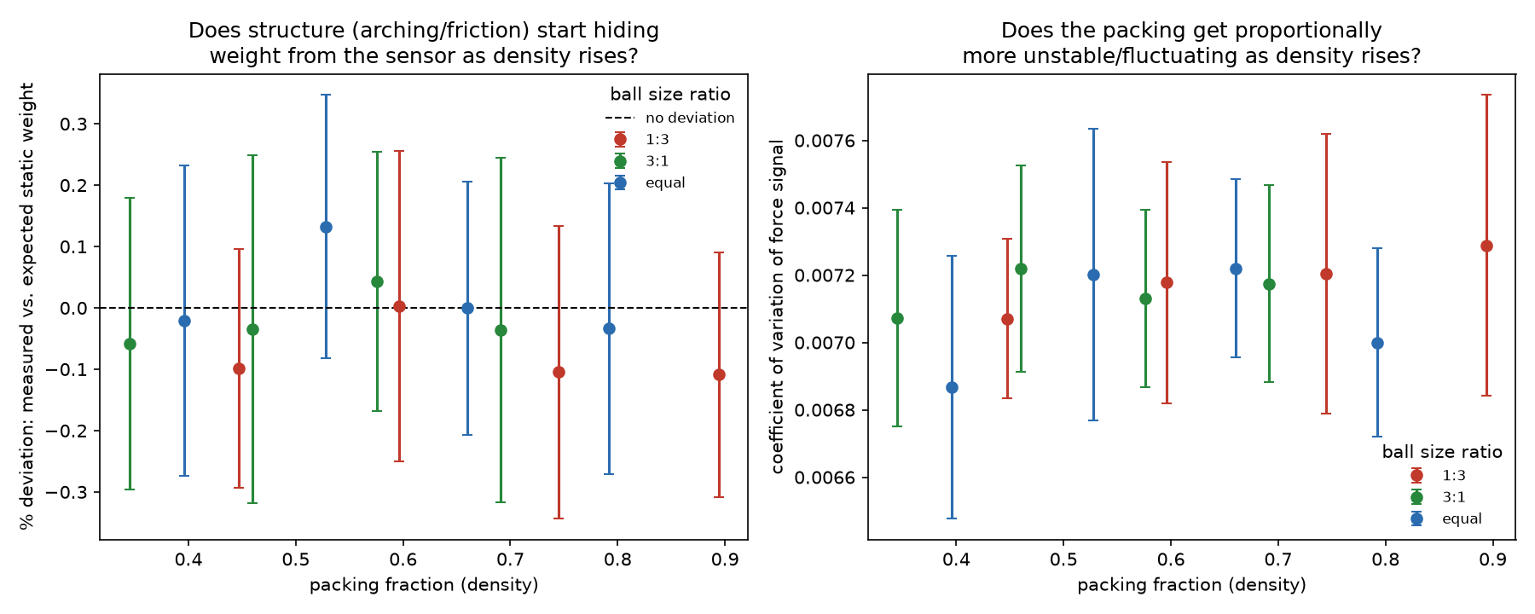
Figure 5. Calibration deviation and fluctuation CV vs. packing fraction (no obstacle).

4.5 Obstacle Factor Analysis (V13-V48)
A factorial ANOVA (obstacle shape x size x angle x position, plus all 2-way interactions) was run on three candidate danger metrics. Redistribution strength was by far the best explained (71% of variance, 29% residual):
Term | sum_sq | F | PR(>F) | pct_variance_explained
C(obstacle_angle_deg) | 1.397 | 191.8 | 1.69e-56 | 32.34
C(obstacle_shape):C(obstacle_angle_deg) | 0.6421 | 88.18 | 1.407e-31 | 14.87
C(obstacle_position) | 0.4132 | 113.5 | 4.633e-23 | 9.567
C(obstacle_size_cm) | 0.2115 | 29.05 | 2.258e-12 | 4.897
C(obstacle_angle_deg):C(obstacle_position) | 0.1909 | 26.21 | 2.582e-11 | 4.419
C(obstacle_size_cm):C(obstacle_angle_deg) | 0.08856 | 6.081 | 9.773e-05 | 2.05
By contrast, raw fluctuation magnitude (93.6% residual) and peak-force spike (92.7% residual) were mostly unexplained noise — obstacle geometry does not meaningfully predict those two, only the redistribution pattern.
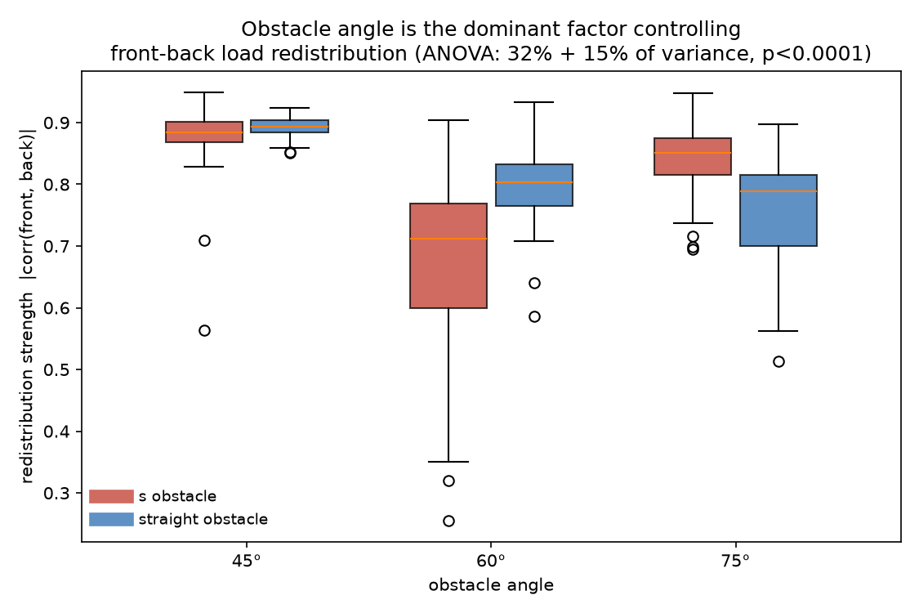
Figure 6. Redistribution strength by obstacle angle and shape.
Tukey HSD (multiple-comparison corrected) confirmed all three angles differ significantly from each other, refining the danger ordering to 45 deg > 75 deg > 60 deg (a non-monotonic 'sweet spot' at 60 deg, not simply 'higher angle = safer'). IMPORTANT CORRECTION: a Tukey HSD across all 36 individual versions found only 264/630 (42%) pairwise comparisons remain significant after correction, and the single top-ranked 'most dangerous' version (V16) is only significantly different from 14/35 (40%) of the others. The angle/shape-interaction factor effect is the robust, reportable finding — an individual version-level danger ranking is not statistically well-supported at only 10 trials per version.

4.6 Model Validation
Two theoretical framings were tested against the data. (1) A literal oscillating/traveling wave: power spectral density analysis found no consistent peak frequency (checked across 30 random trials, peak location scattered randomly, std=1.3 Hz across a 0-4 Hz range) — confirming, via an independent standard method, that there is no periodic wave in this data. (2) Exponential relaxation toward equilibrium: fits degenerated to unphysical time constants (hundreds of thousands of seconds), meaning the redistribution process is still actively developing throughout the full 30-second window and never reaches equilibrium in that time — consistent with the accelerating (not flattening) drift found in section 4.2.
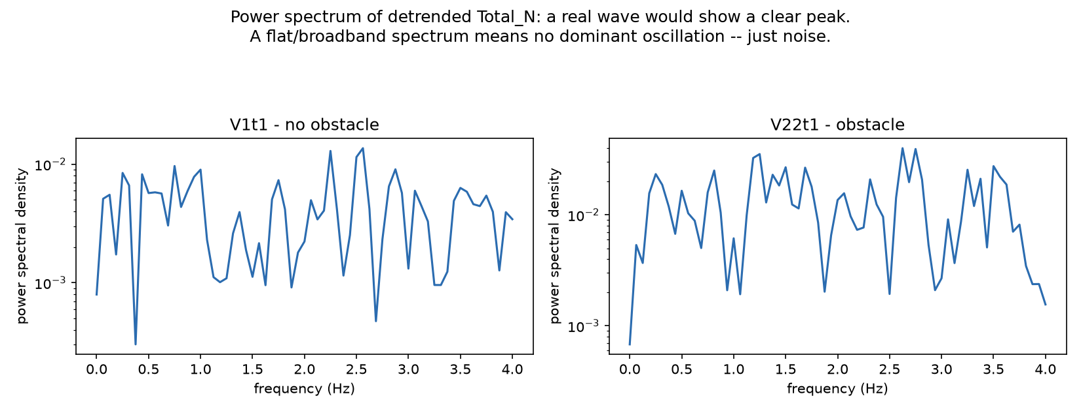
Figure 7. Power spectrum of detrended Total_N (no dominant peak).

5. Summary of Key Output Metrics
Metric | Result
Sensor calibration (measured vs. expected) | R^2 = 0.9998, slope 0.999
Universal drift (all 480 trials) | 100% negative, accelerating (p=7.8e-62)
Redistribution strength, obstacle vs. no-obstacle | -0.81 (std 0.11) vs. -0.40 (std 0.31); 95% CI [+0.345, +0.453]
Density vs. fluctuation CV (no-obstacle, per-trial) | r=0.154, 95% CI [-0.040, +0.332] -- not significant
Obstacle angle effect on redistribution strength | 32% of ANOVA variance, p<0.0001
Obstacle angle danger ordering (Tukey HSD) | 45 deg > 75 deg > 60 deg (all pairs significant)
Individual version ranking robustness | Only 42% of 630 pairwise version comparisons significant
Literal oscillating wave | Not detected (peak frequency scatters randomly, std=1.3 Hz)

6. Limitations & Open Items
- The universal front-loading tendency (Front gains, Middle+Back lose) persists even in no-obstacle baseline trials and is NOT explained by tray tilt (confirmed level) -- the underlying cause remains open.
- Obstacle-to-sensor orientation (exact physical placement for 'middle' vs. 'middle_back') is only partially inferred from data patterns; true confirmation requires a physical measurement or direct confirmation from the experimenter.
- The ratio_10mm_13mm effect on fluctuation at matched ball count was not normalized for total force magnitude (CV) -- part of the effect may be a trivial mass-scaling artifact rather than a genuine composition effect.
- Individual obstacle-version danger rankings should not be over-interpreted; only the factor-level (angle, shape x angle) effects are statistically robust.

7. Remaining Work
- Write the paper-facing narrative mapping results to the proposal's 5 objectives.
- Curate a final, polished figure set for the paper/poster.
- Commit accumulated analysis code, figures, and results to git.

Appendix A: Glossary of Terms & Abbreviations
Every statistical/technical term used in this report, in full, with what it measures and why it was used here.
Term | Full meaning & relevance to this analysis
N (Newton) | The physics unit of force. All sensor readings in this project are in Newtons — how hard the balls press down on a sensor.
Hz (Hertz) | Unit of frequency: cycles (or, for sampling, measurements) per second. Our sensors record at 8 Hz = 8 readings every second.
Packing fraction (phi) | The fraction of a container's volume actually filled with material (here, balls) rather than empty gaps. Our main measure of 'how crowded/dense' a setup is.
Mean / Average | Sum of all values divided by how many there are.
Standard deviation (std) | How spread out a set of numbers is around its average. A small std means the numbers are consistent; a large std means they vary a lot.
Coefficient of Variation (CV) | Standard deviation divided by the mean. Lets you compare 'how noisy' two signals are even when their average sizes are very different — used so that a naturally larger force reading doesn't automatically look 'more unstable' just because its absolute wobble is bigger.
Correlation coefficient (r) | A number from -1 to +1 describing how two quantities move together. +1 = always move together; -1 = always move oppositely (called anti-correlation); 0 = no relationship. Central to this report's 'redistribution strength' feature, which is exactly this correlation computed between sensor rows.
R-squared (R^2) | Coefficient of determination. A number from 0 to 1 showing how well a mathematical model or line fits real data: 1 = the model explains all the variation in the data, 0 = it explains none. Used to judge how good our calibration fit and curve fits were.
RMSE (Root Mean Square Error) | A measure of the typical size of a model's prediction errors, in the same units as the data (Newtons, here). Smaller = better fit. Reported alongside R^2 for the density-pressure curve fits.
p-value | In a statistical test, the probability of seeing a result at least this extreme purely by random chance, if there were actually no real effect. Conventionally, p < 0.05 is called 'statistically significant' -- unlikely to be chance. Used throughout this report to judge whether a pattern is real.
95% Confidence Interval (CI) | A range calculated so that, if the experiment were repeated many times, the true value would fall inside that range about 95% of the time. If a 95% CI crosses zero, we cannot confidently claim the effect is positive OR negative -- it might genuinely be nothing.
Bootstrap / bootstrapping | A way of estimating how uncertain a statistic is (like a mean or a correlation) WITHOUT assuming a specific mathematical formula for it: randomly resample the data you already have, with replacement, thousands of times (we used 5000), recompute the statistic each time, and look at how much it varies. Used here to build the 95% confidence intervals.
t-test / t-statistic | A statistical test that compares the averages of two groups and produces a 't' value; a larger |t| (further from 0) means a bigger, more reliable difference between the groups. Always reported with a p-value.
ANOVA (Analysis of Variance) | A statistical method that takes several possible 'suspects' (here: obstacle shape, size, angle, position) and tells you how much each one actually explains about an outcome, with a confidence level for each. Used to find which obstacle property matters most.
F-statistic | The test statistic ANOVA produces for each factor: how much variation that factor explains relative to random leftover noise. Larger F = stronger evidence that factor genuinely matters.
df (degrees of freedom) | Roughly, how many independent pieces of information went into a calculation (e.g. a factor with 3 levels has 2 degrees of freedom). Needed alongside the F-statistic to determine its p-value, but not something you need to interpret directly.
Sum of squares (sum_sq) | In an ANOVA table, a measure of how much total variability in the outcome is attributable to one particular factor. Dividing a factor's sum_sq by the total gives '% variance explained' -- the single most useful number in our obstacle analysis for ranking which factor matters most.
PR(>F) | The p-value associated with an ANOVA factor's F-statistic (the column header statsmodels, our statistics software, uses by default).
Tukey HSD (Honestly Significant Difference) | A follow-up test run after ANOVA that compares every pair of groups individually while correcting for the fact that testing many pairs at once increases the chance of a false alarm (this correction is called a 'multiple comparison correction'). Used to confirm which specific obstacle angles differ from each other, and to properly (and more cautiously) test the 36 individual obstacle configurations against each other.
Power Spectral Density (PSD) | A technique that breaks a signal down by frequency, showing how much of its variation happens at each oscillation speed. A real repeating wave shows up as a sharp peak; plain noise shows up as a flat, jagged spread across all frequencies with no consistent peak. Used to formally test for a literal traveling/oscillating pressure wave.
Detrending | Mathematically subtracting a straight-line trend from a signal so that smaller fluctuations underneath become easier to see and measure, without the steady drift swamping them.
Exponential relaxation model / tau | A mathematical curve shape (F_inf + (F0-F_inf)*e^(-t/tau)) representing something approaching a stable resting value over time, fast at first and flattening out later. 'Tau' is the time constant: roughly, how many seconds it takes to get most of the way to that resting value. A very large fitted tau (as found here) signals the process has NOT started flattening out within the time we recorded.
Linear regression / slope / intercept | Fitting the simplest possible straight line (y = slope*x + intercept) through data points -- the most basic model against which more complex models (like the hinge/threshold model) are judged.
Hinge / threshold / piecewise model | A model allowing a relationship to change slope at some critical point (here, a critical packing fraction), rather than staying a single straight line the whole way -- the mathematical form of the proposal's 'pressure rises rapidly beyond a critical density' hypothesis.

