https://www.zaramusicconnect.com/

1) Music Page

- Add AMIS Section + Details
Amis: https://amis-online.org/
Live Stream of 2026:

https://www.youtube.com/live/m6mxKxBDjhE?si=A5QWkmIzVHXab1MD

  - Since Grade 8
- Edit Musical Journey
  - Images
  - Correct Dates
  - Music reference videos
  - Music child pictures
  - More child videos and pictures
  - Amis

2) Music Connect Page
- Impact Numbers Section - Svea to do
  - Teachers:
    - 22 in Akanksha
    - 20 in Aseema
    - 15 at the ASB Teaching Academy
    - 10 at Vipla
  - Teachers: 67
  - Adult instructors: 15 globally
  - Students: 1050 students and adults globally
  - 3 Countries: India, US, UK
  - Reference image:
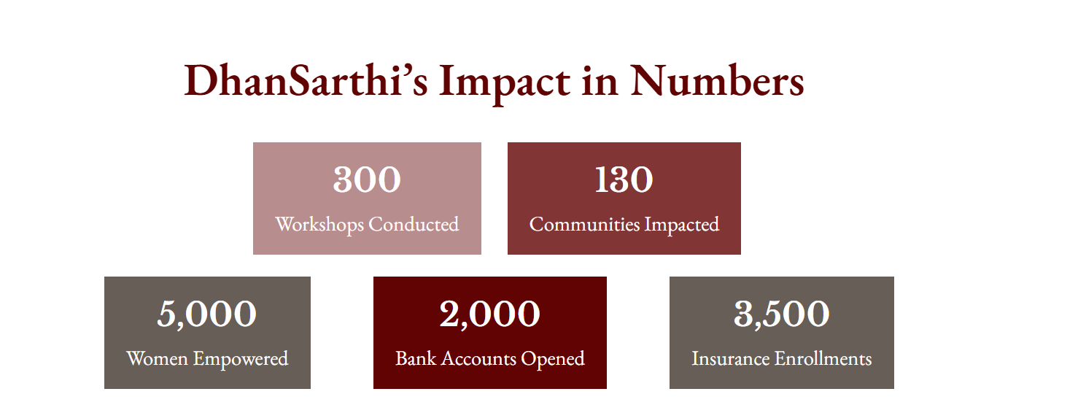
- Move the “Download the Curriculum” on Top, Make it bigger
  - Add the correct link to the pdf of ‘Activities Only’ curriculum

3) Remove Musings Section (Delete)

4) Remove Music & The Brain Section (Delete)

5) Psychology Publications
- Rename to Published Work (Header)
- Add remaining links
https://www.youngminds.org.uk/young-person/blog/why-music-matters/

6) Photos
- Rename to Photography (header, on page)
- Add additional photos

7) Certificates and Awards

8) References

