**HTML 5 Assignment**

**Level – L2**

**General Instructions:**

1. Write the solutions for each of the assignments in a separate .html file.
2. You can include the applicable and relevant user defined .js files, sample image files etc., as necessary to implement your solution.
3. Capture screen shots of the output of the program wherever applicable and submit it along with the solutions.
4. Practice and use the best practices while implementing the solution like proper formatting, indentation, usage of useful comments, meaningful variable and function names etc.,
5. This assignment is on HTML5, so use appropriate HTML5 new inputs, attributes, elements etc., wherever applicable.
6. Submit the .html files, .js files, image files used in your implementation and screenshots while submitting the assignment.

**Assignments:**

A Project team wants us to design a Kanban/Task Board as below using HTML5 features:

Astra Project – Kanban Board

Location Details: Latitude: 12.9716N Longitude: 77.5946E

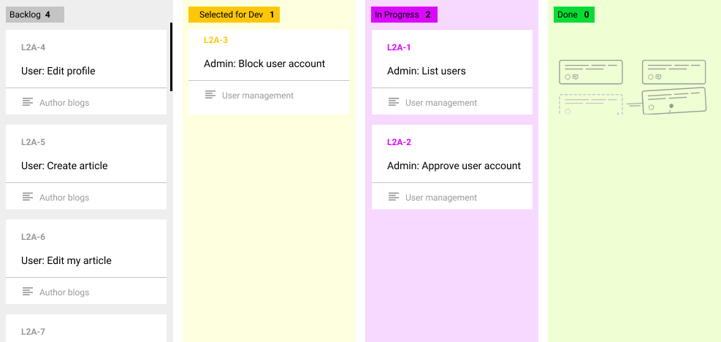

**Explanation of Kanban/Task Board:**

1. The Kanban board shows the various tasks of a project bucketed into categories like “backlog”, “Selected for Dev”, “In Progress” and “Done” there by showing the status of tasks of the project.
2. Every task has a task id – E.g.: L2A-6; a task name – E.g.: User: Edit my article; an Epic name – E.g.: Author Blogs
3. All the tasks initially are assigned to the “backlog” bucket.
4. When the team selects a task for development, they should be able to drag a task from “backlog” bucket and drop into the “Selected for Dev” bucket
5. Similarly, when the tasks are in progress, they will be dragged from the “Selected for Dev” bucket and dropped into the “In Progress” bucket
6. Once the task is completed, they are dragged and dropped into the “Done” bucket
7. Also, a task can be dragged from the next bucket to the previous bucket as well – E.g.: a task can be dragged from “Done” to “In Progress” or from “Done” to “Selected for Dev”.

**Implementation requirements:**

1. The panels of each of the stages have to be designed using SVG with a background color of your choice.
2. The top of the panel also should display the total number of tasks in that bucket at any given point in time. Example: In the above picture, you can see that there are 4 tasks in “backlog”, 1 task is “Selected for Dev”, 2 tasks are in “In Progress” and 0 are “Done”. These are not static values, these are dynamic values which is calculated based on how many tasks exist in that bucket. You can implement it using simple JavaScript and use HTML5 web storage to calculate and store the number of tasks in each panel.
3. Use HTML5 drag and drop facility to enable dragging and dropping facility on each of these buckets.
4. The top right of the board also shows the current location details of latitude and longitude. You can use HTML5 Geolocations for this.
5. Have a meaningful heading as suggested in the picture above.
6. Tasks can be created as div or any other HTML5 structural elements with appropriate details.
7. The above colors are only indicative. You are welcome to use any other color combinations of your choice and use any CSS styling for the same.