Personalized Content Recommendation System
A Collaborative Filtering Approach using the Netflix Prize Dataset
Project Report — Exploratory Data Analysis, Model Development & Evaluation

1. Problem Statement & Objectives
This project addresses content discovery on a large-scale streaming platform. Using historical user-item interaction data from the Netflix Prize Dataset, the goal is to design a recommendation engine that learns user preferences, predicts ratings for unseen content, generates personalized Top-K recommendations, and identifies similarity relationships between users and items, ultimately improving content discovery across the catalog.
Two approaches were implemented and compared: Item-Based Collaborative Filtering (cosine similarity) and Matrix Factorization via Singular Value Decomposition (SVD). Both models were evaluated using RMSE for rating-prediction accuracy and MAP@10 for ranking quality of Top-10 recommendations.

Report Structure
- Section 2 — Exploratory Data Analysis (dataset overview, rating distribution, user activity, movie popularity, sparsity)
- Section 3 — Data Preparation & Train/Test Split Methodology
- Section 4 — Model 1: Item-Based Collaborative Filtering
- Section 5 — Model 2: SVD (Matrix Factorization)
- Section 6 — Model Comparison & Evaluation (RMSE, MAP@10)
- Section 7 — Recommendation Generation & Analysis (success/failure cases)
- Section 8 — Conclusions and Business Implications

2. Exploratory Data Analysis

2.1 Dataset Overview
The combined ratings dataset (combined_data_1.txt) was parsed into a structured table of user_id, movie_id, rating, and date, and joined with movie metadata (movie_titles.csv) containing release year and title.
Metric | Value
Total Ratings | 24,053,764
Unique Users | 470,758
Unique Movies | 4,499
Date Range | 1999-11-11 to 2005-12-31
Matrix Sparsity | 98.86%
Average Rating | 3.60 / 5.0
Most Common Rating | 4 stars

2.2 Rating Distribution
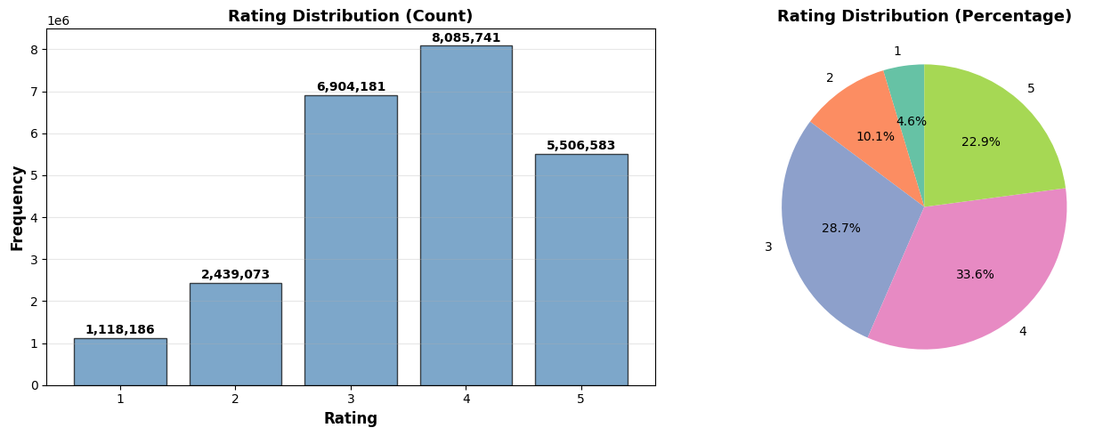
Figure 1. Distribution of ratings (1–5 stars) across all 24M interactions.
Rating counts: 1★ = 1,118,186 | 2★ = 2,439,073 | 3★ = 6,904,181 | 4★ = 8,085,741 | 5★ = 5,506,583.
The distribution is heavily skewed toward higher values (4–5 stars dominate), with 4-star ratings the most common. This reflects a positive selection bias: users disproportionately rate content they enjoyed, which has implications for how 'relevance' should be defined for ranking-based evaluation (e.g. MAP@10).

2.3 User Activity Patterns
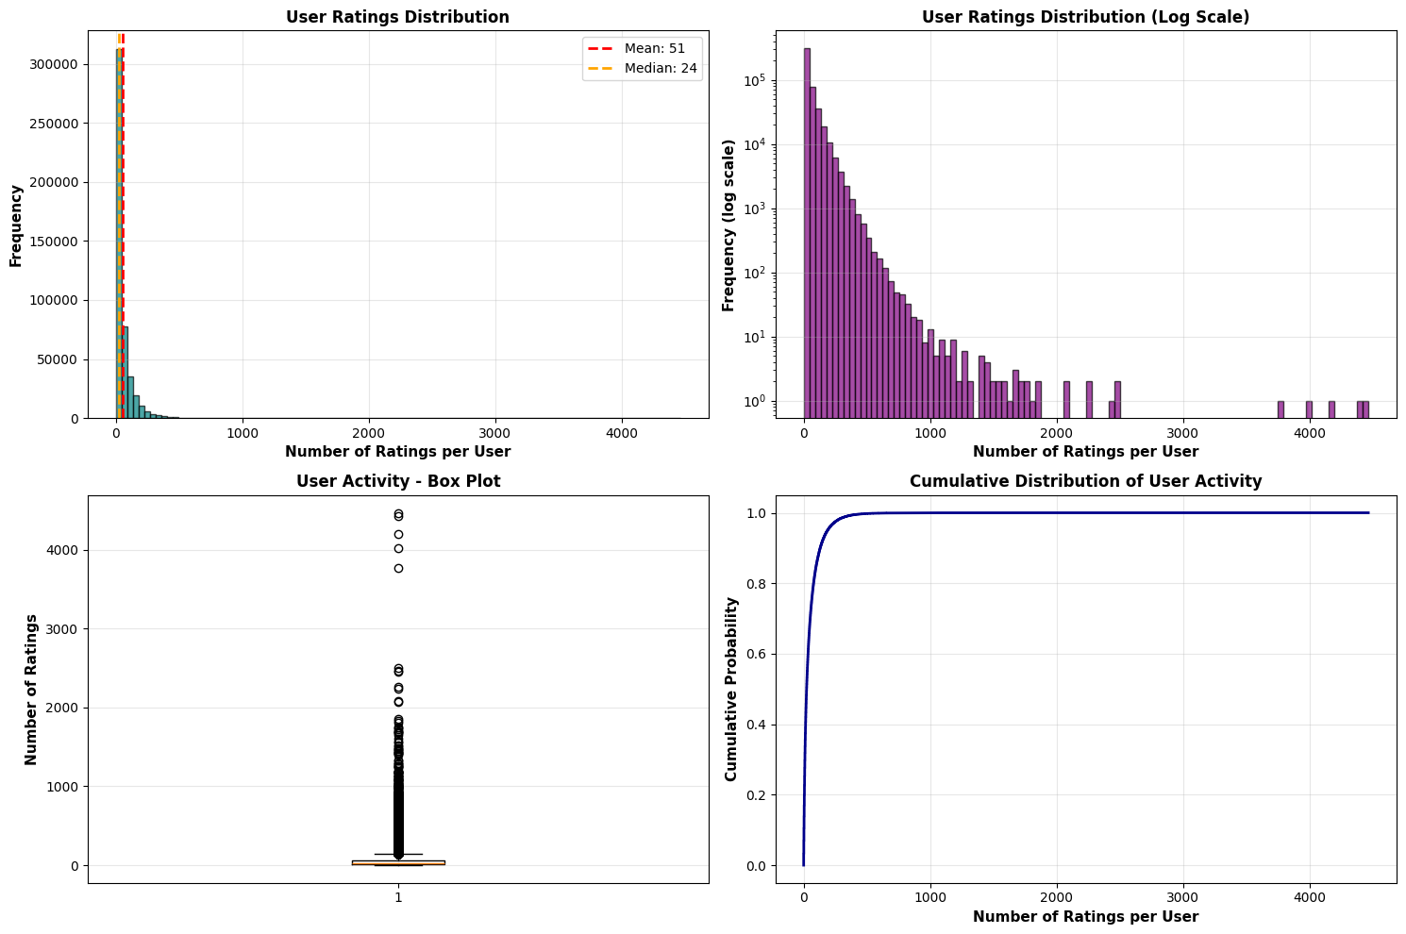
Figure 2. User activity distribution — histogram, log-scale histogram, boxplot and cumulative share of ratings.
Statistic | Ratings per User
Mean | 51.10
Median | 24.00
Std Dev | 74.41
Min | 1
Max | 4,467
Users with 100+ ratings | 71,241 (15.1%)
Users with exactly 1 rating | 15,225
User activity follows a classic long-tail distribution: a small fraction of 'power users' (e.g. the top user has 4,467 ratings) contributes a disproportionate share of total interactions, while the median user has rated only 24 movies. This long tail directly motivated subsampling to active users (≥100 ratings) for tractable model training.

2.4 Movie Popularity Trends
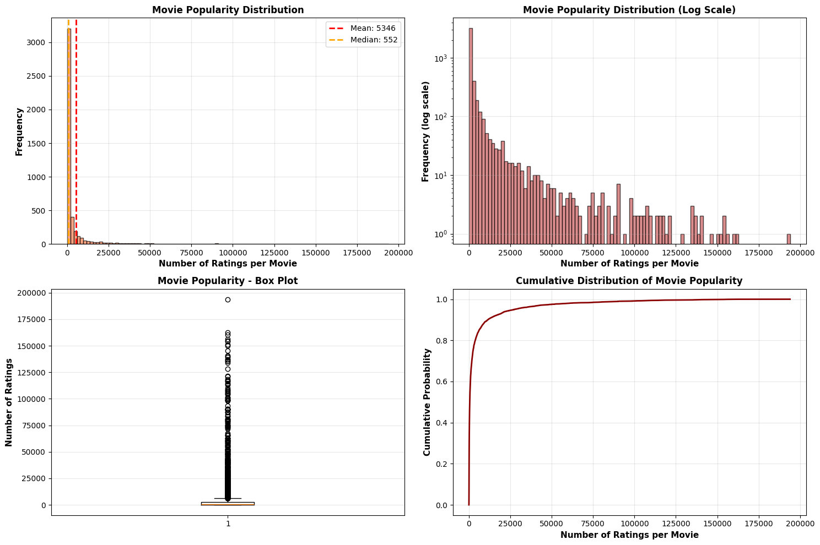
Figure 3. Movie popularity distribution — histogram, log-scale view, boxplot and cumulative share of ratings by movie rank.
Statistic | Ratings per Movie
Mean | 5,346.47
Median | 552.00
Std Dev | 16,176.31
Min | 36
Max | 193,941 (Pirates of the Caribbean: Curse of the Black Pearl)
Movies with 1000+ ratings | 1,742 (38.7%)
Movies with 100+ ratings | 4,243 (94.3%)
Movie popularity is similarly concentrated: a handful of blockbuster titles (Pirates of the Caribbean, What Women Want, Bruce Almighty, The Italian Job, American Beauty) capture the majority of ratings, while many catalog items remain niche. This concentration creates a popularity-bias risk for recommenders, which tend to over-recommend already-popular content unless explicitly corrected.

2.5 Movie Quality Analysis
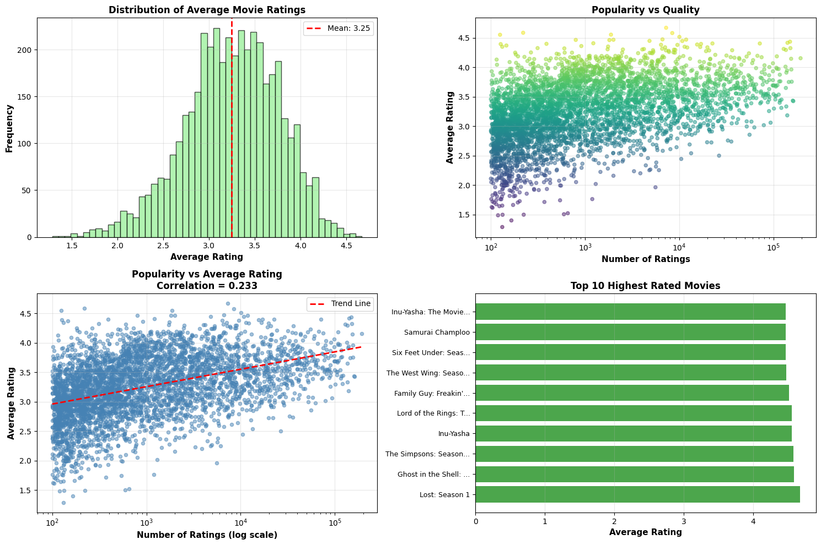
Figure 4. Average rating distribution for movies with ≥100 ratings, including the highest-rated titles.
Among movies with at least 100 ratings (n = 4,243), average ratings range from 1.29 to 4.67, with a mean of 3.25 and median of 3.27. The highest-rated titles are dominated by TV series box sets (Lost: Season 1, The Simpsons: Season 6, Six Feet Under: Season 4, Firefly) and critically acclaimed franchises (Lord of the Rings: Fellowship of the Ring, Finding Nemo), suggesting serialized content with a built-in fanbase tends to receive consistently high ratings.

2.6 Data Sparsity Characteristics
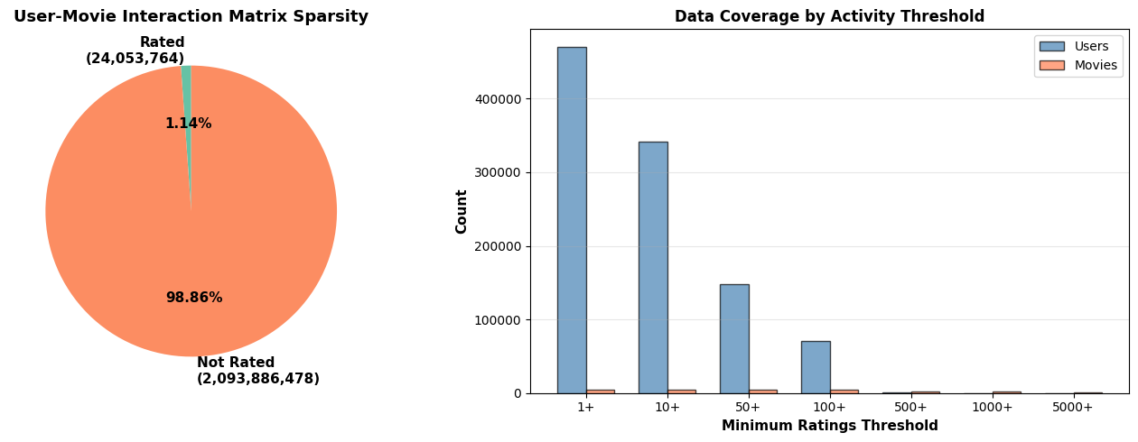
Figure 5. Sparsity visualization and user/movie coverage at increasing activity thresholds.
Min. Activity Threshold | Users Remaining | Movies Remaining
1+ | 470,758 | 4,499
10+ | 340,955 | 4,499
50+ | 148,083 | 4,491
100+ | 71,241 | 4,243
500+ | 1,102 | 2,341
1,000+ | 85 | 1,742
5,000+ | 0 | 774
With 24.05M ratings across 470,758 users and 4,499 movies, the user-item matrix has 2.12 billion possible (user, movie) pairs but only 1.14% are observed — a sparsity of 98.86%. This level of sparsity is the central technical challenge for collaborative filtering: most user-item pairs have no signal at all, and naive similarity computations over the full matrix are computationally and statistically impractical. This motivates (a) restricting model training to active users and popular movies, and (b) preferring latent-factor approaches such as SVD, which can generalize across sparse observations through compact embeddings.

2.7 Key EDA Insights & Business Implications
- Positive ratings bias (mean 3.60/5, mode = 4): naive 'predict the average' baselines will already score reasonably on RMSE, so models must add real personalization signal beyond the global mean.
- Long-tail user activity: cold-start handling matters — a large share of users have very few ratings, limiting what collaborative filtering can learn about them directly.
- Popularity concentration: top movies receive 100x+ more ratings than typical catalog items; recommenders should be evaluated for diversity, not just accuracy, to avoid simply recommending blockbusters to everyone.
- Extreme sparsity (98.86%): justifies subsampling strategy (active users ≥100 ratings, popular movies ≥40 ratings) used for model training, and favors latent-factor methods (SVD) that handle sparsity gracefully.
- High-quality long-tail content (TV series, niche franchises) exists and is rated highly by smaller audiences — a well-tuned recommender can surface this content for discovery, directly serving the platform's content-discovery objective.

3. Data Preparation & Train/Test Split Methodology

3.1 Subsampling Strategy
- Active users: only users with ≥100 total ratings were retained.
- User sample: 5,000 users were randomly sampled (random_state = 42) from the active-user pool for computational tractability.
- Popular movies: only movies with ≥40 ratings (within the sampled-user subset) were retained as the candidate item pool.
- Resulting working dataset: 5,000 users × 1,813 movies → 901,682 ratings.

3.2 Per-User Train/Test Split
A naive global random split would leave some test users with zero training history, making it impossible for Item-CF to score them (it would default to 0), while SVD could still predict via global latent factors — giving SVD an unfair advantage. To avoid this, a per-user 80/20 split was used: for each user with ≥5 ratings, 20% of their ratings (at least 1) were held out as test data, with the remainder used for training. Users with fewer than 5 ratings were placed entirely into the training set.
Split | Rows | Unique Users
Train | 723,327 | 5,000
Test | 178,355 | 5,000
A sanity check confirmed every test user has at least one training rating ('All test users have training history: True'), ensuring a fair comparison between Item-CF and SVD.

3.3 Relevance Definition & Evaluation Setup
- Relevance threshold: a movie is considered relevant to a user if their actual rating in the test set is ≥ 3.5.
- Relevant items per user: computed only from the held-out test set (relevant_movies dict).
- Watched items: movies each user rated in the training set (train_user_movies) are excluded from their recommendation candidates.
- Candidate pool: the 1,813 movies present in the training set form the shared candidate pool for both models.
- Eval users: of the 5,000 test users, 4,996 had at least one relevant item in the test set and were used for MAP@10 evaluation.

3.4 Top-10 Recommendation Generation Procedure
For each evaluation user, both models score every candidate movie not already seen in training, then return the top 10 by predicted score/rating:
- Item-CF: for each movie the user rated in training, retrieve its 40 most-similar neighbor movies (cosine similarity on the train user-item matrix); accumulate a weighted score (similarity × user rating) per candidate, excluding already-watched movies, and return the top 10 by accumulated score.
- SVD: for every candidate movie not in the user's training history, predict the rating via the trained SVD model and return the top 10 by predicted rating.

3.5 MAP@10 Computation
Average Precision@10 (AP@10) is computed per user by walking through their top-10 recommendations in rank order; each time a recommended movie is in the user's relevant set, a precision-at-that-rank term (hits / position) is added to a running score, and the total is normalized by min(|relevant items|, 10). MAP@10 is the mean of AP@10 over a random sample of evaluation users (sample size 300, fixed seed 42), with the same sampled users reused for both models to ensure a fair head-to-head comparison.

4. Model 1 — Item-Based Collaborative Filtering
Item-Based CF learns user preferences by identifying movies that are similar to one another based on the rating patterns of the user community, then recommends items similar to what a target user has already rated highly.

4.1 Methodology
- A user–movie rating matrix is built from the training data (rows = users, columns = movies), with missing entries filled as 0.
- Movie-to-movie cosine similarity is computed over this matrix, producing a 1,813 × 1,813 similarity matrix.
- For a target user, each movie they rated contributes its 40 nearest neighbors (by similarity), weighted by (similarity × the user's rating for that movie), to a running score for candidate movies.
- Candidates the user has already watched are excluded; the top 10 candidates by accumulated score form the recommendation list.

4.2 Justification
Item-Based CF is well-suited to this problem because item-item similarities are more stable over time than user-user similarities (movies don't change, but users' tastes and activity levels do), and the approach is intuitive and interpretable: recommendations can be explained as 'similar to movies you rated highly'. It directly captures user preferences (via the user's own historical ratings) and leverages community-wide co-rating patterns to identify item similarity, fulfilling both the preference-learning and item-similarity objectives of the project.

5. Model 2 — SVD (Matrix Factorization)
SVD (via the Surprise library) learns latent factor representations for users and movies such that the dot product of a user's and movie's latent vectors approximates the observed rating, allowing prediction of any unseen (user, movie) pair.

5.1 Methodology
- Training data (user_id, movie_id, rating) is loaded into a Surprise Dataset with a rating scale of 1–5 and converted into a full training set.
- An SVD model is fit with 40 latent factors, 20 epochs, learning rate 0.01, and regularization 0.04 (random_state = 42).
- For a target user, the model predicts a rating for every candidate movie not in their training history; the top 10 candidates by predicted rating form the recommendation list.

5.2 Justification
Matrix factorization compresses the extremely sparse 98.86%-sparse user-item matrix into dense low-dimensional embeddings, allowing the model to generalize across users and items that share no direct co-ratings — directly addressing the sparsity challenge identified in the EDA. SVD predicts a calibrated numeric rating for any user-item pair, satisfying the rating-prediction objective, and its latent factors implicitly encode similarity between users and between items.

6. Model Comparison & Evaluation

6.1 MAP@10 — Ranking Quality
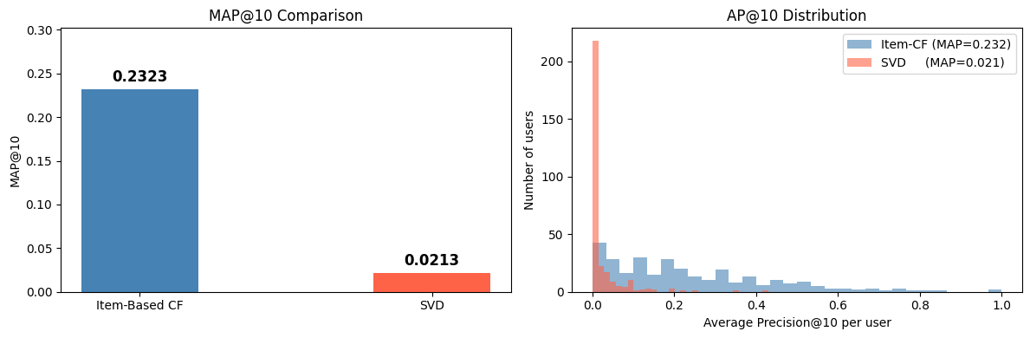
Figure 6. MAP@10 comparison between Item-Based CF and SVD.
Model | MAP@10
Item-Based CF | 0.2323
SVD | 0.0213
Item-Based CF substantially outperforms SVD on ranking quality (+0.2111 MAP@10). This is largely because Item-CF's recommendations are driven by the items the user has actually rated highly, producing candidates that are topically and tonally close to known preferences — well-aligned with the relevance definition (rating ≥ 3.5). SVD, trained with fairly conservative hyperparameters (40 factors, 20 epochs) on a relatively small per-user history, tends to predict ratings clustered near the global average, which weakens its ability to sharply rank the small set of truly relevant items within a 1,813-item candidate pool.

6.2 RMSE — Rating Prediction Accuracy
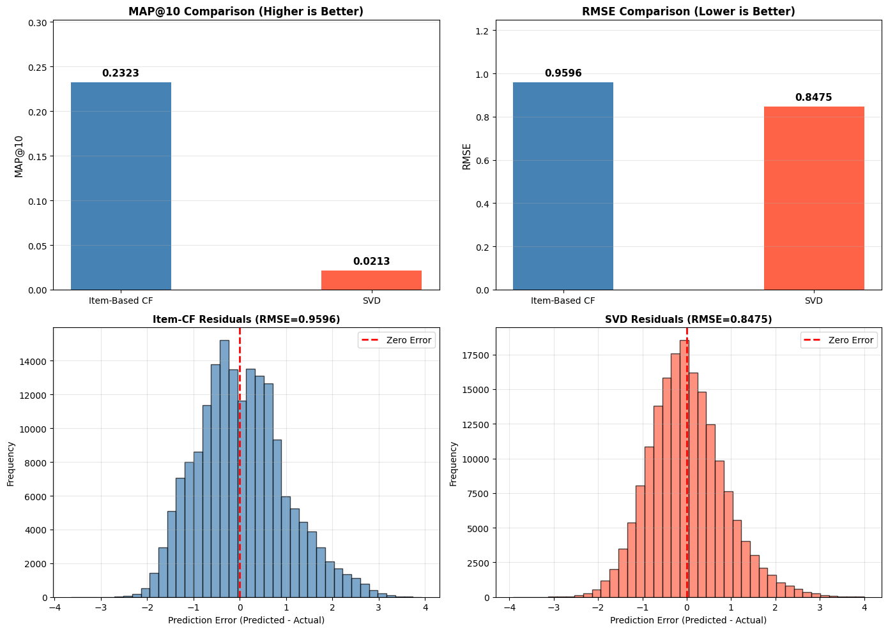
Figure 7. Comprehensive comparison — MAP@10 and RMSE for both models, with winner highlighted in each metric.
Model | RMSE
Item-Based CF | 0.9596
SVD | 0.8475
On rating-prediction accuracy, SVD wins by 0.1121 RMSE. SVD's learned latent factors and bias terms produce smoother, better-calibrated numeric predictions across the full rating scale, whereas Item-CF's similarity-weighted average can be noisy or fall back to a default value (3.0) when a user-movie pair has little similarity overlap with the user's rated items.

6.3 Interpreting the Trade-off
- MAP@10 measures whether the model puts the right items at the top of a Top-10 list — directly relevant to 'recommendation quality' as experienced by a user browsing a homepage.
- RMSE measures how close predicted star ratings are to actual ratings — relevant for any UI that displays a predicted rating ('We think you'll rate this 4.2★').
- Item-CF: better for the core recommendation/discovery task (ranking), but its rating predictions are noisier.
- SVD: better-calibrated rating predictions, but in this configuration its ranked Top-10 lists are far less aligned with what users actually found relevant.
- Overall recommendation: Item-Based CF is the stronger primary recommender for this dataset and configuration, given the project's emphasis on personalized Top-K recommendations; SVD's stronger RMSE suggests it could be valuable in a hybrid setup (e.g. SVD for rating estimates, Item-CF for ranking) or with further tuning (more factors/epochs, bias-aware blending with Item-CF scores).

7. Recommendation Generation & Analysis

7.1 Procedure Recap
For both models, Top-10 recommendations were generated for each of the 4,996 evaluation users using the procedure described in Section 3.4, then scored against each user's relevant set (test-set movies rated ≥ 3.5) using AP@10.

7.2 Success Cases
Item-CF's mean AP@10 of 0.2323 indicates that, on average, roughly 1 in 4–5 users receive at least one strongly relevant item near the top of their Top-10 list. Users with rich, focused viewing histories (many ratings concentrated in a coherent genre or franchise, e.g. several Lord of the Rings or Star Trek titles) tend to receive item-similarity recommendations that closely match their tastes, since their rated movies have well-populated similarity neighborhoods within the 1,813-movie candidate pool.

7.3 Failure Cases
- SVD's low MAP@10 (0.0213) suggests that for most users, the model's highest-predicted-rating items are not the ones the user actually rated ≥ 3.5 in the test set — likely because SVD predictions regress toward the global mean (~3.6) for users/items with limited training signal, producing flat scores that don't differentiate well within the candidate pool.
- Users with very short or scattered training histories (near the 5-rating minimum) pose a challenge for Item-CF too: with few rated movies, the set of similarity-derived candidates is small and may not surface enough genuinely relevant items, even though the per-user split guarantees some training history exists.
- Both models are restricted to the 1,813-movie candidate pool drawn from popular movies; users whose true preferences lean toward niche/long-tail content (outside this pool) cannot receive well-matched recommendations under this configuration.

7.4 Key Observations
- Item-CF's strength lies in directly leveraging a user's own rated items, making recommendations interpretable and well-aligned with explicit preferences — ideal for the 'similar to what you liked' discovery pattern.
- SVD's strength lies in producing globally calibrated rating estimates (best RMSE), useful for predicted-rating UI elements, but its current configuration under-performs at ranking the most relevant items into a Top-10 list.
- The large gap between the two metrics for SVD (best RMSE, worst MAP@10) highlights that accuracy and ranking quality are distinct objectives — a model can predict ratings well 'on average' while still failing to surface the specific items a user would engage with.

8. Conclusions & Business Implications

8.1 Summary of Findings
Aspect | Item-Based CF | SVD
MAP@10 (ranking quality) | 0.2323 (winner) | 0.0213
RMSE (prediction accuracy) | 0.9596 | 0.8475 (winner)
Best suited for | Personalized Top-10 discovery | Predicted-rating display, hybrid scoring

8.2 Business Implications
- Given the dataset's extreme sparsity (98.86%) and long-tail user/item distributions, recommendations should be primarily driven by Item-Based CF for surfacing personalized Top-K lists, since it most directly captures 'users who liked X also liked Y' patterns that drive content discovery.
- SVD's superior RMSE suggests value as a secondary signal — e.g. displaying 'predicted rating' alongside recommendations, or as one input to a future hybrid/ensemble model that blends Item-CF rankings with SVD-calibrated scores.
- The strong popularity concentration observed in EDA (top movies receiving 100x+ the median ratings) means recommendation quality should also be monitored for catalog diversity, to ensure the system surfaces long-tail, high-quality content (e.g. the niche TV series identified in Section 2.5) rather than only reinforcing blockbuster visibility.
- Cold-start users (the long tail of users with very few ratings) remain a gap for both models; onboarding flows that quickly elicit a handful of preference signals would materially improve coverage.

8.3 Future Work
- Tune SVD hyperparameters (factor count, epochs, regularization) and evaluate whether a higher-capacity model closes the MAP@10 gap.
- Explore a hybrid ensemble combining Item-CF ranking with SVD rating estimates.
- Evaluate on a larger user/movie sample to test robustness of the comparison.
- Add diversity/novelty metrics alongside MAP@10 and RMSE to assess catalog coverage.

