End-to-End Data Engineering Pipeline Documentation
Assignment: ABC Retail Solutions - Case Assessment
Given By: Neostats

1. Introduction and Workflow Overview

This project was designed as an end-to-end data engineering solution for ABC Retail Solutions, focusing on transforming raw transactional data into reliable, business-ready insights.

The raw dataset originated from two independent retail source systems and contained several real-world data quality challenges. These included inconsistent category naming, mixed date formats within the same column, missing product prices, duplicate transactions, and the presence of personally identifiable customer information stored in plain text.

Rather than treating these issues in isolation, the objective of this project was to design a clean, auditable, and scalable data pipeline that mirrors how data engineering problems are solved in a production environment.

The final solution follows a structured Extract → Transform → Load (ETL) approach:
- Raw data is ingested from Excel files
- Cleaned and standardized using Python (Pandas)
- Enriched with derived business metrics
- Stored locally and in Azure Blob Storage
- Visualized through an interactive Power BI dashboard

This document walks through the architecture, data flow, cleaning decisions, transformations, and final insights, with an emphasis on why each decision was made, not just how it was implemented.

2. Architecture Diagram
The architecture of the pipeline is intentionally simple yet production-oriented. It is designed to clearly separate responsibilities across ingestion, transformation, storage, and reporting layers.
At the source layer, retail transaction data is provided through an Excel file containing two transactional sheets and one product reference sheet. These are ingested into Python using Pandas, where each source is preserved and tagged to maintain traceability.
The transformation layer handles all data quality issues, including validation, standardization, and feature engineering. Personally identifiable information is securely masked before any data is written to disk or uploaded to the cloud.
The output layer stores clean datasets locally for analysis and uploads the same outputs to Azure Blob Storage, simulating a cloud-based data lake setup. Finally, the processed data is consumed by Power BI to deliver business insights through interactive dashboards.
This layered design ensures the pipeline is easy to debug, extend, and automate in the future.
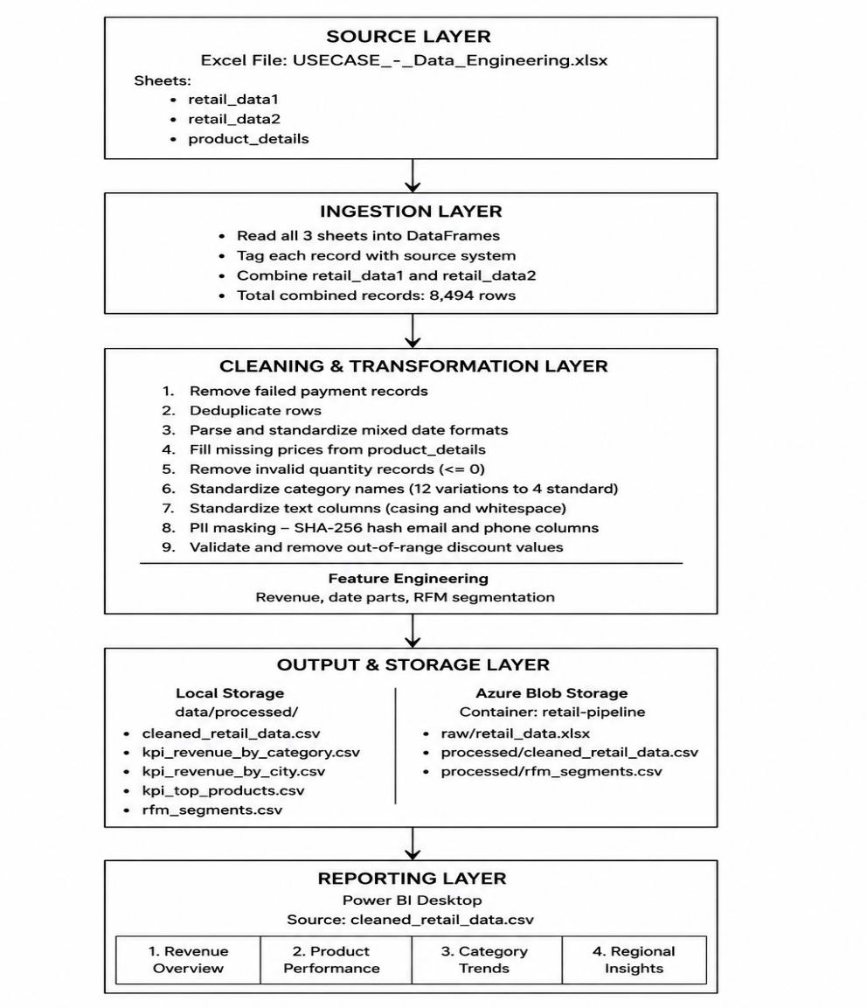

3. Data Flow Diagram

The data flow diagram below focuses specifically on how data moves and transforms at each stage of the pipeline. As the architecture diagram shows the system components, this diagram shows what happens to the actual data records through the processes.

Source |  | Process |  | Store |  | Output
retail_data1  retail_data2  product_details  (8,494 raw rows) |  | Ingest + Merge  Clean + Validate  Transform  Mask PII  Aggregate KPIs |  | Local CSV  data/processed/  + Azure Blob  retail-pipeline/  (~7,200 clean rows) |  | Power BI  Dashboard  (4 pages)

3.1 Data Flow Steps in Detail

This section explains how data moves through the pipeline from the source Excel file to the final Power BI dashboard. Each step focuses on making the data cleaner, more reliable, and ready for analysis.

The process begins with reading the raw data from Excel and ends with visual insights generated in Power BI.

Step-by-Step Data Flow:

Reading Source Data
The input Excel file contains three sheets: retail_data1, retail_data2, and product_details.
All three sheets are read into Python using pd.read_excel() and stored as separate Pandas DataFrames for further processing.

Combining Retail Data
The two retail transaction sheets (retail_data1 and retail_data2) are merged into a single DataFrame using pd.concat().
A new column is added to track the source of each record, which helps in debugging and traceability.

Preparing Product Reference Data
The product_details sheet is converted into a dictionary (price_map) where product IDs map to their prices.
This reference is later used to fill in missing price values.

Removing Failed Transactions
Records related to failed or unsuccessful payments are filtered out to ensure that only valid transactions are analyzed.

Deduplication
Exact duplicate rows are removed from the dataset to avoid double-counting transactions.

Date Standardization
The dataset contains dates in multiple formats. These are parsed and converted into a single standard date format to maintain consistency.

Handling Missing Prices
Any missing price values in the retail data are filled using the price_map created from the product details sheet.

Validating Quantity Values
Rows with invalid quantity values (less than or equal to zero) are removed, as they do not represent meaningful sales.

Category Standardization
Category names that appear in different variations are cleaned and mapped into four standard category values.

PII Masking
Sensitive fields such as email IDs and phone numbers are hashed using SHA-256.
The original values are dropped to ensure data privacy.

Feature Engineering
New features such as total revenue, date-based attributes (month, year), and RFM metrics are calculated to support analysis.

Saving Clean Data Locally
The final cleaned dataset is saved as cleaned_retail_data.csv along with other KPI files in the local data/processed directory.

Uploading to Cloud Storage
The cleaned CSV files are uploaded to Azure Blob Storage for backup and future scalability.

Reporting and Visualization
The cleaned dataset is loaded into Power BI, where dashboards are created to analyze revenue, product performance, category trends, and regional insights.

4. Data Model

The data model for this project consists of two fact tables and one dimension table as input, which are processed into a single cleaned and enriched output table. Below is a description of all tables and their columns.

4.1 Table Relationship Diagram

This is the ER Diagram. The transaction data is stored in two tables, retail_data1 and retail_data2, both having the same structure and using transaction_id as the primary key. These tables store customer, product, and purchase-related details. The product_details table acts as a reference table and uses product_id as its primary key. The product_id in the retail tables works as a foreign key linking each transaction to its corresponding product. This relationship helps maintain consistent product information and supports accurate price validation and revenue calculation.
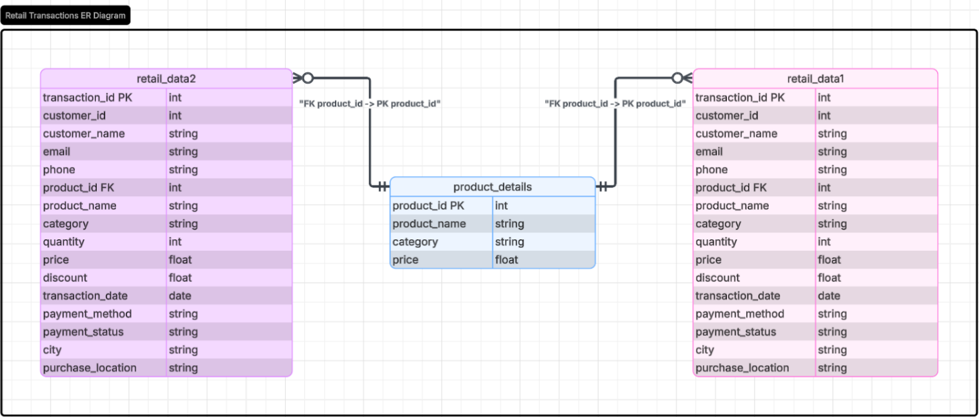

4.2 Input Table Schemas

Column | Data Type | Description | Issues Found
transaction_id | String | Unique identifier for each transaction | Duplicates from failed payments
customer_id | String | Unique customer identifier | None
customer_name | String | Full name of the customer | Leading/trailing whitespace
email | String | Customer email address (PII) | Raw PII – requires masking
phone | String | Customer phone number (PII) | Raw PII - requires masking
product_id | String | Foreign key referencing product_details | None
product_name | String | Name of product purchased | Inconsistent letter casing
category | String | Product category | 12 inconsistent category variations
quantity | Integer | Number of units purchased | Negative and zero values present
price | Float | Unit price of the product | ~809 missing across both datasets
discount | Float | Discount applied (0.0 to 1.0) | Some values out of valid range
transaction_date | Mixed | Date transaction occurred | Excel serial numbers + string dates
payment_method | String | Payment mode used | None
payment_status | String | Status of payment | Failed records mixed with successful
city | String | City of purchase | Minor whitespace issues
purchase_location | String | Online or offline purchase channel | Inconsistent casing

4.3 Output Table Schema (Cleaned Dataset - Additional Columns)

New Column | Derived From | Logic
revenue | price, quantity, discount | Calculated as price × quantity × (1 − discount)
year | transaction_date | Year extracted from transaction date
month | transaction_date | Extracted month as integer
month_name | transaction_date | Abbreviated month name (Jan, Feb, etc.)
quarter | transaction_date | Derived quarter Q1 - Q4
day_of_week | transaction_date | Full day name (Monday, Tuesday, etc.)
is_weekend | day_of_week | True if Saturday or Sunday, else False
email_masked | email | SHA-256 hash of original email, first 20 characters retained
phone_masked | phone | SHA-256 hash of original phone, first 20 characters retained
source | Assigned during ingestion | Indicates original source dataset

5. Assumptions Made

In real-world data engineering projects, datasets are rarely perfectly documented or fully consistent. During this assignment, several assumptions had to be made based on observed data patterns and typical retail business logic.
All assumptions are documented below to maintain transparency, reproducibility, and ease of review. Each decision prioritizes data accuracy and business correctness over aggressive or risky data manipulation.

5.1 Failed Payment Records Should Be Excluded
The dataset contained both successful and failed payment records. Only successful transactions were treated as valid sales. Failed payments do not represent completed purchases, and including them would inflate transaction counts and distort revenue metrics. If required, failed payment attempts can still be analyzed separately from the raw dataset.

5.2 Negative and Zero Quantities Are Considered Invalid
Records with zero or negative quantity values were removed. In a sales dataset, such values usually indicate data entry issues or incorrectly recorded returns. Since no explicit return indicator was available, these records could not be reliably interpreted and were excluded to avoid incorrect revenue calculations.

5.3 Missing Prices Are Filled Using the product_details Reference Table
Missing price values were populated using the reference price from the product_details table based on product_id. This approach was preferred over statistical imputation because the reference table represents business-defined product prices. Only null price values were updated; existing prices were left unchanged.

5.4 Category Names Are Mapped Using an Explicit Dictionary
Twelve different variations of the same four category names were found across the datasets. Examples include ELEC, electronics, and Electronics, all of which refer to the same category. Rather than using fuzzy matching or a machine learning approach, I built a simple dictionary that explicitly maps each known variation to one of four standard values: Electronics, Clothing, Furniture, and Home Appliances. Using an explicit map makes the standardization predictable and easy to audit. Only null price values were updated; existing prices were left unchanged.

5.5 Both Date Formats Are Equally Valid and Must Be Preserved
The transaction_date column contained two completely different formats in the same column. Some values were Excel serial numbers, which count the number of days since 30th December 1899. Others were date strings in MM-DD-YYYY format. A custom parsing function was written to detect the type of each value and apply the correct conversion. Both formats produce accurate dates after parsing, so no records were dropped purely because of date format issues.

5.6 SHA-256 Hashing Is Sufficient PII Protection for This Use Case
Customer email addresses and phone numbers were treated as sensitive data. These fields were masked using SHA-256 hashing, a one-way cryptographic function. The first 20 characters of the hash were retained as a compact identifier, and the original PII columns were removed from the final dataset.

5.7 Discounts Outside the 0 to 1 Range Are Errors
Discount values were expected to fall between 0 and 1. Any values outside this range were treated as data errors and removed. These records were not corrected due to the absence of reliable information to determine the intended discount.

5.8 Revenue Formula Assumes Net Revenue After Discount
Revenue was calculated using the formula:
revenue = price × quantity × (1 − discount)
This reflects the actual money received after the discount is applied, which is the standard way to define revenue in a retail context.

6. Data Cleaning Strategy

The cleaning steps were applied in a specific order because some steps depend on the results of earlier ones. For example, deduplication comes after removing failed payments, because some transaction IDs appear multiple times only across different payment statuses. Running deduplication first would incorrectly remove records that should be kept.

Step | Issue Being Fixed | Method | Records Affected
1 | Failed payment records included in data | Filter rows where payment_status == 'successful' | ~1,200+ rows removed
2 | Exact duplicate rows | df.drop_duplicates() across all columns | Multiple rows removed
3 | Mixed date formats (serial numbers and strings) | Custom parsing logic to detect serial vs string dates | All rows standardized
4 | Missing price values | Map product_id to price from product_details, fill only null values | ~809 rows filled
5 | Negative and zero quantity values | Filter: quantity > 0 | ~100+ rows removed
6 | Inconsistent category names (12 variations) | Explicit dictionary mapping all variations to 4 standard values | All category values standardized
7 | Inconsistent text casing and whitespace | .str.title().str.strip() for names, .str.lower().str.strip() for channels | All text columns cleaned
8 | Raw PII in email and phone columns | SHA-256 hashing, original columns dropped | All rows - PII removed
9 | Discount values outside 0 to 1 range | Filter: discount >= 0 and discount <= 1 | Few rows removed

6.1 Cleaning Step Details
Step 1: Removing Failed Payments
The payment_status column was checked and only rows with the value 'successful' were retained. This was the first step because some transaction IDs appeared across both failed and successful records, and keeping the failed ones would have interfered with deduplication.
Step 2: Deduplication
After removing failed records, the combined dataset was checked for exact duplicate rows across all columns. Any row that was identical to another in every field was dropped. This handles cases where the same transaction was accidentally ingested twice from the same source.
Step 3: Date Standardization
A custom function was written that checks the type of each value in the transaction_date column. If the value is an integer or float, it is treated as an Excel serial number and converted by adding that many days to the base date of 30th December 1899. If the value is a string, it is parsed using the MM-DD-YYYY format. If the value is already a datetime object, it is passed through unchanged. All outputs are converted to Python datetime format.
Step 4: Price Imputation
A lookup dictionary was built from the product_details table, mapping each product_id to its standard price. This dictionary was then used to fill null values in the price column of the transaction data. The apply function was used row by row, checking whether the price was null before looking it up. This ensures that original prices, even if they differ slightly from the reference price, are never overwritten.
Step 5: Quantity Validation
A simple greater-than-zero filter was applied to the quantity column. Rows with zero or negative quantities were removed. The number of rows removed was logged to make the impact of this step visible.
Step 6: Category Standardization
A Python dictionary was defined with all 12 observed category name variations as keys and the four standard category names as values. The .map() function was applied to the category column. Any value not present in the dictionary falls back to its original value, which was designed as a safety measure.

Step 7: Text Column Cleaning
Three types of text cleaning were applied depending on the column. Product names were title-cased and stripped of leading and trailing whitespace. Purchase location values were lowercased and stripped. Customer name and city columns were stripped of whitespace only, without changing their casing.
Step 8: PII Masking
Python's built-in hashlib library was used to apply SHA-256 hashing to the email and phone columns. A helper function was written that takes a value, encodes it to bytes, hashes it using SHA-256, and returns the first 20 characters of the resulting hexadecimal string. The masked values were stored in two new columns called email_masked and phone_masked. The original email and phone columns were then dropped from the dataframe.
Step 9: Discount Validation
The discount column was filtered to only retain rows where the value was between 0 and 1 inclusive. The few records that fell outside this range were removed since they represented data entry errors with no clear correct value.

7. Transformation Logic

After cleaning, the dataset was enriched with several engineered features that support both the KPI calculations and the Power BI dashboard. Each transformation is explained below.

7.1 Revenue Calculation
The single most important derived column is revenue. It represents the actual money earned from each transaction after applying the discount to the unit price. The formula used is:

revenue = price x quantity x (1 - discount)

For example, if a product costs 500 rupees and a customer buys 3 units at a 10% discount, the revenue is 500 x 3 x 0.90 = 1,350 rupees. All revenue values were rounded to two decimal places.

7.2 Date Feature Engineering
Breaking the transaction date into individual components makes time-based filtering and grouping much easier in Power BI. The following features were extracted from the transaction_date column after it was standardized:
Feature | Extraction Method | Example Value | Used For
year | transaction_date.dt.year | 2025 | Year-over-year comparisons
month | transaction_date.dt.month | 3 | Monthly trend analysis
month_name | transaction_date.dt.strftime('%b') | Mar | Chart axis labels in Power BI
quarter | transaction_date.dt.quarter | 1 (Q1) | Quarterly business reporting
day_of_week | transaction_date.dt.day_name() | Wednesday | Identifying peak transaction days
is_weekend | day_of_week in [Saturday, Sunday] | False | Weekend vs weekday analysis

7.3 KPI Aggregations

The following KPIs were calculated from the transformed dataset to measure business performance and support dashboard visualizations.
KPI | Formula | Purpose
Total Revenue | SUM(revenue) | Overall business performance metric
Total Transactions | COUNT DISTINCT(transaction_id) | Volume of completed sales
Total Unique Customers | COUNT DISTINCT(customer_id) | Customer reach
Average Order Value | AVERAGE(revenue) | Typical spend per transaction
Total Units Sold | SUM(quantity) | Product volume measurement
Revenue by Category | SUM(revenue) grouped by category | Category-level performance
Revenue by City | SUM(revenue) grouped by city | Geographic distribution
Average Discount | AVERAGE(discount) x 100 | Discounting behaviour
MoM Growth % | (Current - Previous) / Previous x 100 | Month over month trend

7.4 RFM Customer Segmentation
Beyond the core KPIs, an RFM analysis was implemented to segment customers based on their purchasing behaviour. RFM stands for Recency, Frequency, and Monetary. Each customer receives a score on all three dimensions, and the combined score places them into one of four segments.

Dimension | What It Measures | How Calculated
Recency (R) | How recently the customer made a purchase | Number of days between the customer’s last transaction and the snapshot date (one day after the latest transaction in the dataset)
Frequency (F) | How often the customer transacts | Count of distinct transaction IDs per customer
Monetary (M) | How much the customer spends | Total revenue generated by the customer

Combined Score | Segment | What It Means for the Business
10 to 12 | Champions | Bought recently, buy often, spend the most. Best customers to retain.
7 to 9 | Loyal Customers | Regular buyers with a solid relationship. Worth nurturing.
5 to 6 | Potential Loyalists | Recent buyers who could become loyal with the right engagement.
3 to 4 | At Risk | Used to buy but have gone quiet. Need re-engagement campaigns.

7.5 Month-over-Month Revenue Growth
To make it easy to spot momentum in the business, the percentage change in revenue from one month to the next was calculated. The formula is straightforward: take the difference between the current month revenue and the previous month revenue, divide by the previous month revenue, and multiply by 100. This metric was saved as a separate output file and is also visible in the Power BI dashboard.

7.6 Discount Impact Analysis
One extra analysis was added to explore whether offering higher discounts was actually resulting in more revenue. For each category, the average discount percentage and total revenue were calculated side by side. This allows the business to see whether heavier discounting is translating into proportionally better sales performance, or whether discounts are simply reducing margins without a meaningful volume benefit.

8. Visual Insights
The Power BI dashboard was built across four dedicated pages. Each page focuses on a different lens of the business and is designed to be readable by a non-technical audience. All pages include slicers so that the data can be filtered interactively without needing to modify any underlying query or code.

Page 1: Revenue Overview
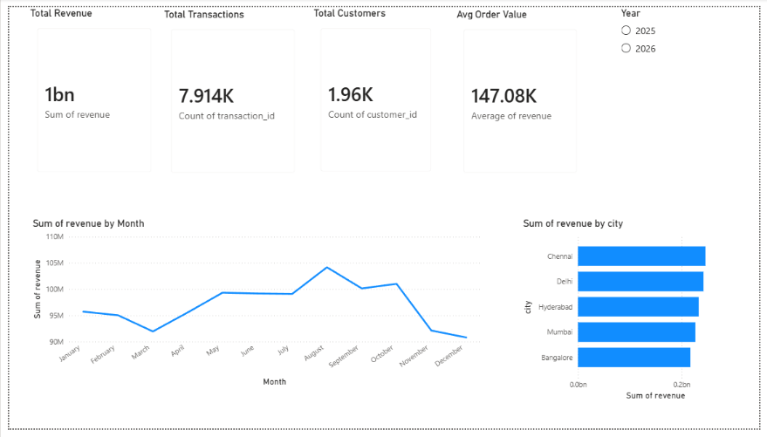

Figure 1: Revenue overview dashboard showing key KPIs and monthly trends
This is the first page a user sees when they open the dashboard. Four KPI cards run across the top of the page showing Total Revenue, Total Transactions, Total Customers, and Average Order Value. These give an immediate sense of scale and performance. Below the cards, a line chart tracks how revenue has moved from month to month, which makes seasonal patterns easy to spot. A bar chart beside it breaks revenue down by city, which shows which geographic markets are performing best. A year slicer at the top right applies across the whole page.
The main insight from this page is the monthly trend line. If there are specific months with revenue dips or spikes, those periods can be investigated further on the other pages by filtering to that time window.

Page 2: Product Performance
This page answers the question of which products are driving the most business. A horizontal bar chart shows the top ten products by total revenue, with a Top N filter applied so it always shows the current ten best performers regardless of how the data is filtered. A donut chart sits alongside it showing how each product category contributes to overall revenue as a proportion. Below these two visuals, a detailed table lists all products with their revenue, units sold, and transaction count. A category slicer allows the user to isolate one category and see how products within it compare.
A key insight visible on this page is whether the top products by revenue are the same as the top products by units sold. Sometimes a product generates high revenue because of its price rather than its volume, and spotting this distinction matters for inventory and pricing decisions.
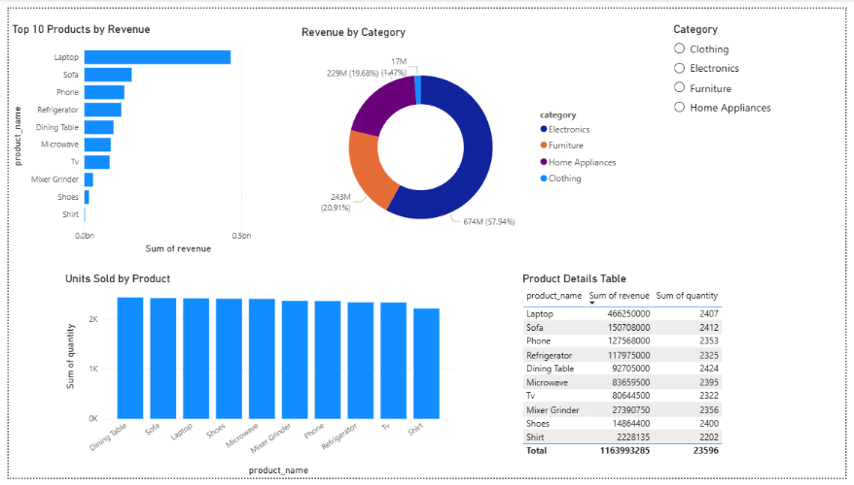

Figure 2: Product performance highlighting top products, category contribution, and sales metrics.

Page 3: Category Trends
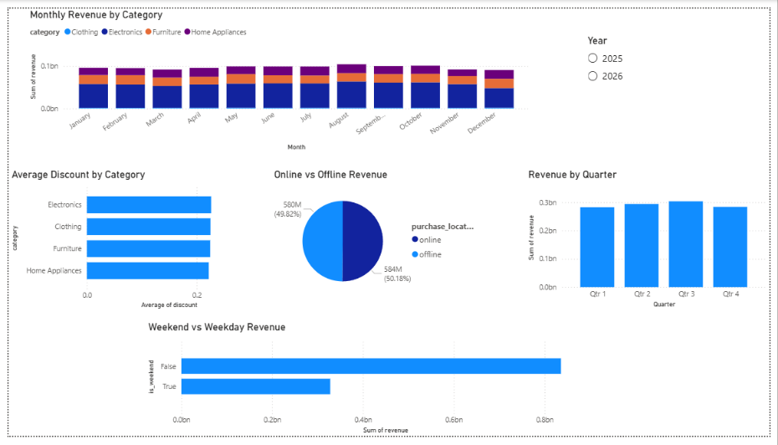

Figure 3: Category trends illustrating monthly performance, discount behavior, and channel mix.

This page is designed for understanding how different product categories behave over time. A stacked column chart shows monthly revenue split by category, which makes it easy to see whether one category is driving most of the growth or whether performance is spread across all four. An average discount bar chart sits beside it to surface whether certain categories are being discounted more heavily than others. A pie chart shows the online versus offline revenue split, and a separate chart compares performance by quarter. A year slicer allows the page to be filtered to any specific year in the dataset.
The stacked column chart is particularly useful for spotting whether seasonal trends are category-specific. For instance, if electronics revenue peaks in one specific month while clothing stays flat, that is an important signal for procurement and marketing planning.

Page 4: Regional Insights
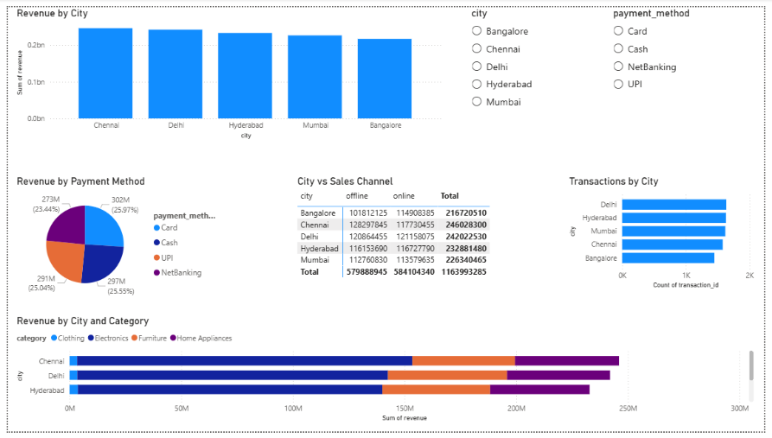

Figure 4: Regional insights displaying city-wise revenue, channel split, and payment preferences.

The final page zooms into the geographic dimension of the business. A column chart ranks all cities by total revenue, making the top and bottom performing markets immediately visible. A matrix visual breaks each city down by sales channel, showing online versus offline revenue side by side in a compact grid. A stacked bar chart then adds category detail to the city view, so it is possible to see which product types are popular in each city. Payment method preferences are shown in a pie chart, and transaction counts by city are displayed in a separate bar chart. Two slicers, one for city and one for payment method, allow the user to isolate specific combinations for deeper exploration.
One useful thing to look for on this page is whether online and offline revenue are balanced across cities, or whether certain cities rely almost entirely on one channel. That kind of imbalance often reflects differences in local market maturity or customer demographics.

9. Azure Blob Storage Setup

Microsoft Azure Blob Storage was configured as the cloud storage layer for this pipeline. The setup uses the Python Azure Storage Blob SDK to upload files directly from the notebook after the cleaning and transformation steps are complete.

9.1 Container Structure

Storage Account: neostatsretail
Container Name: retail-pipeline

retail-pipeline/
raw/
retail_data.xlsx
processed/
cleaned_retail_data.csv
rfm_segments.csv

9.2 Security
The Azure connection string is stored in a local .env file and loaded at runtime using the python-dotenv library. This file is listed in .gitignore and never committed to the GitHub repository. All PII data is hashed before any file is uploaded, so no raw personal information is stored in the cloud.

10. Setup and Usage Guide

Prerequisites
- Python 3.x installed on the machine
- Jupyter Notebook installed via pip install jupyter
- Required libraries installed from requirements.txt
- Microsoft Power BI Desktop installed
- Git and a GitHub account configured
- Microsoft Azure student account for the optional cloud upload step

10.2 Steps to Run
1. Clone the repository from GitHub to your local machine
- Run pip install -r requirements.txt to install all dependencies
- Place the raw Excel file in the data/raw/ folder
- Open a terminal in the project root and run: jupyter notebook
- Open notebooks/retail_pipeline.ipynb in the browser
- Run cells from top to bottom using Shift + Enter
- Check data/processed/ for the cleaned output files
- Open powerbi/retail_dashboard.pbix in Power BI Desktop

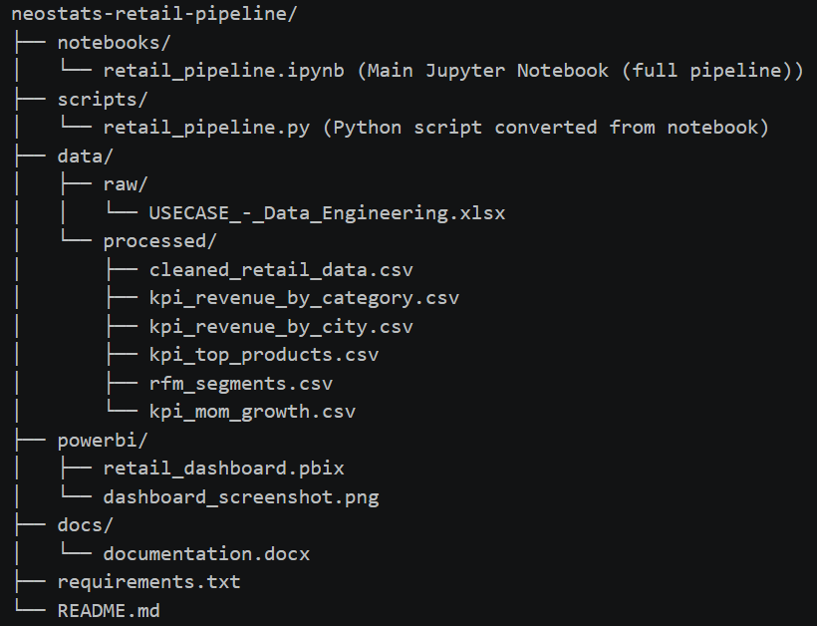
10.3 Repository Folder Structure

11. Closing Notes

This solution covers everything laid out in the assignment brief. The pipeline runs from raw Excel files through nine cleaning steps and several feature engineering transformations, producing a clean dataset that feeds directly into a four-page Power BI dashboard. Azure Blob Storage is configured for cloud-based file storage, and all code, documentation, and dashboard files are organized in a GitHub repository.
A few extra things were added beyond the core requirements. The RFM customer segmentation provides the business with a practical tool for targeting different customer groups. The Month-over-Month growth analysis makes trend momentum visible at a glance. The Discount Impact Analysis helps the business question whether its discounting strategy is actually working. And throughout the notebook, logging was added at each major step so that the pipeline is easy to debug and audit.
If this pipeline were to be extended for production use, the next natural step would be to automate it with a scheduling tool so that new transaction batches could be processed automatically rather than run manually. The architecture is already set up in a way that would make this transition straightforward.

