TraffiSense: An Explainable, Digital-Twin-Driven Intelligent Traffic Management and Violation Detection System
Sachin Nair  Dept. of Computer Engineering  Pillai College of Engineering  Navi Mumbai, India  nsachin23comp@student.mes.ac.in | Aditya Vijay Kumar  Dept. of Computer Engineering  Pillai College of Engineering  Navi Mumbai, India  [email] | Ranjit Iyer  Dept. of Computer Engineering  Pillai College of Engineering  Navi Mumbai, India  [email]
Dr. Siddharth Hariharan
Dept. of Computer Engineering
Pillai College of Engineering
Navi Mumbai, India
[email]

Abstract—Indian urban junctions combine heterogeneous, lane-less traffic with frequent helmet, triple-riding and red-light violations, while enforcement and signal timing still depend largely on manual observation and fixed plans. This paper surveys the methods that underpin automated traffic enforcement and adaptive signal control, and presents an integrated system built on them for Indian roads. Video from junction cameras is analysed with a YOLO detector trained on the India Driving Dataset and ByteTrack tracking; dedicated modules check helmet use, triple riding, red-light jumping and speed, read Indian number plates and recognise emergency vehicles for exemption. Every module is precision-first: a violation is reported only when the evidence is certain, uncertain cases are routed to a human reviewer, and confirmed cases become e-challans with fingerprinted evidence on a web platform. For signal control, a Unity-based simulator of an Indian four-arm junction models mixed traffic, red-light jumping, free left turns and bus-stop spillback, and is used to evaluate PRAVAH, a person-weighted, red-patience-aware adaptive controller proposed in this work. In simulation PRAVAH gave the lowest mean wait per person in all six test scenarios, 17–47 % below a queue-pressure adaptive controller in five of them and on par near capacity. The detection modules make few wrong calls on held-out videos at the cost of coverage, which remains the main limitation.
Keywords—Intelligent Transportation Systems, Traffic Violation Detection, Adaptive Traffic Signal Control, Automatic Number Plate Recognition, Helmet Detection, Mixed Traffic, Microscopic Traffic Simulation, Computer Vision
I. INTRODUCTION
Road traffic in Indian cities is unlike the lane-disciplined traffic for which most enforcement and signal-control systems were designed. Two-wheelers make up a large share of vehicles and move between lanes, autorickshaws, buses and trucks share the same carriageway, and left turns are often free. Common violations such as riding without a helmet, carrying three people on a two-wheeler and jumping a red light are frequent, yet they are still largely detected by police officers watching camera feeds or standing at junctions. At the same time, many junctions run fixed signal plans that do not respond to the traffic actually waiting.
Computer vision has made it practical to detect vehicles in camera video in real time [4], and large datasets collected from Indian traffic cameras [5] make it possible to train detectors for local vehicle types. Recent work has applied these detectors to helmet and triple-riding violations [6]–[9]. However, an enforcement system has a stricter requirement than a detector benchmark: a wrong challan affects a citizen, so a system must know when it is not sure. Similarly, adaptive signal control has a long history [1]–[4], but most methods measure demand in vehicles and assume orderly queues, which fits Indian mixed traffic poorly.
This paper reviews ten recent works (2025–2026) on adaptive signal control, emergency-vehicle priority, object detection, Indian traffic data, two-wheeler violation detection and low-resolution number-plate recognition, identifies the gaps that matter for Indian junctions, and describes an integrated system that addresses them. The main contributions are:
- An end-to-end, precision-first violation pipeline for Indian traffic video: shared detection and tracking, modules for helmet, triple riding, red light and speed, an Indian number-plate reader with explicit READ / NOT SURE / UNREADABLE outputs, and emergency-vehicle exemption, feeding a review and e-challan web platform.
- A Unity-based microscopic simulator of an Indian four-arm junction with lane-less two-wheelers, red-light jumping, free left turns, bus-stop spillback and stray cattle, with a Python bridge so that controllers written in Python can run the simulated signal.
- PRAVAH, an adaptive signal controller that weights waiting people rather than vehicles, penalises long red waits that lead to red-light jumping, learns each approach’s discharge rate online, avoids feeding a blocked junction and times ambulance priority.
- An evaluation against fixed-time, Webster-designed and queue-pressure adaptive control on identical simulated traffic, together with held-out video results for the detection modules.
II. LITERATURE SURVEY
A. Adaptive and intelligent signal control
Classical practice designs fixed-time plans with Webster’s method, and adaptive systems change timing from detector measurements. Tolani et al. [1] automate signal timing from the density of approaching vehicles: proximity sensors placed upstream of the signal measure vehicle speed and density, and a machine-learning model built on the Edge Impulse platform predicts the density and arrival time of vehicles, so that green times follow real-time demand instead of preset timers. Lai et al. [2] take a different route with LLMLight, in which a large language model receives a prompt describing current traffic and reasons about which phase to serve; a specialised backbone, LightGPT, was trained for the task, and the framework was evaluated on ten real and synthetic datasets and by fifteen human experts, improving generalisation and interpretability over reinforcement-learning controllers. Both measure demand per vehicle and assume lane-based queues.
B. Emergency-vehicle priority
Alruwaili et al. [3] address emergency response times with a system that detects ambulances from both sound and video, using an LSTM network on MFCC spectrograms for sirens and a ResNet18 network for images, and gives the ambulance priority at Raspberry Pi-controlled signals. Like most preemption schemes, priority is granted as soon as the ambulance is detected, which interrupts other approaches regardless of the queue in front of the ambulance.
C. Detection models and Indian traffic data
YOLOv12 by Tian et al. [4] brings attention mechanisms into the YOLO family while keeping real-time speed; its smallest model reaches 40.6 % mAP on COCO at 1.64 ms per image on a T4 GPU. For Indian roads, the UVH-26 dataset of Sharma et al. [5] provides 26,646 full-HD images from about 2,800 Bengaluru Safe-City CCTV cameras with 1.8 million boxes over 14 Indian vehicle classes, including two-wheelers, autorickshaws and tempo-travellers, labelled through a hackathon of 565 students, together with detection models trained on it.
D. Two-wheeler violation detection
Deshpande et al. [6] detect helmet violations in Indian smart-city scenes in two stages, a DetectNet_v2 model to localise riders followed by YOLOv8 for helmets and number plates, reporting 98.56 % helmet and 97.6 % plate detection accuracy on 1,715 images. The same group [7] detects triple riding from surveillance cameras at different heights and angles, reporting 91.42 % triple-rider, 98 % two-wheeler and 81 % plate detection accuracy. Saravanan and Rajini [8] classify double and triple riders with a modified Mask R-CNN using ResNet-50 and DenseNet-121 backbones, reaching 97.93 % triple-rider detection accuracy. Rawat et al. [9] build DashCop, an end-to-end system that generates e-tickets from dashcam video, with a module that associates riders with their motorcycles and a new annotated dataset, RideSafe-400.
E. Low-resolution number plates
Laroca et al. [10] organised the ICPR 2026 competition on low-resolution licence plate recognition, built on the LRLPR-26 dataset of 20,000 training and 3,000 test tracks, each pairing low-resolution and high-resolution images of the same plate captured by real surveillance cameras. It highlights that long capture distances and compression make plates illegible, which is exactly the situation of plates on wide junction cameras.
TABLE I
SUMMARY OF THE SURVEYED LITERATURE
SR NO | PAPER | SUMMARY
1 | M. Tolani, G. E. Saathwik, A. Roy, L. A. Ameeth, D. B. Rao, A. Bajpai and A. Balodi, “Machine Learning Based Adaptive Traffic Prediction and Control Using Edge Impulse Platform,” Scientific Reports, 2025 [1] | Proposes an autonomous signal-timing system driven by the density of vehicles approaching the signal. Proximity sensors placed at a fixed distance upstream measure vehicle speed and density, and an Edge-Impulse machine-learning model predicts density and arrival time. Signal timings are adjusted in real time instead of using preset timers, reducing congestion and delay. [1]
2 | S. Lai, Z. Xu, W. Zhang, H. Liu and H. Xiong, “LLMLight: Large Language Models as Traffic Signal Control Agents,” ACM SIGKDD (KDD), 2025 [2] | Uses a large language model as the decision agent for traffic signal control, prompted with real-time traffic conditions. A specialised backbone, LightGPT, is trained for signal control to reduce cost. Experiments on ten real and synthetic datasets and evaluation by fifteen human experts show better generalisation and interpretability than reinforcement-learning methods. [2]
3 | M. Alruwaili, A. Ali, M. Almutairi, A. Alsahyan and M. Mohamed, “LSTM and ResNet18 for Optimized Ambulance Routing and Traffic Signal Control in Emergency Situations,” Scientific Reports, 2025 [3] | Presents a real-time traffic management system to reduce emergency medical response times. Sirens are detected with an LSTM on MFCC spectrograms and ambulances in images with a transfer-learned ResNet18; the outputs drive Raspberry Pi-based signal prioritisation. Priority is granted on detection. [3]
4 | Y. Tian, Q. Ye and D. Doermann, “YOLOv12: Attention-Centric Real-Time Object Detectors,” arXiv, 2025 [4] | Introduces an attention-centric YOLO framework that keeps the speed of CNN-based detectors while gaining the accuracy of attention. YOLOv12-N reaches 40.6 % mAP with 1.64 ms latency on a T4 GPU, outperforming earlier real-time detectors. [4]
5 | A. Sharma et al., “The Urban Vision Hackathon Dataset and Models: Towards Image Annotations and Accurate Vision Models for Indian Traffic,” arXiv, 2025 [5] | Releases UVH-26: 26,646 1080p images from about 2,800 Bengaluru Safe-City CCTV cameras, annotated by 565 students with 1.8 million boxes over 14 Indian vehicle classes such as two-wheeler, auto-rickshaw and tempo-traveller, along with detection models trained on the data. [5]
6 | U. U. Deshpande et al., “Computer-Vision Based Automatic Rider Helmet Violation Detection and Vehicle Identification in Indian Smart City Scenarios Using NVIDIA TAO Toolkit and YOLOv8,” Frontiers in Artificial Intelligence, 2025 [6] | A two-stage system: DetectNet_v2 localises riders and YOLOv8 detects helmet violations and extracts number plates. On a custom dataset of 1,715 motorcycle images from Indian roads it reports 98.56 % helmet detection and 97.6 % number-plate detection accuracy. [6]
7 | U. U. Deshpande et al., “Automatic Two-Wheeler Rider Identification and Triple-Riding Detection in Surveillance Systems Using Deep-Learning Models,” Discover Artificial Intelligence, 2025 [7] | Detects triple riding from surveillance cameras mounted at different heights and angles. A ResNet18-based DetectNet_v2 handles occlusion and distant vehicles, and YOLOv8 counts riders and reads plates, reporting 91.42 % triple-rider, 98 % two-wheeler and 81 % number-plate detection accuracy. [7]
8 | M. Saravanan and G. K. Rajini, “Automatic Detection of Triples Rider Violations Using an Optimized Mask R-CNN Framework,” Systems Science & Control Engineering, 2025 [8] | Classifies double and triple riders, with and without motorcycles, using a modified Mask R-CNN with DenseNet-121 and ResNet-50 networks. Reports 97.93 % triple-rider detection, 97.41 % double/triple classification and 98.22 % segmentation accuracy across weather conditions. [8]
9 | D. Rawat, K. Gupta, A. B. Roy and R. K. Sarvadevabhatla, “DashCop: Automated E-ticket Generation for Two-Wheeler Traffic Violations Using Dashcam Videos,” arXiv, 2025 [9] | An end-to-end system that processes vehicle-mounted dashcam video to detect triple riding and helmet non-compliance and generate e-tickets. A segmentation and cross-association module links riders to their motorcycles, and the RideSafe-400 annotated video dataset is released for evaluation. [9]
10 | R. Laroca et al., “ICPR 2026 Competition on Low-Resolution License Plate Recognition,” ICPR, 2026 [10] | Reports the first competition dedicated to low-resolution plate recognition on real surveillance data. The LRLPR-26 dataset has 20,000 training and 3,000 test tracks of paired low- and high-resolution plate images, showing how distance and compression make plates hard to read. [10]

F. Gaps for Indian junctions
Table I summarises the surveyed works. Four gaps stand out. First, the signal controllers [1], [2] measure demand in vehicles, while Indian junctions mix two-wheelers carrying one or two people with buses carrying forty, so a vehicle count is a poor measure of who is waiting; they also do not treat long red waits, which provoke red-light jumping, as a risk. Second, emergency priority [3] is granted immediately rather than timed to the queue ahead of the ambulance. Third, the violation detectors [6]–[9] are evaluated by accuracy on test images; an enforcement system must also know when it is not sure, because a wrong challan affects a citizen, and plates on wide camera views are often too small to read [10]. Fourth, enforcement and signal control are studied separately, although they use the same cameras and the same vehicle tracks.
III. PROPOSED SYSTEM
The proposed system (Fig. 1) has one shared video-analysis layer feeding two uses: enforcement, which produces evidence and e-challans, and signal control, which uses the measured traffic to choose signal timing. All modules follow one rule: an automatic decision is made only when the evidence is certain; otherwise the case goes to a human reviewer, and nothing is printed or charged on a guess.
A. Shared detection and tracking
Each video is sampled at five frames per second. A YOLO11 detector trained on the India Driving Dataset (IDD) finds vehicles, riders and people, and the ByteTrack tracker keeps one identity per vehicle across frames; track fragments of the same vehicle are merged when one starts where another ended. The same tracks are reused by every module, so a vehicle is decided once even if several modules examine it.
B. Violation modules
The helmet module classifies each rider’s head on enlarged crops and votes over at least three frames, reporting “no helmet” only above a strict threshold. The triple-riding module counts riders on each two-wheeler with a “not sure” band between its two thresholds. The red-light module reads the signal state and checks stop-line crossing during red. The speed module reports a calibrated speed range with a confidence level rather than a single number. Lane structure is estimated from traffic motion for context only and never creates a challan.
C. Identity and exemption
The number-plate reader searches inside each tracked vehicle, enlarged to 640 pixels, reads each plate crop with a recogniser fine-tuned on Indian plates, votes character by character across frames and checks the Indian registration format. Each vehicle is labelled READ, NOT SURE or UNREADABLE, and only READ plates are printed. An emergency-vehicle classifier on CLIP image features exempts ambulances, police and fire vehicles, sending borderline cases to review.
D. Review and e-challan platform
A FastAPI and React web platform stores each analysis, shows the video with every finding on a timeline, routes uncertain findings to reviewers and issues a PDF e-challan for confirmed cases. Every challan carries fingerprinted evidence frames and a plain-language explanation of why it was raised.
E. Signal control and simulation
The signal-control part is evaluated in a simulator of an Indian four-arm junction, described in Section IV. The measured traffic of an analysed video can be loaded into the simulator, so that controllers can be compared on traffic recorded at a real junction; such results are always labelled as simulated.
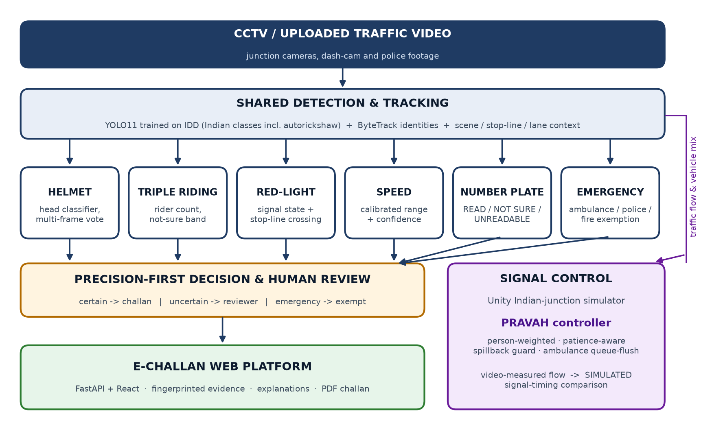
Fig. 1. Architecture of the proposed system: shared video analysis feeding precision-first enforcement and signal control.
F. PRAVAH controller
PRAVAH (Person-weighted, Red-patience-Aware, Vehicle-mix Adaptive Headway control) serves one approach at a time, which is common at Indian junctions. It uses only what the junction camera reports within 100 m of the stop line. A person who has waited w seconds contributes an urgency
U(w) = 1 + (w / τ)², τ = 75 s (1)
so that long waits, which lead to red-light jumping, become expensive quickly. Each waiting vehicle counts its typical occupants (about 40 for a bus, 1.4 for a two-wheeler). The time needed to clear approach a is
C_{a} = 2 + Q_{a} / ŝ_{a} (2)
where Qₐ is the queued load in passenger-car units and ŝₐ the discharge rate, initialised from the Indian Roads Congress saturation flow of 525 PCU/h per metre of approach width and learned online from the vehicles that actually cross during green. The gain of serving approach a next is
G_{a} = Σ p_{i} U(w_{i}) · φ(o_{a}) / (C_{a} + L) (3)
where pᵢ are occupants, L = 5 s is the amber and all-red loss, and φ(o) = clip(1 − (o − 0.5)/0.4, 0, 1) discounts an approach whose exit is more than half full, so the controller does not feed a blocked junction box. After clearing its planned queue, a green continues only while it relieves more urgency per second (ŝₐ times the urgency per PCU of the remaining queue) than the best other approach would; any approach that has waited 90 s is served next. For an ambulance, the switch is timed so that its queue has cleared when it arrives: the green changes when its estimated arrival time falls below its clearance time plus L and 2 s.
IV. IMPLEMENTATION
The video pipeline is written in Python with Ultralytics YOLO11, ByteTrack, OpenCV and PyTorch; detectors and classifiers were trained on Kaggle T4 GPUs. The number-plate recogniser is a fine-tuned compact transformer OCR model exported to ONNX. The web platform uses FastAPI with SQLite and a React and TypeScript front end.
The simulator is built in Unity 6 with C#. Its core is a headless microscopic model with a 0.1 s step: vehicles follow the Intelligent Driver Model, drive on the left, and arrive with a typical Indian mix (38 % two-wheelers, 28 % cars, 16 % autorickshaws, 8 % trucks, 6 % buses, 4 % bicycles), weighted with Indian Roads Congress passenger-car units (0.5 for a two-wheeler, 1.2 for an autorickshaw, 2.2 for a bus or truck). Two-wheelers take lateral positions across the lane and creep past the stop line; each driver has a patience after which they jump the red; left turns are free; buses and autos stop just past the junction; a vehicle stuck in the junction box blocks cross traffic; stray cattle occasionally block the kerb lane. A three-dimensional view with day, night and monsoon lighting and eight camera modes, including junction CCTV views with detection boxes, is used for demonstration (Fig. 2).
Four controllers are compared on identical arrivals: a fixed 30 s rotation, a fixed-time plan designed with Webster’s method [1] from the true flows, a queue-pressure adaptive controller, and PRAVAH. A TCP bridge lets Python controllers run the simulated signal; a shadow test, in which the C# and Python implementations of PRAVAH received identical states, found no disagreement in 83,702 decisions. The web platform can run all controllers on the traffic measured from an analysed video.
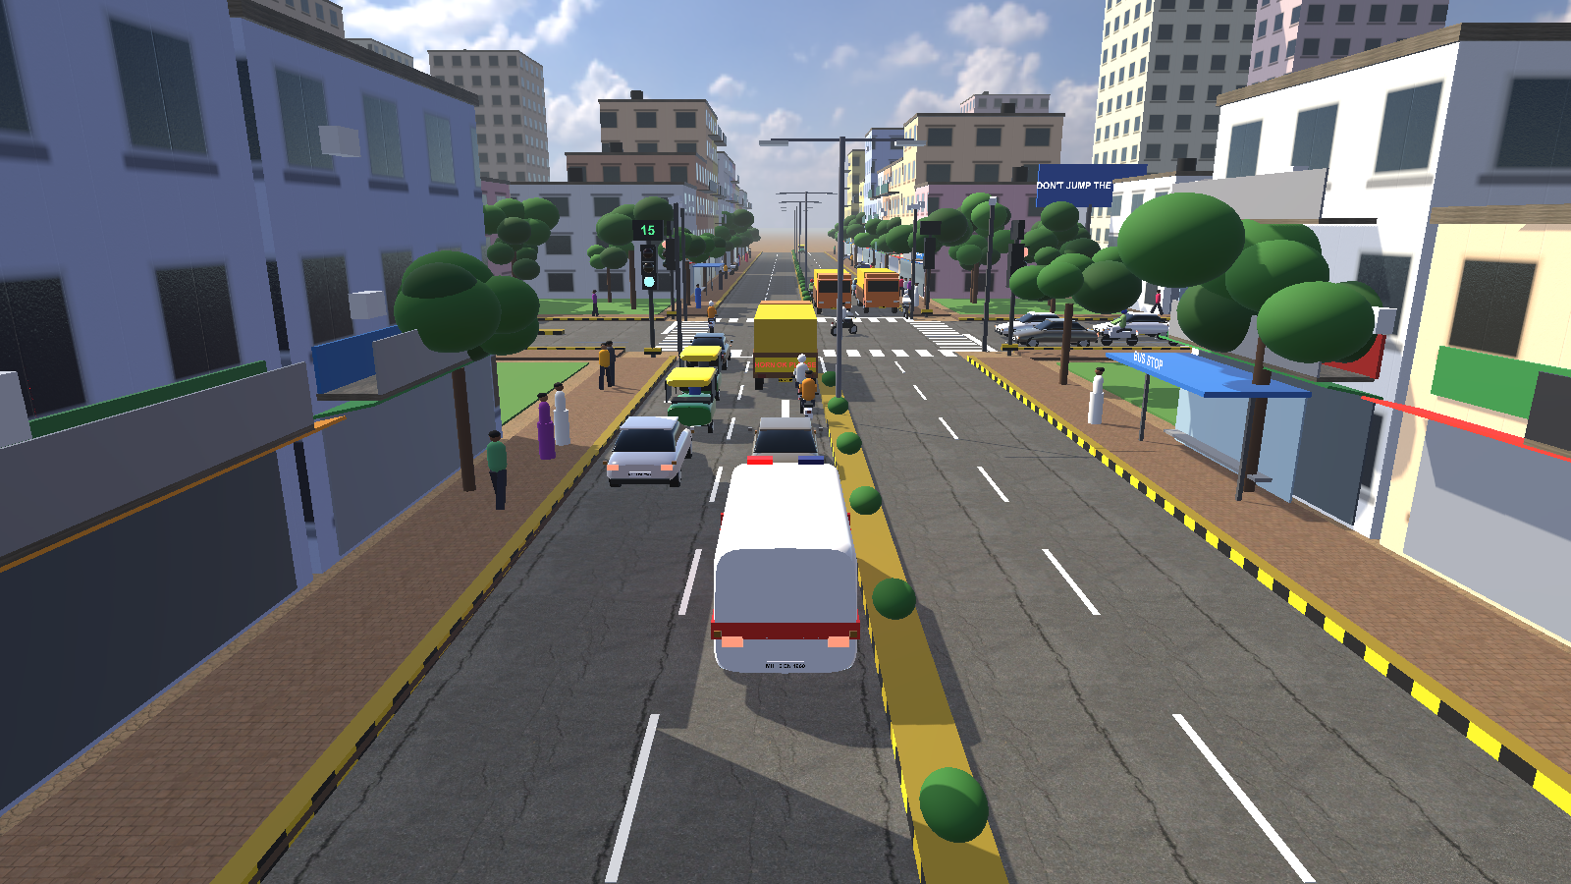
Fig. 2. The Unity junction simulator: chase view behind an ambulance on an Indian arterial (CC0 photographic sky and road textures).
V. RESULTS AND DISCUSSION
A. Signal control in simulation
Each controller was run for 30 simulated minutes in six scenarios with three random seeds, all controllers receiving the same arrivals in each seed. Table II and Fig. 3 report the mean wait per person, that is, time stopped before the stop line weighted by occupants. PRAVAH gave the lowest wait per person in every scenario. Compared with the queue-pressure adaptive controller it was 42 % lower in balanced city traffic, 17 % lower in the office rush, 35 % lower on the market road, 47 % lower at night and 21 % lower in the ambulance-heavy scenario. Ambulances waited 0.1–0.4 s on average in five scenarios and 7.6 s near capacity.
The gains are not uniform. Near capacity PRAVAH was on par with the adaptive controller (73.8 s against 75.7 s), with a longer worst-case wait (295 s against 268 s) and slightly more red-light jumps. In the ambulance-heavy scenario its worst wait was 148 s against 101 s. These results come from a simulator whose driver-behaviour parameters (patience, dwell times) are estimates, so they show how the controllers compare rather than predict real delays.
Running an earlier, rule-based adaptive controller of the project through the Python bridge gave a further finding: it performed well in moderate traffic but broke down near capacity, with a mean wait of 98.7 s, throughput falling to 2,339 vehicles/h and 486 vehicles left queued. The lack of a waiting-time limit and of a spillback check explains this, and motivated both features in PRAVAH.
TABLE II
MEAN WAIT PER PERSON (S) IN SIMULATION — 30 MIN, 3 SEEDS, IDENTICAL ARRIVALS
Scenario | Fixed 30 s | Webster | Queue-pressure adaptive | PRAVAH (proposed) | PRAVAH vs adaptive
City balanced | 38.9 | 36.3 | 26.9 | 15.5 | −42 %
Office rush (N–S) | 89.8 | 36.3 | 23.3 | 19.4 | −17 %
Market road (cattle, bus stops) | 41.5 | 30.7 | 22.3 | 14.4 | −35 %
Peak near capacity | 87.0 | 98.1 | 75.7 | 73.8 | −3 %
Night | 31.6 | 11.1 | 5.5 | 2.9 | −47 %
Ambulance corridor | 41.0 | 29.6 | 20.2 | 15.9 | −21 %

TABLE III
DETECTION MODULES ON HELD-OUT DATA
Module | Held-out test | Result | Design choice
Number-plate reader | 299 Indian plate images | 81.6 % plates and 95.6 % characters exact; at the operating point it answers for 64 %, 99.5 % correct | Reads only when certain
Helmet | 7 unseen videos, 367 riders | 4 wrong decisions; 44 % sent to review; 27 of 81 no-helmet riders caught | Avoid wrong challans
Triple riding | Held-out cameras, 980 bikes, 125 triples | 50 triples caught (40 %), 0 wrong, 8.3 % not sure | Never wrong on test
Emergency exemption | 170 emergency, 2,450 ordinary vehicles | 58 % exempted automatically, 84 % exempted or reviewed; 0 ordinary vehicles wrongly exempted | No wrongful exemption
Speed | Calibrated demonstration video | Mean error 9.1 %; 90 % range contains the true speed for 90 % of vehicles | Range, not a point value

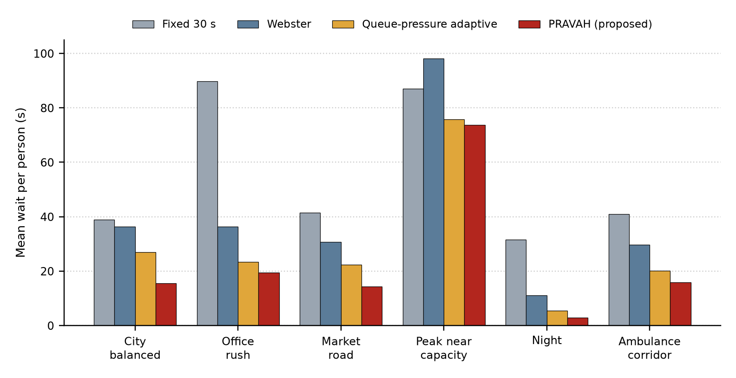
Fig. 3. Mean wait per person by controller and scenario (lower is better).
B. Detection modules on held-out data
Table III summarises the detection modules on data not used for training. All operating points were chosen to avoid wrong decisions, so coverage is the limiting factor. On still plate images the reader answers for 64 % of plates and is correct for 99.5 % of those; on street video, however, plates are often too small, and only about 1–3 % of vehicles received a READ result in the test clips. Retraining the plate detector on enlarged vehicle crops from Indian street video is in progress to address this.
VI. FUTURE SCOPE
The most important next step is coverage of the detection modules on street-level video, where plates and riders are small: retraining the plate detector on enlarged vehicle crops, and labelling more camera views, including phone footage, for helmet and triple-riding detection. For signal control, a sensitivity study over driver patience, dwell times, camera range and demand is under way to test whether PRAVAH’s advantage holds when the simulator’s assumptions change. Field validation with measured queue lengths at a real junction, coordination of neighbouring junctions along a corridor, pedestrian phases and deployment on edge devices beside the camera are further directions.
VII. CONCLUSION
This paper reviewed ten recent works (2025–2026) on adaptive signal control, emergency priority, detection, Indian traffic data, two-wheeler violations and low-resolution number plates, and identified four gaps for Indian junctions: demand measured in vehicles rather than people and long waits not treated as a cause of red-light jumping, emergency priority not timed to the queue, detection evaluated by accuracy rather than by its ability to abstain, and enforcement separated from signal control. The proposed system addresses them with a precision-first violation pipeline and e-challan platform, an Indian junction simulator, and the PRAVAH controller. In simulation PRAVAH reduced the mean wait per person in every scenario tested, by 17–47 % against a queue-pressure adaptive controller in five of six scenarios, while being on par near capacity. On held-out video the detection modules made few wrong decisions, and their limited coverage on street-level footage is the main area for further work.
REFERENCES
[1] M. Tolani, G. E. Saathwik, A. Roy, L. A. Ameeth, D. B. Rao, A. Bajpai and A. Balodi, “Machine learning based adaptive traffic prediction and control using edge impulse platform,” Scientific Reports, vol. 15, art. 17161, 2025, doi: 10.1038/s41598-025-00762-4.
[2] S. Lai, Z. Xu, W. Zhang, H. Liu and H. Xiong, “LLMLight: Large language models as traffic signal control agents,” in Proc. 31st ACM SIGKDD Conf. Knowledge Discovery and Data Mining (KDD), vol. 1, 2025, pp. 2335–2346, doi: 10.1145/3690624.3709379.
[3] M. Alruwaili, A. Ali, M. Almutairi, A. Alsahyan and M. Mohamed, “LSTM and ResNet18 for optimized ambulance routing and traffic signal control in emergency situations,” Scientific Reports, vol. 15, art. 6011, 2025, doi: 10.1038/s41598-025-89651-4.
[4] Y. Tian, Q. Ye and D. Doermann, “YOLOv12: Attention-centric real-time object detectors,” arXiv:2502.12524, 2025.
[5] A. Sharma, C. Mhatre, S. Gawali, R. Bokkasam, B. Kishore, V. Pattanaik, T. Rambha, A. R. Pinjari, V. Kovvali, A. Chakraborty, P. Rathore, R. Krishnapuram and Y. Simmhan, “The Urban Vision Hackathon dataset and models: Towards image annotations and accurate vision models for Indian traffic,” arXiv:2511.02563, 2025.
[6] U. U. Deshpande, G. K. O. Michael, S. D. C. S. Araujo, V. Deshpande, R. Patil, R. A. A. Chate, V. R. Tandur, S. S. Goudar, S. Ingale and V. Charantimath, “Computer-vision based automatic rider helmet violation detection and vehicle identification in Indian smart city scenarios using NVIDIA TAO toolkit and YOLOv8,” Frontiers in Artificial Intelligence, vol. 8, art. 1582257, 2025, doi: 10.3389/frai.2025.1582257.
[7] U. U. Deshpande, S. Shanbhag, R. Patil, R. A. A. Chate, S. D. C. S. Araujo, K. Pinto, J. Arjun, M. Patil and B. Nirwani, “Automatic two-wheeler rider identification and triple-riding detection in surveillance systems using deep-learning models,” Discover Artificial Intelligence, vol. 5, art. 104, 2025, doi: 10.1007/s44163-025-00263-3.
[8] M. Saravanan and G. K. Rajini, “Automatic detection of triples rider violations using an optimized mask R-CNN framework,” Systems Science & Control Engineering, vol. 13, no. 1, art. 2546829, 2025, doi: 10.1080/21642583.2025.2546829.
[9] D. Rawat, K. Gupta, A. B. Roy and R. K. Sarvadevabhatla, “DashCop: Automated e-ticket generation for two-wheeler traffic violations using dashcam videos,” arXiv:2503.00428, 2025.
[10] R. Laroca et al., “ICPR 2026 competition on low-resolution license plate recognition,” in Proc. Int. Conf. Pattern Recognition (ICPR), 2026, arXiv:2604.22506.

