Object in Java Script

Object in a data type in java script. Object helps to store multiple data related to a particular item in a single variable. Objects in JavaScript, just as in many other programming languages, can be compared to objects in real life . In JavaScript an object is a standalone entity, with properties and type. Compare it with a cup, for example. A cup is an object with properties . A cup has a colour, a desigh, a weigh, a material which made of etc. Likewise JavaScript object can have properties, which define their characteristics.

Objects, in JavaScript, is it’s most important data-type and forms the building blocks for modern JavaScript. These objects are quite different from JavaScript’s primitive data-types(Number, String, Boolean, null, undefined and symbol) in the sense that while these primitive data-types all store a single value each (depending on their types)

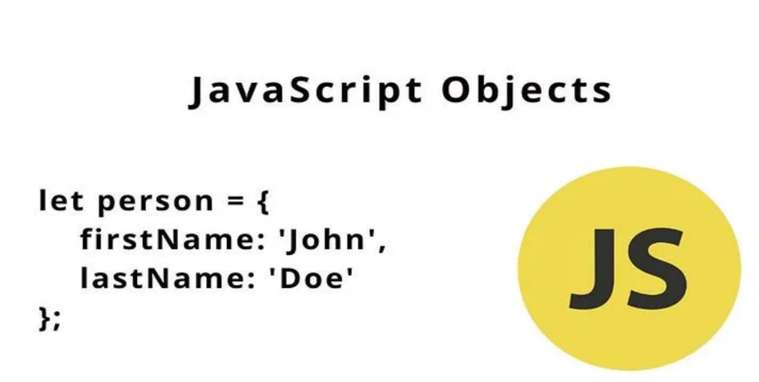

**Objects and properties**

A JavaScript object has properties associated with it. A property of an object can be explained as a variable that is attached to the object. Object properties are basically the same as ordinary JavaScript variables, except for the attachment to objects. The properties of an object define the characteristics of the object. You access the properties of an object with a simple dot-notation:

objectName.propertyName

In JavaScript, almost "everything" is an object.

* Booleans can be objects (if defined with the new keyword)
* Numbers can be objects (if defined with the new keyword)
* Strings can be objects (if defined with the new keyword)
* Dates are always objects
* Maths are always objects
* Regular expressions are always objects
* Arrays are always objects
* Functions are always objects
* Objects are always objects

All JavaScript values, except primitives, are objects.

Objects are complex and each object may contain a combination of primitive data-types as well as reference data-types.  
An object is a reference data type. Variables that are assigned a reference value are given a reference or a pointer to that value. That reference or pointer points to the location in memory where the object is stored. The variables don’t actually store the value.

Otherway around, objects in JavaScript may be defined as an unordered collection of related data, of primitive or reference types, in the form of “key: value” pairs. These keys can be variables or functions and are called properties and methods, respectively, in the context of an object.  
An object can be created with figure brackets {} with an optional list of properties. A property is a “key: value” pair, where a key is the property name value can be anything.