**Module 2: EC2 and EFS Assignment**

**1. Create an EFS and connect it to 3 different EC2 instances. Make sure that all instances have different operating systems. For instance, Ubuntu, Red Hat Linux and Amazon Linux 2.**

**Create 3 Instances with RedHat, Amazon-Linux & Ubuntu OS:**

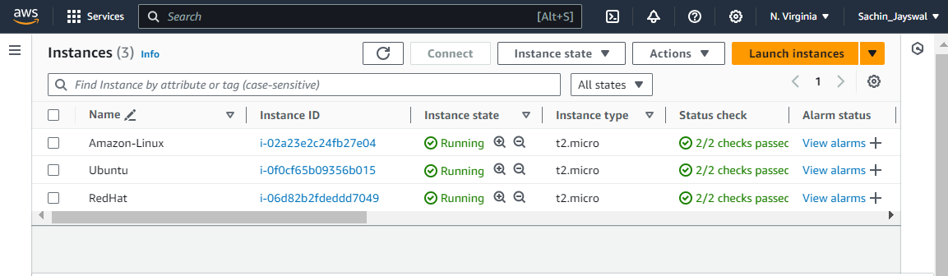

**Go to EFS and Create New EFS**

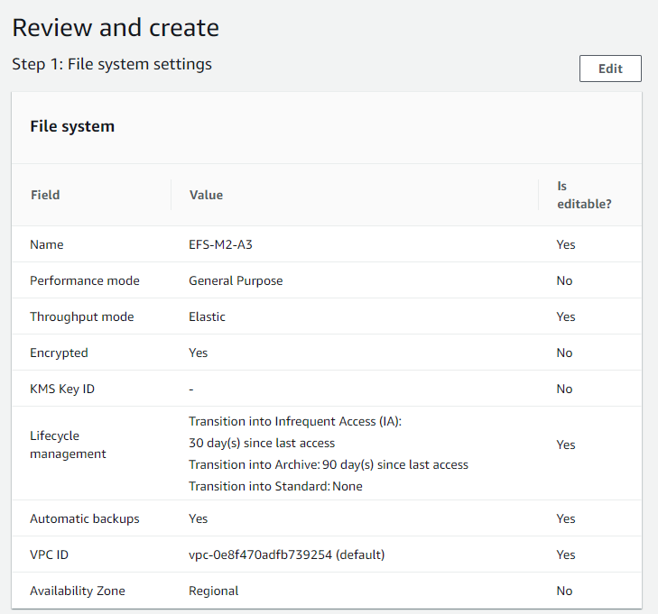

**Select the EFS and Click View Details**

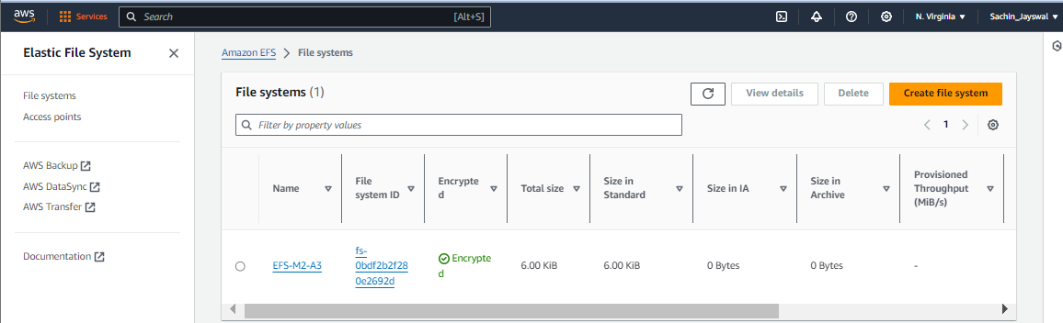

**Select the Mount via IP**

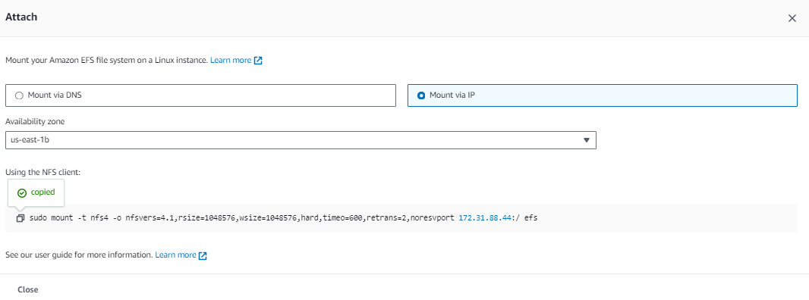

**Go to Network and take the SG group name for the server in which availability zone it is.**

**Add the IP range of your Servers in Inbound rule of that SG group**

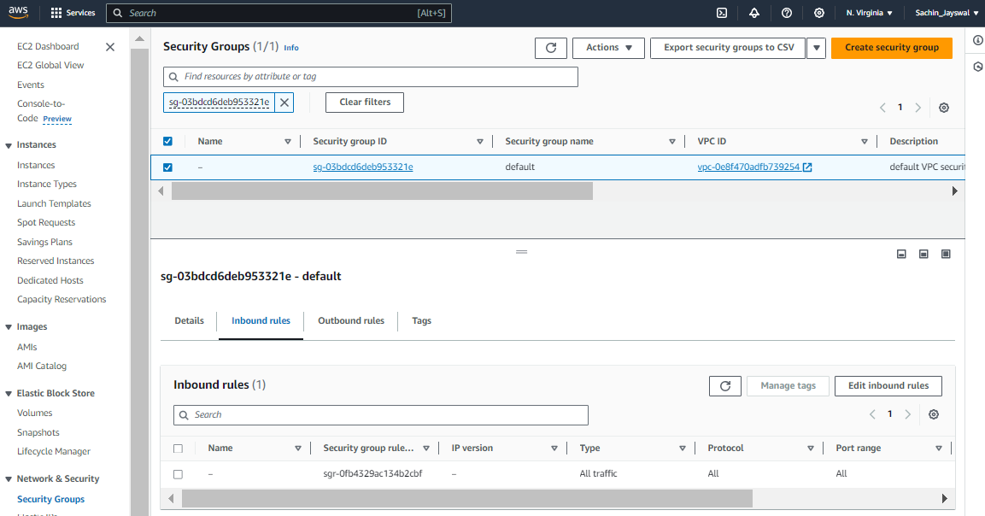

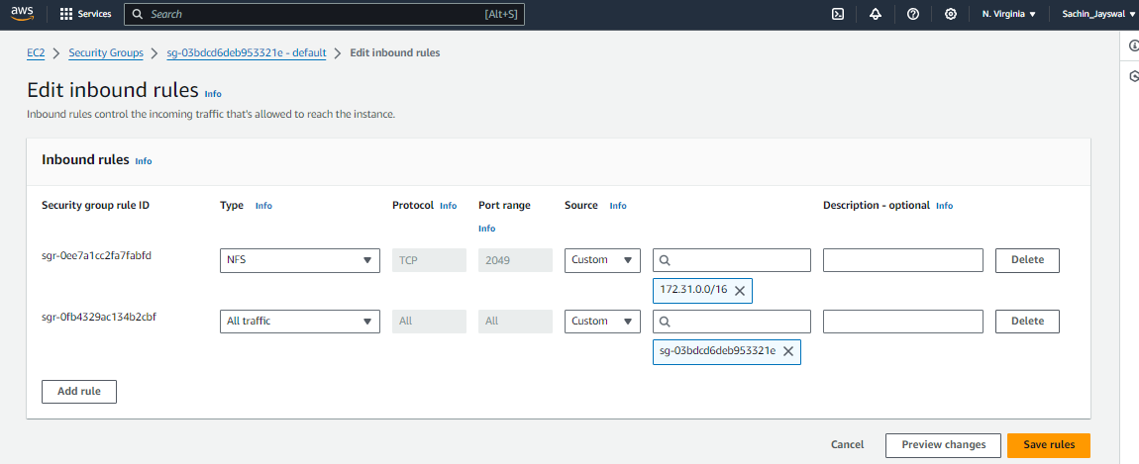

**1.**

**Setup/Mount you EFS to 1st Server by following below command in snippet:**

**Create a folder EFS & Add file to it**

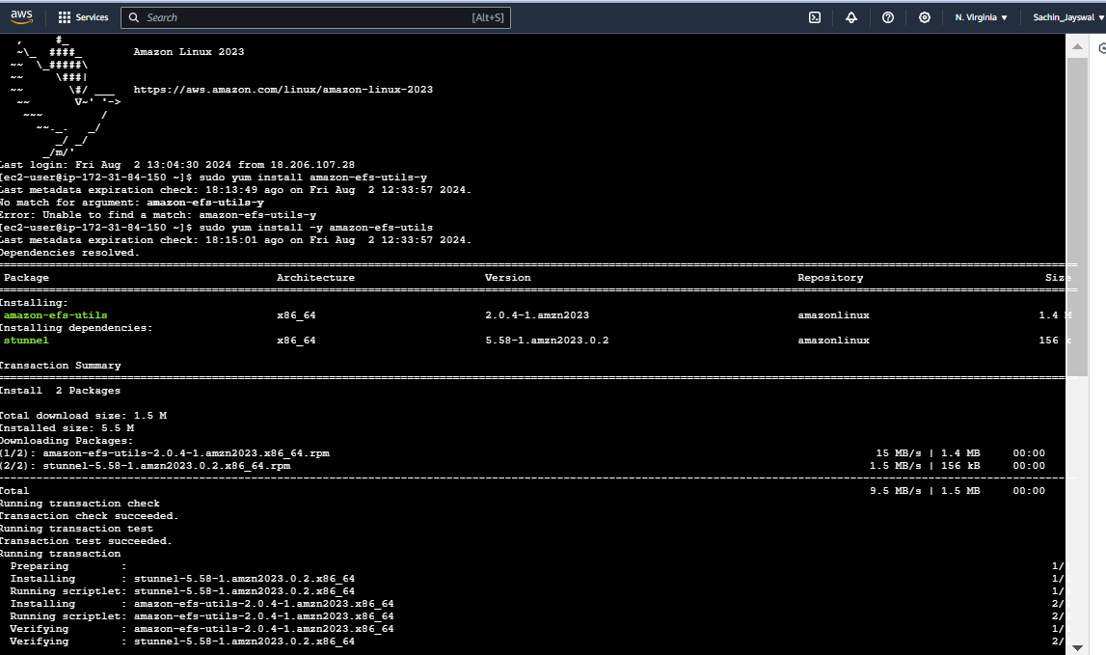

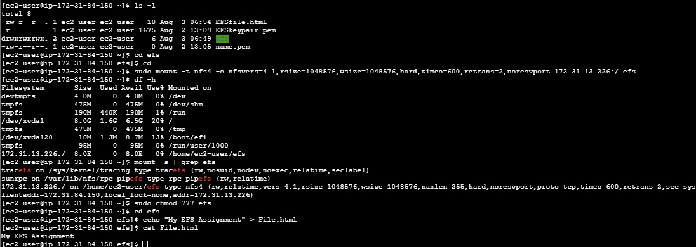

**2.**

**Setup/Mount you EFS to 2nd Server by following below command in snippet:**

**Create a folder EFS & View file which you saved in 1st server.**

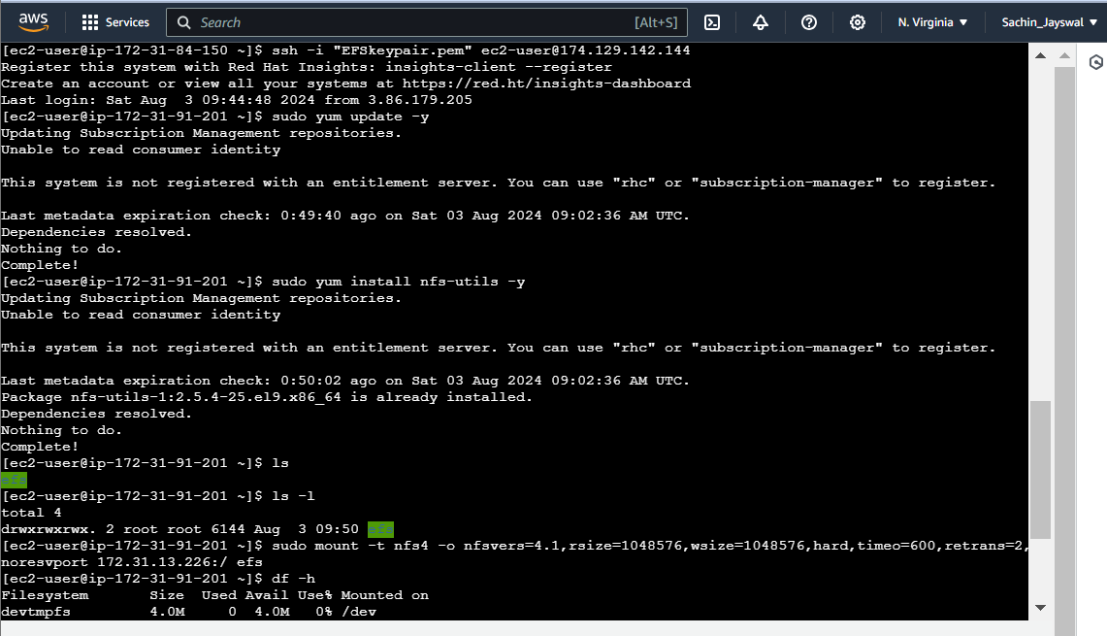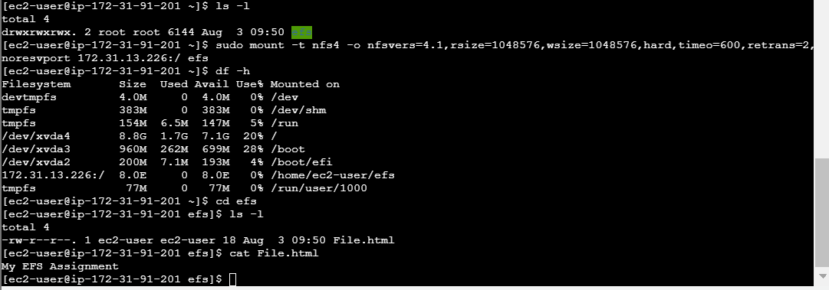

**3.**

**Setup/Mount you EFS to 3rd Server by following below command in snippet:**

**Create a folder EFS & View file which you saved in 1st server.**

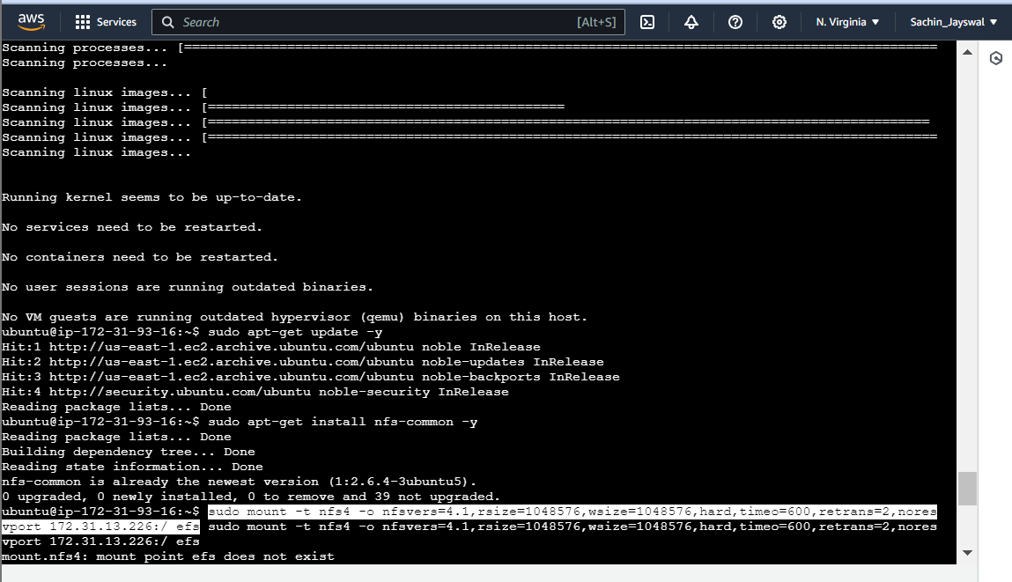

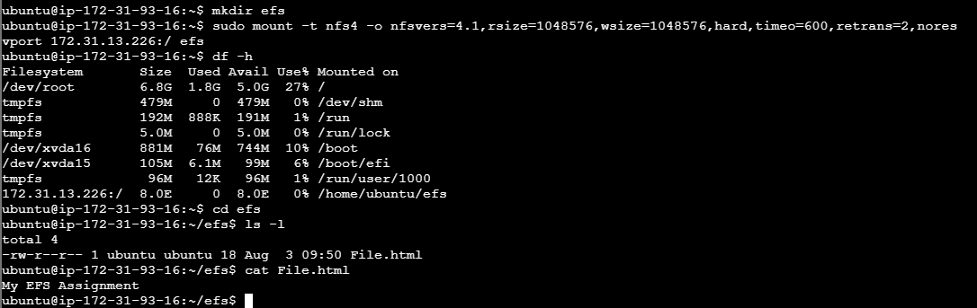

**Sachin Jaiswal**