**Module 2: Case Study**

**Problem Statement:** You work for XYZ Corporation. Your corporation is working on an application and they require secured web servers on Linux to launch the application.

**Tasks To Be Performed:** 1. Create an instance in the US-East-1 (N. Virginia) region with Linux OS and manage the requirement of web servers of your company using AMI. 2. Replicate the instance in the US-West-2 (Oregon) region. 3. Build two EBS volumes and attach them to the instance in the US-East-1 (N. Virginia) region. 4. Delete one volume after detaching it and extend the size of the other volume. 5. Take backup of this EBS volume

**Create instance 1:**

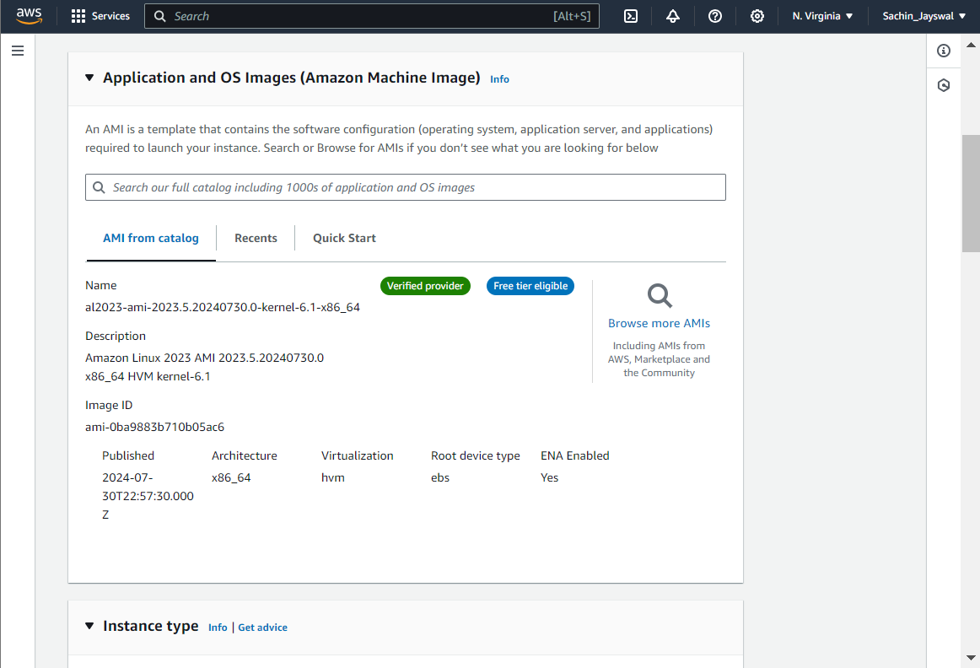

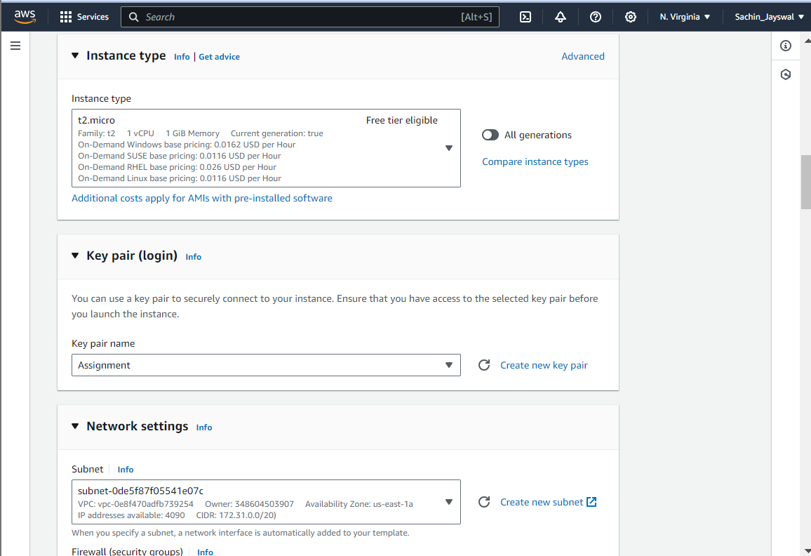

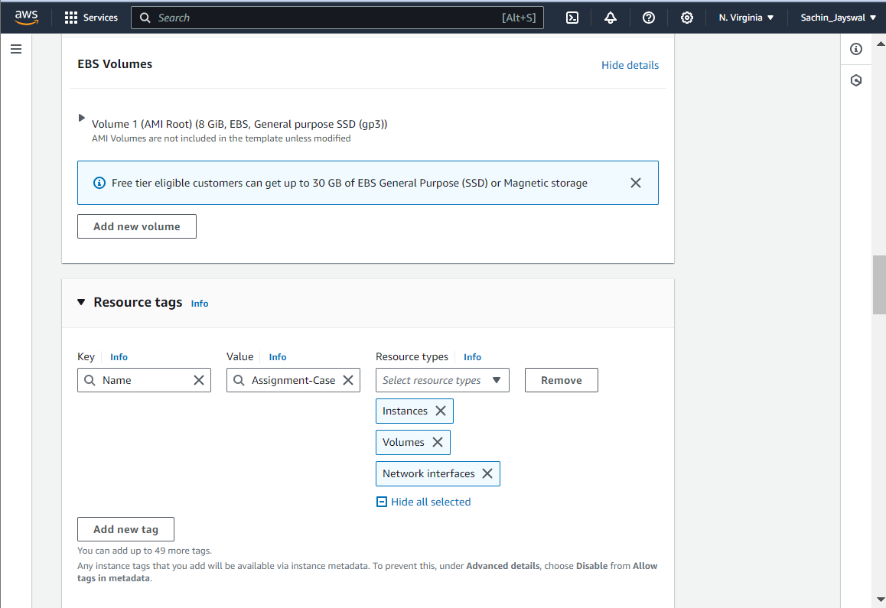

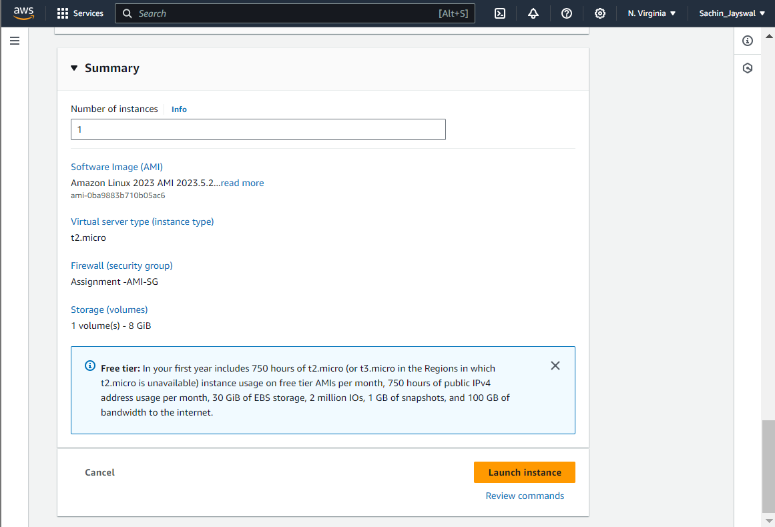

**Create AMI:**

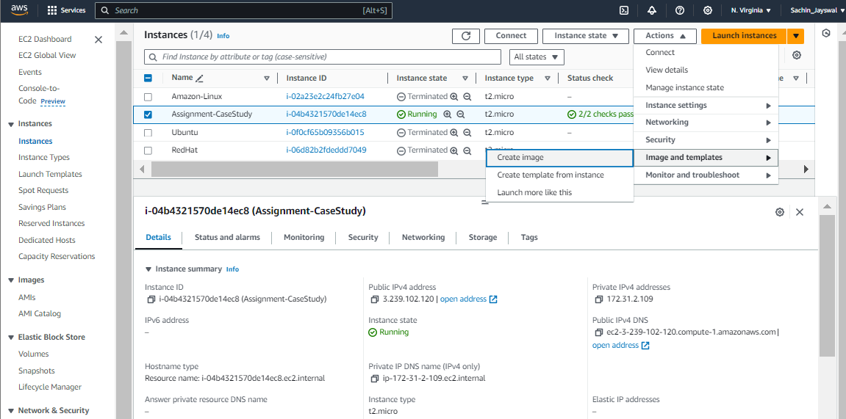

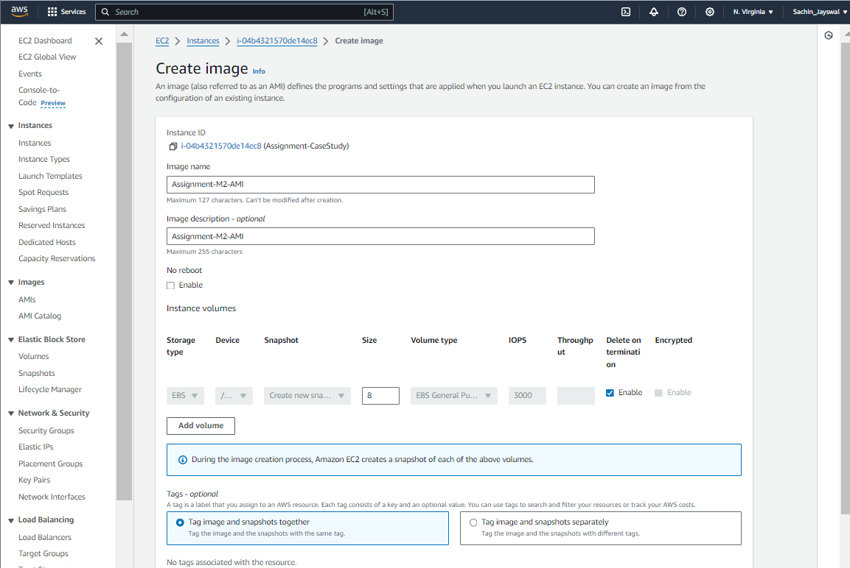

**Copy AMI to us-west Region:**

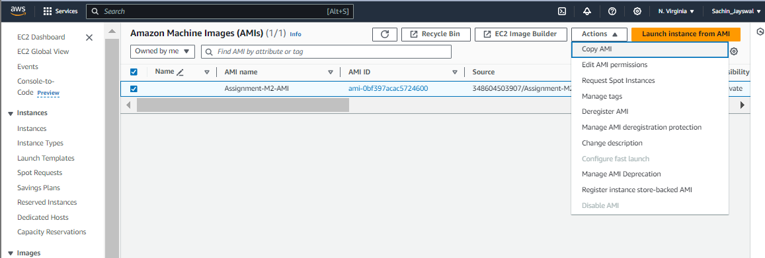

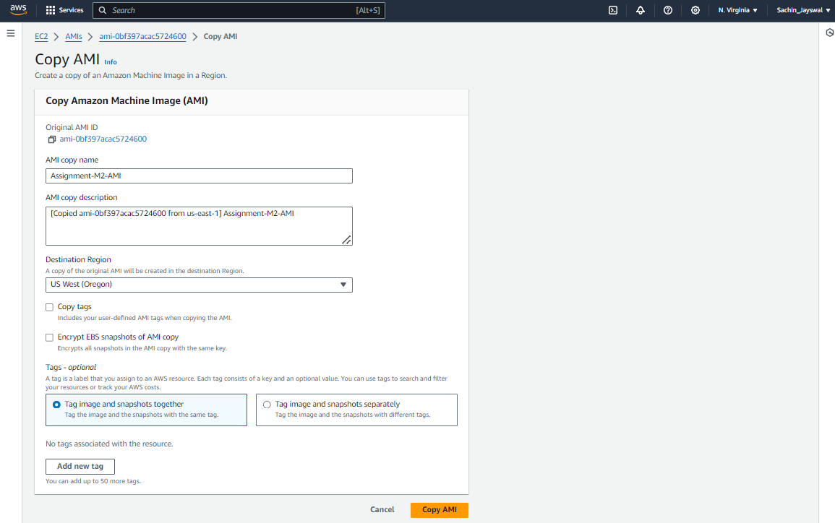

**Create Instance in us-west using you AMI:**

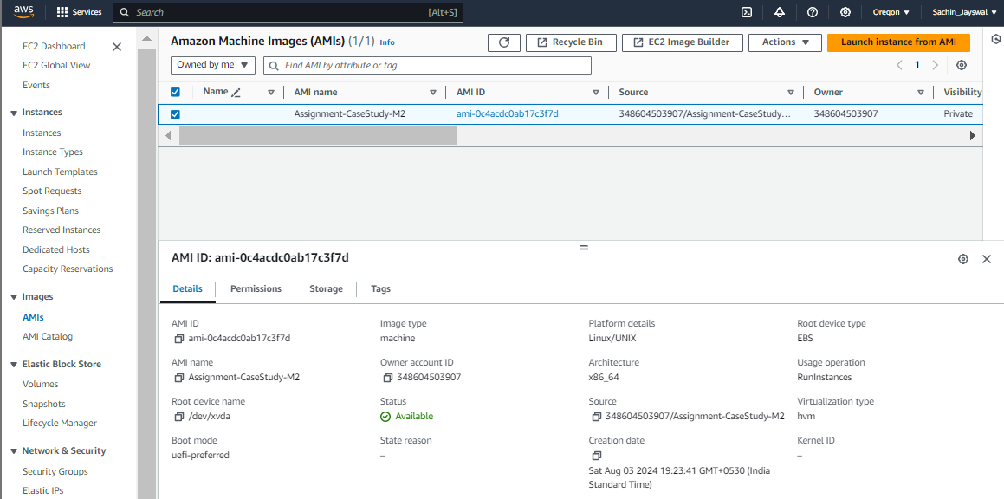

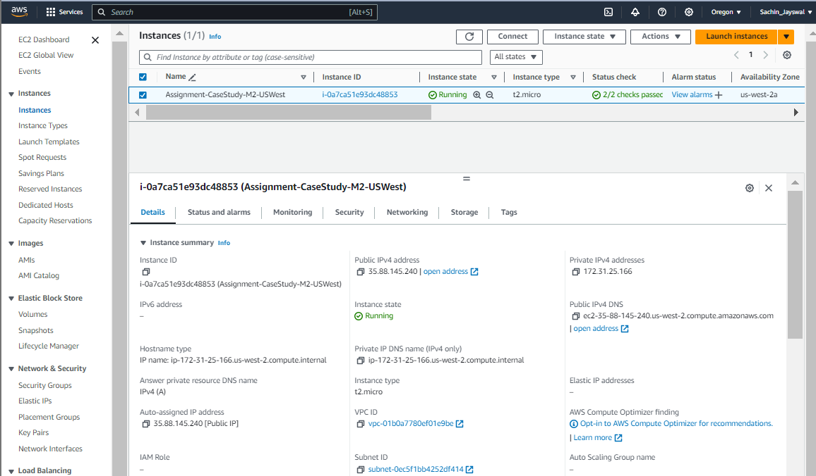

**Create Volume 1 & Create Volume 2:**

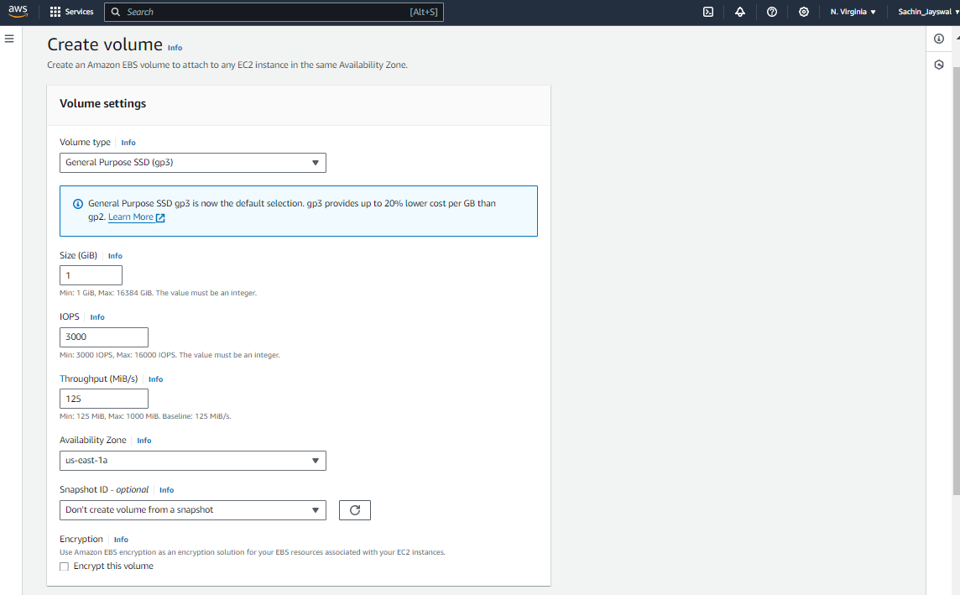

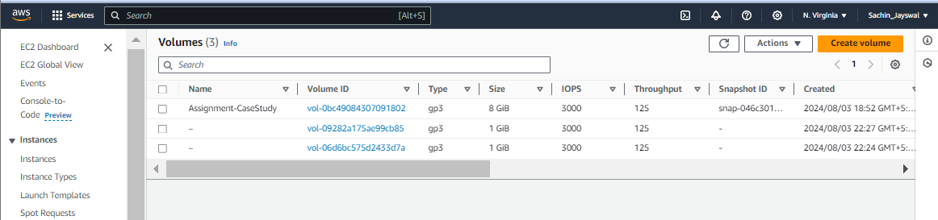

**Attach both the Volumes in us-east Instance:**

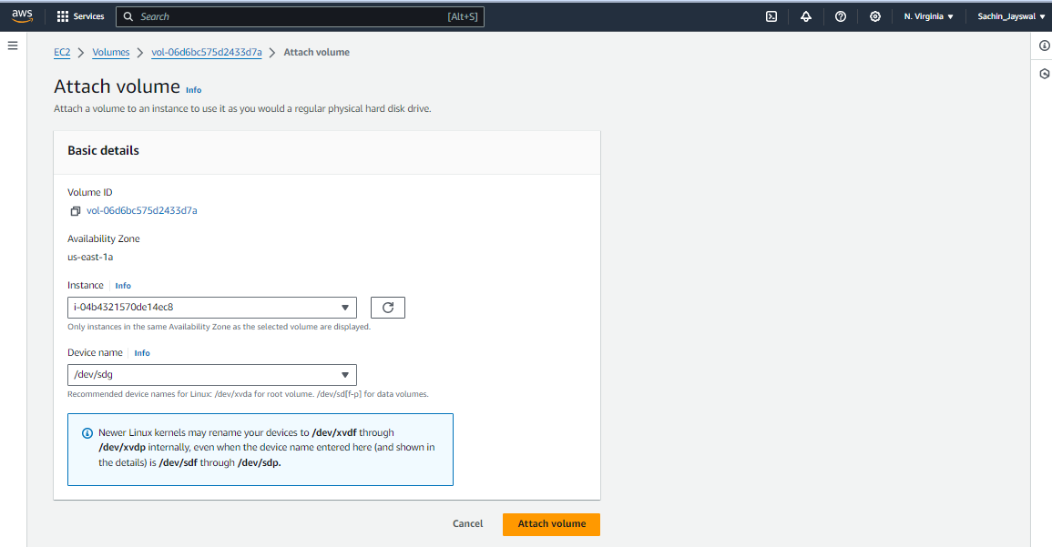

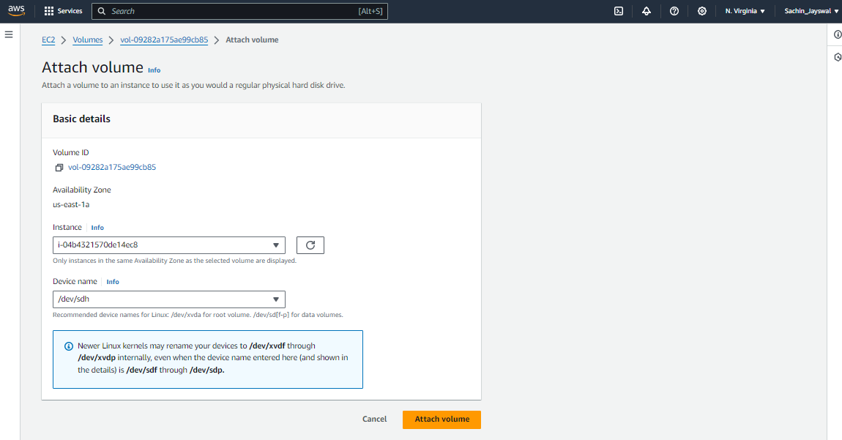

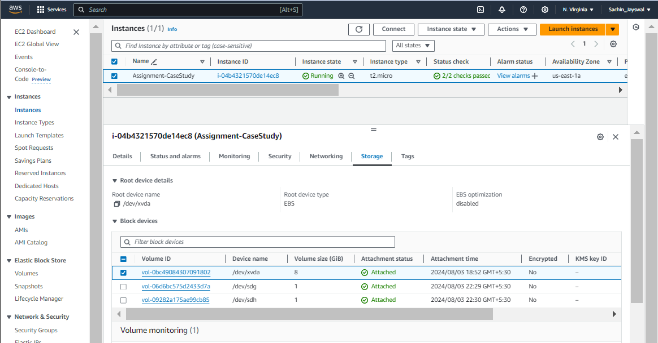

**Setup Web server:**

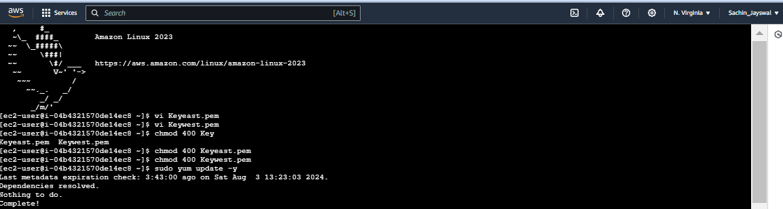

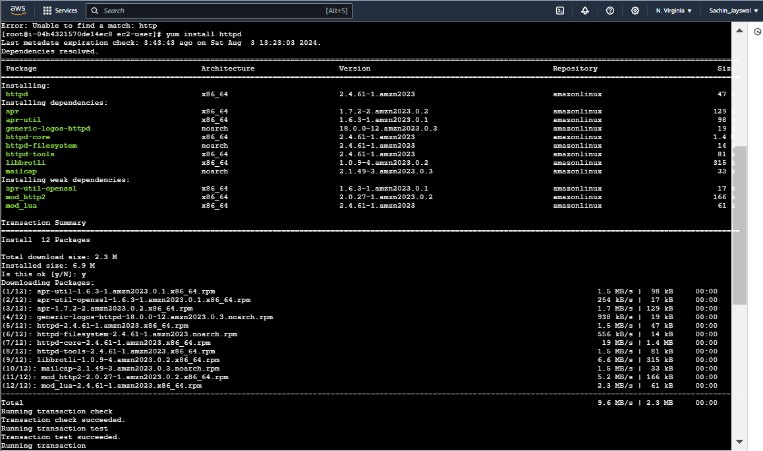

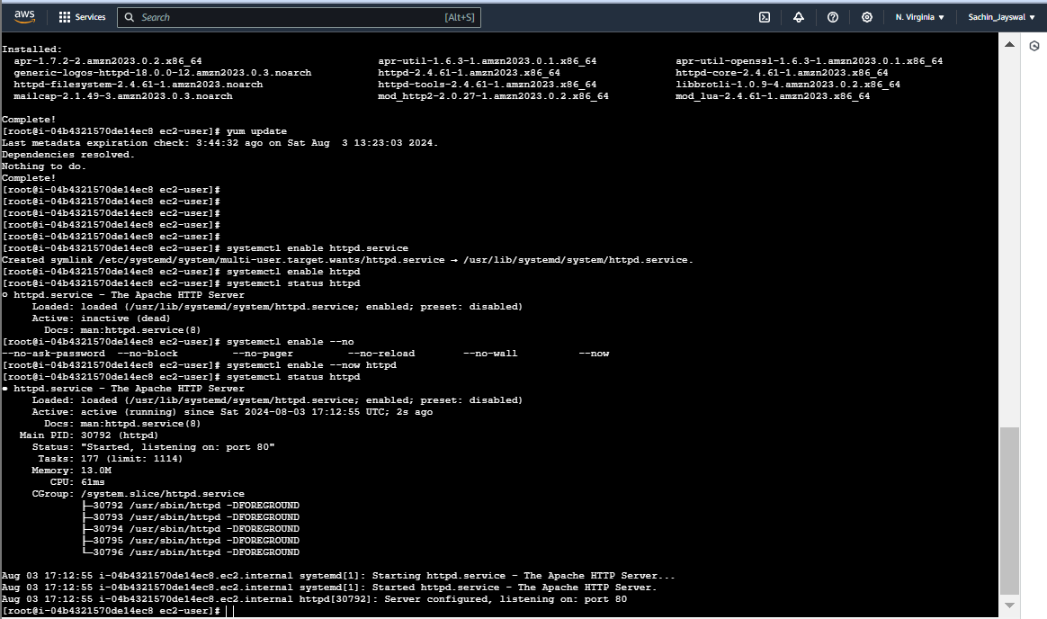

**Check and Format the partition:**

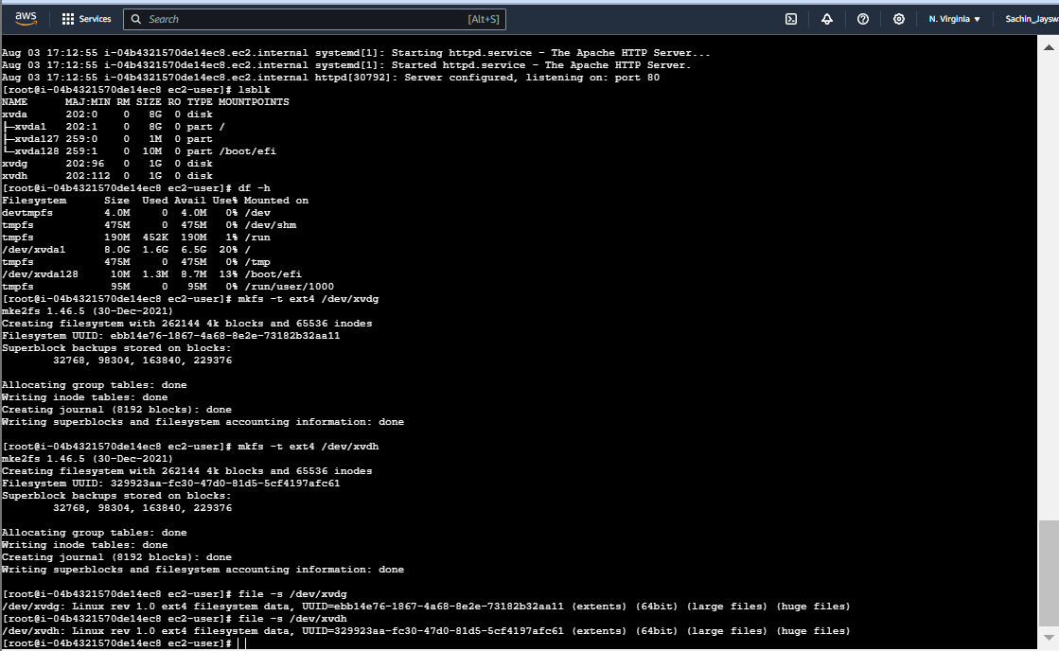

**Create Folder for each volume and mount the volume to it and then unmount the volume1:**

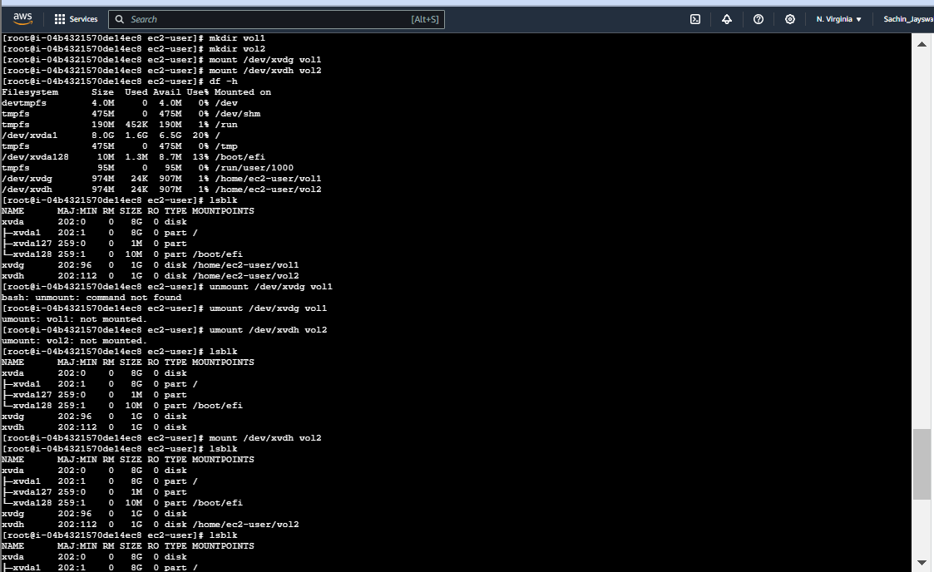

**Delete the Volume1:**

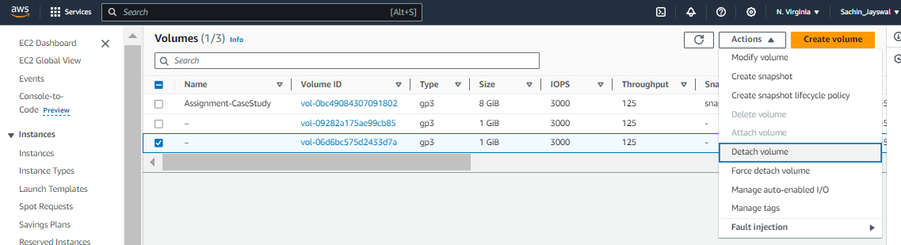

**Extend the Volume2:**

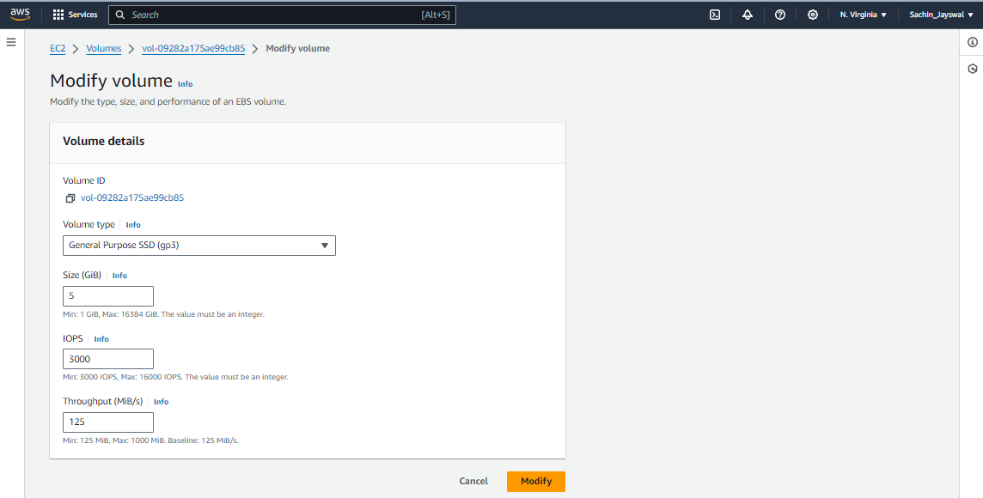

**Resize the modified Volume:**

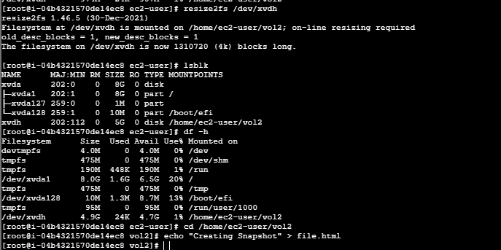

**Create Snapshot of volume 2:**

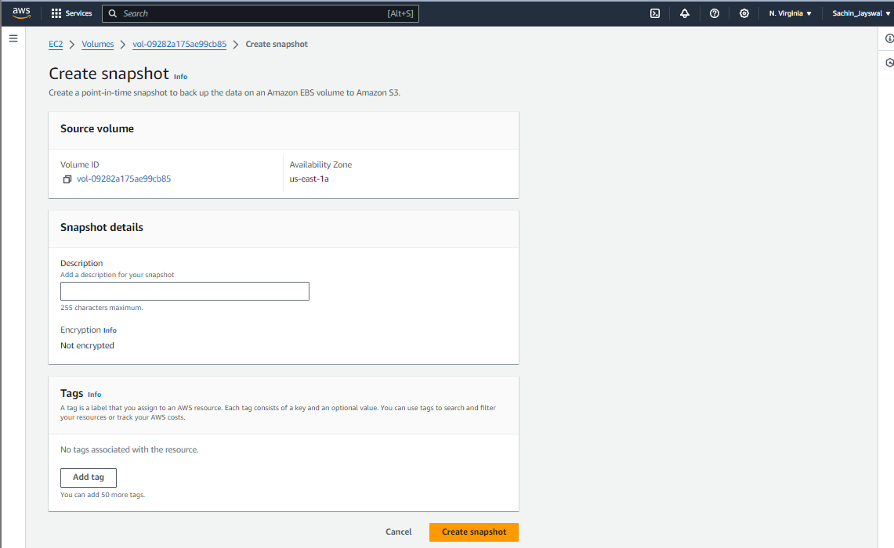

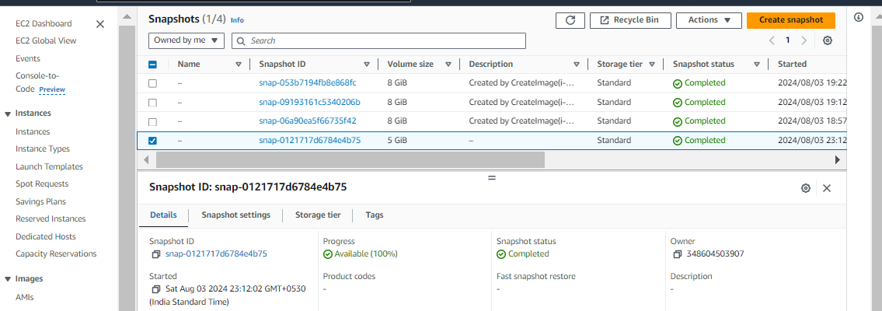

**Sachin Jaiswal**