**Module 3: IAM Users Assignment**

**Problem Statement:** You work for XYZ Corporation. To maintain the security of the AWS account and the resources you have been asked to implement a solution that can help easily recognize and monitor the different users.

**Tasks To Be Performed:** 1. Create 4 IAM users named “Dev1”, “Dev2”, “Test1”, and “Test2”. 2. Create 2 groups named “Dev Team” and “Ops Team”. 3. Add Dev1 and Dev2 to the Dev Team. 4. Add Dev1, Test1 and Test2 to the Ops Team.

**Create Users:**

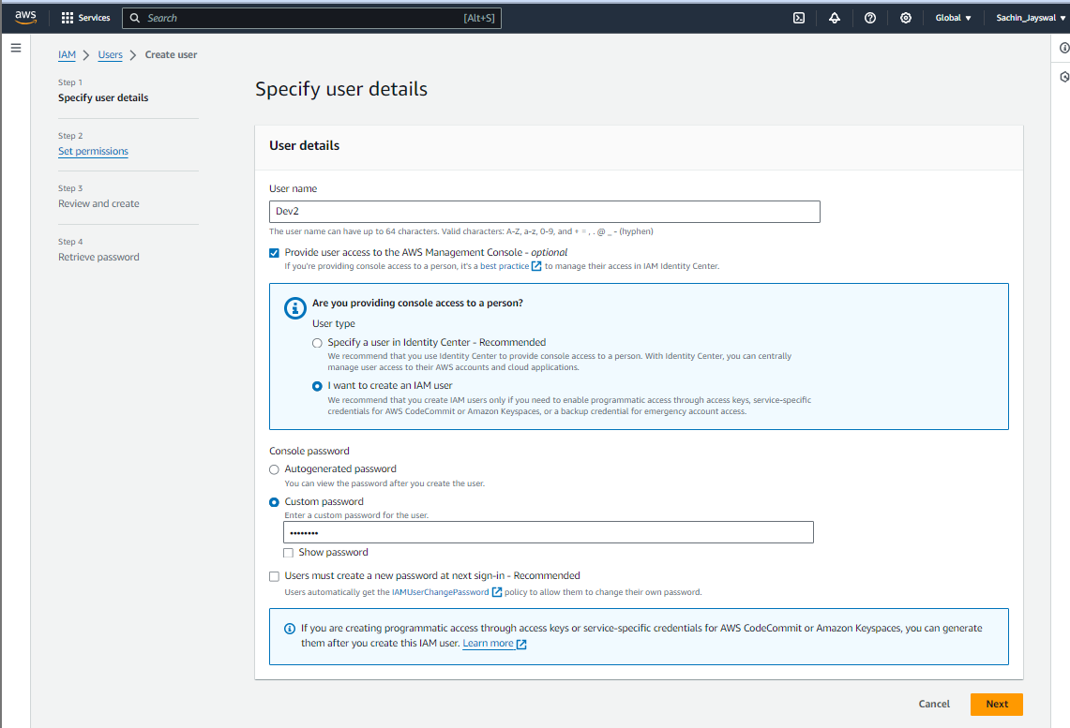

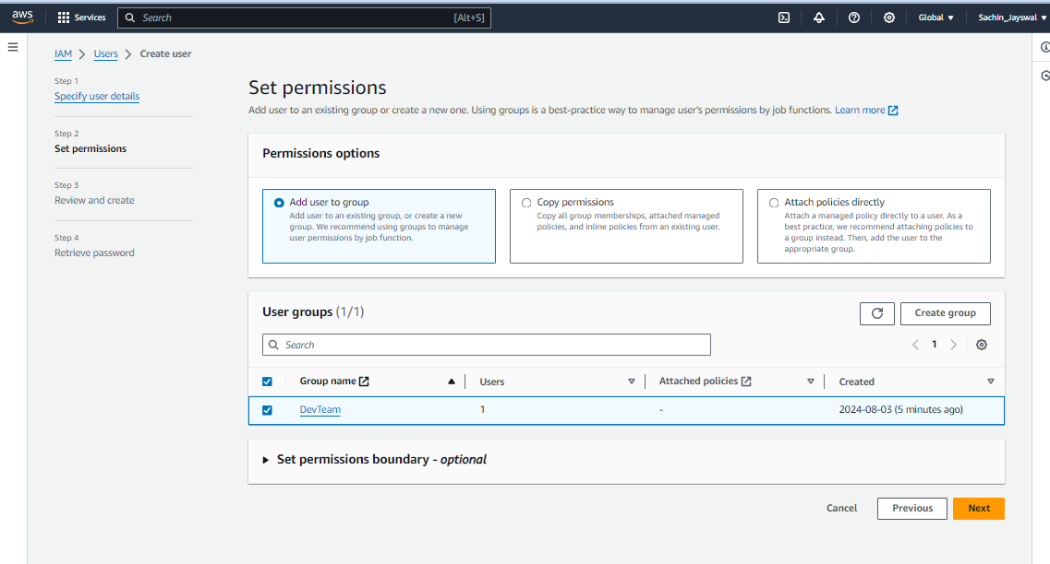

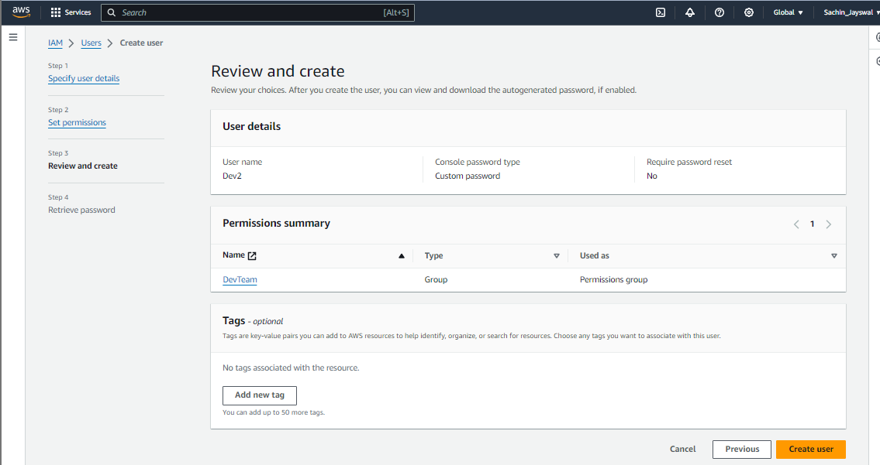

**Create Groups:**

