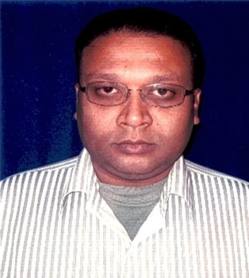 CURRICULUM VITAE

**Gadhuli Bazar, Near Azara Police Station,**

**Azara, Guwahati – 781017. (Assam)**

**Contact Phone No: +91-8812925890**

**E-mail:gunajitm@gmail .com**

# GUNAJIT MEDHI

## *CAREER OBJECTIVE*

## To work with a Reputed Organization, and to achieve the desired goals.

### WORK EXPERIENCE

1. Presently working with **MDS Online (P) Ltd**, Guwahati, Assam, as a **Web Research Analyst** from **September 2012 – September 2016.**
2. Worked with **Web.Com India** **(P)** **Ltd**, Guwahati, Assam, as a **Project Supervisor (Managing a team of data entry operators for the entire Old Deeds Data Entry Project in DC Office, Kamrup Metro, Guwahati),** from **July 2010 – September 2012.**
3. Worked with **Soft-matrix Technologies**. **(P)** **Ltd**, Guwahati, Assam, as a **Team Leader,** from **January 2008 – June 2009.**
4. Worked with **Infovision (Int) Ltd**., Udyog Vihar, Gurgaon, as a **Team Leader,** from **April 2006 – January 2008.**
5. Worked with **Colwell & Salmon Communications (I) Ltd**., Sector-58, Noida, as a **Customer Care Officer,** from **April 2005 – April 2006.**
6. Worked with **NIIT Smart Serve LTD**., Udyog Vihar, Gurgaon, as an **Executive** from **January 2004 – April 2005.**
7. Worked with **vCustomer Services (P) Ltd**. Mathura Road, New Delhi, as a **Technical Support Engineer**, from **September 2002 – December 2003.**

### EDUCATIONAL QUALIFICATION

3 years **Bachelor of Science (B.Sc.)**, from **North Eastern Hill University,** Shillong (Meghalaya).

### TECHNICAL QUALIFICATION

Passed 2 years **Higher Diploma in Software Engineering (HDSE)**, from **Aptech Computer Education,** Shillong (Meghalaya) securing **63%** in aggregate.

**Specialization**  : Oracle8i, Access Technologies, Visual Basic

**Packages**  : C++, VC++, VJ++, NETWORKING.

**Operating System**  : Windows 98, 2000, NT, Xp

**RDBMS**  : FoxPro, Oracle, Access.

### PERSONAL

**Father’s Name**  : S.K. Medhi

**Permanent Address**  : C/o S K Medhi, Gadhuli Bazar,

Near Azara Police Station, Azara  Guwahati -781017, (Assam).

**Date of Birth**  : 23rd September, 1977

### HOBBIES

### Listening Music, Reading Newspapers, Watching Movies.

#### *DECLARATION*

I (Gunajit Medhi) declare that the above mentioned information as stated by me is true to my knowledge, and if any discrimination found then my candidature is liable to be cancelled.

**Date:**

**Place:** **Guwahati** **(GUNAJIT MEDHI)**