**RESUME**

**LEENA JAISWAL** 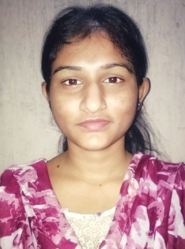

**Mobile No** :- +91 9101400942

**Email Id** :- leenajaiswal1995@gmail.com

**Objective** :-

To work in an organization where I can give my best towards the development of the organisation, as well as enhance self improvement through a continuous process of knowledge acquisition and self appraisal.

**Educational Qualification:-**

|  |  |  |  |  |
| --- | --- | --- | --- | --- |
| **Qualification** | **School** | **Board** | **Year** | **Percentage** |
| 10th High School | Rose English High School | S.E.B.A. | 2012 | 45.83% |
| 12th Higher Secondary | Bokakhat Higher Secondary School (Science Stream) | A.H.S.E.C. | 2015 | 47.20% |
| B.COM (hons) | J.D.S.G. College bokakhat | Dibrugarh university | 2016-19 | 50.83 % |

**Experiences:-**

* **4 years of extensive experience pertaining to the educational sector.**
* **1 year work experience in the corporate sector , as a Customer Retention Officer in INSYNC Business Solution Ltd.**

**Educational and professional certification:**

* **Tourist guide in Kaziranga tourism training program.**

**Computer Skills :-**

* Basic Knowledge in computer application.
* Professional Diploma in Technology and Programming.

**Achievements :-**

* Participation in various cultural activities.
* Won certificates and accolades in vocal competitions.

**Hobbies :-**

* Singing
* Travelling
* Philately

**Strength :-**

* Honesty
* Hard Working
* Effective communication and interpersonal skill.
* Can handle any work pressure and challenges.

**Language proficiency :-**

* English
* Hindi
* Assamese

**Personal Details :-**

* Date of Birth :- 12th September 1995
* Father’s Name :- Late Omprakash Jaiswal
* Mother’s Name :- Mrs Parbati Jaiswal
* Gender :- Female
* Nationality :- Indian

**Permanent Address:-**

Kolakhuwa Gaon, Bokakhat

P.O.Bokakhat, Dist – Golaghat (Assam)

Pin – 785612

**Declaration: -** I hereby declare that the above mentioned information is true to the best of my knowledge.

**Place :-**

**Date :-**

**(Leena Jaiswal)**