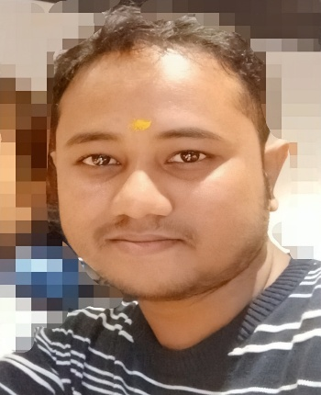**CURRICULUM VITAE**

**Name: Prejit Borah**

**C/O.Jiten Ch. Borah**

**Permanent Address :Baroholia, Tezpur, Assam**

**Present Address: Zoo Narengi Road, Guwahati**   
**Mobile: 9706367674, 9101964858**

**Career Objective**

*To contribute to the profession, by achieving a position, which is commensurate with my experience and qualification and which provides a challenging environment for growth. Seeking for a well deserved job as per my qualifications. I possess valuable skills such as persuasiveness and sound judgment that I believe* *make me best suited. I am seeking for a well established career in any field that is relevant*

**Skills**

* + Good Communication Skills, Confident, Vision and Clarity of Thoughts.
  + Skilled in case analysis and planning along with Legal complianc.
  + Remarkable analytical, logical and mathematical skills.
  + Key skills of drafting and pleading
  + Innovative in assessing the qualities of people.
  + Efficient in communicating well in written and verbal both.
  + The ability to motivate people.

**Personal Qualities**

* Using self ideology for a better result in this field.
* Making use of deferent technique for attaining the goal of the organization.
* Hardworking and Enthusiastic

**Experience**

Administrative Assistant, September 2015 onwards

* Schedule and coordinate meetings, appointments, and travel arrangements for supervisors and managers
* Analyzing the requirement of organization.
* Drafting and pleading
* Developed new filing and organizational practices,
* Maintain utmost discretion when dealing with sensitive topics
* Manage travel and expense reports for department team members
* Typed documents such as correspondence, drafts, memos, and emails,
* **Academic qualification**
* Pursuing LL.B presently from Tezpur Law College
* Bachelor Degree passed in Computer Science.
* Higher Secondary passed with Physics Chemistry Maths under CBSE board.
* High School passed under CBSE board of AISSE .

**TECHNICAL SKILLS**

* **Proficiency in C++ Java, Microsoft Office (Excel, Word, PowerPoint.)**
* **Internet Savvy**

**Training s**

* Participation Certificate in 12days training in CISCO Networking CCNA Security conducted by IBNC India in Association with ACES-ACEM IIT Delhi and 1 Media Learning Put. Ltd. Tezpur University Assam.
* Participated in University Network Design and University Network Security.

**Personal Details**

* + Date of Birth: 13/3/1985  
    Languages Known: Assamese, Hindi & English(read write and speak)   
    Father’s Name : Jiten CH. Borah. Mother’s Name : Priya Kumari Das Borah. Marital Status :Single

***I do hereby declare that the details in this resume are true as per my knowledge and documents.***

***Prejit Borah***