**Supply and Distribution Management System**

**Software Requirements Specification Document**

|  |  |
| --- | --- |
| **Roll No.** | **Name** |
| CS-062 | Sachin Karmani |
| CS-023 | Ruhail Mangi |
| CS-067 | Deepak Kumar |

**General Table of Contents:**

1. Introduction

1.1 Purpose ……………………………………………………………………………03

1.2 Document Conventions ………………………………………………………….03

1.3 Project Scope ……………………. ………………………………………………03

1.4 References ……………………….……………………………….………………03

2. Overall Description ………………………………………………………………………...03

2.1 Product Perspective …………………………………………………………...…03

2.2 Product Features …………………………………………………………………04

2.3 User Classes and Characteristics ………………………………………………05

2.4 Operating Environment ………………………………………………………..…05

3. Functional Requirements ……………………………………………………………….…05

4. Nonfunctional Requirements ……………………………………………………………...06

4.1 Safety Requirements ……………………………………………………………..06

4.2 Software Quality Attributes ………………………………………………………06

4.3 Security Requirements .…..………………………………………………………07

5. Interface Requirements ……………………………………………………………………07

5.1 User Interfaces ……………………………………………………………………07

5.2 Hardware Interfaces ……………………………………………………………...07

5.3 Software Interfaces ……………………………………………………………….07

5.4 Communications Interfaces …..…………………………………………………..………07

**1. Introduction**

**1.1 PURPOSE:**

The purpose of this document is to build a desktop based system to easily manage the purchases of products from the supplier and their distribution to customers.

**1.2 DOCUMENT CONVENTIONS:**

This document uses the following conventions:

|  |  |
| --- | --- |
| Convention | Meaning |
| DB | Database |
| ER | Entity Relationship |

**1.3 PROJECT SCOPE:**

The purpose of the supply and distribution management system is to ease the managements of purchases and sales and to create a convenient and easy-to-use application for end users. The system is based on a relational database with its stock and purchase order management functions. It will also help in managing quotations and payments from customers. It also helps in keeping track of the business with each individual customer.

**1.4 REFERENCES**

Database System Concepts by Abraham Silberschatz, Henry F. Korth

**2. OVERALL DESCRIPTION**

**2.1 PRODUCT PERSPECTIVE**

A supply and distribution management database stores the following information.

• Purchase orders: It includes all purchase orders made to the supplier along with the items in each order. It also marks the status of each purchase order

• Quotations: It includes the data of the quoted price of each item given to a customer at a particular time.

• Customer orders: It includes the details of the orders given by each customer along with their status.

• Invoices: It includes the data of each invoice against a customer order and also includes delivery data. Partial deliveries can be made against a customer order.

• Stock: It includes the data of each individual item. The current quantity and minimum required quantity are stored in it.

• Payments: It includes the data of payments made by customers against their bills. It can also track partial payments against each bill.

**2.2 PRODUCT FEATURES**

The major features of supply and distribution management system as shown in below

(ER model):

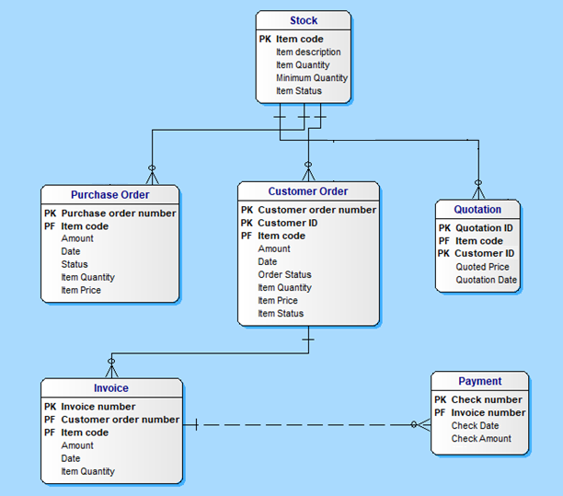

**2.3 USER CLASSIFICATION (ROLES):**

Employees:

The employees can manage the functionalities of the supply and distribution management system:

* Purchase orders
* Quotations
* Customer Orders
* Stock
* Payments
* Data Analytics

**2.4 OPERATING ENVIRONMENT:**

Operating environment for the supply and distribution management system is as listed below.

1. Operating system: Windows.
2. Database: SQL database
3. Platform: Python

**3 FUNCTIONAL REQUIREMENTS:**

Managing Purchase orders:

* Create purchase orders.
* Mark their status after receiving products against a particular purchase order.

Creating Quotations:

* Generate quotations of item(s) for a particular customer.
* Check quotation history for each customer.

Managing Customer Orders:

* Enter the data of the orders received from customers.
* Check the status of each item in the customer order.

Creating Invoices:

* Generate required complete or partial invoices against a pending order at the time of product delivery.
* Check the payment status of each invoice

Stock:

* Check status of each item in the stock.
* Alert user in case of shortage of an item

Payments:

* Enter the record of payment against an invoice.
* Track payments against a particular invoice.

Data Analytics:

* Check patterns of purchase and sale each individual item over a period of time.
* Observe the sales made to each customer.
* Observe the pattern of sales of an item to a specific customer.

**4 NON-FUNCTIONAL REQUIREMENTS:**

In order to simplify the design, facilitate delivery of the application and, the following requirements and assumptions have been defined:

**4.1 SAFETY REQUIREMENTS**

The database of the application should be stored in a cloud folder and can be backed up immediately in case of an extensive damage to a wide portion of the database due to catastrophic failure, such as a disk crash.

**4.2 SOFTWARE QUALITY ATTRIBUTES**

1. An order may contain multiple line items, where each line item relates to a specific product and quantity required. A product shall not appear more than once in an order.
2. There are no minimum order quantities.
3. Partial deliveries of item(s) are allowed.
4. The supplier will always ship the requested number of a product to a warehouse i.e. we assume it can always supply the required quantity.
5. When a purchase request brings a warehouse quantity to below a certain level, the warehouse makes a request of the supplier for more stock.

**4.3 SECURITY REQUIREMENTS:**

Dedicated system will be used for the application and can be used on one system only.

**5. INTERFACE REQUIREMENTS:**

**5.1 USER INTERFACES:**

Front-end software: Python

Back-end software: SQL

**5.2 HARDWARE INTERFACES**

Since the desktop application does not have any designated hardware, it does not require any direct hardware interfaces.

**5.3 SOFTWARE INTERFACES**

Following are the software used for the flight management online application. Include the software details as per your project:

|  |  |
| --- | --- |
| Component | Description |
| Operating System | We have chosen Windows operating system for its best support and user-friendliness. |
| Application Interface | We have used Python language for its versitality and simplicity. |
| Database | We have used SQL to store data of all parts of the system |

**5.4 COMMUNICATION INTERFACES:**

Python distribution must be installed to run the application on the desktop system.