Name: _________________________________
Figurative Language Poem 1  Sketch  By Carl Sandburg  The shadows of the ships  Rock on the crest  In the low blue lustre  Of the tardy and the soft inrolling tide.  A long brown bar at the dip of the sky  Puts an arm of sand in the span of salt.  The lucid and endless wrinkles  Draw in, lapse and withdraw.  Wavelets crumble and white spent bubbles  Wash on the floor of the beach.  Rocking on the crest  In the low blue lustre  Are the shadows of the ships. | 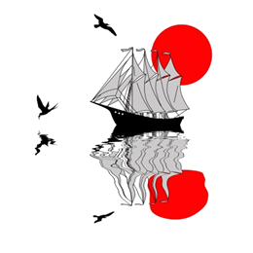

Review Questions

Directions: Respond to these questions to the best of your ability. Answer the questions completely. If you need more space, use the back or a separate sheet.

1. Identify an example of personification: explain what is being personified how.

2. Identify an example of hyperbole: explain how it is exaggerated.

3. Identify an example of metaphor: explain which two things are being compared.

4. Find two separate examples of alliteration. List the alliterative words.

5. Where is repetition used in this poem? Why do you think that it is used this way?

6. What action is described in the third stanza of the poem?

7. How is imagery used in this poem? What is described?

8. What is the mood of this poem? How does it make you feel?

