**UCS1712 – Graphics and Multimedia Lab**

**Ex-10: Image Editing and Manipulation**

**Name:** Satheesh Kumar G R

**Reg. No.:** 185001136

**AIM**

To Perform basic operations on an image (retouch image, add filters, masks, etc) using GIMP software to enhance it.

**OUTPUT:**

ORGINAL IMAGE



RETOUCH



FILTER

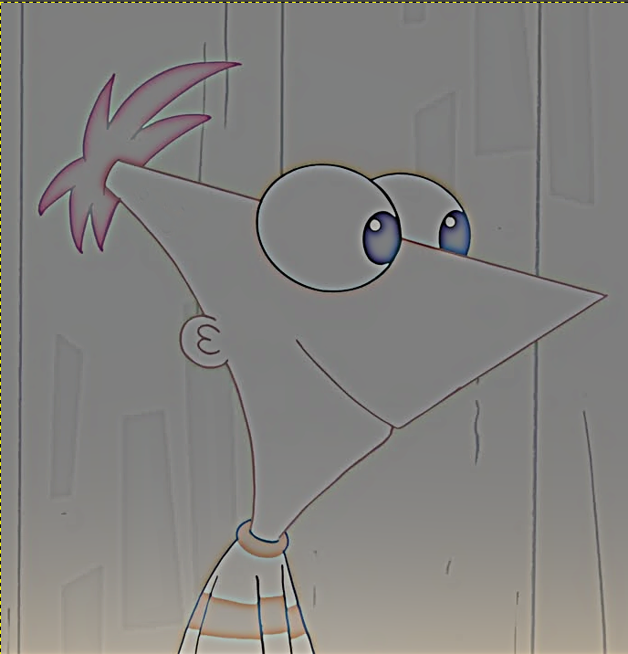

LAYER MASK

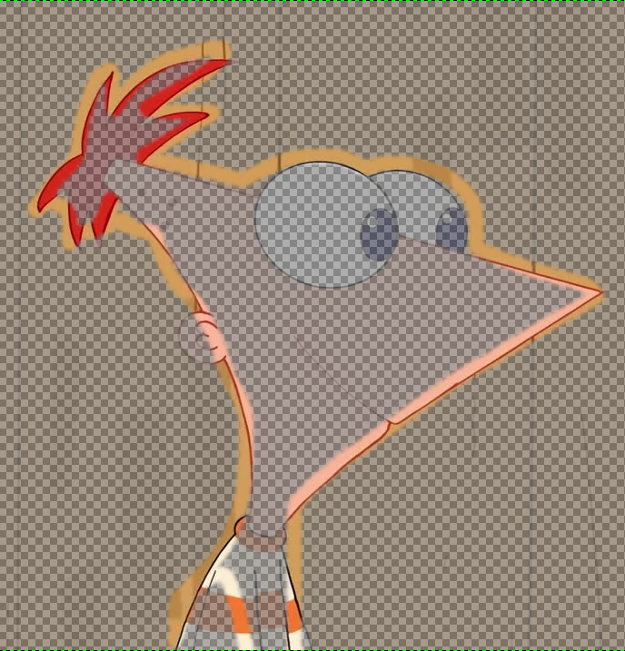

**RESULT:**

Thus, Image Editing and Manipulation was implemented successfully.

**AIM**

To Perform basic operations on an image (retouch image, add filters, masks, etc) using GIMP software to enhance it.

**OUTPUT:**

FRAME-1

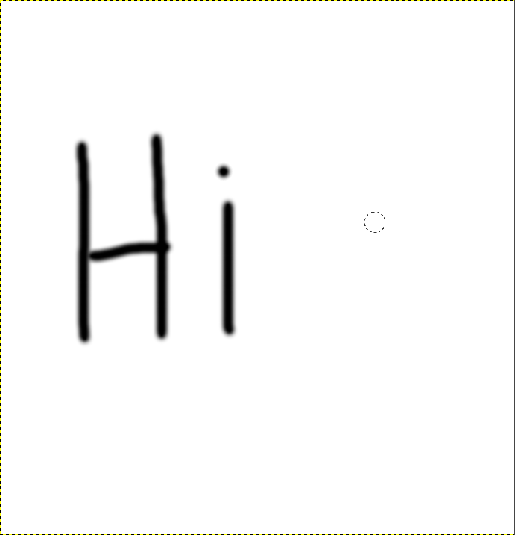

FRAME-2



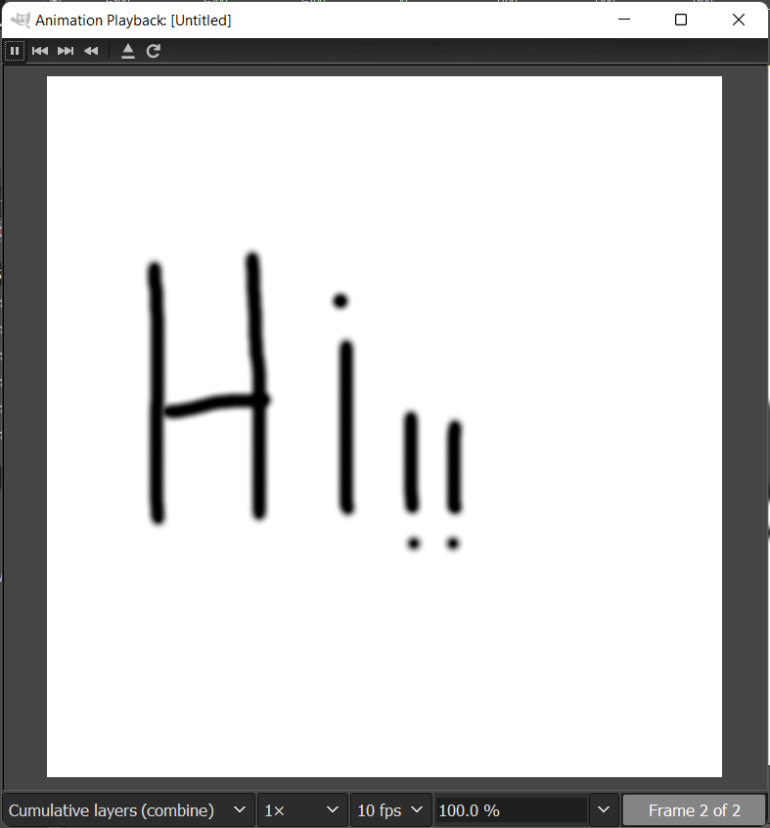

**RESULT:**

Thus, Simple gif was animateded successfully.