# SSN COLLEGE OF ENGINEERING DEPARTMENT OF COMPUTER SCIENCE AND ENGINEERING

**UCS1712 – GRAPHICS AND MULTIMEDIA LAB**

EX NO: 11- 2D Animation

**Name**: Satheesh Kumar G R

**Reg.No:**185001136

# AIM :

To create a simple 2D animation sequence video with a minimum of 2 objects using GIMP Software.

# Frames Used :



2

1

|  |  |
| --- | --- |
| 3 | 4 |
| 5 | 6 |
| 7 | 8 |

**Layers :**

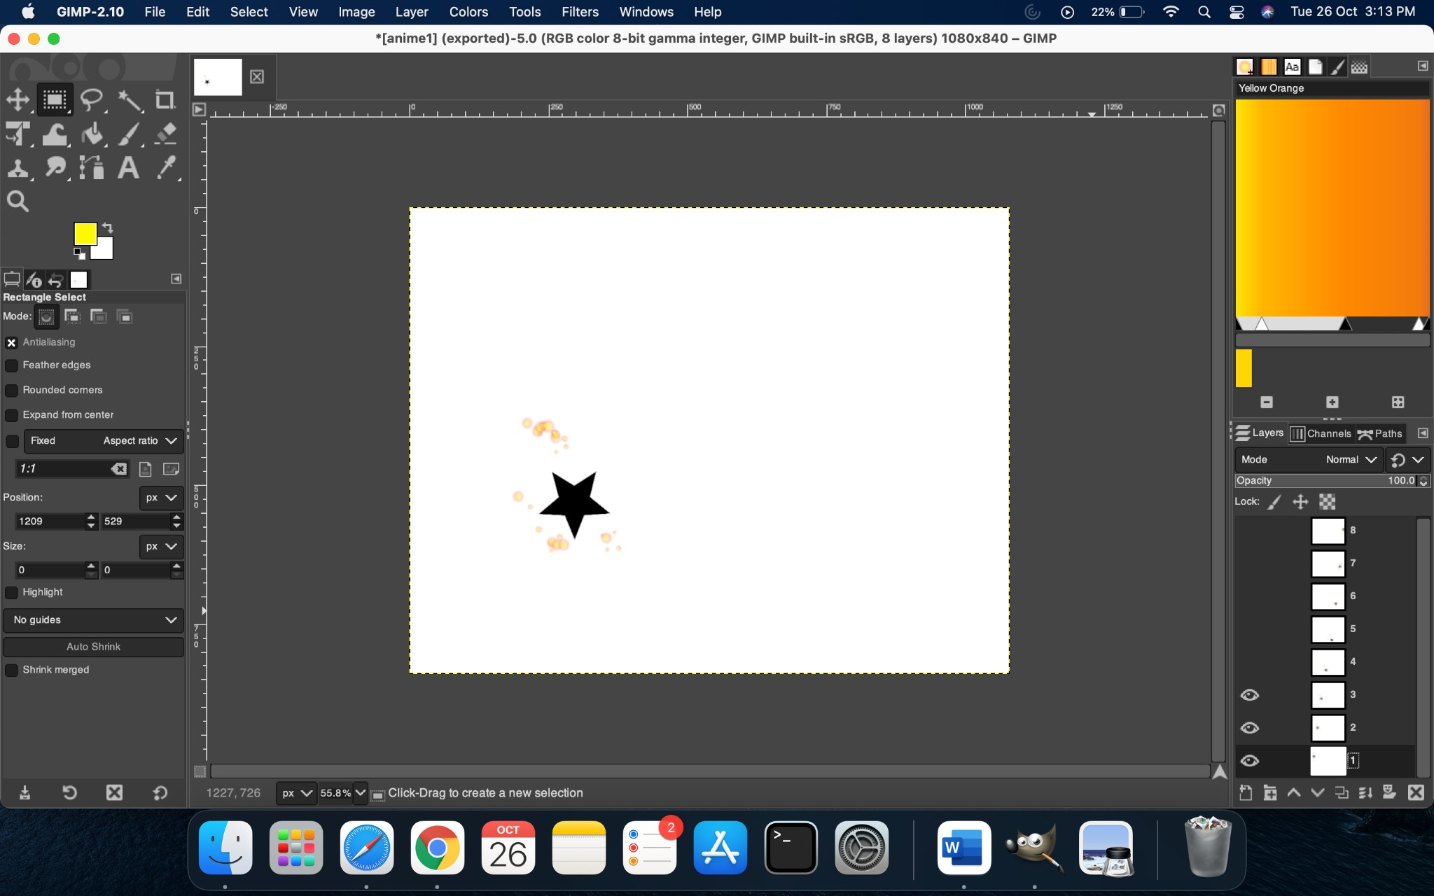

**OUTPUT GIF:**



**RESULT :**

Thus created a simple 2D animation sequence video with a minimum of 2 objects using GIMP Software successfully.