**SSN College of Engineering**

**Department of Computer Science and Engineering**

## UCS1712 – GRAPHICS AND MULTIMEDIA LAB

**EX NO: 8 –** 3D Transformations

Name: Satheesh Kumar G R

Register Number:185001136

Semester: VII

Batch: 2018-2022

**AIM**

To Write a c++ program using OPENGL to perform 3D transformations – translation, scaling and rotation

(along all three axes).

**ALGORITHM:**

1. Read the choice of operation to be performed.
2. For Translation:
   1. Read translation factor (tx,ty,tz).
   2. For each vertex (x,y,z) apply translation as follows:
      1. x = x+tx
      2. y = y+ty
      3. z = z+tz
3. For Rotation:
   1. Read the degree of rotation Ɵ for polygon and line.
   2. Read the axis of rotation.
   3. If axis of rotation is z-axis:
      1. For each vertex (x,y,z) the new vertex is computed as follows:
         1. x = xcos Ɵ - ysin Ɵ
         2. y = xsin Ɵ + ycos Ɵ
         3. z = z
   4. If axis of rotation is x-axis:
      1. For each vertex (x,y,z) the new vertex is computed as follows:
         1. y = ycos Ɵ - zsin Ɵ
         2. z = ysin Ɵ + zcos Ɵ
         3. x = x
   5. If axis of rotation is y-axis:
      1. For each vertex (x,y,z) the new vertex is computed as follows:
         1. z = zcos Ɵ - xsin Ɵ
         2. x = zsin Ɵ + xcos Ɵ
         3. y = y
4. For Scaling:
   1. Read scaling factor (sx,sy,sz).
   2. Set the fixed point (fx,fy,fz) as the first vertex.
   3. For each vertex (x,y,z) apply scaling as follows:
      1. x = (x*sx)
      2. y = (y*sy)
      3. z = (z*sz)

**CODE:**

#include<iostream>

#include<math.h>

#include<GL/glut.h>

using namespace std;

typedef float Matrix4 [4][4];

Matrix4 theMatrix;

static GLfloat input[8][3]=

{

    {40,40,-50},{90,40,-50},{90,90,-50},{40,90,-50},

    {30,30,0},{80,30,0},{80,80,0},{30,80,0}

};

float output[8][3];

float tx,ty,tz;

float sx,sy,sz;

float angle;

int choice,choiceRot;

void setIdentityM(Matrix4 m)

{

for(int i=0;i<4;i++)

    for(int j=0;j<4;j++)

        m[i][j]=(i==j);

}

void translate(int tx,int ty,int tz)

{

for(int i=0;i<8;i++)

{

output[i][0]=input[i][0]+tx;

output[i][1]=input[i][1]+ty;

output[i][2]=input[i][2]+tz;

}

}

void scale(int sx,int sy,int sz)

{

    theMatrix[0][0]=sx;

    theMatrix[1][1]=sy;

    theMatrix[2][2]=sz;

for(int i=0;i<8;i++)

{

output[i][0]=input[i][0]+50;

output[i][1]=input[i][1]+50;

output[i][2]=input[i][2]+50;

}

}

void RotateX(float angle) //Parallel to x

{

 angle = angle*3.142/180;

  theMatrix[1][1] = cos(angle);

 theMatrix[1][2] = -sin(angle);

 theMatrix[2][1] = sin(angle);

 theMatrix[2][2] = cos(angle);

}

void RotateY(float angle) //parallel to y

{

 angle = angle*3.14/180;

 theMatrix[0][0] = cos(angle);

 theMatrix[0][2] = -sin(angle);

 theMatrix[2][0] = sin(angle);

 theMatrix[2][2] = cos(angle);

}

void RotateZ(float angle) //parallel to z

{

 angle = angle*3.14/180;

 theMatrix[0][0] = cos(angle);

 theMatrix[0][1] = sin(angle);

 theMatrix[1][0] = -sin(angle);

 theMatrix[1][1] = cos(angle);

}

void multiplyM()

{

//We Don't require 4th row and column in scaling and rotation

//[8][3]=[8][3]*[3][3] //4th not used

for(int i=0;i<8;i++)

 {

    for(int j=0;j<3;j++)

    {

        output[i][j]=0;

        for(int k=0;k<3;k++)

        {

            output[i][j]=output[i][j]+input[i][k]*theMatrix[k][j];

        }

    }

}

}

void Axes(void)

{

 glColor3f (0.0, 0.0, 0.0);               // Set the color to BLACK

 glBegin(GL_LINES);                       // Plotting X-Axis

 glVertex2s(-1000 ,0);

 glVertex2s( 1000 ,0);

 glEnd();

 glBegin(GL_LINES);                       // Plotting Y-Axis

 glVertex2s(0 ,-1000);

 glVertex2s(0 , 1000);

 glEnd();

}

void draw(float a[8][3])

{

    glBegin(GL_QUADS);

     glColor3f(0.7,0.4,0.5); //behind

    glVertex3fv(a[0]);

    glVertex3fv(a[1]);

    glVertex3fv(a[2]);

    glVertex3fv(a[3]);

    glColor3f(0.8,0.2,0.4);  //bottom

   glVertex3fv(a[0]);

   glVertex3fv(a[1]);

   glVertex3fv(a[5]);

   glVertex3fv(a[4]);

   glColor3f(0.3,0.6,0.7); //left

  glVertex3fv(a[0]);

  glVertex3fv(a[4]);

  glVertex3fv(a[7]);

  glVertex3fv(a[3]);

  glColor3f(0.2,0.8,0.2);  //right

 glVertex3fv(a[1]);

 glVertex3fv(a[2]);

 glVertex3fv(a[6]);

 glVertex3fv(a[5]);

 glColor3f(0.7,0.7,0.2); //up

glVertex3fv(a[2]);

glVertex3fv(a[3]);

glVertex3fv(a[7]);

glVertex3fv(a[6]);

glColor3f(1.0,0.1,0.1);

glVertex3fv(a[4]);

glVertex3fv(a[5]);

glVertex3fv(a[6]);

glVertex3fv(a[7]);

glEnd();

}

void init()

{

    glClearColor(1.0,1.0,1.0,1.0); //set backgrond color to white

    glOrtho(-454.0,454.0,-250.0,250.0,-250.0,250.0);

    // Set the no. of Co-ordinates along X & Y axes and their gappings

    glEnable(GL_DEPTH_TEST);

     // To Render the surfaces Properly according to their depths

}

void display()

{

glClear(GL_COLOR_BUFFER_BIT|GL_DEPTH_BUFFER_BIT);

Axes();

glColor3f(1.0,0.0,0.0);

draw(input);

setIdentityM(theMatrix);

switch(choice)

{

case 1:

    translate(tx,ty,tz);

    break;

 case 2:

    scale(sx,sy,sz);

 multiplyM();

    break;

 case 3:

    switch (choiceRot) {

    case 1:

        RotateX(angle);

        break;

    case 2: RotateY(angle);

        break;

    case 3:

        RotateZ(angle);

        break;

    default:

        break;

    }

multiplyM();

    break;

}

draw(output);

glFlush();

}

int main(int argc, char** argv)

{

    glutInit(&argc,argv);

    glutInitDisplayMode(GLUT_SINGLE|GLUT_RGB|GLUT_DEPTH);

    glutInitWindowSize(1362,750);

    glutInitWindowPosition(0,0);

    glutCreateWindow("3D TRANSFORMATIONS");

    init();

    cout<<"Enter your choice number:\n1.Translation\n2.Scaling\n3.Rotation\n=>";

    cin>>choice;

    switch (choice) {

    case 1:

        cout<<"\nEnter Tx,Ty &Tz: \n";

        cin>>tx>>ty>>tz;

        break;

    case 2:

        cout<<"\nEnter Sx,Sy & Sz: \n";

        cin>>sx>>sy>>sz;

        break;

    case 3:

        cout<<"Enter your choice for Rotation about axis:\n1.parallel to X-axis."

             <<"(y& z)\n2.parallel to Y-axis.(x& z)\n3.parallel to Z-axis."

              <<"(x& y)\n =>";

        cin>>choiceRot;

        switch (choiceRot) {

        case 1:

            cout<<"\nENter Rotation angle: ";

            cin>>angle;

            break;

        case 2:

            cout<<"\nENter Rotation angle: ";

            cin>>angle;

            break;

        case 3:

            cout<<"\nENter Rotation angle: ";

            cin>>angle;

            break;

        default:

            break;

        }

        break;

    default:

        break;

    }

    glutDisplayFunc(display);

    glutMainLoop();

return 0;

}

**OUTPUT:**

**TRANSLATION:**

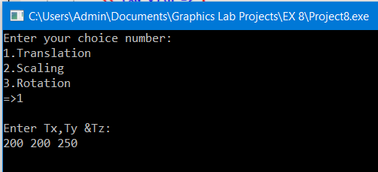



**SCALING:**

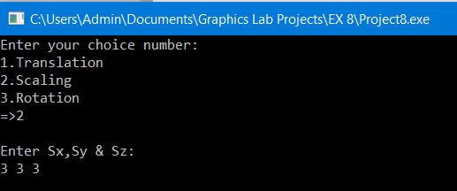

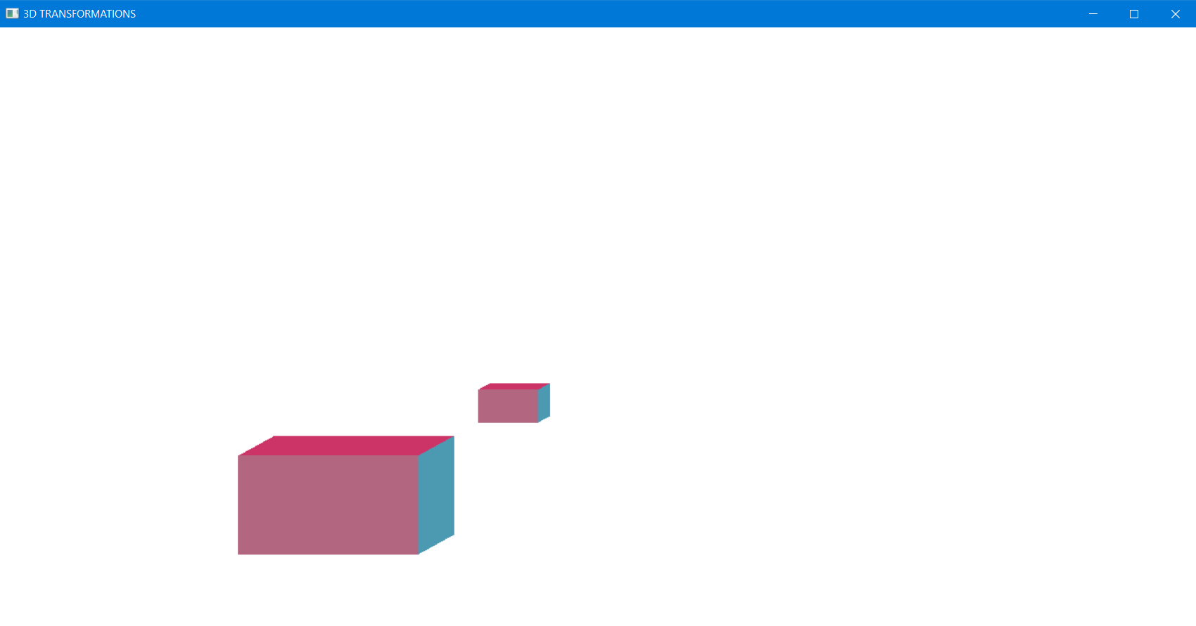

**ROTATION:**

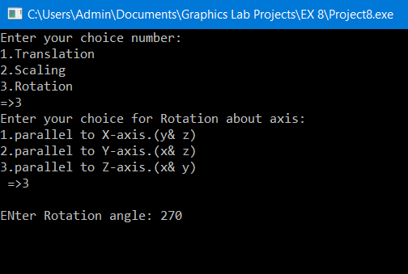



**RESULT:**

OPENGL programs to perform 3D tranformations was designed and implemented successfully.