**CHANGES TO PROSPECT REQUESTED ON APRIL 1ST, 2020**

1) Unit # Move-In Date ADD: Parking Space #__________(this will be preassigned in the parking table as described below)

2) If tenant clicks +Add Item, following message should appear. If one or 2 bedrooms selected,

“Your Lease includes one assigned parking space. You can purchase one additional parking space for a monthly charge of $100 by clicking the “Add Item”. Additional parking spaces are limited and available on a first-come, first-serve basis.

And if 3 bedrooms are selected,

“Your Lease includes two assigned parking spaces. You can purchase one additional parking space for a monthly charge of $100 by clicking the “Add Item”. Additional parking spaces are limited and available on a first-come, first-serve basis.

. 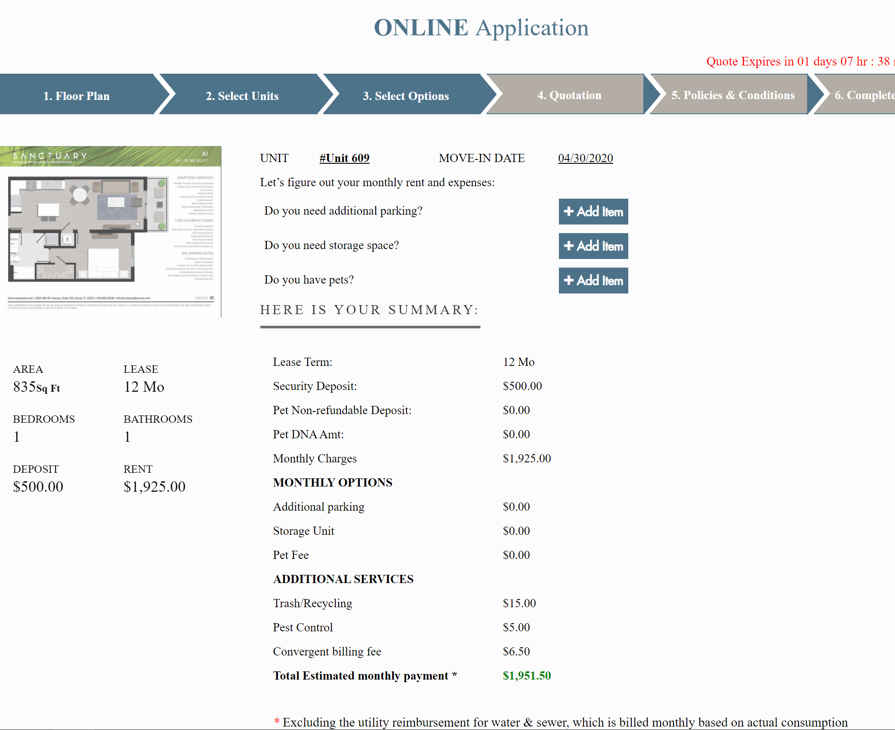

The parking space Admin table must be completely changed.

There is a total of 348 parking spaces. We will assign one parking space for each of the 1-BR and 2-BRs units and two parking spaces for the 3-BRs. There are 102 1-BR and 102 2-BRs and 22-3BRs, so we will have 248 assigned parking spaces. We will leave 3 parking spaces for employees and the remaining 97 spaces will be rented on a first-come, first-serve basis, and will be assigned when the prospect selects the +Add Item in the “Do you need additional parking?” All spaces will have the same cost of $100/month.

The table should provide a parking space #__________ and a unit #____________ which will prefill for all the 226 units. The remaining unassigned 97 spaces will be assigned in order as prospects select additional parking.

The parking space table should also link to the Vehicle information which is completed in the prospect application and the vehicle Tag, and model/make of vehicle should populate the parking space table.

The search function should allow to search by “Parking Space#, Vehicle Tag, tenant name, or unit #.

Delete the table with parking charge. All parking fee is $100/month. Add Space# , Unit #, change “Description” to “Location” (this would be East or West Garage and floor number. Add drop box E-3, E-4, E-5 or W-3,W-4,W-5) Leave charges to show if it is a space included or rented. If included charge is $0.00. If available for rent, charge is $100. (See existing table below/suggested table following)

Lastly, add parking space # to the Unit table, so that both fields mirror each other. The parking space # can be entered in the unit table, or the unit can be entered in the parking space #. Once entered on either table, it appears on the other one.

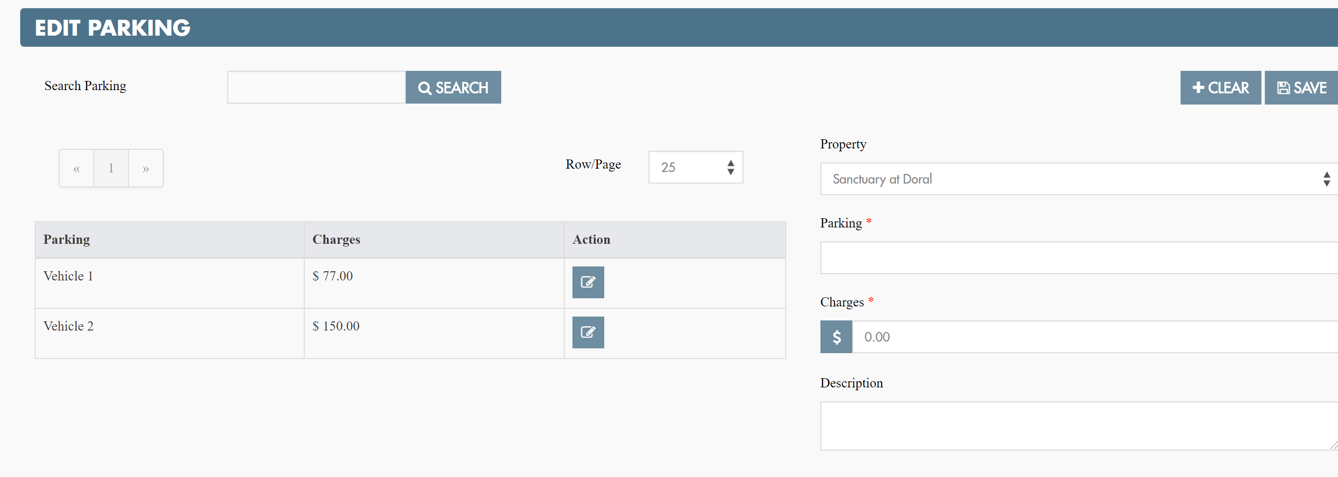



Space #

Unit #

Tenant/Owner of Vehicle

Location: Dropbox E-3, E-4, E-5, W-3, W-4, W-5

Vehicle Tag#____________________

Vehicle Make__________________ Model _____________________

By space #, unit #, vehicle tag #, tenant name

(As a side note, we probably should have a table with all the fees. I don’t know if these is too difficult at the moment, but certainly worth looking into in the future, so Admin only has one place to go when making changes to any of the existing fees: Pet fee; Trash/Recycle fee; Convergent fee; late payment fee; NSF fee; Pet Clean-up fee; Parking fee; Exterminating fee)

Need full workflow on all fees, how they will be charged and how frequently, how admin/tenant will be notified, etc.

1. How does the parking spots that get assigned?
   1. Need the list of parking spots and what unit they are assigned to (we can enter it in backend through the database originally). It then can be maintained in the Edit Parking/Unit
      1. 102 1-BR and 102 2-BRs and 22-3BRs, so we will have 248 assigned parking spaces
   2. Need the list of the additional parking spots
      1. Floor & number of spots or spot number of the parking spot
2. Where is the parking spot number or location going to show?
   1. In additional steps or pages in the prospect portal/tenant portal/admin portal
3. When does the parking spot get assigned to the unit?
   1. At what point in the application process?
4. Additional added parking spots how will this be cancelled and removed from the monthly bill?
   1. When does the parking spot become available when the lease term ends or when the unit becomes available?
5. For additional parking should tenants be recommended or restricted on spots based on the side of the building they reside?
   1. This can be hardcoded as quick measure
      1. (Units 01-20 are on west side) Unit would be 101
      2. (Units 21-39 are on east side)
6. Please confirm that the parking spaces for the units must be taken even if they don’t have a car
7. Is there small or compact unit spaces?
   1. They can select any of the two options and will need to make into different list
   2. Also requesting handicap parking
8. Is vehicle tag a key assigned by Shoma to each registered car or the license plate?
9. Can tenants add additional parking later?
10. What is the limit to the amount of spaces that a tenant can buy?
    1. Is this 1 space per tenant? (3 bedrooms can have 6 occupants)
11. Are any of the 97 additional spaces reserved for guest?
    1. 348 the complete parking of the property of just the garages

**Impact analysis**: list where the changes need to happen (prospect/tenant/admin and where)

This will impact several areas in the Prospect portal

* Step 3. Select Option
* Step 5. Policies & Conditions
  + G. Vehicle Info
  + I. Payment Info
* Any other areas the parking spot info needs to be added

Tenant

* Monthly payments
* Editing vehicle info under profile
* Possibly additional parking later
* Any other areas the parking spot info needs to be added

Admin

* Property Unit
* Tenant Vehicle Information
* Tenant Billing Information
* Edit Parking
* Tenant fees page (when added at future point)
* Any other areas the parking spot info needs to be added

Database

* Edit and add new tables in order to store and map spaces to tenants/units