1. Floor Plan Page: (Modal) Spelling error – Change to “Model “



1. 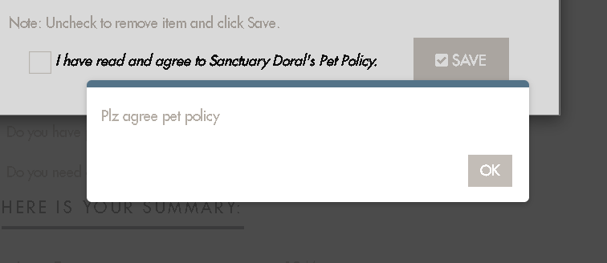 [**I have read and agree to Sanctuary Doral's Pet Policy.**](javascript:void(0);) Highlight the word Pet Policy ( make it Bold, and make it look like a clickable option)

Please agree to the pet policy

1. Remove the space after the word midnight and (. Fullstop)

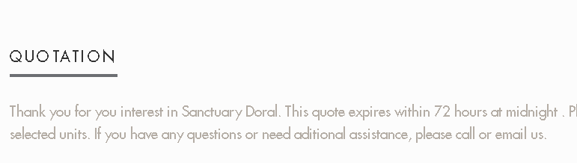

1. Change the Status to ( In- Progress) for both applicant and co-applicant

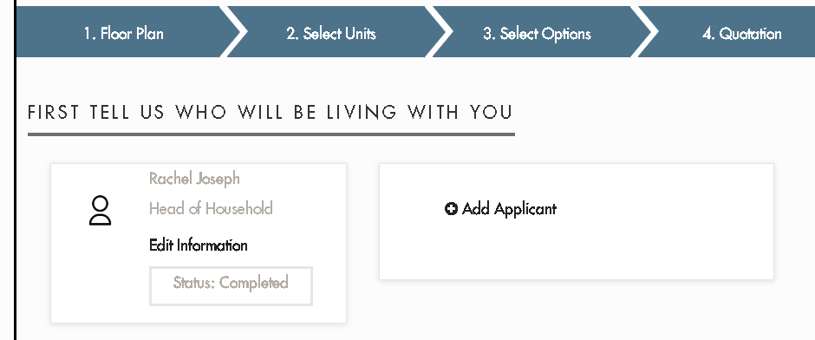

1. First Applicant change wording “ Head of Household” to “Primary Applicant”
2. Pop up box change: for Primary Applicant, Remove (relationship textbox )

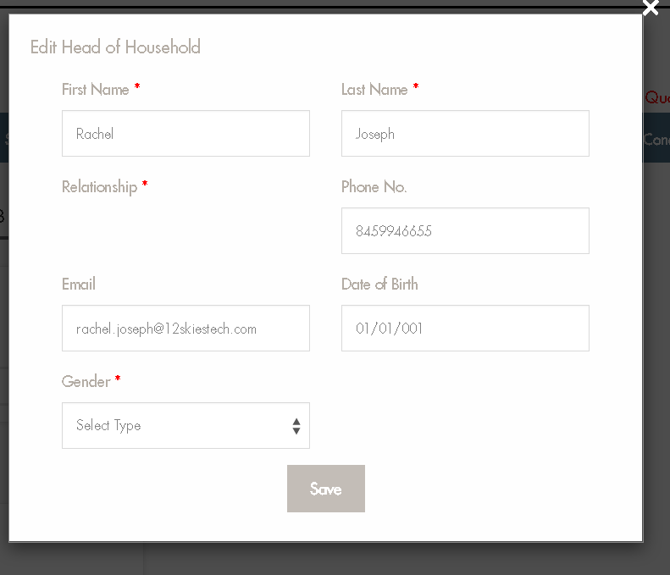

1. Add Applicant pop up box: relationship field drop down menu not working

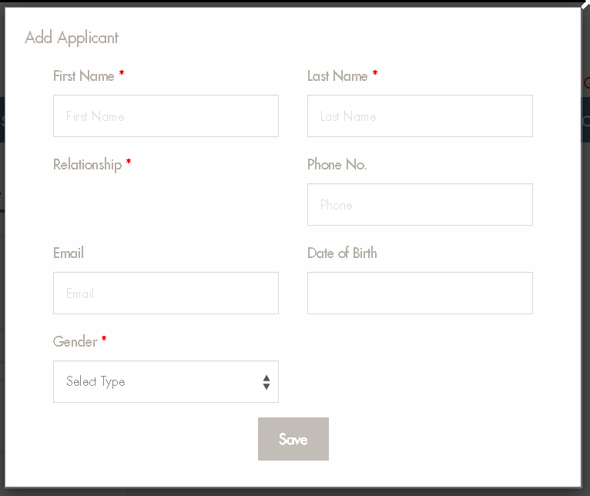

1. Spelling error “Fedral to Federal “
2. Change paystubs1,2,3 to Upload1,2,3,
3. For further update, have a alert box when a doc/ image is uploaded.
4. Change Title: Add Pets to Add Pet Information (in the Policies and terms page)
5. In Pet Information: Change to What is your Pets Name? Mandatory field: Weight, Breed, Name.