Java Script

JavaScript is one of the **3 languages** all web developers **must** learn:

   1. **HTML** to define the content of web pages

   2. **CSS** to specify the layout of web pages

   3. **JavaScript** to program the behavior of web pages

One of many JavaScript HTML methods is getElementById()

document.getElementById("demo").innerHTML = "Hello JavaScript";

How to chage backround color automatically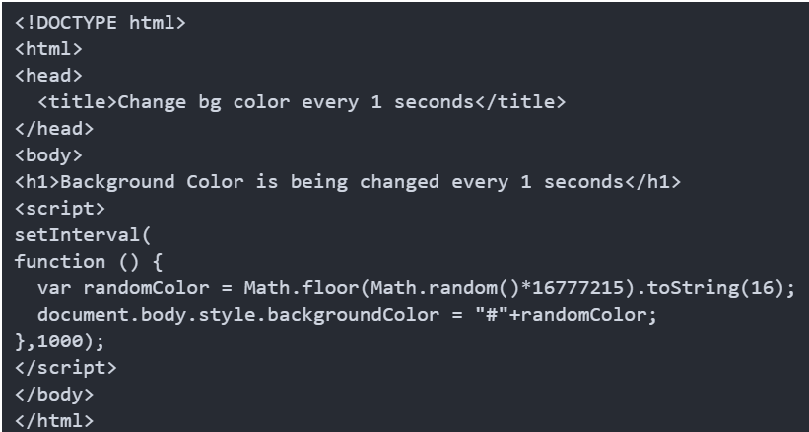

How to set automatic slider in javsript

<html>

<head>

<meta charset="utf-8" />

<title></title>

<meta name="viewport" content="width=device-width, initial-scale=1">

<style>

* {

box-sizing: border-box;

}

body {

font-family: Verdana, sans-serif;

}

.mySlides {

display: none;

}

img {

vertical-align: middle;

}

/* Slideshow container */

.slideshow-container {

max-width: 1000px;

position: relative;

margin: auto;

}

/* Caption text */

.text {

color: #f2f2f2;

font-size: 15px;

padding: 8px 12px;

position: absolute;

bottom: 8px;

width: 100%;

text-align: center;

}

/* Number text (1/3 etc) */

.numbertext {

color: #f2f2f2;

font-size: 12px;

padding: 8px 12px;

position: absolute;

top: 0;

}

/* The dots/bullets/indicators */

.dot {

height: 15px;

width: 15px;

margin: 0 2px;

background-color: #bbb;

border-radius: 50%;

display: inline-block;

transition: background-color 0.6s ease;

}

.active {

background-color: #717171;

}

/* Fading animation */

.fade {

-webkit-animation-name: fade;

-webkit-animation-duration: 1.5s;

animation-name: fade;

animation-duration: 1.5s;

}

@-webkit-keyframes fade {

from {

opacity: .4

}

to {

opacity: 1

}

}

@keyframes fade {

from {

opacity: .4

}

to {

opacity: 1

}

}

/* On smaller screens, decrease text size */

@media only screen and (max-width: 300px) {

.text {

font-size: 11px

}

}

</style>

</head>

<body>

<h2>Automatic Slideshow</h2>

<p>Change image every 2 seconds:</p>

<div class="slideshow-container">

<div class="mySlides fade">

<div class="numbertext">1 / 3</div>

<img src="img/image1.jpg" style="width:100%">

<div class="text">Caption Text</div>

</div>

<div class="mySlides fade">

<div class="numbertext">2 / 3</div>

<img src="img/image2.jpg" style="width:100%">

<div class="text">Caption Two</div>

</div>

<div class="mySlides fade">

<div class="numbertext">3 / 3</div>

<img src="img/image3.jpg" style="width:100%">

<div class="text">Caption Three</div>

</div>

</div>

<br>

<div style="text-align:center">

<span class="dot"></span>

<span class="dot"></span>

<span class="dot"></span>

</div>

<script>

var slideIndex = 0;

showSlides();

function showSlides() {

var i;

var slides = document.getElementsByClassName("mySlides");

var dots = document.getElementsByClassName("dot");

for (i = 0; i < slides.length; i++) {

slides[i].style.display = "none";

}

slideIndex++;

if (slideIndex > slides.length) {slideIndex = 1}

for (i = 0; i < dots.length; i++) {

dots[i].className = dots[i].className.replace(" active", "");

}

slides[slideIndex-1].style.display = "block";

dots[slideIndex-1].className += " active";

setTimeout(showSlides, 2000); // Change image every 2 seconds

}

</script>

</body>

</html>