About the Free Seminar:
Free Seminar on the topic:  “Investor Awareness Program for Financial Literacy and Commodity Market Awareness“  Date of Event:  11th November 2025  Name of Expert:  Mr. Aashih Shah  About Expert: Expert Mr. Aashish Shah is a well known personality. He is MBA, M.Com, LLB, Wealth Multipliers, Limca Book Record Holder ( Four Times ), Management Trainer and Motivator, Visiting Faculty at several Business management colleges , Consultant with several institutions , NISM Financial Market Trainer, IGRP member of BSE , NSE, MCX and MSE. | 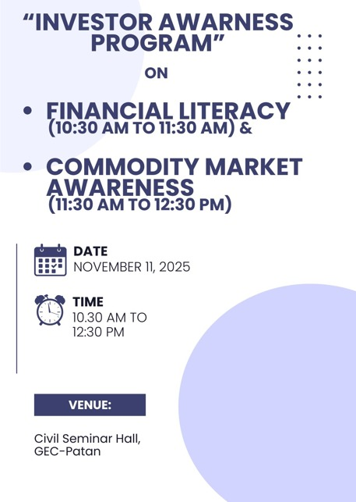
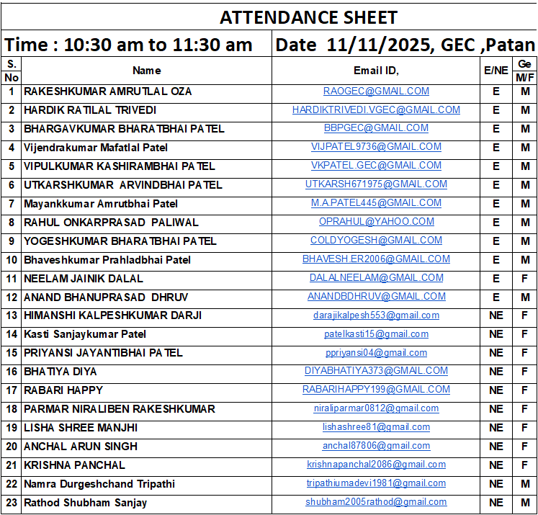 | 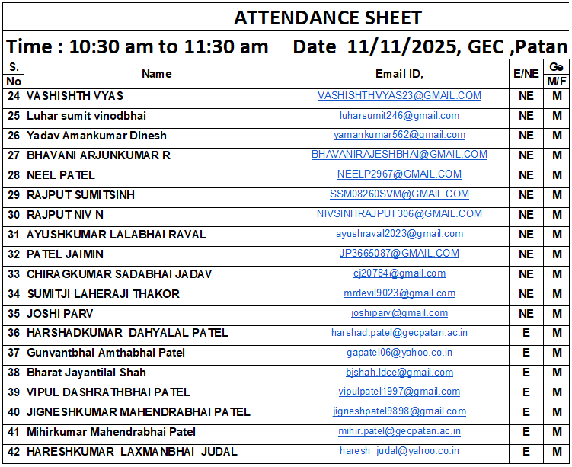

Photographs of an event:
