Deploying Your Google ADK Agent
to Google Cloud Platform

Product: Google Agent Development Kit (ADK) | Agent: adk_simple_bot | August 2026

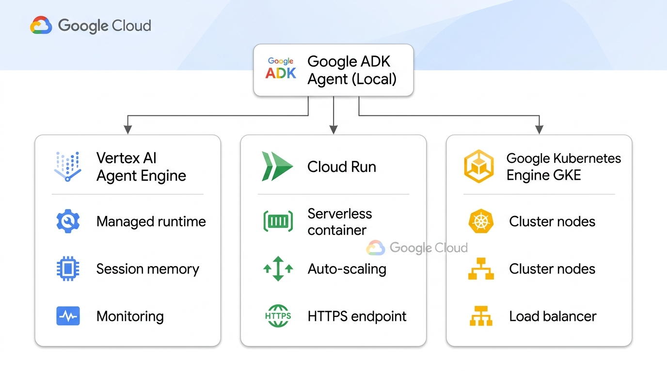
Figure 1 — Three supported deployment paths from a local Google ADK agent to Google Cloud Platform

Overview
The Google Agent Development Kit (ADK) is an open-source, code-first Python framework for building and deploying production-grade AI agents. After testing your agent locally with adk web, you are ready to deploy it to Google Cloud Platform (GCP). This guide covers all three officially supported deployment options:
Option | Type | Effort Level
A — Vertex AI Agent Engine | Fully Managed (PaaS) | ⭐ Lowest
B — Cloud Run | Serverless Containers | ⭐⭐ Low
C — GKE | Container Orchestration | ⭐⭐⭐ High

Before You Begin — Common Prerequisites

1. Google Cloud Project
An active Google Cloud Project with billing enabled: https://console.cloud.google.com

2. Install the Google Cloud CLI
# macOS (via Homebrew)
brew install google-cloud-sdk
# Authenticate and set your project
gcloud auth login
gcloud config set project YOUR_PROJECT_ID

3. Verify Your Project Structure
Agent_Development_Kit/ ← Run all commands from here
├── .env ← Contains GOOGLE_API_KEY
├── pyproject.toml
├── requirements.txt ← Generate this (see below)
└── adk_simple_bot/
├── __init__.py ← Must contain: from . import agent
├── agent.py ← Must define: root_agent = Agent(...)
├── prompt.py
└── tools/
├── __init__.py
└── dummy_wether.py

4. Generate requirements.txt
uv pip freeze > requirements.txt
⚠️ Always run deployment commands from the project root directory (Agent_Development_Kit/), not from inside the adk_simple_bot/ subfolder.

Option A — Vertex AI Agent Engine
✅ Best for: Teams who want Google to manage all infrastructure, with built-in session memory and monitoring out of the box.

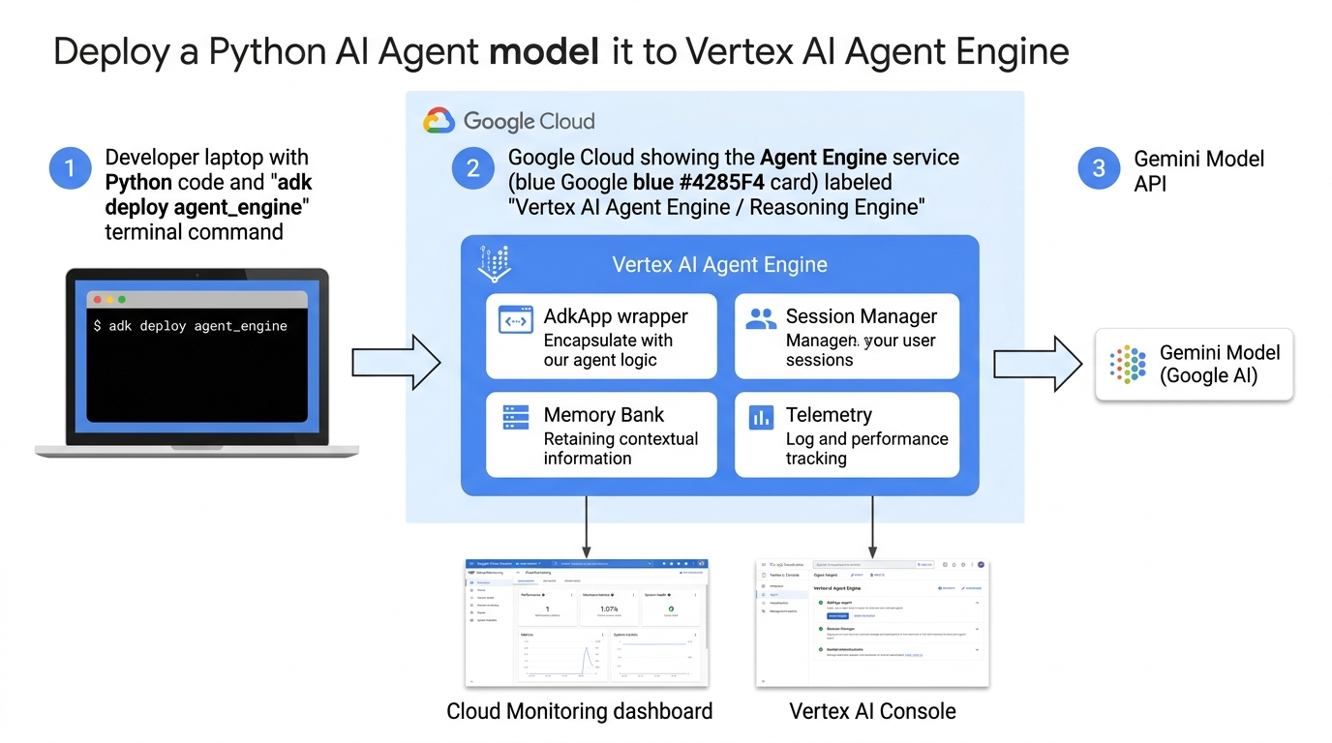
Figure 2 — Architecture: Deploying your ADK agent to Vertex AI Agent Engine

What Is Vertex AI Agent Engine?
Vertex AI Agent Engine (part of the Gemini Enterprise Agent Platform) is Google's fully managed runtime for ADK agents. You upload your Python code and Google handles everything else: scaling, sessions, memory, telemetry, and monitoring dashboards.

Step 1 — Enable the Vertex AI API
gcloud services enable aiplatform.googleapis.com

Step 2 — Install ADK with Vertex AI Support
pip install "google-adk[vertexai]"
# Or with uv (your project uses uv):
uv add "google-adk[vertexai]"

Step 3 — Create a Cloud Storage Bucket for Staging
gcloud storage buckets create gs://YOUR_PROJECT_ID-adk-staging \
--location=us-central1

Step 4 — Deploy Using the ADK CLI
cd /Users/sachinmishra/Desktop/Agent_Development_Kit
uv run adk deploy agent_engine \
--project=YOUR_PROJECT_ID \
--region=us-central1 \
--display_name="adk_simple_bot" \
--staging_bucket=gs://YOUR_PROJECT_ID-adk-staging \
adk_simple_bot
What happens when you run this command:
- ADK wraps your root_agent in a reasoning_engines.AdkApp object
- It packages your code and uploads it to the staging bucket
- Vertex AI provisions a managed runtime and deploys your agent
- You receive a resource_name upon completion

Step 5 — Verify in the Cloud Console
Go to Vertex AI Console → Agent Engine in the Google Cloud Console to see your deployed agent, monitoring metrics, and session logs.

Step 6 — Test Your Deployed Agent
import vertexai
from vertexai.preview import reasoning_engines
vertexai.init(project="YOUR_PROJECT_ID", location="us-central1")
agent = reasoning_engines.ReasoningEngine(
"projects/YOUR_PROJECT_ID/locations/us-central1/reasoningEngines/123456789"
)
session = agent.create_session(user_id="user_001")
response = agent.stream_query(
user_id="user_001",
session_id=session["id"],
message="What is the weather in Delhi?"
)
for chunk in response:
print(chunk, end="", flush=True)

Pros & Cons
✅ Advantages | ❌ Limitations
Zero infrastructure management | Cannot deploy a custom Web UI directly
Built-in session persistence | Less container-level flexibility
Full monitoring dashboard in GCP Console | Fragmented pricing across 4 meters
Tightest Gemini model integration | Limited regional availability
No Docker knowledge needed

Option B — Cloud Run
✅ Best for: Most ADK agent deployments. Serverless containers with true scale-to-zero, custom web UIs, and straightforward CI/CD integration.

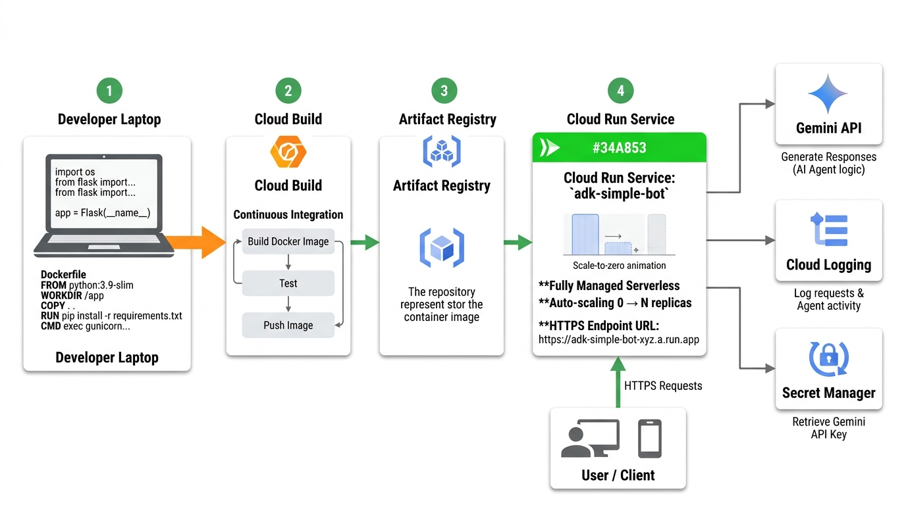
Figure 3 — Architecture: Deploying your ADK agent to Cloud Run via containerization pipeline

What Is Cloud Run?
Cloud Run is Google's fully managed serverless container platform. Your ADK agent is packaged as a Docker container and deployed as a scalable HTTPS service. It automatically scales from zero (when idle) to thousands of instances (under load) — you pay $0.00 when no traffic.

Step 1 — Enable Required APIs
gcloud services enable \
run.googleapis.com \
artifactregistry.googleapis.com \
cloudbuild.googleapis.com

Step 2 — Create an Artifact Registry Repository
gcloud artifacts repositories create adk-agents \
--repository-format=docker \
--location=us-central1 \
--description="ADK agent container images"

Step 3 — Create a Dockerfile
Create this file in your project root (Agent_Development_Kit/):
FROM python:3.12-slim
WORKDIR /app
COPY requirements.txt .
RUN pip install --no-cache-dir -r requirements.txt
COPY . .
ENV PYTHONUNBUFFERED=1
ENV PORT=8080
EXPOSE 8080
CMD ["adk", "api_server", \
"--host", "0.0.0.0", \
"--port", "8080", \
"adk_simple_bot"]

Step 4A — Deploy Using the ADK CLI (Simplest)
adk deploy cloud_run \
--project=YOUR_PROJECT_ID \
--region=us-central1 \
--service_name=adk-simple-bot \
adk_simple_bot

Step 4B — Deploy Using gcloud (Manual Control)
# Build and push image
gcloud builds submit \
--tag us-central1-docker.pkg.dev/YOUR_PROJECT_ID/adk-agents/adk-simple-bot:v1 .
# Deploy to Cloud Run
gcloud run deploy adk-simple-bot \
--image us-central1-docker.pkg.dev/YOUR_PROJECT_ID/adk-agents/adk-simple-bot:v1 \
--platform managed \
--region us-central1 \
--allow-unauthenticated

Step 5 — Store API Key Securely with Secret Manager
gcloud services enable secretmanager.googleapis.com
echo -n "YOUR_GOOGLE_API_KEY" | \
gcloud secrets create GOOGLE_API_KEY \
--replication-policy="automatic" \
--data-file=-
# Redeploy with the secret mounted
gcloud run deploy adk-simple-bot \
--image us-central1-docker.pkg.dev/YOUR_PROJECT_ID/adk-agents/adk-simple-bot:v1 \
--region us-central1 \
--set-secrets "GOOGLE_API_KEY=GOOGLE_API_KEY:latest"

Step 6 — Get Your Live Service URL
gcloud run services describe adk-simple-bot \
--region us-central1 \
--format="value(status.url)"
# Example output:
# https://adk-simple-bot-abc123-uc.a.run.app

Step 7 — Handle Session State (Optional)
Cloud Run is stateless by default. For persistent conversation sessions, connect to Cloud Firestore:
gcloud services enable firestore.googleapis.com
gcloud firestore databases create --region=us-central1

Pros & Cons
✅ Advantages | ❌ Limitations
True scale-to-zero ($0 idle cost) | Session state needs Firestore
Full container flexibility | Requires a Dockerfile
Supports custom Web UIs | Cold-start latency on first request
Easy CI/CD pipeline integration
Identity-Aware Proxy (IAP) support
Supports HTTP streaming & WebSockets

Option C — Google Kubernetes Engine (GKE)
✅ Best for: Enterprise teams needing GPU support, complex custom networking, self-hosted LLMs, or organizations already standardized on Kubernetes.

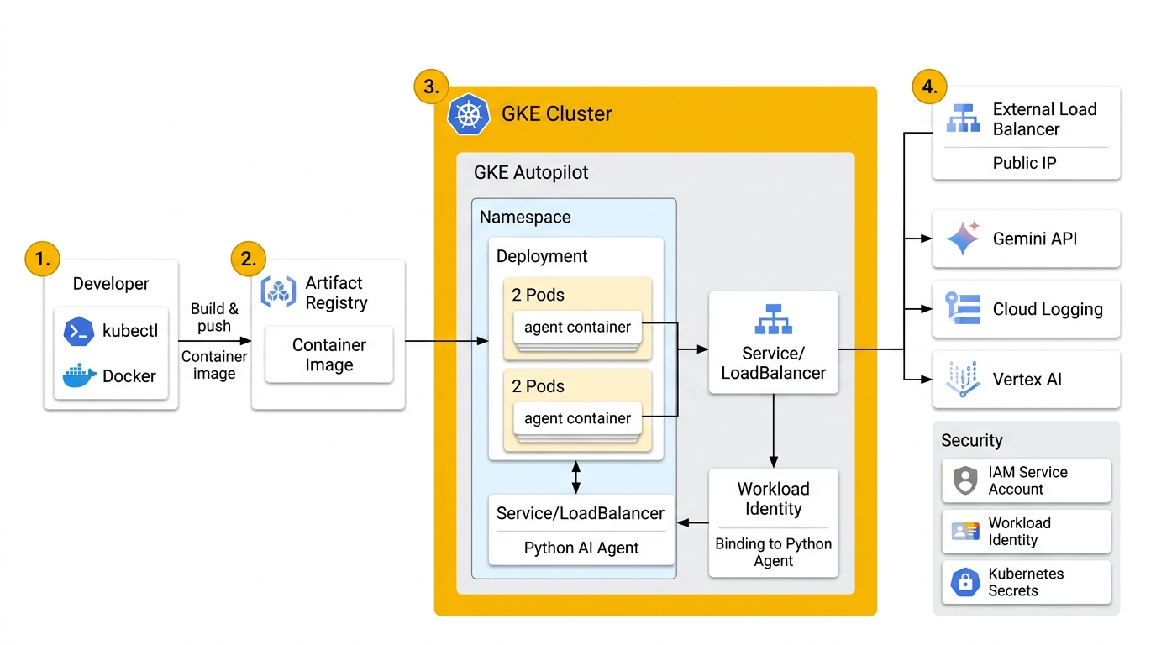
Figure 4 — Architecture: Deploying your ADK agent to GKE with Workload Identity

What Is GKE?
Google Kubernetes Engine (GKE) gives you full Kubernetes-based container orchestration. Use GKE Autopilot (recommended) for simplified cluster management while retaining full flexibility.

Step 1 — Enable Required APIs
gcloud services enable \
container.googleapis.com \
artifactregistry.googleapis.com \
aiplatform.googleapis.com

Step 2 — Create a GKE Autopilot Cluster
gcloud container clusters create-auto adk-agents-cluster \
--region=us-central1 \
--project=YOUR_PROJECT_ID

Step 3 — Configure kubectl Access
gcloud container clusters get-credentials adk-agents-cluster \
--region=us-central1
kubectl get nodes

Step 4 — Build & Push Container Image
gcloud builds submit \
--tag us-central1-docker.pkg.dev/YOUR_PROJECT_ID/adk-agents/adk-simple-bot:v1 \
.

Step 5 — Create Kubernetes Deployment Manifest (k8s-deployment.yaml)
apiVersion: apps/v1
kind: Deployment
metadata:
name: adk-simple-bot
namespace: default
spec:
replicas: 2
selector:
matchLabels:
app: adk-simple-bot
template:
metadata:
labels:
app: adk-simple-bot
spec:
serviceAccountName: adk-simple-bot-sa
containers:
- name: adk-simple-bot
image: us-central1-docker.pkg.dev/YOUR_PROJECT_ID/adk-agents/adk-simple-bot:v1
ports:
- containerPort: 8080
env:
- name: GOOGLE_API_KEY
valueFrom:
secretKeyRef:
name: google-api-key-secret
key: GOOGLE_API_KEY
resources:
requests:
cpu: "250m"
memory: "512Mi"
limits:
cpu: "1"
memory: "2Gi"
---
apiVersion: v1
kind: Service
metadata:
name: adk-simple-bot-service
spec:
selector:
app: adk-simple-bot
ports:
- protocol: TCP
port: 80
targetPort: 8080
type: LoadBalancer

Step 6 — Create Kubernetes Secret
kubectl create secret generic google-api-key-secret \
--from-literal=GOOGLE_API_KEY=YOUR_GOOGLE_API_KEY

Step 7 — Set Up Workload Identity (Secure Auth)
kubectl create serviceaccount adk-simple-bot-sa
gcloud iam service-accounts create adk-simple-bot-gsa \
--display-name="ADK Simple Bot Service Account"
gcloud projects add-iam-policy-binding YOUR_PROJECT_ID \
--member="serviceAccount:adk-simple-bot-gsa@YOUR_PROJECT_ID.iam.gserviceaccount.com" \
--role="roles/aiplatform.user"
gcloud iam service-accounts add-iam-policy-binding \
adk-simple-bot-gsa@YOUR_PROJECT_ID.iam.gserviceaccount.com \
--role="roles/iam.workloadIdentityUser" \
--member="serviceAccount:YOUR_PROJECT_ID.svc.id.goog[default/adk-simple-bot-sa]"
kubectl annotate serviceaccount adk-simple-bot-sa \
iam.gke.io/gcp-service-account=adk-simple-bot-gsa@YOUR_PROJECT_ID.iam.gserviceaccount.com

Step 8 — Deploy to GKE
kubectl apply -f k8s-deployment.yaml
kubectl get pods --watch

Step 9 — Get External IP
kubectl get service adk-simple-bot-service

ADK CLI Shortcut
adk deploy gke \
--project=YOUR_PROJECT_ID \
--region=us-central1 \
--cluster=adk-agents-cluster \
adk_simple_bot

Pros & Cons
✅ Advantages | ❌ Limitations
Maximum infrastructure control | Steepest learning curve
GPU node pool support for custom LLMs | No native scale-to-zero
Complex networking & security policies | Requires Kubernetes expertise
Ideal for self-hosted models (vLLM, Llama) | Highest management overhead
Works with existing Kubernetes tooling | Cluster always costs money when idle

Side-by-Side Comparison
Feature | Vertex AI Agent Engine | Cloud Run | GKE
Deployment Effort | ⭐ Very Low | ⭐⭐ Low | ⭐⭐⭐ High
Infrastructure Mgmt | Google manages all | Serverless (none) | You manage cluster
Session Persistence | ✅ Built-in | ❌ Needs Firestore | ❌ Needs Firestore
Scale to Zero | ✅ Yes | ✅ Yes | ❌ No
Custom Dockerfile | ❌ Not needed | ✅ Required | ✅ Required
Custom Web UI | ❌ Not supported | ✅ Yes | ✅ Yes
GPU Node Pools | ❌ No | ❌ Limited | ✅ Yes
Monitoring Dashboard | ✅ Built-in | Via Cloud Logging | Via Cloud Logging
ADK CLI Command | adk deploy agent_engine | adk deploy cloud_run | adk deploy gke
Idle Cost | Low | $0.00 ✅ | Cluster accrues
Recommended For | Managed deployments | Most use cases ✅ | Enterprise/GPU

Decision Guide — Which Option to Choose?
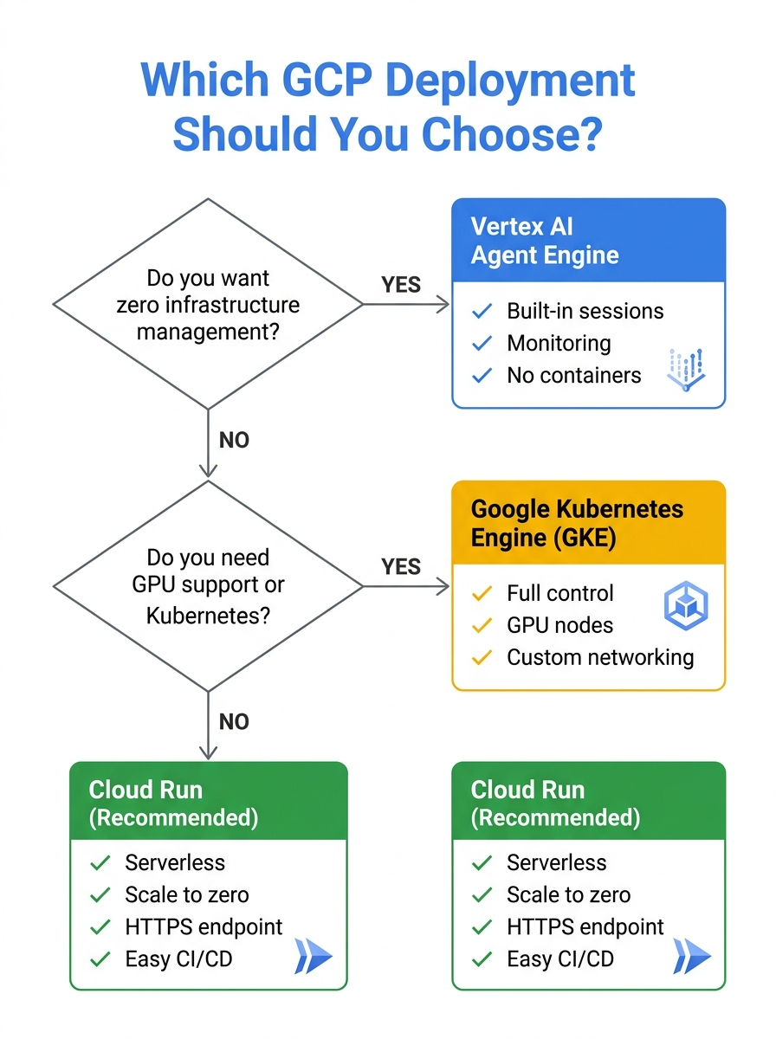
Figure 5 — Decision flowchart: Choose the right GCP deployment for your ADK agent

⭐ Recommendation for adk_simple_bot: Start with Cloud Run. It provides the best balance of simplicity, cost-efficiency, and flexibility. When you need built-in session memory without extra code, migrate to Vertex AI Agent Engine.

Quick Reference — All CLI Commands
# ── Common Setup ──────────────────────────────────────────
gcloud auth login
gcloud config set project YOUR_PROJECT_ID
# ── Option A: Vertex AI Agent Engine ──────────────────────
gcloud services enable aiplatform.googleapis.com
uv run adk deploy agent_engine \
--project=YOUR_PROJECT_ID \
--region=us-central1 \
--display_name=adk_simple_bot \
adk_simple_bot
# ── Option B: Cloud Run ────────────────────────────────────
gcloud services enable run.googleapis.com artifactregistry.googleapis.com
adk deploy cloud_run \
--project=YOUR_PROJECT_ID \
--region=us-central1 \
--service_name=adk-simple-bot \
adk_simple_bot
# ── Option C: GKE ──────────────────────────────────────────
gcloud services enable container.googleapis.com
gcloud container clusters create-auto adk-agents-cluster --region=us-central1
adk deploy gke \
--project=YOUR_PROJECT_ID \
--region=us-central1 \
--cluster=adk-agents-cluster \
adk_simple_bot

Useful Resources
Resource | Link
ADK Official Documentation | https://adk.dev
Google Cloud Console | https://console.cloud.google.com
Vertex AI Agent Engine Docs | https://cloud.google.com/vertex-ai/generative-ai/docs/agent-engine
Cloud Run Documentation | https://cloud.google.com/run/docs
GKE Documentation | https://cloud.google.com/kubernetes-engine/docs
Google AI Studio (API Keys) | https://aistudio.google.com/app/api-keys
Secret Manager | https://cloud.google.com/secret-manager/docs
Artifact Registry | https://cloud.google.com/artifact-registry/docs

Google ADK Deployment Guide | Agent: adk_simple_bot | Platform: Google Cloud Platform | August 2026

