**Guidelines to fetch data from .db file**

import SQLite3: Import the sqlite3 module in your Jupyter Notebook.

Retrieve Table Names: Query to retrieve the names of all tables in the database:

import sqlite3

*# Connect to the SQLite database file*

conn = sqlite3.connect('Database.db')

*# Replace* ‘Database.db' *with the path to your .db file if the file is in another directory.*

*# Create a cursor object*

cursor = conn.cursor()

*# Query to retrieve table names*

cursor.execute("SELECT name FROM sqlite_master WHERE type='table';")

*# Fetch all table names*

tables = cursor.fetchall()

*# Print the table names*

for table in tables:

print(table[0])

*# Close the connection*

conn.close()

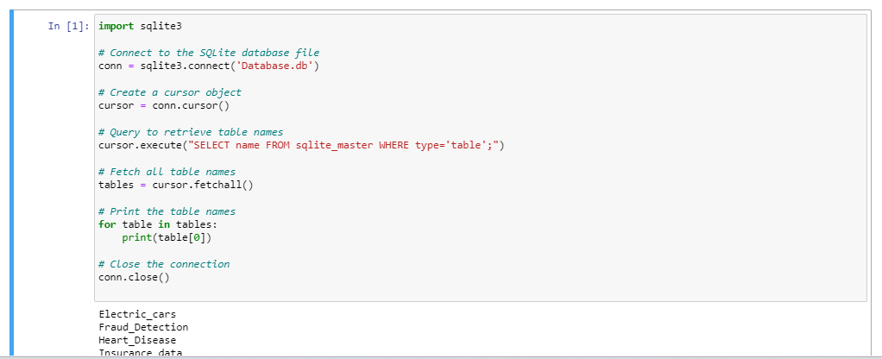

The database contains the following datasets:

1. Electric_cars
2. Fraud_detection
3. Heart_disease
4. Insurance_Prediction
5. TripAdviser_Reviews
6. Ecommerce_data
7. Automobile_data
8. Supermarket_data

Each project's problem statement specifies which dataset to use.

**Code to create a Dataframe:**

conn = sqlite3.connect('Database.db')

df = pd.read_sql_query('Select * from Electric_cars' , conn)

df

*(Make sure to replace 'Table_name' with the name of the table you want to read data from.)*

